ROAD TO THE RESURRECTION - Week 2
Mount of Transfiguration – “Don’t Put God In A Box”

Review - WEEK 1 CAESAREA PHILIPPI –

In Matt 16 Jesus brought His disciples 25 miles North of Galilee to a town called Caesarea Philippi. While he was there he asked “who do you say I am”, and only Peter got the correct answer.

Matt 16:16-17 Simon Peter answered, “You are the Messiah, the Son of the living God.” Jesus replied, “Blessed are you, Simon son of Jonah, for this was not revealed to you by flesh and blood, but by my Father in heaven

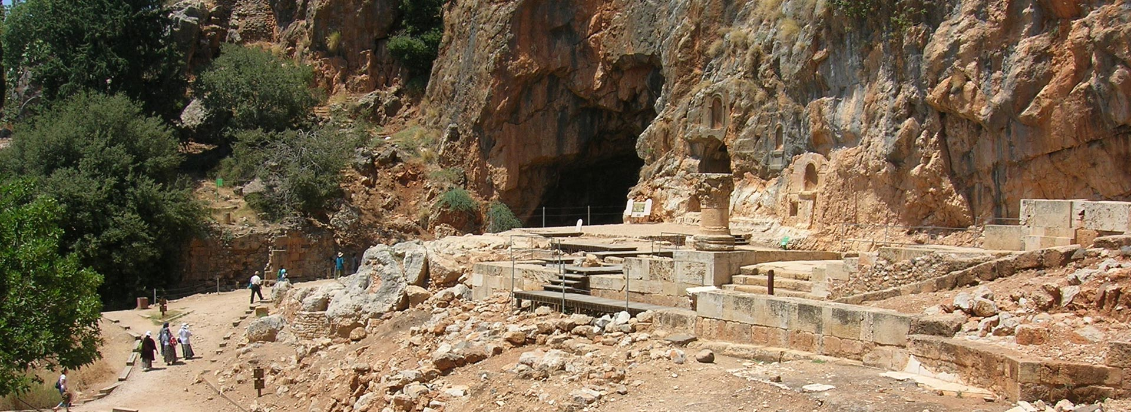

WEEK 2: “Mount of Transfiguration”

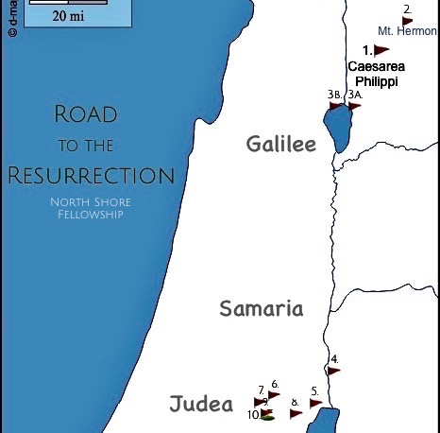

MATT 17:1-9
After six days Jesus took with him Peter, James and John the brother of James, and led them up a high mountain by themselves. ² There he was transfigured before them. His face shone like the sun, and his clothes became as white as the light. ³ Just then there appeared before them Moses and Elijah, talking with Jesus.
⁴ Peter said to Jesus, “Lord, it is good for us to be here. If you wish, I will put up three shelters—one for you, one for Moses and one for Elijah.”
⁵ While he was still speaking, a bright cloud covered them, and a voice from the cloud said, “This is my Son, whom I love; with him I am well pleased. Listen to him!”

⁶ When the disciples heard this, they fell facedown to the ground, terrified. ⁷ But Jesus came and touched them. “Get up,” he said. “Don’t be afraid.” ⁸ When they looked up, they saw no one except Jesus.
⁹ As they were coming down the mountain, Jesus instructed them, “Don’t tell anyone what you have seen, until the Son of Man has been raised from the dead.”

Mountain of Transfiguration

Where was it?

Two popular theories – Mt. Tabor and Mt. Hermon:

- Mt Tabor

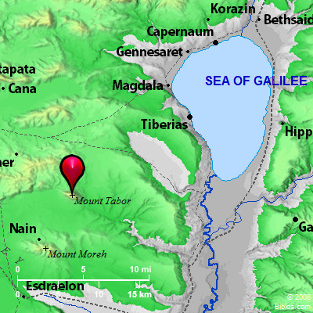

A stand-alone large “hill” that is situated between Galilea and Nazareth. Popular Mt. of Transfiguration tourist site.

- Mt. Hermon
A real Mountain, (nearly 10,000 ft. and often snowcapped). Situated between Lebanon, Syria and Israel. A more likely choice in that it is as “mountain” and in the general vicinity of CP.

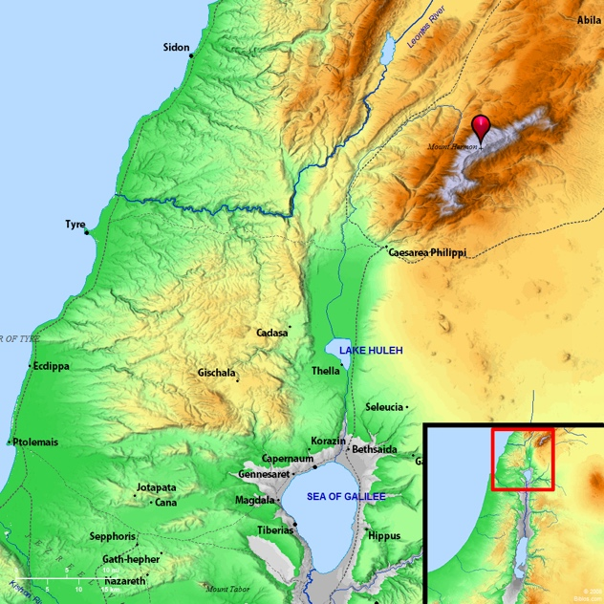

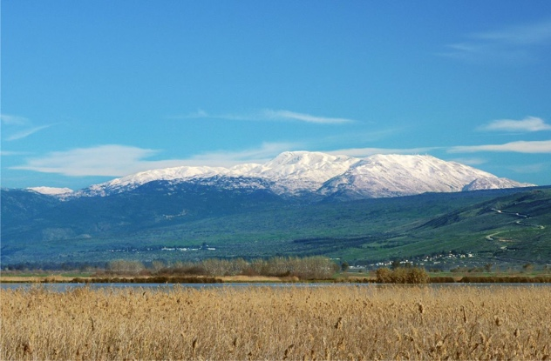

Matt 17:1-3 After six days Jesus took with him Peter, James and John the brother of James, and led them up a high mountain by themselves. ² There he was transfigured before them. His face shone like the sun, and his clothes became as white as the light. ³ Just then there appeared before them Moses and Elijah, talking with Jesus.

What they spoke about:
Luke 9:31 “³¹ They spoke about his departure, which he was about to bring to fulfillment at Jerusalem.”

Plan: To go to Jerusalem, to suffer, to die and to be raised from the dead. This all needed to be done to fulfill the Law and the Prophets.

Matt 5:17 ¹⁷ “Do not think that I have come to abolish the Law or the Prophets; I have not come to abolish them but to fulfill them.

Peter’s Response:
⁴ Peter said to Jesus, “Lord, it is good for us to be here. If you wish, I will put up three shelters—one for you, one for Moses and one for Elijah.”

This is my son, whom I love…
Matt 17:5 While he was still speaking, a bright cloud covered them, and a voice from the cloud said, “This is my Son, whom I love; with him I am well pleased. Listen to him!”

Matt 16:23 “…you do not have in mind the concerns of God, but merely human concerns.”

You can’t put God in a box.

Acts 7:48 “…the Most High does not live in houses made by human hands”.

Acts 2:17 “…this is what was spoken by the prophet Joel: ‘In the last days, God says, I will pour out my Spirit on all people.”

Quote: “Outside the box, but inside the Bible”.

Gal 3:3 Are you so foolish? After beginning by means of the Spirit, are you now trying to finish by means of the flesh?

- Let’s let the Spirit start, continue and complete the work he is doing in our churches.
- Let’s not try to take over, or put God in a box.
- Allow him to show you new things, even if you’ve been following him for years.
- Allow Him to take you outside your comfort-zone, to keep you from getting into a rut.
- Believe that He can do more than we even ask or imagine, not because of our own power but His power at work in us.

Eph 3:20
²⁰ Now to him who is able to do immeasurably more than all we ask or imagine, according to his power that is at work within us, ²¹ to him be glory in the church and in Christ Jesus throughout all generations, for ever and ever! Amen.

