TRIUMPHAL ENTRY – Palm Sunday

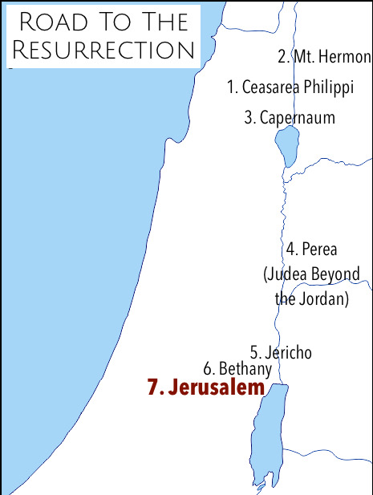

Matt 21:1-11 (NIV)
21 As they approached Jerusalem and came to Bethphage on the Mount of Olives, Jesus sent two disciples, ² saying to them, “Go to the village ahead of you, and at once you will find a donkey tied there, with her colt by her. Untie them and bring them to me. ³ If anyone says anything to you, say that the Lord needs them, and he will send them right away.”

⁴ This took place to fulfill what was spoken through the prophet:
⁵ “Say to Daughter Zion,
‘See, your king comes to you,
gentle and riding on a donkey,
and on a colt, the foal of a donkey.’”

⁶ The disciples went and did as Jesus had instructed them. ⁷ They brought the donkey and the colt and placed their cloaks on them for Jesus to sit on. ⁸ A very large crowd spread their cloaks on the road, while others cut branches from the trees and spread them on the road.⁹ The crowds that went ahead of him and those that followed shouted,

“Hosanna to the Son of David!”
“Blessed is he who comes in the name of the Lord!”
“Hosanna in the highest heaven!”
¹⁰ When Jesus entered Jerusalem, the whole city was stirred and asked, “Who is this?” ¹¹ The crowds answered, “This is Jesus, the prophet from Nazareth in Galilee.”

- Matthew and John mention the verse in Zechariah 9:9, “riding on a donkey, on a colt, the foal of a donkey.”
- All but Luke mention "branches", and only John specifies "palm branches".
- The crowd's greeting to Jesus is different in all accounts.
- Matthew and Luke include some admonishment by the Pharisees and a reply by Jesus.

FULFILMENT OF PROPHECY:
*Matt 21: ⁴ This took place to fulfill what was spoken through the prophet: ⁵ “Say to Daughter Zion, ‘See, your king comes to you, gentle and riding on a donkey, and on a colt, the foal of a donkey.”
Zech. 9:9 Rejoice greatly, Daughter Zion!
Shout, Daughter Jerusalem!See, your king comes to you,
righteous and victorious lowly and riding on a donkey,
on a colt, the foal of a donkey. (Messianic Prophecy)

MATTHEW 21:9 says: “The crowds that went ahead of him and those that followed shouted, “Hosanna to the Son of David!” “Blessed is he who comes in the name of the Lord!” “Hosanna in the highest heaven!”

HOSANNA – “SAVE US” - Used both as a war campaign cry AND an exclamation of Praise and Adoration.

PHARISEES RESPONSE:
- Luke:19 ³⁹ Some of the Pharisees in the crowd said to Jesus, “Teacher, rebuke your disciples!”
⁴⁰ [Jesus] “I tell you,” he replied, “if they keep quiet, the stones will cry out.”

THE DONKEY’S STORY:
- Other than Jesus, the main character of this story is …The Donkey.
- Donkeys are sort of pitiful animals.
- What kids ever say that their favorite Animal is a Donkey?
- How many of us ever wanted to dress up as a donkey for Halloween or a Masquerade party?
- Donkeys get very little respect.

YOU, without Jesus are just you.

YOU as you carry Jesus into situations and environments, have the potential of being part of the greatest mission in history,

God’s Kingdom here on Earth as it is in Heaven.

John 12:32 “if I be lifted up from the earth I will draw all people unto myself”.

