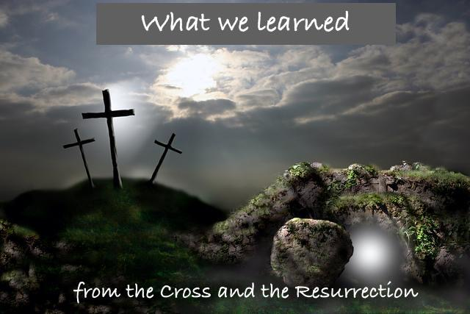
What we learned from the resurrection

Luke 23:39-43
³⁹ One of the criminals who were hanged railed at him, saying, “Are you not the Christ? Save yourself and us!” ⁴⁰ But the other rebuked him, saying, “Do you not fear God, since you are under the same sentence of condemnation? ⁴¹ And we indeed justly, for we are receiving the due reward of our deeds; but this man has done nothing wrong.” ⁴² And he said, “Jesus, remember me when you come into your kingdom.” ⁴³ And he said to him, “Truly, I say to you, today you will be with me in paradise.”

“New Covenant of My Blood”?
Luke 22: 20 “And likewise the cup after they had eaten, saying, “This cup that is poured out for you is the new covenant in my blood.”

Jer. 31:31-34
“The days are coming,” declares the Lord,
“when I will make a new covenant
with the people of Israel
and with the people of Judah.
³² It will not be like the covenant
I made with their ancestors
when I took them by the hand
to lead them out of Egypt,

because they broke my covenant,
though I was a husband to^{[d]} them,^{[e]}”
declares the Lord.
³³ “This is the covenant I will make with the people of Israel
after that time,” declares the Lord.
“I will put my law in their minds
and write it on their hearts.
I will be their God,
and they will be my people.

³⁴ No longer will they teach their neighbor,
or say to one another, ‘Know the Lord,’
because they will all know me,
from the least of them to the greatest,”
declares the Lord.
“For I will forgive their wickedness
and will remember their sins no more.”

BELIEVING: (Gr. “Pisteuo” – from “pistis” Trust / Faith)

“Believing on the Lord Jesus is not the METHOD that we “attain” salvation, it’s the MANNER by which we “receive” salvation.”

  - John 1:12 But as many as received Him, to them He gave the right to become children of God, to those who believe in His name:

  - Romans 10:9-10 “if you confess with your mouth the Lord Jesus and believe in your heart that God has raised Him from the dead, you will be saved. For with the heart one believes unto righteousness, and with the mouth confession is made unto salvation”

  - Acts 16:30-31 And he brought them out and said, “Sirs, what must I do to be saved?” So they said, “Believe on the Lord Jesus Christ, and you will be saved.

Titus 3:4-6 When God our Savior revealed his kindness and love, ⁵ he saved us, not because of the righteous things we had done, but because of his mercy. He washed away our sins, giving us a new birth and new life through the Holy Spirit. ⁶ He generously poured out the Spirit upon us through Jesus Christ our Savior. ⁷ Because of his grace he made us right in his sight and gave us confidence that we will inherit eternal life.

Gal 2:8-9
⁸ For it is by grace you have been saved, through faith—and this is not from yourselves, it is the gift of God— ⁹ not by works, so that no one can boast.

“Justification by Faith” is the opposite of “Salvation by works”

Acts 15:10-11
¹⁰ Now then, why do you try to test God by putting on the necks of Gentiles a yoke that neither we nor our ancestors have been able to bear? ¹¹ No! We believe it is through the grace of our Lord Jesus that we are saved, just as they are.”

John 3:16
¹⁶ “For God so loved the world, that he gave his only Son, that whoever believes in him should not perish but have eternal life.

