FINDING GOD’S LOVE IN A TROUBLED WORLD

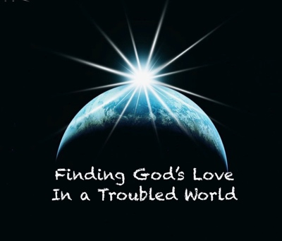

GOD’S LOVE

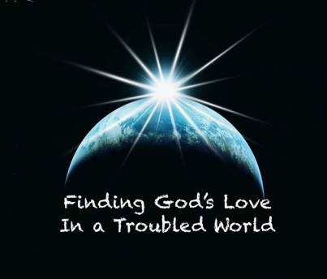

Roman 8:35-39
³⁵ Who shall separate us from the love of Christ? Shall trouble or hardship or persecution or famine or nakedness or danger or sword? >>>

³⁷ No, in all these things we are more than conquerors through him who loved us. ³⁸ For I am convinced that neither death nor life, neither angels nor demons, neither the present nor the future, nor any powers, ³⁹ neither height nor depth, nor anything else in all creation, will be able to separate us from the love of God that is in Christ Jesus our Lord.”

LOVE = “The opposite of selfishness”

John 15:13 “Greater love has no one than this: to lay down one's life for one's friends.”

Psalm 139:17-18 “How precious also are Your thoughts to me, O God!
How great is the sum of them!
If I should count them, they would be more in number than the sand”

1 John 3:1 “See what great love the Father has lavished on us, that we should be called children of God! And that is what we are!”

A look at the “John” of 1st John.

- This is John the apostle who wrote 5 books of the New Testament (Gospel of John, 1,2,& 3 John and Revelation).

- He and his older brother James (who was martyred in Acts 12, were among the first apostles to follow Jesus and nicknamed “Sons of Thunder”

- Their parent were Zebedee and Salome, and they lived in Galilee just like Peter and Andrew.

- Peter, James and John made up the “inner-circle” of Jesus’ confidantes

- He was youngest of the original 12 apostles and the oldest surviving member of that group.

- His books were the latest written among NT entries and his letters were written around the turn of the century 95-100AD

- John refers to himself as the “apostle whom Jesus loved” (John 13 & 19) which means that more than anything that He wrote, experienced or understood, Love was the basis of his relationship with Jesus, and with the Father who (in his own words) “so loved the world”.

1st John 1:1-4 That which was from the beginning, which we have heard, which we have seen with our eyes, which we have looked at and our hands have touched—this we proclaim concerning the Word of life. ² The life appeared; we have seen it and testify to it, and we proclaim to you the eternal life, which was with the Father and has appeared to us. ³ We proclaim to you what we have seen and heard, so that you also may have fellowship with us. And our fellowship is with the Father and with his Son, Jesus Christ. ⁴ We write this to make our joy complete.

STEP 1 TO FINDING GOD’S LOVE IN A TROUBLED WORLD
***Know the love of the Father so that your Joy may be complete!

John 15:9-11 “As the Father has loved me, so have I loved you. Now remain in my love. ¹⁰ If you keep my commands, you will remain in my love, just as I have kept my Father’s commands and remain in his love. ¹¹ I have told you this so that my joy may be in you and that your joy may be complete.

