BELIEVE

Finding God’s Love in a Troubled World

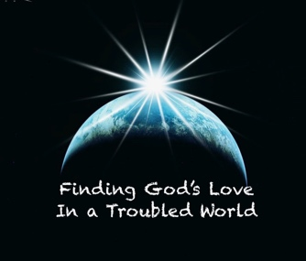

KEY #1 TO FINDING GOD’S LOVE IN A TROUBLED WORLD:
Know that God loves you!

KEY #2 TO FINDING GOD’S LOVE IN A TROUBLED WORLD:
Walk in the Light!

KEY #3 TO FINDING GOD’S LOVE IN A TROUBLED WORLD:
Do not love the World

KEY #4 TO FINDING GOD’S LOVE IN A TROUBLED WORLD:
Be Children of God

1st John 3:11 “ For this is the message you heard from the beginning: We should love one another.”

KEY #5 TO FINDING GOD’S LOVE IN A TROUBLED WORLD:
“Love One Another”

Psalm 27:13 - I would have lost heart, unless I had believed that I would see the goodness of the Lord in the land of the living.

This Week:
STEP #6 “Believe”

TEXT:

1st John 5:1-5 (NKJV) Whoever believes that Jesus is the Christ is born of God, and everyone who loves Him who begot also loves him who is begotten of Him. ² By this we know that we love the children of God, when we love God and keep His commandments. ³ For this is the love of God, that we keep His commandments. And His commandments are not burdensome. ⁴ For whatever is born of God overcomes the world. And this is the victory that has overcome the world—our faith. ⁵ Who is he who overcomes the world, but he who believes that Jesus is the Son of God?

1st John 5:1-5 (ESV) Everyone who believes that Jesus is the Christ has become a child of God. And everyone who loves the Father loves his children, too. ² We know we love God’s children if we love God and obey his commandments. ³ Loving God means keeping his commandments, and his commandments are not burdensome. ⁴ For every child of God defeats this evil world, and we achieve this victory through our faith. ⁵ And who can win this battle against the world? Only those who believe that Jesus is the Son of God.

Verse 1
Everyone who believes that Jesus is the Christ has become a child of God.
[ Key #4 Be Children of God ]

And everyone who loves the Father loves his children, too.

Verse 2
We know we love God’s children if we love God and obey his commandments.

[ Key #5 “Love One Another” ]

Verse 3
Loving God means keeping his commandments, and his commandments are not burdensome

[ Key #2 TO FINDING GOD’S LOVE IN A TROUBLED WORLD:
Walk in the Light! ]

Verse 4
For every child of God defeats this evil world,
[ Key #1 Know that God loves you! & Key #3 ;Do not love the World ]

and we achieve this victory through our faith.

Verse 5: And who can win this battle against the world?

( In other words, “who can find God’s love in this troubled world?”…)

Only those who believe that Jesus is the Son of God.

STEP #6 “Believe”

Verse 1: Everyone who believes that Jesus is the Christ has become a child of God.

Verse 5: And who can win this battle against the world? Only those who believe that Jesus is the Son of God.

- JESUS IS THE CHRIST

- JESUS IS THE SON OF GOD

JESUS

- CHRIST - What does that mean and do we believe it?

- SON OF GOD - Why is this so important?

- CHRIST – MESSIAH

“Christ” is based on the Greek word of Messiah
“Messiah” is based on the Hebrew form of Christ

Matt 16: 13-20
¹³ When Jesus came to the region of Caesarea Philippi, he asked his disciples, “Who do people say the Son of Man is?”
¹⁴ They replied, “Some say John the Baptist; others say Elijah; and still others, Jeremiah or one of the prophets.”
¹⁵ “But what about you?” he asked. “Who do you say I am?”

¹⁶ Simon Peter answered, “You are the Messiah, the Son of the living God.”
¹⁷ Jesus replied, “Blessed are you, Simon son of Jonah, for this was not revealed to you by flesh and blood, but by my Father in heaven.

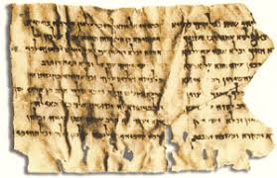

“…"He shall be called the Son of the God; they will call him the Son of the Most High...He will judge the earth in righteousness...and every nation will bow down to him..” (Son of God" fragment 4Q246)

- SON OF GOD

John 1
1 In the beginning was the Word, and the Word was with God, and the Word was God.
>>>>

¹⁴ The Word became flesh and made his dwelling among us. We have seen his glory, the glory of the one and only Son, who came from the Father, full of grace and truth.

KEY #1 – How much God loves you!
KEY #2 – What it is to Walk in the Light!
KEY #3 TO FINDING GOD’S LOVE by not loving the World
KEY #4 What it means to Be Children of God
KEY #5 Experience an environment of love on earth when we truly “Love One Another”
KEY #6 How we can know and experience God’s love in a troubled world simply by Believing that he is the messiah, the Son of the Living God.

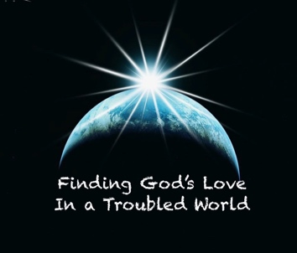

1st Peter 2:9 ⁹ But you are a chosen people, a royal priesthood, a holy nation, God’s special possession, that you may declare the praises of him who called you out of darkness into his wonderful light!

