Healing

“Jehova-Rapha” (The God Who Heals)
“Rapha-El” (Healing God).

JESUS OUR HEALER – One of the Four C&MA Distinctives 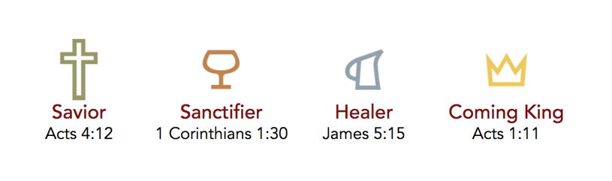

Isaiah 53:5 “But he was pierced for our transgressions,
he was crushed for our iniquities;
the punishment that brought us peace was on him,
and by his wounds we are healed.”

The Power of Healing Comes from Jesus Not from Faith:

Jesus is the healer!

A friend once remarked, “You were healed by faith.”
“Oh, no,” I said, “I was healed by Christ.”
What is the difference? There is a great difference. There came a time when there was a little thing between me and Christ; when even faith seemed to come between me and Jesus. I thought I should have to work up the faith, so I labored to get the faith. At last I thought I had it; that if I put my whole weight upon it, it would hold. When I thought I had got the faith, I said, “Heal me.” I was trusting in myself, in my own heart, in my own faith. I was asking the Lord to do something for me because of something in me, not because of something in Him.
(AB Simpson (1891) – Founder of the C&MA)

Psalm 103:2-4 “Bless the Lord, O my soul, and forget not all his benefits, who forgives all your iniquity, who heals all your diseases, who redeems your life from the pit, who crowns you with steadfast love and mercy…”

QUESTION: Why Isn’t Everyone Healed?

Isaiah 55:8-9
⁸ For my thoughts are not your thoughts,
neither are your ways my ways, declares the Lord.
⁹ For as the heavens are higher than the earth,
so are my ways higher than your ways
and my thoughts than your thoughts.

1st John 3:8 ”… The Son of God appeared for this purpose, to destroy the works of the devil.”

“HEALING or HEAVEN – Either way we win!”

James 4:13-15
¹³ Come now, you who say, “Today or tomorrow we will go into such and such a town and spend a year there and trade and make a profit”— ¹⁴ yet you do not know what tomorrow will bring. What is your life? For you are a mist that appears for a little time and then vanishes. ¹⁵ Instead you ought to say, “If the Lord wills, we will live and do this or that.

Healing is all about glorifying Jesus. It’s not about us. It’s all about Him!

So how is it done?

- There is no magic formula
- No special prayer
- No specific hand-motion or position
- No special oil

James 5:13-16
¹³ Is anyone among you in trouble? Let them pray. Is anyone happy? Let them sing songs of praise. ¹⁴ Is anyone among you sick? Let them call the elders of the church to pray over them and anoint them with oil in the name of the Lord. ¹⁵ And the prayer offered in faith will make the sick person well; the Lord will raise them up. If they have sinned, they will be forgiven.

ASK

- James 4:2 “You have not because you ask not”
- Phil 4:16 “Let your requests be known to God”

