Last Week:

“Saved by Grace, Not by Good Deeds, lest anyone should boast”

Galatians 2:9-10
⁹ James, Cephas and John, those esteemed as pillars, gave me and Barnabas the right hand of fellowship when they recognized the grace given to me. They agreed that we should go to the Gentiles, and they to the circumcised. ¹⁰ All they asked was that we should continue to remember the poor, the very thing I had been eager to do all along.

Our church responded so well to the call to help the needy last week. We purchased 30 Turkeys and gave over 3000 socks and gloves to needy families in Red Bank as a result of our Thanksgiving and “Hands & Feet campaign”.

We should be proud of ourselves, and feel good about what we did, but let’s be very careful about that. As we just read, it’s so important that we remember the poor and show Jesus’ love and compassion to the needy. But when start to allow that to become the “most important” thing, even above “preaching the gospel” or “making disciples”, we will have gotten off track.
More Importantly, when we start to believe that our “helping the needy” somehow validates our church or makes us acceptable to God, then we’ve really lost touch with Grace, just like the Galatian churches, which is what compelled Paul to write this strong letter to them.

We will continue to passionately pursue opportunities to help the needy as much as we are able, but that is not our message.
Our message is Jesus, and His blood that saves us by His grace.
Otherwise our “Good Deeds” will become to us, what “the Law” was to the Galatians.
Remember: “We are saved by Grace, not by Works or Good Deeds.”

Gal 2:20-21 (ending of chapter 2) “I have been crucified with Christ and I no longer live, but Christ lives in me. The life I now live in the body, I live by faith in the Son of God, who loved me and gave himself for me. ²¹ I do not set aside the grace of God, for if righteousness could be gained through the law (OR Good Deeds) , Christ died for nothing!”

This Week: “JBF Grace”

Galatians 3 You foolish Galatians! Who has bewitched you? Before your very eyes Jesus Christ was clearly portrayed as crucified. ² I would like to learn just one thing from you: Did you receive the Spirit by the works of the law, or by believing what you heard? ³ Are you so foolish? After beginning by means of the Spirit, are you now trying to finish by means of the flesh? ⁴ Have you experienced so much in vain—if it really was in vain? ⁵ So again I ask, does God give you his Spirit and work miracles among you by the works of the law, or by your believing what you heard? ⁶ So also Abraham “believed God, and it was credited to him as righteousness.”
⁷ Understand, then, that those who have faith are children of Abraham. ⁸ Scripture foresaw that God would justify the Gentiles by faith, and announced the gospel in advance to Abraham: “All nations will be blessed through you.” ⁹ So those who rely on faith are blessed along with Abraham, the man of faith.
¹⁰ For all who rely on the works of the law are under a curse, as it is written: “Cursed is everyone who does not continue to do everything written in the Book of the Law.” ¹¹ Clearly no one who relies on the law is justified before God, because “the righteous will live by faith.”^{[f]} ¹² The law is not based on faith; on the contrary, it says, “The person who does these things will live by them.”^{[g]} ¹³ Christ redeemed us from the curse of the law by becoming a curse for us, for it is written: “Cursed is everyone who is hung on a pole.” ¹⁴ He redeemed us in order that the blessing given to Abraham might come to the Gentiles through Christ Jesus, so that by faith we might receive the promise of the Spirit.

The Law and the Promise
¹⁵ Brothers and sisters, let me take an example from everyday life. Just as no one can set aside or add to a human covenant that has been duly established, so it is in this case. ¹⁶ The promises were spoken to Abraham and to his seed. Scripture does not say “and to seeds,” meaning many people, but “and to your seed,”^{[i]} meaning one person, who is Christ. ¹⁷ What I mean is this: The law, introduced 430 years later, does not set aside the covenant previously established by God and thus do away with the promise. ¹⁸ For if the inheritance depends on the law, then it no longer depends on the promise; but God in his grace gave it to Abraham through a promise.

This week Paul is trying to explain something to the Galatians that they needed to hear.
He calls them “Foolish Galatians”.
He asks if they received the spirit by “works of the law” or by “Believing what you have heard”.
He then uses the story of Abraham to show the difference between “Works of the law and Believing by Faith”.

Once again it’s the battle of “Grace vs. Works”, but with a twist.

JUSTICICATION BY FAITH - Being Saved by Grace through Faith

OR
JUSTIFICATION BY WORKS - Trying to earn salvation through Works or Good Deeds.

“JUSTIFICATION” – Imputed Righteousness
The opposite of condemnation
“Justified” – “Just as if I’d hadn’t sinned.”

In order to understand this, you have to understand Abraham.
You need to get a glimpse of what his faith was like and why he is the Fore-runner of JBF.

Abraham grew up in the land of Ur worshipping idols (Josh 24)
He was called by God to leave his home and go to a land he did not know (Heb 11:8).
His obedience to God was based on his Faith in God, even though he did not know much about God.
He had no Bible, no Torah, no organized Hebrew religion but he believed upon God and acted in faith.
He is called the Father of Faith because the Bible says multiple times that Abraham’s “Faith was counted to him as righteousness”
In other words, he is the Father of “JBF”.

- Romans..4:9 Is this blessing then only for the circumcised, or also for the uncircumcised? For we say that faith was counted to Abraham as righteousness.

- Romans 4:22 That is why his faith was “counted to him as righteousness.”

- Gal.3:6 “just as Abraham “believed God, and it was counted to him as righteousness”

- James..2:23 “and the Scripture was fulfilled that says, “Abraham believed God, and it was counted to him as righteousness”—and he was called a friend of God.

Paul was trying to tell the Galatians that we are like Abraham, so stop trying to be like Moses.

What’s the difference?

Abraham – (The Promise) Justification by Faith

Moses – (The Law) Righteousness through the law.
(Rom 10:5 Moses writes this about the righteousness that is by the law: “The person who does these things will live by them.)
Let’s take a quick look at Abraham:

Covenant (Promise) of Abraham

Gen 12: “I will make you a great nation; I will bless you and make your name great; and you shall be a blessing. I will bless those who bless you, and I will curse him who curses you; and in you all the families of the earth shall be blessed”

Gen. 15 After this, the word of the Lord came to Abram in a vision:
“Do not be afraid, Abram.
I am your shield,
your very great reward.”
² But Abram said, “Sovereign Lord, what can you give me since I remain childless and the one who will inherit my estate is Eliezer of Damascus?” ³ And Abram said, “You have given me no children; so a servant in my household will be my heir.”
⁴ Then the word of the Lord came to him: “This man will not be your heir, but a son who is your own flesh and blood will be your heir.” ⁵ He took him outside and said, “Look up at the sky and count the stars—if indeed you can count them.” Then he said to him, “So shall your offspring be.”
⁶ Abram believed the Lord, and he credited it to him as righteousness.

Paul was saying “Don’t look past Jesus to get to the law, Look through Jesus to get to the Promise”

STORY BOARDS:

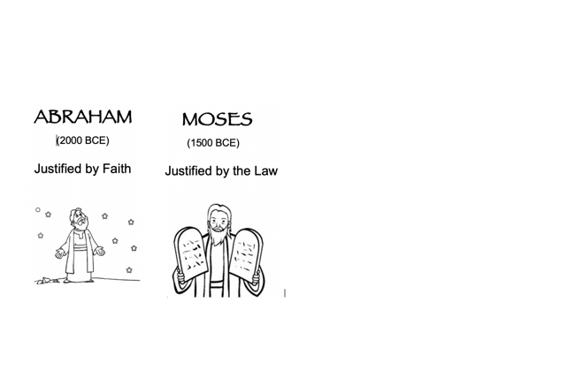

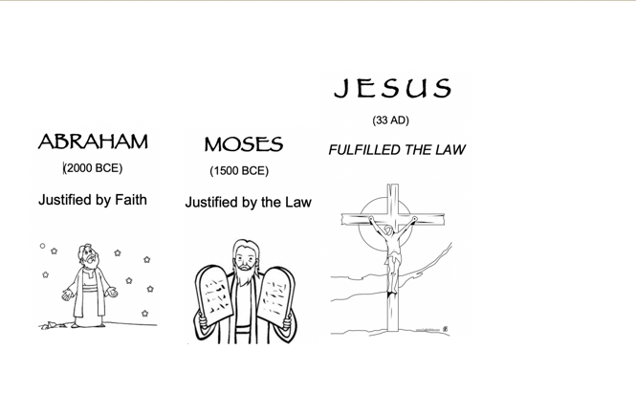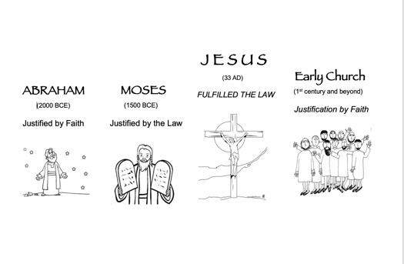

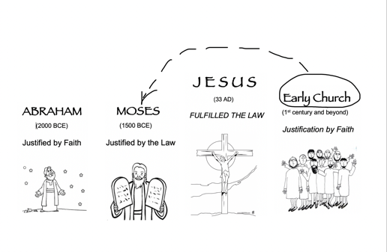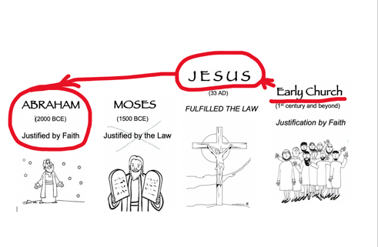

--------------------------------------------------------------------------------------------------
Another Application of Gal. 3:

Gal. 3 (NKJV) “O foolish Galatians! Who has bewitched you ^{[a]}that you should not obey the truth, before whose eyes Jesus Christ was clearly portrayed ^{[b]}among you as crucified? ² This only I want to learn from you: Did you receive the Spirit by the works of the law, or by the hearing of faith? ³ Are you so foolish? Having begun in the Spirit, are you now being made perfect by the flesh?

Former Church Lesson Learned:
- Things were growing rapidly and the huge building was just about done.
- We were starting to become proud of our progress, our growth, our building
- We were becoming less dependent on God, and more self-sufficient in big and small things
- God humbled us in a big way.

As we just saw, this verse was originally intended for the Galatians who were trying to continue the work of grace by their own works,

…but it can also apply to any of us who have experienced a great move of the Holy Spirit, where he transforms our lives, did some amazing things and allow us to use our gifts to something really God-inspired and special. Then after things go well for a while, we decide to take over and continue it with our own strength.

We need to remember not to become overly self-sufficient and self-reliant or systems dependent within this organic move of the Spirit.

We have to remind ourselves that this church is the work of the Lord, we can not take over his work with Human effort.

What begun in the Spirit, should always continue in the Spirit.

So let’s commit to reminding each other and remembering ourselves,

That whether it’s our own justification

Or

Doing great things for God,

The Word tells us in

Zech. 4:6
It’s ‘Not by might nor by power, but by my Spirit,’ says the Lord Almighty.

