Uncomplicated Grace

Gal. 4:4 “But when the set time had fully come, God sent his Son, born of a woman, born under the law, ⁵ to redeem those under the law, that we might receive adoption to sonship.”

John 1:12 “Yet to all who did receive him, to those who believed in his name, he gave the right to become children of God”

FRUIT OF THE SPIRIT

John 4:19-24 “Sir,” the woman said, “I can see that you are a prophet. ²⁰ Our ancestors worshiped on this mountain, but you Jews claim that the place where we must worship is in Jerusalem.”

²¹ “Woman,” Jesus replied, “believe me, a time is coming when you will worship the Father neither on this mountain nor in Jerusalem. ²² You Samaritans worship what you do not know; we worship what we do know, for salvation is from the Jews.

²³ Yet a time is coming and has now come when the true worshipers will worship the Father in the Spirit and in truth, for they are the kind of worshipers the Father seeks. ²⁴ God is spirit, and his worshipers must worship in the Spirit and in truth.”

“Ruach Elohim” ( Spirit of God )

Gal. 5:16-25
¹⁶ I say then: Walk in the Spirit, and you shall not fulfill the lust of the flesh. ¹⁷ For the flesh lusts against the Spirit, and the Spirit against the flesh; and these are contrary to one another, so that you do not do the things that you wish. ¹⁸ But if you are led by the Spirit, you are not under the law.

¹⁹ Now the works of the flesh are evident, which are: adultery, fornication, uncleanness, lewdness, ²⁰ idolatry, sorcery, hatred, contentions, jealousies, outbursts of wrath, selfish ambitions, dissensions, heresies, ²¹ envy, murders, drunkenness, revelries, and the like; of which I tell you beforehand, just as I also told you in time past, that those who practice such things will not inherit the kingdom of God.

²² But the fruit of the Spirit is love, joy, peace, longsuffering, kindness, goodness, faithfulness, ²³ gentleness, self-control. Against such there is no law. ²⁴ And those who are Christ’s have crucified the flesh with its passions and desires. ²⁵ If we live in the Spirit, let us also walk in the Spirit

Jesus said:

Matt 7:16 “You will know them by their fruits.”

Matt 6:17 “every good tree bears good fruit, but a bad tree bears bad fruit.”

Gal. 5: 22-23 …The fruit of the Spirit is love, joy, peace, patience, kindness, goodness, faithfulness,²³ gentleness, self-control…”

The Fruit of the Spirit:

- LOVE: Listed first, because it is most important. It may even be an umbrella term for the rest. Love means willing the highest good for another. (opposite of selfishness)

- Joy: - A deep experience of gladness, not contingent upon circumstances and happiness.

- Peace – “Shalom” A deep sense of completeness . (Perfect – “as it should be”.)

- Patience – Longsuffering, forbearance

- Kindness - A tendency to do for others, regardless of self-interest.

- Goodness – Moral excellence, virtue

- Faithfulness – Loyalty and commitment to others (including God).

- Gentleness – Meekness and humility of spirit.

- Self-Control – Temperance, self-restraint.

Matt 7:16 “You will know them by their fruits.”

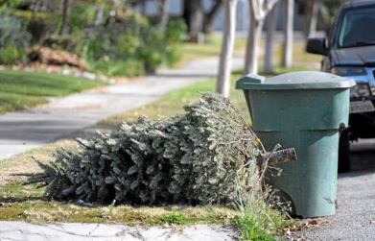

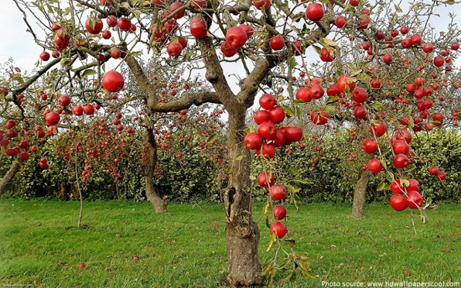

Gal. 5:25 “If we live in the Spirit, let us also walk in the Spirit”

