EYES ON JESUS

Mark 12:38-44 “As he taught, Jesus said, “Watch out for the teachers of the law. They like to walk around in flowing robes and be greeted with respect in the marketplaces, ³⁹ and have the most important seats in the synagogues and the places of honor at banquets. ⁴⁰ They devour widows’ houses and for a show make lengthy prayers. These men will be punished most severely.”

⁴¹ Jesus sat down opposite the place where the offerings were put and watched the crowd putting their money into the temple treasury. Many rich people threw in large amounts. ⁴² But a poor widow came and put in two very small copper coins, worth only a few cents.
⁴³ Calling his disciples to him, Jesus said, “Truly I tell you, this poor widow has put more into the treasury than all the others. ⁴⁴ They all gave out of their wealth; but she, out of her poverty, put in everything—all she had to live on.”

Giving and Humility

Jesus is “people-watching” in the city of Jerusalem this final week before the cross. He is observing some of the regular characters who dwell in the area around the temple throughout the day.
He calls our attention to three wo groups of people and one specific person;
- The Teachers of the law
- The rich people in the temple
- A poor widow
He saw arrogance and pride in the Teachers of the Law and Rich people in the temple, and humility and generosity in the poor widow.
In his observations he makes comments about each, regarding their pride or humility, and their giving and generosity.

I .Giving
⁴¹ Jesus sat down opposite the place where the offerings were put and watched the crowd putting their money into the temple treasury. Many rich people threw in large amounts. ⁴² But a poor widow came and put in two very small copper coins, worth only a few cents.

He noted that the rich people were giving out of abundance of their excess, but the poor widow was giving sacrificially. The KJV says she gave “two mites, which make a farthing” (a very small amount of money).

In his observation, he did not condemn the rich for their giving, but he did commend the widow for hers. Her offering was an example of total faith in God, trusting in him even for sustenance.

⁴³ Calling his disciples to him, Jesus said, “Truly I tell you, this poor widow has put more into the treasury than all the others. ⁴⁴ They all gave out of their wealth; but she, out of her poverty, put in everything—all she had to live on.”

She gave the last of her money. Much like the widow of Zarephath, who gave her last meal to Elijah (1 Kings 17:7–16), the widow in the temple gave away her last means of self-support. Jesus did not stop her, or run after her to perform a miracle of provision. No, he knew she was trusting God and putting into practice that which she had read or been taught about giving;

Mal 3:10 “Bring all the tithes into the storehouse,
That there may be food in My house,
And try Me now in this,”
Says the Lord of hosts,
“If I will not open for you the windows of heaven
And pour out for you such blessing
That there will not be room enough to receive it.”

Do you think the widow left the temple completely destitute, went home, and died of starvation? No. The Bible teaches that God provides for our needs. We don’t know the particular details of this widow’s future, but we can be certain that, if did this in an act of trust/faith in God, she was provided for. Just as God provided for the widow of Zarephath and her son in Elijah’s day, God also provided for the widow in Jesus’ day.
Jesus never condemned anyone for giving, even the giving of the Pharisees, in fact it was the one thing he commended them on;

Luke 11:42 “What sorrow awaits you Pharisees! For you are careful to tithe even the tiniest income from your herb gardens, but you ignore justice and the love of God. You should tithe, yes, but do not neglect the more important things.”

Tithing / giving is our way of showing God that we trust Him, not ourselves. He is our provider, we are just the stewards of that which he entrusts to us.

Alliance Core Value #3: Stewardship
Everything we have belongs to God. We are His stewards.

1 Chron 29:14 “Everything we have has come from you, and we give you only what you first gave us!”

I look at tithing as a way to let God do the financial provision of my household, as opposed to doing it on my own. As we give, we get into “His flow”, whereas he fills us up and we allow it to flow through us. As long as we are not backlogging, the flow continues.

We want to be like the Sea of Galilee, not the Dead Sea. One has flow in and gives out and is alive, the other has flow in but does not give out and is dead.

>>>>>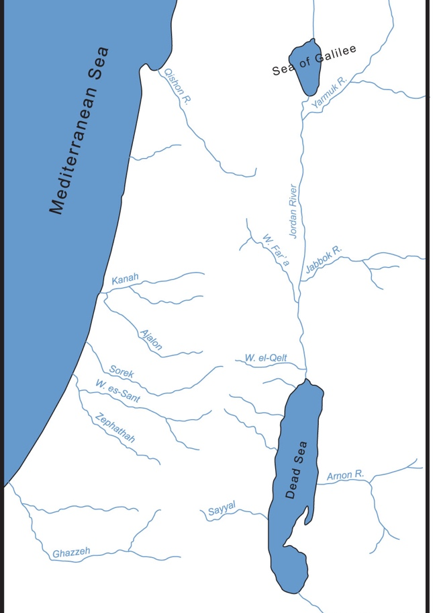<<<<<
II .Humility

V. 38-39 “Watch out for the teachers of the law. They like to walk around in flowing robes and be greeted with respect in the marketplaces, ³⁹ and have the most important seats in the synagogues and the places of honor at banquets.”

Here Jesus is giving a warning about the “Teachers of the Law”, (likely the scribes and Pharisees). He is telling us that these are people who “want to be liked”. They want to be popular, noticed and respected. They are known for having a superiority complex and spewing out judgements, criticisms and sanctimonious platitudes. Yet they are steeped with pride and hypocrisy.

They are often referred to as the “religious leaders” which is accurate, but the truth is that the entire community of Jews was a religious community, so these Teachers of the law, are basically just members of the community, perhaps community leaders, who want to be respected and listened to.

Their judgements, criticisms and sanctimonious platitudes have suppressed the people and even subjected well-intentioned Jews into a posture of subservience, which is how they gained and maintained, their power and the upper-hand in society.

They tried to convince others that;

“They knew more than them”
“They did more than them”
“They cared more than them”

They were able to convince the common Jewish people that they were spiritually and morally superior than they were, but they did not fool or intimidate Jesus.

He was able to look directly into the motive of their hearts and was quick to point out their hypocrisy, initially in a covert manner through parables, but here in this final week, outwardly and in the open.

He tells us that their sin will not go unnoticed by God and that “These men will be punished most severely.” (v.40)

Jesus tells us…

Matt 23:3 “…don’t follow their example. For they don’t practice what they teach.”

Throughout the gospels Jesus warns us of the sin of pride,

Matt 23:12 “For those who exalt themselves will be humbled, and those who humble themselves will be exalted.”

Jesus warns us about these people because of the damage they can do with their attitudes and criticisms.

How many times have you heard, read or felt the message from someone with their own agenda, trying to convince you through judgements and sanctimonious platitudes;

- “I know more than you”
- “I do more than you”
- “I care more than you”

Jesus says “Watch out for these”

Psalm 1:1 “Blessed is the man who walks not in the counsel of the wicked, nor stands in the way of sinners, nor sits in the seat of scoffers”

It’s important not to listen to these people,
it’s equally important not to become like these people.

Jesus tell us in the Beatitudes;

Matt 5:5 “⁵Blessed are the meek, for they will inherit the Earth.”

The bible tells us so much about the importance of humility. Often times humbling ourselves comes with a reward directly from God;

2 Chron 7:14 “if my people, who are called by my name, will humble themselves and pray and seek my face and turn from their wicked ways, then I will hear from heaven, and I will forgive their sin and will heal their land.”

This was the main prayer for “THE RETURN – National and Global Day of Prayer and Repentance” on Sept, 26th as thousands gathered to pray in Washington DC. Several of the leaders pointed out that the first part of this message (given to Solomon at night by the Lord as they were about to dedicate the temple);

“if my people, who are called by my name, will humble themselves…”

1 Peter 5:6 “Humble yourselves, therefore, under God's mighty hand, that he may lift you up in due time.”
Sometimes as the people of God, who know the truth, it’s hard not to react harshly to those who spew out falsehoods and lies, but the Bible clearly warns us to maintain humility in all we do.

I often thought that if there was anyone in the NT that might have had a superiority complex and felt they were higher, better and closer to Jesus than the rest, it would have been James, Jesus’ brother that he knew his whole life and grew up with. Yet James offers some of the most prolific words on humility in the Bible.

James 4:6-10 “And he gives grace generously. As the Scriptures say,
“God opposes the proud
but gives grace to the humble.”
⁷ So humble yourselves before God. Resist the devil, and he will flee from you. ⁸ Come close to God, and God will come close to you. Wash your hands, you sinners; purify your hearts, for your loyalty is divided between God and the world.
… ¹⁰ Humble yourselves before the Lord, and he will lift you up in honor.

Closing:
So let’s decide and purpose in our hearts NOT to be like the arrogant teachers of the law only want to be liked and listened to, and did not honor God in humility.

Let’s also be on guard, not to be swayed, or influenced by those whom Jesus says “don’t follow their example. For they don’t practice what they teach”

Just as there is reward being faithful to God in your giving, as we saw in the poor widow at the temple,
There is reward in true humility and fear of the Lord.
King Solomon, one of the wisest and wealthiest men in history tells us;

“True humility and fear of the Lord
lead to riches, honor, and long life.” (Proverbs 22:4)

