EYES ON JESUS
LIVING AMONG THE LIVING
[Jesus Crucifixion]
MARK15:⁴⁰ Some women were watching from a distance. Among them were Mary Magdalene, Mary the mother of James the younger and of Joseph, and Salome. ⁴¹ In Galilee these women had followed him and cared for his needs. Many other women who had come up with him to Jerusalem were also there.
The Burial of Jesus
⁴² It was Preparation Day (that is, the day before the Sabbath). So as evening approached, ⁴³ Joseph of Arimathea, a prominent member of the Council, who was himself waiting for the kingdom of God, went boldly to Pilate and asked for Jesus’ body. ⁴⁴ Pilate was surprised to hear that he was already dead. Summoning the centurion, he asked him if Jesus had already died. ⁴⁵ When he learned from the centurion that it was so, he gave the body to Joseph.
[ Crucified victims could sometimes live for days before eventually dying from bleeding out, or asphyxiation]
⁴⁶ So Joseph bought some linen cloth, took down the body, wrapped it in the linen, and placed it in a tomb cut out of rock. Then he rolled a stone against the entrance of the tomb. ⁴⁷ Mary Magdalene and Mary the mother of Joseph saw where he was laid.

Garden Tomb 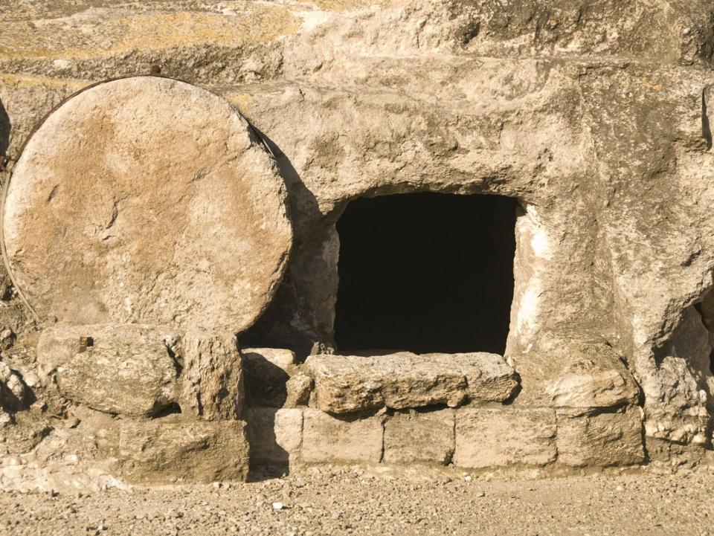 Stone
Mark 16 When the Sabbath was over, Mary Magdalene, Mary the mother of James, and Salome bought spices so that they might go to anoint Jesus’ body. ² Very early on the first day of the week, just after sunrise, they were on their way to the tomb ³ and they asked each other, “Who will roll the stone away from the entrance of the tomb?”
⁴ But when they looked up, they saw that the stone, which was very large, had been rolled away. ⁵ As they entered the tomb, they saw a young man dressed in a white robe sitting on the right side, and they were alarmed.
⁶ “Don’t be alarmed,” he said. “You are looking for Jesus the Nazarene, who was crucified. He has risen! He is not here. See the place where they laid him. ⁷ But go, tell his disciples and Peter, ‘He is going ahead of you into Galilee. There you will see him, just as he told you.’”
⁸ Trembling and bewildered, the women went out and fled from the tomb. They said nothing to anyone, because they were afraid.
⁹ Now when He rose early on the first day of the week, He appeared first to Mary Magdalene, out of whom He had cast seven demons. [from Mark’s 2nd ending]

Each of the four gospels gives a unique account of Resurrection Morning, mentioning; who actually went to the tomb, the appearance of angels, what they saw, and what actually took place.
When they are compared to each other, they seem a bit confusing and perhaps even contradictory.
However… When they’re all put together into one narrative, they fit perfectly, and you can see that there was quite a lot of activity the morning of that Jesus rose from the dead;
So much happened; The earth shook, the Stone was rolled away, Angels appeared, Five Women came to the tomb, Peter and John came to see, and Mary encountered Jesus outside in the garden.
What’s interesting is that the first eyewitness to see Jesus after He was resurrected was Mary Magdalene. She was the one with the most questionable reputation because she had been possessed by seven demons before she met Jesus.

A compilation of the four gospel accounts would go something like this;
- Mary Magdalene and several other women travel from Bethany to Jesus’ tomb at dawn.

- Around that time, the earth shakes, the stone is rolled away and two angels appear.

- Nearing Jesus’ tomb, the women notice the stone rolled away.

- An Angel explains that “He is Risen”.

- Mary Magdalene runs “with fear and great joy” to tell Peter and John what had happened (no one else).

- Peter and John run to the tomb, John arrives first, but Peter arrives and goes inside.

- Peter goes into the empty tomb and sees the graveclothes folded.

- Outside the tomb Mary Magdalene encounters Jesus.

- Mary goes to tell the other disciples what had happened, but they did not believe.

As we go further into the 2nd ending of Mark, you’ll see that some of the disciples initially struggled with “unbelief” regarding the resurrection. As much as Jesus told them about His suffering, death and Resurrection, the trauma of seeing Him arrested, tortured and crucified caused them to fear and recoil.
The very ones whom you would expect to believe, struggled with unbelief.
Unbelief is rampant in society, even among so called “believers”

[ I read a recent article about the president of one of the oldest and most well—established seminaries in NYC who said “she does not believe in the “literal” resurrection of Jesus. Very sad for someone who is placed in charge of training and preparing people for pastoral ministry. I think we would be surprised and saddened at how many people doubt, or are not fully convinced of Jesus’ resurrection some of whom are in teaching and vocational ministries. They assert that Jesus was a great man and example of God’s love, but some of the things we take as literal, are meant to be symbolic.]
If Jesus lived the life He lived and then died without rising from the dead, he would have been a very great man, perhaps the greatest that ever lived. His only flaw would have been that He said He would rise again and did not. In fact He was so influential, that perhaps His followers would rationalize and say He Will rise again someday, or He only meant that He would figuratively rise again. But, Jesus was quite literal when He claimed (at least three times) “I will suffer, died, and rise again”.

This fact, the part about someone who had died coming back to life is a little too much for some people to believe. It sounds preposterous to the logical mind. We tend to rationalize and say, maybe He never fully died on the cross, or maybe the apostles stole his body from the grave and only “claimed” that they saw him and spoke with Him afterward, or maybe someone else who looked like Jesus stepped in as an impersonator and fooled them all.

If this happened, would it still be OK to follow Jesus and His word here in the modern age?

I mean, Christianity offers a pretty good practical foundation for civilizations to follow. It teaches ethics and morality and usually helps societies maintain peace. it actually encourages Love, charity, compassion and justice and the teachings of Jesus are widely embraced throughout the world.

So, even if the whole “literal Resurrection” thing is not even true, some would say that Christianity still has value.

The problem is that if it’s not true, the whole thing is a waste of time,
And All of us who follow Jesus today and have ever lived and died for Him in history are (according to our own Bible) “Useless and pitiful”.

1st Corinthians 15:12-19 “But tell me this—since we preach that Christ rose from the dead, why are some of you saying there will be no resurrection of the dead? ¹³ For if there is no resurrection of the dead, then Christ has not been raised either. ¹⁴ And if Christ has not been raised, then all our preaching is useless, and your faith is useless. ¹⁵ And we apostles would all be lying about God—for we have said that God raised Christ from the grave. But that can’t be true if there is no resurrection of the dead. ¹⁶ And if there is no resurrection of the dead, then Christ has not been raised. ¹⁷ And if Christ has not been raised, then your faith is useless and you are still guilty of your sins. ¹⁸ In that case, all who have died believing in Christ are lost! ¹⁹ And if our hope in Christ is only for this life, we are more to be pitied than anyone in the world.”

Looking for the LIVING AMONG THE DEAD?
The grave, the empty tomb.
"Why do you look for the living among the dead?

Luke 24:1-8 “On the first day of the week, very early in the morning, the women took the spices they had prepared and went to the tomb. ² They found the stone rolled away from the tomb, ³ but when they entered, they did not find the body of the Lord Jesus. ⁴ While they were wondering about this, suddenly two men in clothes that gleamed like lightning stood beside them. ⁵ In their fright the women bowed down with their faces to the ground, but the men said to them, “Why do you look for the living among the dead? ⁶ He is not here; he has risen! Remember how he told you, while he was still with you in Galilee: ⁷ ‘The Son of Man must be delivered over to the hands of sinners, be crucified and on the third day be raised again.’ ” ⁸ Then they remembered his words.

WHAT DOES IT MEAN NOW TO “LOOK FOR THE LIVING AMONG THE DEAD”
(Many people approach Religion as; looking for God in dead works, traditions and historical studies.)
Some look at Jesus as someone who lived a long time ago, died and went away, but left us a book to study, and gather information about how to live.
This what it means to “look for someone among the dead,- who IS STILL ALIVE”!
Jesus clearly told us “And surely I am with you always, to the very end of the age.”

Famous book “The Quest for the Historical Jesus” (by Nobel Peace Prize winning Humanitarian Albert Schweitzer 1906) is a review of dozens of other authors through the centuries who would only look upon Jesus as a Historical figure and nothing else. Schweitzer himself, although he refutes many of these positions in the book, is still typical of many theologians and historians and would not declare his belief in the Resurrection of Jesus.
The approach of getting to know Jesus only through academic, historical and intellectual means is the modern version of “Looking for the Living among the dead.”

Sadly, some Christians approach Jesus in this way.
Example: If an author is dead, the best way to get to know the author is through their own writings, their biography and if they have one, their auto-biography.
If the author is still alive, the best way is to read what they’ve written AND SPEND TIME WITH THEM one on one.
Jesus is Still Alive! He is with us, through the Holy Spirit he continues to live in us, empower us, encourage us and Teach Us!
John 14:26 “the Helper, the Holy Spirit, whom the Father will send in My name, He will teach you all things, and bring to your remembrance all things that I said to you.
All of us are guilty from time to time of treating Jesus as if He were someone who died years and years ago, and all He left us was an ancient scroll.
(Sort of like the sad Elvis fans looking for his ghost at Graceland… Elvis died and did not rise again)

JESUS DIED, ROSE AGAIN AND NEVER DIED AGAIN – HE IS STILL ALIVE!
We have no reason to be sad, JESUS IS NOT DEAD, HE IS RISEN and lives in us!
Gal 4:6 “God has sent forth the “Spirit of His Son” into your hearts, crying out, "Abba, Father!"

We have the SPIRIT OF HIS SON in our hearts!

WE SHOULD’NT BE – SEEKING THE LIVING AMONG THE DEAD?
WE SHOULD BE - SEEKING THE LIVING AMONG THE LIVING!

Rom 8:11 “And if the Spirit of him who raised Jesus from the dead is living in you, he who raised Christ from the dead will also give life to your mortal bodies because of his Spirit who lives in you.”

