“ONE NEW HUMANITY” - Soul or the Spirit
R Giglio 1/28/21

I have found the secret to walking in the spirit, is to understand what the Spirit is, especially compared to the Soul. Knowing that the Spirit is the part of us that connects with God’s power, love and understanding, and the Soul is the part of us that “by nature” is intent on gratifying the cravings of the flesh.
Hebrews 4:12 “For the word of God is living and powerful, and sharper than any two-edged sword, piercing even to the division of soul and spirit ”
Our SOUL (our Mind and Emotions), tries to control and govern our whole being, often leading us into conflict and despair.
Our SPIRIT, when it is made alive by Jesus, is the part of us that connects to God’s power and love, resulting in peace in our innermost being, which in turn effects our WHOLE being; Body Soul and Spirit.

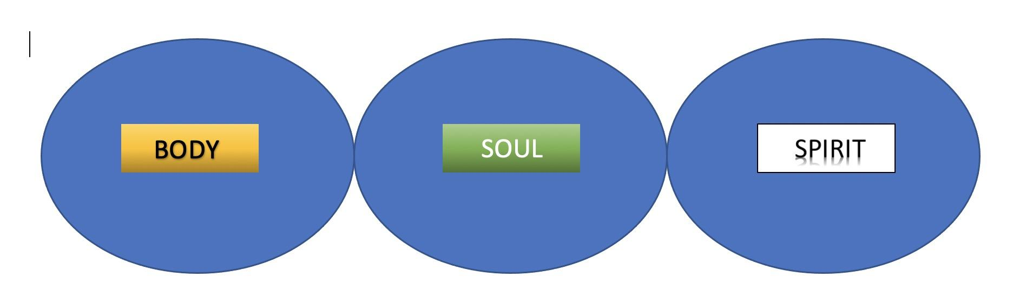
1 Thessalonians 5:23 “²³ May the God of peace set you apart for Himself. May every part of you be set apart for God. May your spirit and your soul and your body be kept complete.”

We learned that the part of our Soul (Mind/Emotions), that is pulls us away from our spiritual life is “our Flesh”,

And the part of our soul that connects to our spirit through Faith/believing is “our Heart”.
It is in our Spirit that we commune with God and Have fellowship with His Spirit.
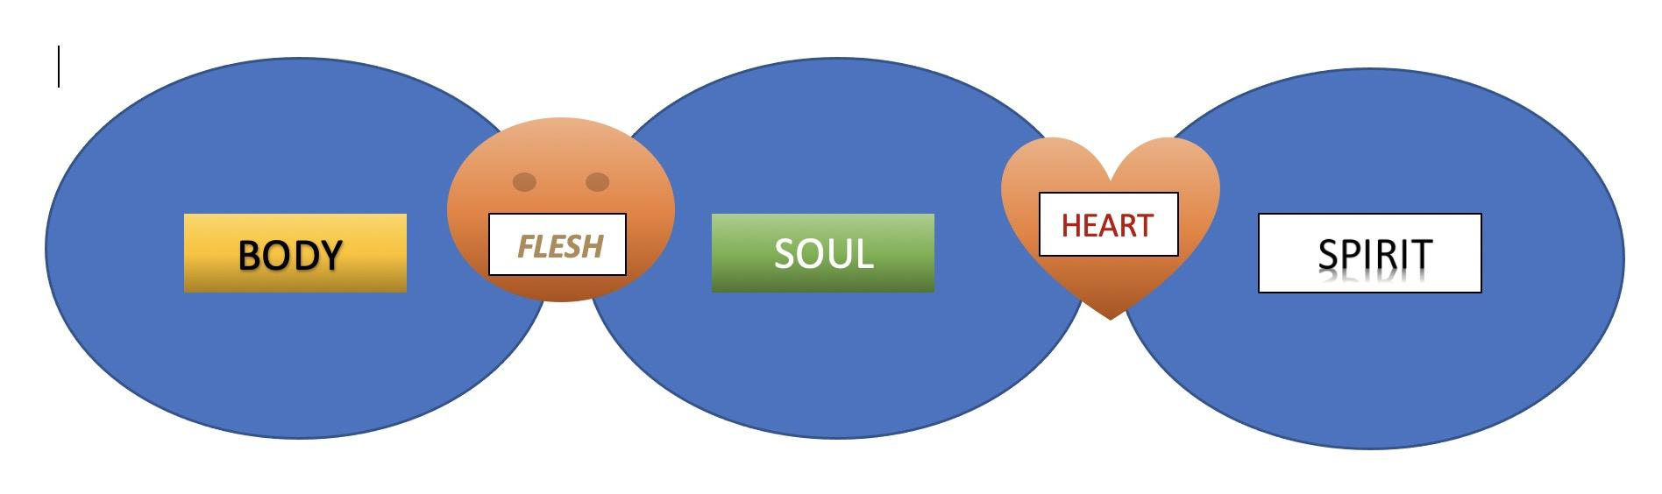
Before we believed on Jesus and received New Life in Him, we were dead in our spirits. We could not experience the fruit of the spirit or connect with God in our spirit.
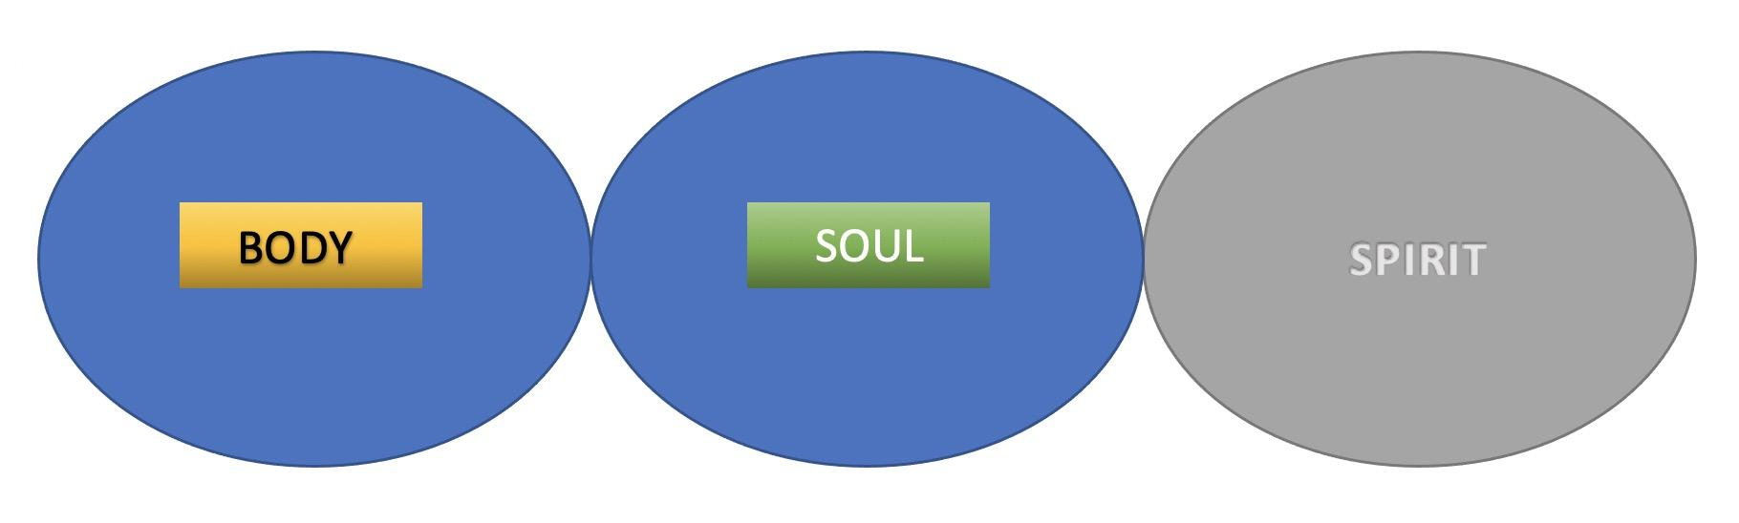
Jude 19 “These are the people who follow mere natural instincts and do not have the Spirit.”
The moment we believe in Jesus, His Spirit enters into our spirit and we are “made alive”

Eph 2:4 “But because of his great love for us, God, who is rich in mercy, ⁵ made us alive with Christ even when we were dead in transgressions - it is by grace you have been saved (through faith).
Now our spirit, soul and body experience the life, peace and presence of God’s Spirit, and we are made new.
The most important part of our being however, is our spirit.
John 3:6 “That which is born of the flesh is flesh, and that which is born of the Spirit is spirit.”
John 4:24 “God is Spirit, and those who worship Him must worship in spirit and truth.”
(Here is the diagram with the Spirit on top.)
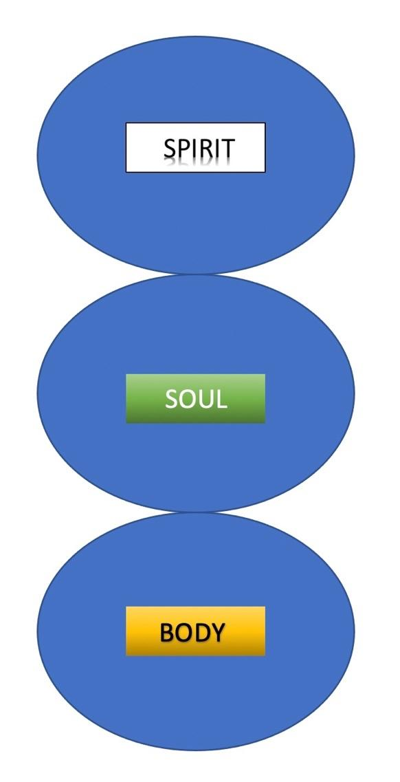
When we prioritize living by the Spirit, the spirit becomes the head of “the snowman” and the Soul and body are subject to its leading. (not the other way around).

When we relate to each other in the spirit, we experience deep fellowship “In Christ Jesus” that we would not have simply in the Soul (mind/emotions) or the Body.
Eph. 4:3 “Make every effort to keep the unity of the Spirit through the bond of peace.”
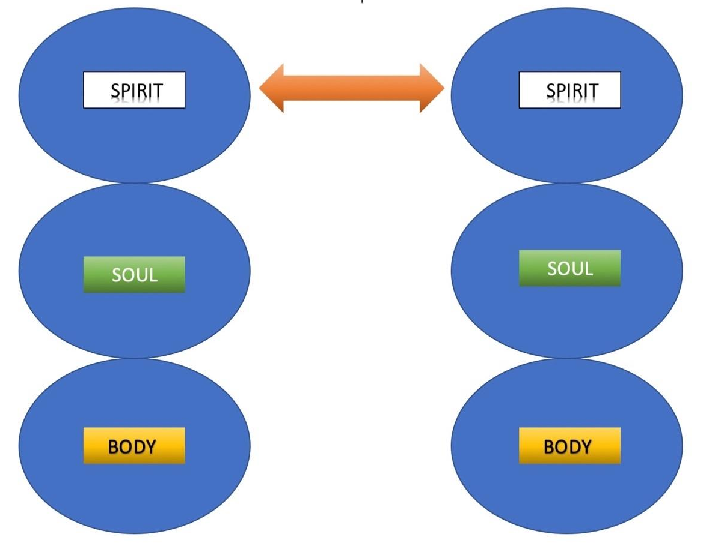

This week, in Eph. 2:11-22 Paul reminds the Ephesians of the unity that they have in the Spirit, even though they are very different from one another in the Soul and the Body.

Eph 2:11-22 “Therefore, remember that formerly you who are Gentiles by birth and called “uncircumcised” by those who call themselves “the circumcision” (which is done in the body by human hands)— ¹² remember that at that time you were separate from Christ, excluded from citizenship in Israel and foreigners to the covenants of the promise, without hope and without God in the world. ¹³ But now in Christ Jesus you who once were far away have been brought near by the blood of Christ.
¹⁴ For he himself is our peace, who has made the two groups one and has destroyed the barrier, the dividing wall of hostility, ¹⁵ by setting aside in his flesh the law with its commands and regulations. His purpose was to create in himself one new humanity out of the two, thus making peace, ¹⁶ and in one body to reconcile both of them to God through the cross, by which he put to death their hostility. ¹⁷ He came and preached peace to you who were far away and peace to those who were near. ¹⁸ For through him we both have access to the Father by one Spirit.
¹⁹ Consequently, you are no longer foreigners and strangers, but fellow citizens with God’s people and also members of his household, ²⁰ built on the foundation of the apostles and prophets, with Christ Jesus himself as the chief cornerstone. ²¹ In him the whole building is joined together and rises to become a holy temple in the Lord. ²² And in him you too are being built together to become a dwelling in which God lives by his Spirit.”

Gentiles - “Gentiles = nations,” The term Gentile is one belonging to any nation or people group other than the Jewish people group. The Hebrew word is “Goy” which is where the word “heathen” comes from.
In Bible times, there was one group of people, who were God’s people; “The Jews”, everyone else was considered a heathen.

Many of the believers in Ephesus were Gentiles, which is why Paul was very specific to declare to them that although they were once NOT part of the God’s family, but because of Jesus, they are now every bit as much as natural born Jews.

Eph 2:12-13 “that at that time you were without Christ, being aliens from the commonwealth of Israel and strangers from the covenants of promise, having no hope and without God in the world. But now in Christ Jesus you who once were far off have been brought near by the blood of Christ.”

But this was not because of their;

- BODY – Ethnic distinctions, circumcision, pedigree
or the
- SOUL – Religious traditions, cultural customs, etc.
It was clearly because of the
- SPIRIT – (v.22) “built together to become a dwelling in which God lives by his Spirit”

Personal Story:

Sitting on plane behind several very Orthodox Jewish men, they wore ultra-orthodox clothing, prayed their daily prayers with head coverings, tefillin and phylacteries.

They seemed like strange foreigners to most people in the plane.

If these were Bible Times, (here would be no planes : ) but these would be the only ones who were God’s people, everyone else would foreigners and strangers to the household of God.

If Paul or any of the Apostles walked onto the plane, those would be the only people that they had anything in common with (language, prayers, study of scripture) UNTIL they sensed the Spirit of God in some of us.

Then, that would be the most important thing they had in common with anyone on the plane and we would have unity in the spirit, which goes way beyond language, traditions, customs and ethnicity.

(v. 15) “His purpose was to create in himself one new humanity out of the two, thus making peace,”

PEACE - (shalom = perfection/unity)

We can only experience this when we stop looking at each other primarily in the body, or even the soul, but when we relate to one another in the Spirit.

That’s what it means to be “In Christ Jesus” (One in Messiah)

In order to have peace/unity “in Christ” we have to
STOP regarding ourselves or anyone else primarily with regard to ethnicity, hair/skin/eye color, socio-economic status, height, weight, lefty/righty or color of their car 😁🚗 (yeah, you might as well throw car color in there because it’s just as superficial when compared to life in the Spirit)

[Did you ever pull up to someone who has the same car and color as yours? Do you nod, wave, roll down the window and say hello?...
You may not have any real connection with them except for the car]

When we focus on these things we are prioritizing the body and flesh over the spirit.
Yes, we are prioritizing the body and soul over the spirit!

Which is the opposite of what the Bible commands of us.
From time to time there are issues, sometimes serious ones, that force us to look at things regarding the body and soul/flesh in others,
but that is not where we are to remain, or continue to get stuck on, we have got to move toward identifying and relating to each other in the spirit in order to have peace, and unity.

Even regarding the issues of race and ethnicity. We must come to a place where we are examples to the world of what it means to view people as God sees them.

1st Samuel 16:7 “For the Lord does not see as man sees; for man looks at the outward appearance, but the Lord looks at the heart.”

We should not regard and identify ourselves OR others in terms of our outward appearance, but by who we are IN CHRIST.
That is not to say we ignore our obvious superficial differences, but we certainly don’t let them define who we are “in Christ Jesus” and divide us in any way.

Gal. 3:26-28 “So in Christ Jesus you are all children of God through faith, ²⁷ for all of you who were baptized into Christ have clothed yourselves with Christ. ²⁸ There is neither Jew nor Gentile, neither slave nor free, nor is there male and female, for you are all one “In Christ Jesus.”

“clothed yourselves with Christ” – no longer identified by your outward distinctives, but by Christ within you

- Jew nor Gentile, - (Ethnicity) This does not mean they never referred to people as Jews or Gentiles anymore, they did. It means that in Jesus, those things do not matter. They should not be part of our identity in Christ.

- neither slave nor free, (Socio-Economic) This does not mean that everyone is the same socio-economically, it means we are not to value or identify anyone according to that status, only who they are in Christ.

- nor is there male and female (Gender) This is NOT a call towards gender neutrality, only that men and women, while different physically, are the same spiritually.
Some could say that Paul was being insensitive by not standing up for the causes, and social justice of the oppressed in these groups;

- Gentiles who were sometimes made to feel less important than Jews
- Women who were sometimes made to feel inferior to men.
- Slaves who obviously had a lot less rights and privileges than free-people.
Paul was not saying to deny that these distinctions exist, he is basically saying that “in Christ Jesus we are all children of God through faith.”
The more we see and relate to each other “in Christ Jesus”, the closer we get to having fellowship in the spirit and not conflict in the flesh.

When we look at each other through the “eyes of the Spirit”, we see beyond race, ethnicity, socio-economic status and even gender.

Samaritan Woman at the well:

(Samaritans are the antithesis of Jews in this region. There is much hostility between these two ethnic groups. They only believe in the Pentateuch and reject the Kings, Prophets or anyone who came after Moses, and worship in Shechem on Mt. Gerizim).
She was at Jacob’s well alone in mid-day, Jesus was also alone and asked her for a drink. He then revealed hidden secrets about her life.

John 4:19-24 “¹⁹ “Sir,” the woman said, “I can see that you are a prophet. ²⁰ Our ancestors worshiped on this mountain, but you Jews claim that the place where we must worship is in Jerusalem.”
²¹ “Woman,” Jesus replied, “believe me, a time is coming when you will worship the Father neither on this mountain nor in Jerusalem. ²² You Samaritans worship what you do not know; we worship what we do know, for salvation is from the Jews. ²³ Yet a time is coming and has now come when the true worshipers will worship the Father in the Spirit and in truth, for they are the kind of worshipers the Father seeks. ²⁴ God is spirit, and his worshipers must worship in the Spirit and in truth.”
He was a Jew, she was a Samaritan. That was clear. However, he pointed out that a time is coming and now is. When ethnicity does not matter. (He is speaking about the Kingdom of God).
God is Spirit and is looking for worshippers who will come in “Spirit and truth” not “Ethnicity and Culture”.
Jesus gave us a glimpse of what the Kingdom of God could be like on earth as it is in heaven. Worshipers coming together in spirit and truth, not dragging along, or “being known by” their former identities customs and cultures.
Eph 2:22 “in him you too are being built together to become a dwelling in which God lives by his Spirit.

Gal 3:28 “…for you are all one in Christ Jesus.”

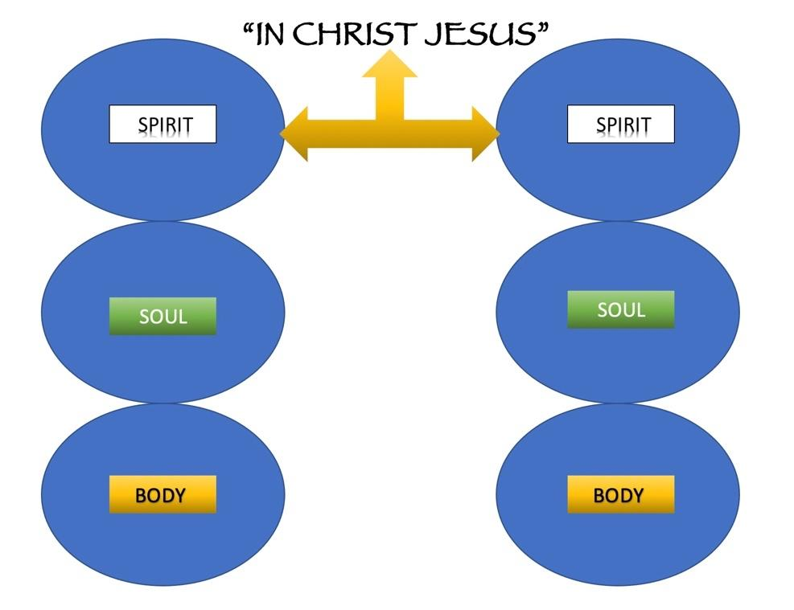

Phil. 2:1-2 “Therefore if you have any encouragement from being united with Christ, if any comfort from his love, if any common sharing in the Spirit, if any tenderness and compassion, ² then make my joy complete by being like-minded, having the same love, being one in spirit…”

This was Paul’s desire for those who came to Christ from many nations, that they would be One through the Spirit of Jesus.

This was also Jesus’ ardent prayer in the Garden of Gethsemane, the night before He died, as He prayed to his father about his followers.

(Let’s receive this prayer for us as well here today…)

John 17:21-23 “That they may all be one, just as you, Father, are in me, and I in you, that they also may be in us, so that the world may believe that you have sent me. The glory that you have given me I have given to them, that they may be one even as we are one, I in them and you in me, that they may become perfectly one, so that the world may know that you sent me and loved them even as you loved me.”

