SOUL OR SPIRIT
“We Were Dead, but Made Alive”
R Giglio 1/12//21

With so much animosity, division and darkness in the world. I find it increasingly more important each day to walk by the spirit, where we can experience peace, joy and strength, every day even in the face of evil, deception and conflict.

I have found the secret to walking in the spirit, is to understand what the Spirit is, especially compared to the Soul. Knowing that the Spirit is the part of us that connects with God power, love and understanding, and the Soul is the part of us that “by nature” is intent on gratifying the cravings of the flesh.
Hebrews 4:12 “For the word of God is living and powerful, and sharper than any two-edged sword, piercing even to the division of soul and spirit ”

The SOUL (our Mind and Emotions), is prone to control and govern our whole being, often leading us into conflict and despair.
Our SPIRIT, when it is made alive by Jesus, will be part of us that connects to God’s power and love, resulting in peace and understanding in our innermost being, which in turn effects our WHOLE being; Body Soul and Spirit.

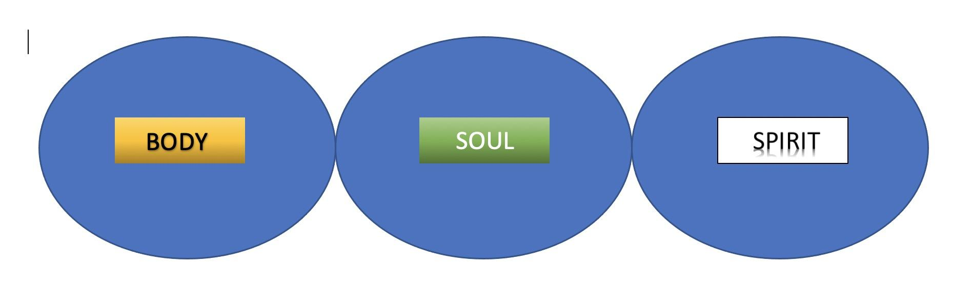
1 Thessalonians 5:23 “May your whole spirit, soul and body be kept blameless”

This diagram is usually presented as an outer circle of the body, with the soul and the spirit contained therein.

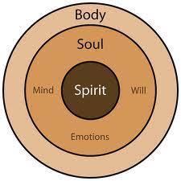

Even though this accurately illustrates that we they are contained in one body, I chose to create my diagram to separate out each entity and illustrate the connection of the Soul, to both the Body and the Spirit.

I want this series to clearly help us see the difference between the Soul and the Spirit.

To do that, we need to know the difference between the “Heart” and the “Flesh”.

Hebrews 4:12 “For the word of God is living and powerful, and sharper than any two-edged sword, piercing even to the division of soul and spirit ”

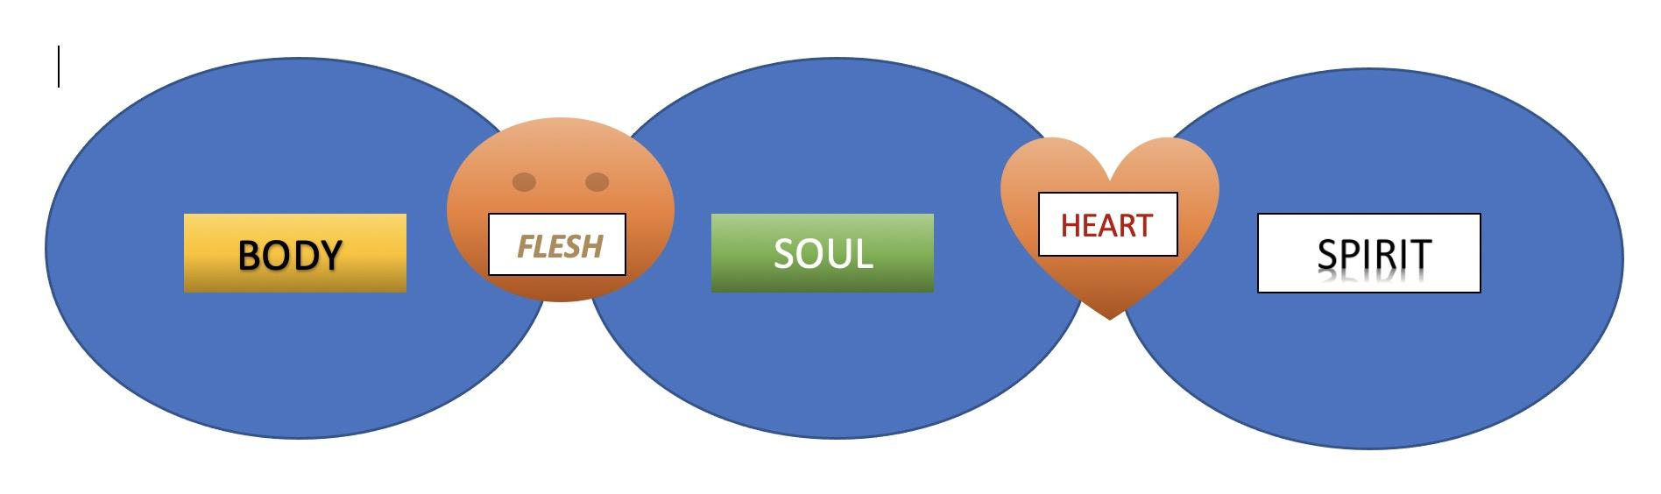
OUR FLESH, is “by nature” intent on gratifying the cravings of the body.

OUR HEART, is the part of us that connects our Soul (mind/emotions) to our Spirit, which when “made alive” in Jesus connects to God’s Spirit within us.

Most people, sadly have not had their spirits “made alive” and spend their whole lives “walking in the Flesh”, and NOT the Spirit, because their Spirits have not yet been “Made Alive”

Gal. 5:16-20 “So I say, walk by the Spirit, and you will not gratify the desires of the flesh. For the flesh desires what is contrary to the Spirit, and the Spirit what is contrary to the flesh. They are in conflict with each other, so that you are not to do whatever you want. But if you are led by the Spirit, you are not under the law.
The acts of the flesh are obvious: sexual immorality, impurity and debauchery; idolatry and witchcraft; hatred, discord, jealousy, fits of rage, selfish ambition, dissensions, factions”

This describes most people who are living in darkness. This is why there is so much hatred, conflict, pride, greed and darkness in the world.

Without having had your spirit made alive by Jesus, and the Holy Spirit dwelling within you, you cannot walk by the Spirit, you are doomed to walking only in the flesh.

EPHESIANS:
Paul reminds the Ephesian church, that they too, were once like this;
EPH 2:1-7 “And you He made alive, who were dead in trespasses and sins, ² in which you once walked according to the course of this world, according to the prince of the power of the air, the spirit who now works in the sons of disobedience, ³ among whom also we all once conducted ourselves in the lusts of our flesh, fulfilling the desires of the flesh and of the mind, and were by nature children of wrath, just as the others.
⁴ But God, who is rich in mercy, because of His great love with which He loved us, ⁵ even when we were dead in trespasses, made us alive together with Christ (by grace you have been saved), ⁶ and raised us up together, and made us sit together in the heavenly places in Christ Jesus, ⁷ that in the ages to come He might show the exceeding riches of His grace in His kindness toward us in Christ Jesus.”
“And you, He made alive, who were dead.”

Remember who he is talking to; Jews and Gentiles living in Ephesus who were;
- Either Gentiles who never knew about God, and lived as Pagans, until they believed on Jesus
or
- Jews who did not believe in Jesus or did not know about Jesus, (Like the “Ephesus 12” – Baptized by John the Baptist, or possibly Apollos).

Paul says that prior to believing in Jesus, they were “dead”.
- How were they dead?
- Were they not breathing?
- Were they braindead?
- Were they Zombies? : { Sort of…. Walking Dead
We all were, compared to the life we live now.

They were “spiritually dead”

- Their Bodies were probably functioning fine.
- Their Soul (mind and emotions) were probably relatively OK.
- Their Spirits, however, were dead, dormant or simply unregenerated.

(SEE DIAGRAM BELOW)
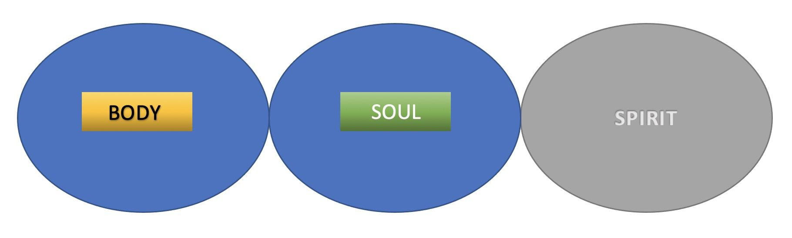
This is how we ALL are before the Holy Spirit makes us Alive, when we believe.
Sadly, much of the world looks like this.
Perhaps your closest friends and family members, are not yet, “Made Alive”
They can’t see through the “eyes of the Heart” (Spirit)
They walk in lost darkness, because their “mind is controlled by the flesh”.

(v. 2&3) “you once walked according to the course of this world, according to the prince of the power of the air, the spirit who now works in the sons of disobedience, ³ among whom also we all once conducted ourselves in the lusts of our flesh, fulfilling the desires of the flesh and of the mind,”

This is not just talking about “Gross Sin” (theological term – “the bad ones”),
This is talking about living apart from God, being governed entirely by our soul (flesh and mind) and disregarding His word.
The “FIRST & WORST” sin of the Bible, would not necessarily be considered “Gross Sin”.
Adam and Eve ate a piece of fruit in the Garden of Eden. Why is that so bad?
Because what they were responding to the voice of the serpent who was tempting them to doubt God.

Gen. 3:1-5 “Now the serpent was more crafty than any of the wild animals the Lord God had made. He said to the woman, “Did God really say, ‘You must not eat from any tree in the garden’?”
² The woman said to the serpent, “We may eat fruit from the trees in the garden, ³ but God did say, ‘You must not eat fruit from the tree that is in the middle of the garden, and you must not touch it, or you will die.’”
⁴ “You will not certainly die,” the serpent said to the woman. ⁵ “For God knows that when you eat from it your eyes will be opened, and you will be like God, knowing good and evil.”
What was their sin?
They wanted to do be independent of God, in fact they wanted to be “like God”.
This is where so much of the world is today.
They want to essentially disregard God, and decide for themselves what is;
Good and Evil, Just or Unjust, Fair or Unfair, Right or Wrong.
This is a clear example of “Walking in the Soul”, and NOT, “Walking in the Spirit”.

Walking in the Spirit requires Faith.
Faith is something that the World (or those who walk only in the Soul) cannot comprehend, because they need to be willing to trust God’s word and “believe” past the realm of the soul into the spirit, through what we call the “Heart”.
This is how we are “saved”, “regenerated”, “Made New”;
Romans 10:9-10a “if you confess with your mouth the Lord Jesus and believe in your heart that God has raised Him from the dead, you will be saved. ¹⁰ For with the heart one believes unto righteousness,”
This is why you cannot please God by simply walking in the SOUL (mind/emotions) and not believing by faith, and living by the Spirit.
Rom 8:8 “Those who are in the realm of the flesh cannot please God.”

Why, because they are telling Him, they don’t need him or want Him. They can do it themselves (Like Adam and Eve), they simply don’t Trust Him, or His word.

Remember, TRUST = FAITH (gr: pistis) - same word.

You can only please God by believing by faith, and living by the Spirit.

Heb 11:6 “without faith it is impossible to please God.”

There is only One Way to please God.

That means going beyond the confines of the Soul,
by Faith believing, and
being made alive into Life by the Spirit.

That applies to you, me, our friends, family, Christian leaders, influencers, politicians…everyone.

Well what about if someone follows the teachings of the Bible but does not necessarily walk by Faith in the Spirit of God?

In my Soul (mind and emotions), I would say yes, I feel that it pleases God because it makes sense that He would appreciate them following His instructions.

In my Spirit, I have to defer to the Word of God, which says;

Rom 8:8 “Those who are in the realm of the flesh cannot please God.”

Heb 11:6 “And without faith it is impossible to please God.”

Remember, the Pharisees followed the Bible more than anyone, but God was not pleased.

The words of God are true and powerful, even when used in a “secular” setting, but they don’t bring life to anyone until that person believes by Faith in the Spirit of God.

The Pharisees embraced and followed the law, but outright rejected the Son of God to His face.

They were applying the Living Word of God to dead spirits, who were not yet “made Alive” by Faith.

Sort of like Luigi Galvani.

Do you know who Luigi Galvani is? [dead frog experiment]

They may have jumped and kicked, but they were still dead.

We can, in the SOUL, apply part of the Bible to our lives.
In some cases it will have great effect on our decisions.
But it will not bring LIFE until we live by the SPIRIT

God did not send His son, and give us Word and send His Spirit, so that we could kick and jump a little, but still be dead.

He made us ALIVE in the spirit, and raised us up to sit together in the heavenly places with Christ Jesus.

That does not happen simply through the Soul, it happens through the Spirit.

Eph. 2:4-7 “But God, who is rich in mercy, because of His great love with which He loved us, ⁵ even when we were dead in trespasses, made us alive together with Christ (by grace you have been saved), ⁶ and raised us up together, and made us sit together in the heavenly places in Christ Jesus, ⁷ that in the ages to come He might show the exceeding riches of His grace in His kindness toward us in Christ Jesus.”

Let go forth with a new, deep, fresh understanding of our Soul and Spirit.
But let’s commit to not simply walking in the Soul,
But walking in the Spirit in power, confidence and new life.

