SOUL, OR THE SPIRIT
Week 2
R. Giglio 1/10/20

“EYES OF YOUR HEART”

The World is in a desperate need for truth, clarity, honestly and authenticity.

We hear, read and are presented with so much information and communication, much of which is skewed or contradictory, OR intentionally misleading or deceptive. The end result is; chaos, dissonance, division and conflict.

How can we be part of the solution, not part of the problem in the things we say and do, and how we react to the mess that the word is in?

By having the “eyes of our hearts enlightened”

When we understand what the eyes of our hearts are, and how they can be enlightened by the Holy Spirit within us, we will begin to
see things through the Spirit, NOT just what is presented to us on the news and Social Media.

We will have God’s perspective on; Politics, COVID, Racism, Justice, Economy, etc.

We will have Peace, Joy, Patience and Self-control even in the face of severe tension and conflict.

Why aren’t’ more Christians experiencing this now?

Because we have a tendency to “See through Eyes of the Soul” not the Spirit?

There is a difference.

In this series, we are studying the difference between the Soul and the Spirit,

And today, we will look at the difference between the Flesh and the Heart.

Asking God to “Open the Eyes of our heart”

But first we need to understand that we are comprised of three unique parts;
Spirit, Soul and Body

1 Thessalonians 5:23 “May God himself, the God of peace, sanctify you through and through. May your whole spirit, soul and body be kept blameless at the coming of our Lord Jesus Christ.”

Hebrews 4:12 “For the word of God is living and powerful, and sharper than any two-edged sword, piercing even to the division of soul and spirit ”

Romans 8:5-6 “The mind governed by the flesh is death, but the mind governed by the Spirit is life and peace.”

In these difficult and alarming times, many of us fall prey to the tendency to worry, react, get angry, become afraid, discouraged, anxious or even disenchanted.

We read news, we hear stories, we feel conflict and distress, and we see unrest and trouble throughout the world.

It’s natural to be very concerned. Everything we sense compels us to be alarmed and uneasy about things taking place in the world and we can’t help but have anxiety about the future.

The battle is NOT just in the world around us. The world is always in conflict.
The battle is going on inside each of us.

It’s a battle between the Spirit and the Flesh,

And the battleground is “The Soul”.

The Key to victory, is understanding the difference between our SOUL and our SPIRIT and walking in the Spirit, not the Soul.

Spirit, Soul and Body

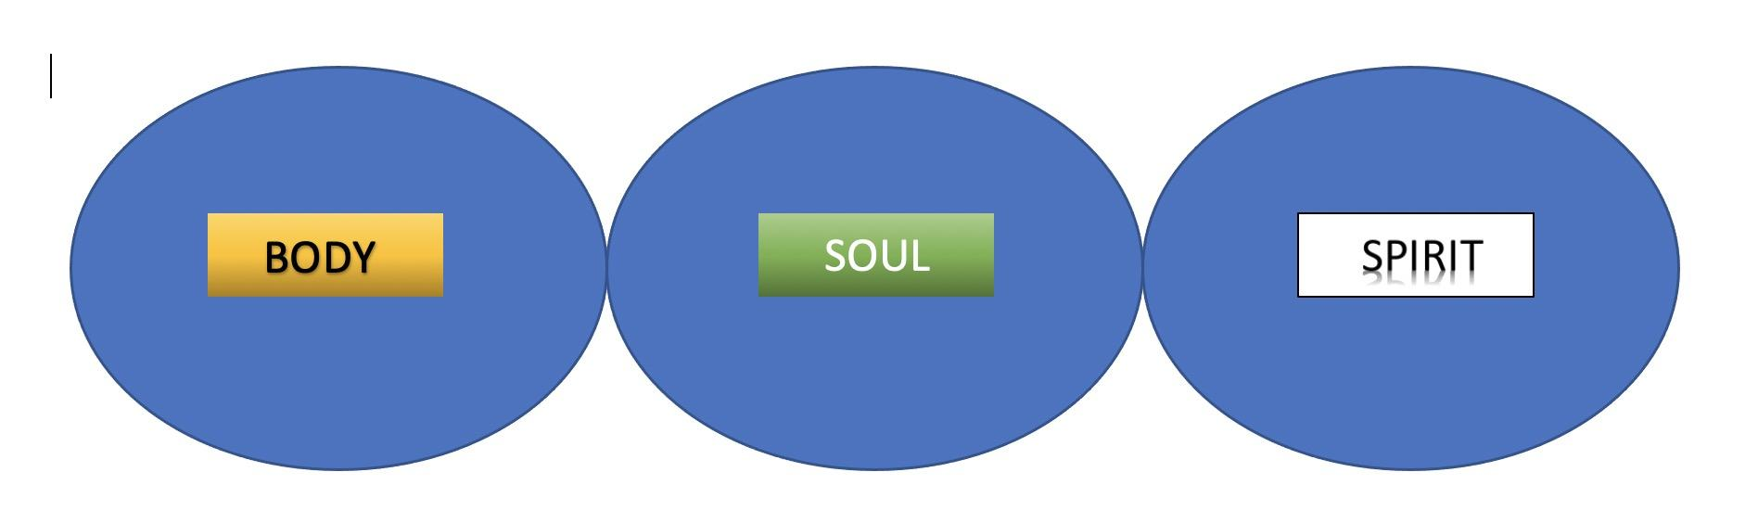
1 Thessalonians 5:23 “May your whole spirit, soul and body be kept blameless at the coming of our Lord Jesus Christ.”
[PICTURE: BODY SOUL SPIRIT ]

BODY
This is our physical Body, “our temporary tent” that we are housed in while here on earth. It is the here where our behaviors, lusts, cravings and habits are manifest.

SOUL
This is our internal self. Our Mind, Our emotions, and our will.

SPIRIT – This is that which is made alive by allowing Jesus to come in
This is the part of us where we “meet God”, “Commune with God”.

Chuck Smith - “it is in the realm of the spirit where man meets God.”

AW Tozer - “our spirit communes with God.”

The battle, “tug of war” often takes place in the realm of the Soul, usually in a part of the Soul that is connected to our Body, known as the “FLESH”

Gal 5:17 “For the flesh desires what is contrary to the Spirit, and the Spirit what is contrary to the flesh. They are in conflict with each other”

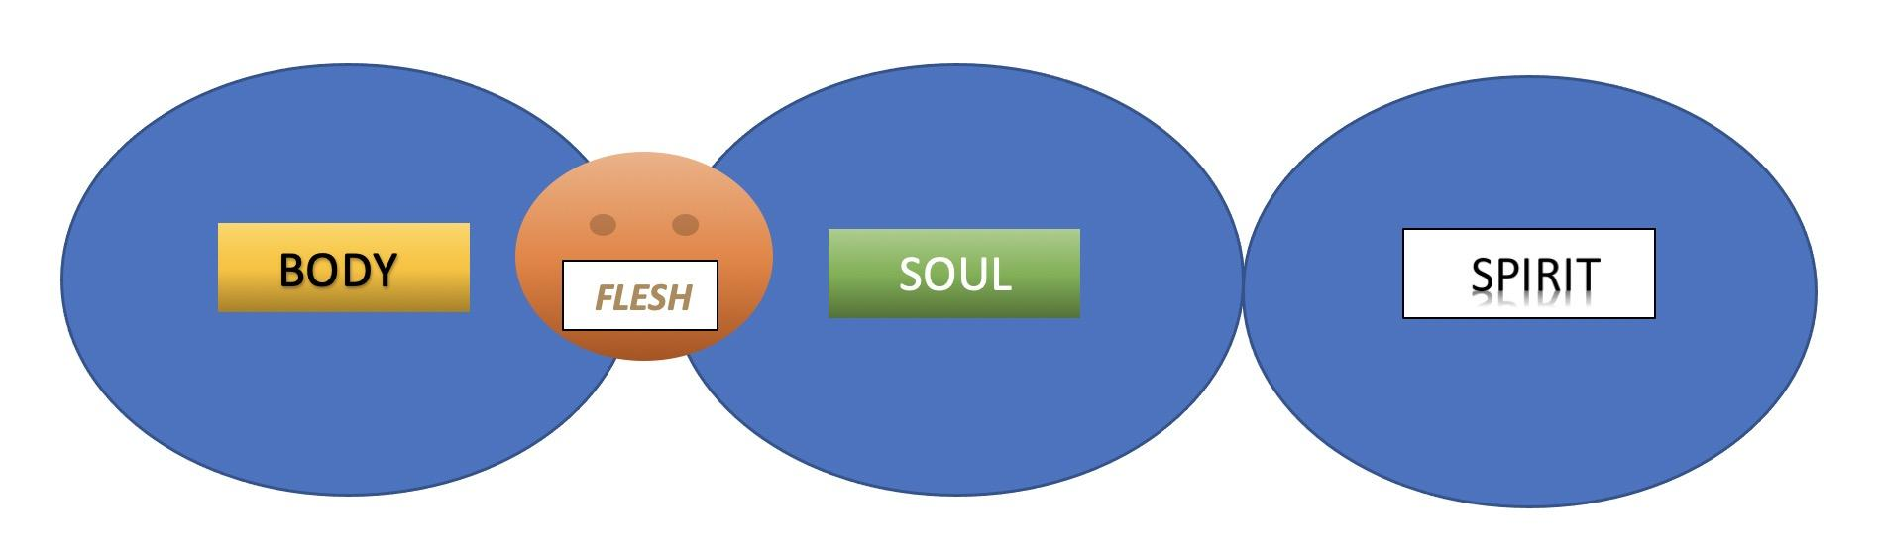
What is the “Flesh”? – The intersect of the BODY and the SOUL
[PICTURE: BODY SOUL SPIRIT - FLESH ]

THE HEART

Rom 10:9 “If you declare with your mouth, "Jesus is Lord," and believe in your heart that God raised him from the dead, you will be saved.”

Prov. 3:5 “Trust in the Lord with all your heart, and lean not on your own understanding”

What is the “Heart”? – The intersect of the SOUL and the SPIRIT
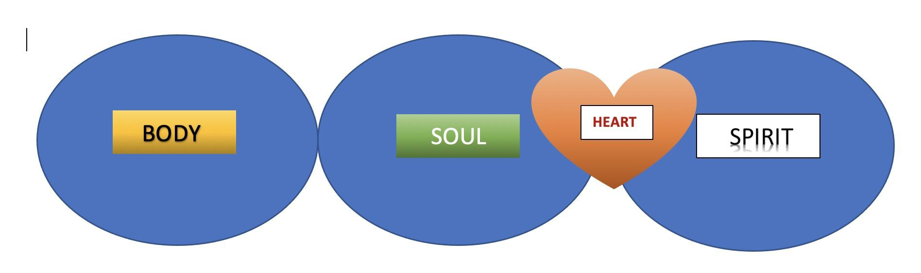
[PICTURE: BODY SOUL SPIRIT - HEART ]

God’s desire for us is to be completely His; BODY, SOUL, and SPIRIT with Heart and Flesh included.

1 Thessalonians 5:23 “May God himself, the God of peace, sanctify you through and through. May your whole spirit, soul and body be kept blameless at the coming of our Lord Jesus Christ.”

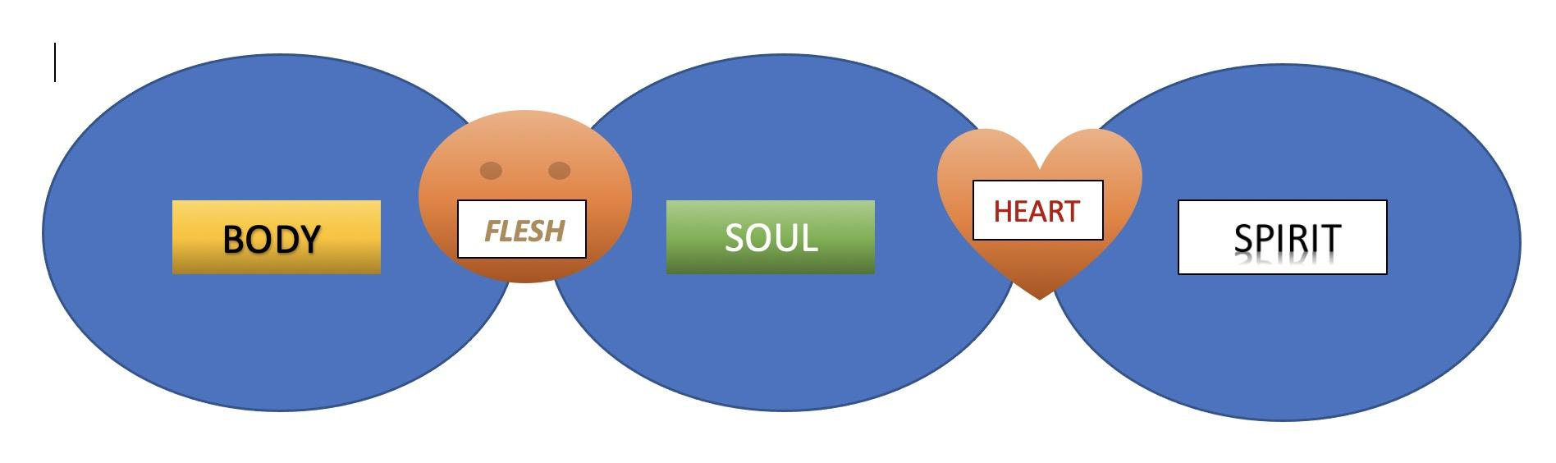
[PICTURE: BODY SOUL SPIRIT – FLESH and HEART ]

David writes about his “Soul yearning for the Lord”, and “his heart and flesh both crying out” for the living God.

Psalm 84:2 “My soul yearns, even faints, for the courts of the LORD; my heart and my flesh cry out for the living God.”

God wants us to seek Him and love Him with every part of us.

GREATEST COMMANDMENT:
Matt 22:37 “Jesus replied: "'Love the Lord your God with all your heart and with all your soul and with all your mind.'”

WHAT IS THE MIND? – The part of the Soul that connects to our body, and also connects to our spirit through believing.

Romans 8:5-6 “The mind governed by the flesh is death, but the mind governed by the Spirit is life and peace.”

The mind (Soul) governed by the flesh is death (stress, worry, anxiety, fear)!
The mind (Soul) governed by the Spirit is life and peace (love peace, joy, patience…)

If you are feeling overwhelmed by fear, worry, stress and anxiety,
It’s likely because you are allowing your mind (soul) to be controlled by your flesh instead of the Spirit.

THIS IS WHY WE ARE STUDYING EPHESIANS
Ephesians as an epistle is not specifically about the SOUL or the SPIRIT, but offers an abundance of practical examples of what it means to be led by the spirit, and overcome the battle of the soul.
Ephesus is a city where Paul planted a church, and saw powerful miracles take place. The gospel spread rapidly throughout the region and many Jews and Gentiles came to faith.
He writes this epistle to remind them of who they are in Christ, and exhort them to move forward in the things of the Spirit as they face battles within them and in unseen places.

Paul in Ephesus – “How it all started”

Paul arrived at Ephesus in Autumn of ’54 and stayed for over three years planting a church. They began in the local synagogue, but got kicked out after three months. They then started meeting in a Lecture Hall, “The lecture hall of Tyrannus” and were there for over two years.
The city of Ephesus is much like our country is today. There is an abundance of wealth and power, but also a tremendous amount of idolatry, spiritual heaviness and political tension.

We find the story of Ephesus, not in Ephesians, but Acts 19.
Acts 19:1-10 “While Apollos was at Corinth, Paul took the road through the interior and arrived at Ephesus. There he found some disciples ² and asked them, “Did you receive the Holy Spirit when you believed?”
They answered, “No, we have not even heard that there is a Holy Spirit.”
³ So Paul asked, “Then what baptism did you receive?”
“John’s baptism,” they replied.
⁴ Paul said, “John’s baptism was a baptism of repentance. He told the people to believe in the one coming after him, that is, in Jesus.” ⁵ On hearing this, they were baptized in the name of the Lord Jesus. ⁶ When Paul placed his hands on them, the Holy Spirit came on them, and they spoke in tongues and prophesied. ⁷ There were about twelve men in all.
⁸ Paul entered the synagogue and spoke boldly there for three months, arguing persuasively about the kingdom of God. ⁹ But some of them became obstinate; they refused to believe and publicly maligned the Way. So Paul left them. He took the disciples with him and had discussions daily in the lecture hall of Tyrannus. ¹⁰ This went on for two years, so that all the Jews and Greeks who lived in the province of Asia heard the word of the Lord.“
Apparently the “believers” whom Paul met, were believers and disciples of John the Baptist, NOT Jesus. Possibly they are some who had gone to Jerusalem while John was baptizing for repentance, but before Jesus came on the scene.
Paul immediately took care of the problem by giving them “the message of truth, the gospel of salvation in Christ, and the promised Holy Spirit”
Paul reminded them of all this in the last verse of Ephesians 1 that we read last week;
Eph 1:13 “And you also were included in Christ when you heard the message of truth, the gospel of your salvation. When you believed, you were marked in him with a seal, the promised Holy Spirit,”
He continues…
This week’s reading from Ephesians:
EPH 1:15-23 “For this reason, ever since I heard about your faith in the Lord Jesus and your love for all God’s people, ¹⁶ I have not stopped giving thanks for you, remembering you in my prayers. ¹⁷ I keep asking that the God of our Lord Jesus Christ, the glorious Father, may give you the Spirit of wisdom and revelation, so that you may know him better. ¹⁸ I pray that the eyes of your heart may be enlightened in order that you may know the hope to which he has called you, the riches of his glorious inheritance in his holy people, ¹⁹ and his incomparably great power for us who believe. That power is the same as the mighty strength ²⁰ he exerted when he raised Christ from the dead and seated him at his right hand in the heavenly realms, ²¹ far above all rule and authority, power and dominion, and every name that is invoked, not only in the present age but also in the one to come. ²² And God placed all things under his feet and appointed him to be head over everything for the church, ²³ which is his body, the fullness of him who fills everything in every way.

Key verse:
EPH. 1:18 “ I pray that the eyes of your heart may be enlightened.”

ENLIGHTENING THE EYES OF YOUR HEART”, is the Spiritual vision that comes when your spirit is indwelled by the Holy Spirit, then He gives you wisdom, knowledge, power and understanding of God.
You begin to see things from His perspective, not the world’s.
As a result you have confidence, peace, joy and comfort that you cannot attain any other way, because you realize that you are part of His Body, “The Church” whose power is far above all rule and authority, power and dominion not only in the present age but also in the one to come.
It’s hard to become fearful and insecure when the “Eyes of your Heart” are enlightened with this truth.
How does this happen? Simply by believing in Him, and trusting in His Word, and Praying.
- Trust His Word above anything you read or hear.
- Believe in His power and authority over any power or authority on Earth.
- Pray that he will enlighten your vision and understanding so that you will know what is real and true.
That’s what we do, He does the rest. It’s God who works in you.
Closing;
My final encouragement and exhortation, is simply to agree in prayer with Paul for you, for me, and for the church, and remind us of who we are in Christ, and who He is in this world, and the world to come.
“I pray that the eyes of your heart may be enlightened in order that you may know the hope to which he has called you, the riches of his glorious inheritance in his holy people, ¹⁹ and his incomparably great power for us who believe. That power is the same as the mighty strength ²⁰ he exerted when he raised Christ from the dead and seated him at his right hand in the heavenly realms, ²¹ far above all rule and authority, power and dominion, and every name that is invoked, not only in the present age but also in the one to come. ²² And God placed all things under his feet and appointed him to be head over everything for the church, ²³ which is his body, the fullness of him who fills everything in every way.”

