DON’T LIVE AS THEY DO
Soul OR the Spirit

Review: “Make every effort to keep the unity of the Spirit through the bond of peace.”
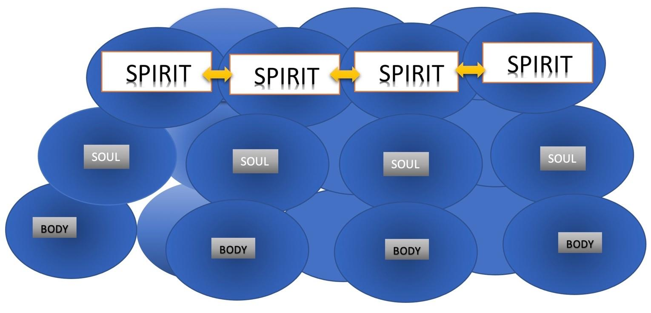
Unity in the spirit is different than unity in the body or soul. (show graphic)
In the Body, (Our physical being) it’s just being together physically, like passengers on an airplane or people in a waiting room
In the Soul, (Our Mind and emotions) it means that your mind and/or emotions made a connection. You share something in common mentally or emotionally. Perhaps you like the same music, sports teams, movies or even shared significant experiences together.
Unity in the Spirit,(The part of us that has been “made alive” to commune and connect with God) this means that you share a spiritual connection with other and experience “Koinonia”.

Koinonia - the deep fellowship that comes only by a connection in the spirit. You are connected with that part of you (spirit) that is made alive by Jesus and connected to God through him.

Eph. 4:17-24
¹⁷ So I tell you this, and insist on it in the Lord, that you must no longer live as the Gentiles do, in the futility of their thinking. ¹⁸ They are darkened in their understanding and separated from the life of God because of the ignorance that is in them due to the hardening of their hearts. ¹⁹ Having lost all sensitivity, they have given themselves over to sensuality so as to indulge in every kind of impurity, and they are full of greed.
Paul is emphatic about this statement; “I insist”, “you must no longer live as the Gentiles do”. Then he points out their; thinking, understanding, ignorance, sensuality and impurity.
Why is he picking on the Gentiles and putting them down? They are basically just unbelievers.
Why is he insisting that we as Christians are so much better than them?
The reason is, The Soul or the Spirit. Unbelievers live by the “flesh”. They are not able to live by the spirit, because theirs spirit is not yet “made alive” (Eph 2:1) , by God’s spirit. So everything they do is geared toward gratifying the Soul or The Body – NOT the Spirit.
Show graphic
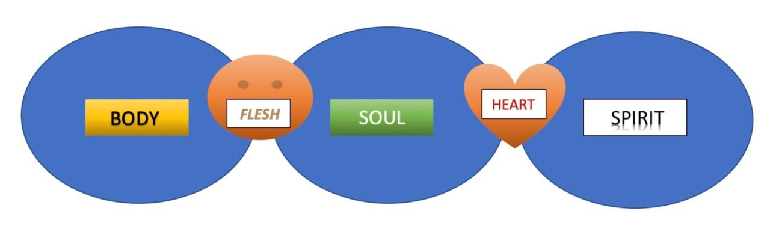
Romans 8:6 ”The mind governed by the flesh is death, but the mind governed by the Spirit is life and peace.”

The “mind” (Soul) governed by the “flesh” (cravings of the body) results in “death”.
The mind (Soul) governed by the “Spirit” through (the heart) is life and peace.
This is exactly what Paul is describing in the Gentiles.
Don’t be like those whose “mind is governed by the flesh”, because the results are “Death”:
- Futility of thinking
- darkened in their understanding
- separated from the life of God
- ignorance that is in them due to the hardening of their hearts
- Having lost all sensitivity, they have given themselves over to sensuality
- indulge in every kind of impurity,
- they are full of greed.
This way of living is an example of spiritual death, especially “separated from the life of God”
That means that none of the; Hope, Joy, Power, Strength, and Love of God is not in their lives.
They live lives that are “darkened in their understanding - due to the hardening of their hearts”, because they do not have the Spirit in them.
Jude 19 “These people are the ones who are creating divisions among you. They follow their natural instincts because they do not have God’s Spirit in them.”

It’s so sad. This is why we must “always be ready to share with everyone who asks you a reason for the hope that is in you” (1 Peter 3:15)
The world desperately needs the life that we have in Jesus.

Eph. 4:20-24
²⁰ That, however, is not the way of life you learned ²¹ when you heard about Christ and were taught in him in accordance with the truth that is in Jesus. ²² You were taught, with regard to your former way of life, to put off your old self, which is being corrupted by its deceitful desires; ²³ to be made new in the attitude of your minds; ²⁴ and to put on the new self, created to be like God in true righteousness and holiness.
Remember when we met the First Ephesians? They did not know about Jesus, only John the Baptist. They did not understand anything about the Spirit. But once they did, they became completely transformed.
Acts 19:1 “Paul, having passed through the upper regions, came to Ephesus. And finding some disciples ² he said to them, “Did you receive the Holy Spirit when you believed?”
So they said to him, “We have not so much as heard whether there is a Holy Spirit.”
³ And he said to them, “Into what then were you baptized?”
So they said, “Into John’s baptism.”
⁴ Then Paul said, “John indeed baptized with a baptism of repentance, saying to the people that they should believe on Him who would come after him, that is, on Christ Jesus.”
⁵ When they heard this, they were baptized in the name of the Lord Jesus. ⁶ And when Paul had laid hands on them, the Holy Spirit came upon them,”
This is why Paul tells them, as we just read “be made new in the attitude of your minds; ²⁴ and to put on the new self, created to be like God”.
How can we be like God? Jesus said, “God is Spirit”.
By allowing Him to bring your spirit to life, and fill it with his Holy Spirit.
Holy Spirit = Ruach Ha Kodesh (Breath of God), God breathed His spirit into those that didn’t even know they had a spirit. (Think; driver airbag, or parachute).
He does the same to us.

Eph 4:25-29
^{25 “}Therefore each of you must put off falsehood and speak truthfully to your neighbor, for we are all members of one body. ²⁶ “In your anger do not sin” Do not let the sun go down while you are still angry, ²⁷ and do not give the devil a foothold. ²⁸ Anyone who has been stealing must steal no longer, but must work, doing something useful with their own hands, that they may have something to share with those in need.²⁹ Do not let any unwholesome talk come out of your mouths, but only what is helpful for building others up according to their needs, that it may benefit those who listen.”
“for we are all members of one body.”
That means we are all not just on the same team, not just members of one family, we are members of one body.
When we act against one another we become like “rogue cells” which attack healthy cells and cause cancer,
or “autoimmune disease” where the body attacks and damages its own tissue.
This is why Paul urges us;
- put off falsehood
Be real with one another, don’t deceive each other or try to be something you’re not.
- speak truthfully to your neighbor
There is no reason to lie to one another, speak truthfully (with gentleness and wisdom)
- In your anger do not sin
”Be angry, but sin not” . Someone else’s shortcomings are never an excuse to be overcome with anger to the point of sin (over-reaction, hatred, revenge)
- Do not let the sun go down while you are still angry,
Do not let anger linger. Settle it quickly or release it before you go to bed.
- do not give the devil a foothold.
The Devil wants to find “traction”, don’t give it to him. He wants to find a way in to the “body” to kill, steal and destroy. Keep him out. (just like you want to avoid COVID from entering your body, you must be vigilant against the devil who wants to get into the church body).

- Anyone who has been stealing must steal no longer, but must work, doing something useful with their own hands, that they may have something to share with those in need.
(apparently there was theft going on in Ephesus. Paul says, don’t just stop stealing, but put your hands to work helping those in need.)

- Do not let any unwholesome talk come out of your mouths, but only what is helpful for building others up according to their needs, that it may benefit those who listen.

Avoid;
- “unwholesome talk” (NIV)
- “corrupt words (NKJV)
- “foul or abusive language” (NLT)

This is not only referring to profanity and inappropriate language, it’s also referring to words that hurt, attack, offend and damage others.
Our words matter!
Prov. 18:21 “Death and life are in the power of the tongue”
Our words, whether written, posted, spoken or otherwise communicated should “build others up according to their needs, and benefit those who listen.”
Be careful what you say, be intentional on not just avoiding harmful communication, but use your words to benefit someone else, you never know how much what you say can encourage and bless others.
There are so many examples of people who have been wounded from childhood at the words of a parent, teacher, coach or friend.
(I still remember both empowering and encouraging words spoken to me as a child, along with some that were damaging and discouraging)
We’ve seen many examples of people in the public eye, even celebrities being fired from high-profile positions for simply saying, or posting something that someone else found offensive.
There are also however, many examples of people whose lives were blessed and transformed, some even rescued from self-destruction by the timely encouraging words of another person! Let’s be THAT kind of person!
Prov. 15:23 “A man has joy by the answer of his mouth, and a word spoken in due season, how good it is!”

Finally, DO NOT GRIEVE THE HOLY SPIRIT!
³⁰ And do not grieve the Holy Spirit of God, with whom you were sealed for the day of redemption. ³¹ Get rid of all bitterness, rage and anger, brawling and slander, along with every form of malice. ³² Be kind and compassionate to one another, forgiving each other, just as in Christ God forgave you.
Question; Who is the Holy Spirit?

Simply put, He is God in Spirit.

A.W. Tozer: “But the Godhead of the Father, of the Son, and of the Holy Ghost, is all one: The Glory equal, the Majesty co-eternal.”

The Holy Spirit is not just some mystical force that hangs around with God and Jesus, He is not their butler or their watchdog. He is co-equal in the Trinity.

How can he be “grieved”?

In order to be grieved, you must have feelings and a personality.

C&MA Statement of Faith; “The Holy Spirit is a divine person, sent to indwell, guide, teach, empower the believer”

He is a Divine person, with a personality.

Charles Stanley; To understand what it means to grieve the Spirit, we must first understand that this indicates the Spirit possesses personality. Only a person can be grieved; therefore, the Spirit must be a divine person in order to have this emotion. Once we understand this, we can better understand how He is grieved, mainly because we too are grieved.

The way we can see the Holy Spirit move more significantly in our lives, is to make room for Him, welcome Him and not grieve Him.

Sometimes the things we do and don’t do can determine how effective the work of the Holy Spirit is in our lives. He never forces his way in, but always responds to a welcoming environment, both in our individual lives and the church.

Words are important, actions are too, but most important I the posture of your heart.

Let’s commit to having hearts that are not hardened to the Holy Spirit, but open to Him.

Not grieving Him by the things we say and do,

But welcoming Him, into every area of our life.

If we do that, I believe that we will see him do “immeasurably more than all we ask or imagine, according to his power that is at work within us.”

That’s my prayer for me, and my prayer for you as well…

