IN LOVE

Soul or the Spirit
R.Giglio 2/11/21
As we move deeper into Ephesians we begin to see that the mystery that Paul’s mentions begins to be revealed.
People of all different backgrounds are being brought together to form one household, built upon the foundation of the Apostles and the Prophets with Jesus being the chief cornerstone.
Paul calls us a “building”, a “Holy Temple” and “dwelling place of God in the Spirit”.
We are joined together with the Lord in the Spirit.

Eph 2:19-22 “you are no longer strangers and foreigners, but fellow citizens with the saints and members of the household of God, ²⁰ having been built on the foundation of the apostles and prophets, Jesus Christ Himself being the chief cornerstone, ²¹ in whom the whole building, being fitted together, grows into a holy temple in the Lord, ²² in whom you also are being built together for a dwelling place of God in the Spirit.

Eph. 3:10-11“His intent was that now, through the church, the manifold wisdom of God should be made known to the rulers and authorities in the heavenly realms, ¹¹ according to his eternal purpose that he accomplished in Christ Jesus our Lord.
Those of us who believe upon the Lord, who have been made alive in Him, by Him, ARE the Church and also the Temple of the Holy Spirit.

Our primary connection to one another is “spiritual” – “whoever is united with the Lord is one with him in spirit” (1 Cor. 6:17)

This is why it’s so important in our everyday life to;
- dwell in the spirit,
- walk in the spirit, and
- relate to one another in the Spirit.
- Elevate our interactions and conversations to things of the spirit

(Finance Company online Customer Service representative)
On a call this week with a random customer service representative for a finance company:

“A Young Man approached me in the parking lot of Home Depot, I thought he was going to try to sell me something.
Instead he asked if he could pray for me.
I was so humbled and blessed, I cannot stop thinking about it.
I told my son “We all need to open our hearts to let the spirit lead us and guide us, and not be so focused on ourselves”

Once we connected on that level, it was all we could talk about.

When you make a connection with someone on a spiritual level, everything else seems so unimportant.

We cannot be fully united with each other OR the Lord in just the Soul and Body.
We can only have “Unity of the Spirit”, IN the Spirit.
.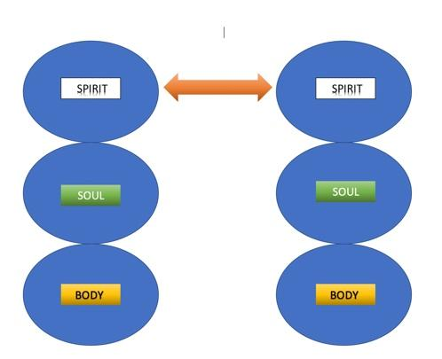.

We can only have fellowship with one another “In Christ Jesus” by approaching Him and each other “in the Spirit”

.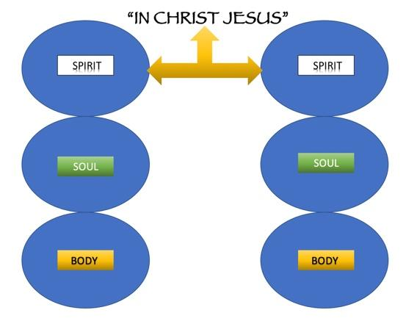.
AND…

We can only be “fitted together, into a holy temple in the Lord, and built together for a dwelling place of God” in the Spirit. (Eph. 2:21-22)
- As the Body of Christ
- As the Temple of the Holy Spirit
- As the Church…
.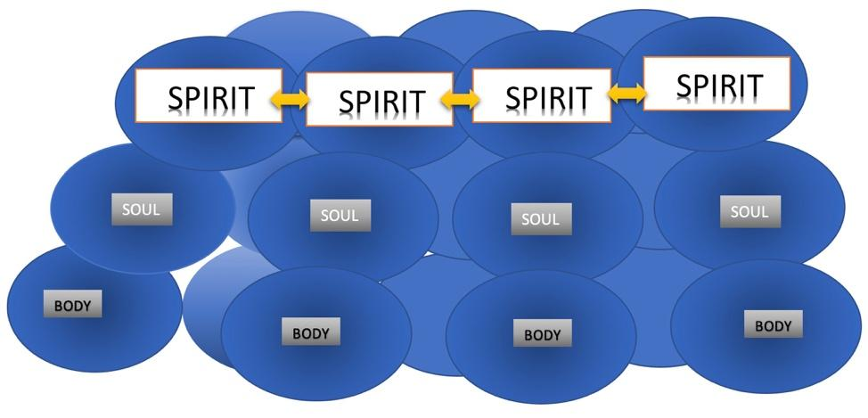.

This is what Eph 4:3 calls the “unity of the Spirit”.
Eph. 3:14-21 “For this reason I kneel before the Father, ¹⁵ from whom every family in heaven and on earth derives its name. ¹⁶ I pray that out of his glorious riches he may strengthen you with power through his Spirit in your inner being, ¹⁷ so that Christ may dwell in your hearts through faith. And I pray that you, being rooted and established in love, ¹⁸ may have power, together with all the Lord’s holy people, to grasp how wide and long and high and deep is the love of Christ, ¹⁹ and to know this love that surpasses knowledge—that you may be filled to the measure of all the fullness of God.
²⁰ Now to him who is able to do immeasurably more than all we ask or imagine, according to his power that is at work within us, ²¹ to him be glory in the church and in Christ Jesus throughout all generations, for ever and ever! Amen.”
verse14: “For this reason I kneel before the Father, 15 from whom every family in heaven and on earth derives its name.” ???
In the world:
Zhang (Chang)
Li (Lee)
Wang
Nguyen (newen)
Garcia
Gonzalez
Hernandez
Smith
Smirniov
Muller (Miller)

All families don’t have the same name, do they?
Most popular Surnames in America:
- SMITH
- JOHNSON
- WILLIAMS
- BROWN
- JONES
- GARCIA
- MILLER
- DAVIS
- RODRIGUEZ
- MARTIN

Charles Ellicott's Bible Commentary for English Readers
(EPH 3:15) “Of whom the whole family in heaven and earth is named.”

The original word (patria) here rendered “family” is literally derived from the word “father” (pater). It has been proposed to render it fatherhood, and translate, from whom all fatherhood derives its name—all fatherhood being, in fact, a shadow and derivative from the Fatherhood of God.

The truth is that God is the “creator” of all things and all mankind. He is also the “Father of all, who is over all and through all and in all” (Eph 4:6)

HOWEVER not all people are His children.

They need to believe on him (John 1:12 “Yet to all who did receive him, to those who believed in his name, he gave the right to become children of God”)
and receive the “Spirit of adoption” (Rom 8);

Romans 8:9 “…if anyone does not have the Spirit of Christ, they do not belong to Christ.”

Romans 8:14-16
¹⁴ For all who are led by the Spirit of God are sons of God. ¹⁵ For you did not receive the spirit of slavery to fall back into fear, but you have received the Spirit of adoption as sons, by whom we cry, “Abba! Father!” ¹⁶ The Spirit himself bears witness with our spirit that we are children of God,

It’s ONLY BY THE SPIRIT that we become Children of God

That’s why Paul continues his prayer…
(v. 16-17) “I pray that out of his glorious riches he may strengthen you with power through his Spirit in your “inner being”, ¹⁷ so that Christ may dwell in your hearts through faith.”
He strengthens us in our inner-being If and when we are made alive in our spirits because Christ comes and dwells in hearts through faith.

Then Paul reminds us that it is all about LOVE

(v.17-19) And I pray that you, being rooted and established in love, ¹⁸ may have power, together with all the Lord’s holy people, to grasp how wide and long and high and deep is the love of Christ,¹⁹ and to know this love that surpasses knowledge—that you may be filled to the measure of all the fullness of God.

This letter to the Ephesians along with the other Prison epistles (Philippians, Colossians, and Philemon AND also 1st Corinthians), shows the basis of Paul’s beliefs and understanding of God.

Love is paramount. Nothing is greater, more important and more powerful than God’s love.

This is the complete opposite of what was established in the Jewish religion that Paul himself preached and propagated. Remember, he was a mean young Pharisee. He was legalistic and shrewd and delighted in persecuting his own people for believing in Jesus.
NOW, he is completely changed. He builds his entire doctrine on a faith that first and foremost understands the love of Christ. He urges us to recognize love not only as a primary building block, but the entire foundation. This is a huge departure from everything they had ever heard before.
Imagine knowing Paul, before his conversion, when he was the “feared and despised pharisee - Saul of Tarsus”, now he is “Paul the Love Guy”
He was IN Ephesus when he wrote 1st Corinthians which includes the famous “love chapter” (Cor.13). He was planting the church in Ephesus; preaching, teaching working and being persecuted while he was writing letters to the other churches he planted (like Corinth). In that letter he shares the new thing that God showed him, and it’s all about love:
1 COR 13:1-8 “If I speak in the tongues of men or of angels, but do not have love, I am only a resounding gong or a clanging cymbal. ² If I have the gift of prophecy and can fathom all mysteries and all knowledge, and if I have a faith that can move mountains, but do not have love, I am nothing. ³ If I give all I possess to the poor and give over my body to hardship that I may boast, but do not have love, I gain nothing.
⁴ Love is patient, love is kind. It does not envy, it does not boast, it is not proud. ⁵ It does not dishonor others, it is not self-seeking, it is not easily angered, it keeps no record of wrongs. ⁶ Love does not delight in evil but rejoices with the truth. ⁷ It always protects, always trusts, always hopes, always perseveres.⁸ Love never fails.”

Paul ends the love chapter with these words:

1st Cor. 13:13 “And now these three remain: faith, hope and love. But the greatest of these is love.”

This is why he writes in Ephesians 3;
- “you being rooted and established “in love”, may have power,” (v.18)
Love gives us power. There is nothing more enduring and inseparable than God’s love. We are the most effective we can be when we are operating in the power of God’s love.

- “To grasp how wide and long and high and deep is the love of Christ,” (v. 18)
James Ryle – If people REALLY knew how much God loves us, it would change everything. We wouldn’t need to teach people because they would spend every moment devouring his word to find out more about Him. We wouldn’t need to lead worship because they would constantly be singing songs of praise and adoration to Him. We wouldn’t even need to evangelize because people would just come running into the arms of a loving God.
- “love that surpasses knowledge - that you may be filled to the measure of all the fullness of God.”(v.19)
Jesus made a monumental statement about love when he was asked :Which is the Greatest Commandment?”. He was being tested, first by the Herodians, then by the Sadducees, then by the Pharisees. They were trying to trick him into saying something where he would discredit himself publicly.
Matt 22:34-40 “Hearing that Jesus had silenced the Sadducees, the Pharisees got together.³⁵ One of them, an expert in the law, tested him with this question: ³⁶ “Teacher, which is the greatest commandment in the Law?”
³⁷ Jesus replied: “‘Love the Lord your God with all your heart and with all your soul and with all your mind.’ ³⁸ This is the first and greatest commandment. ³⁹ And the second is like it: ‘Love your neighbor as yourself.’⁴⁰ All the Law and the Prophets hang on these two commandments.”
Paul is saying the same thing. The Law, The Prophets, anything that was ever written or anything that is to come, is inferior to “love”. Loving God and loving others, is more important than both the law and the prophets, in fact it’s the most important thing in the world.
1st John 4:7-8 “Dear friends, let us love one another, for love comes from God. Everyone who loves has been born of God and knows God. ⁸ Whoever does not love does not know God, because God is love.”

God is love! He loves us and wants us to feel very very loved by him.

God wants to bless you more than you can imagine.
- He wants you to experience deep relationship with Him as His child,
- He wants you to have deep fellowship with others in Him.
- He wants you to have power,
- He wants you to feel how wide and long and high and deep is the love of Christ,
- He wants you to know this love that surpasses knowledge—that you may be filled to the measure of all the fullness of God. (in fact he wants to immeasurably more than all we ask or imagine)
- He wants you to not just be “In Love”, but be “rooted and established in love”

May you feel His spirit upon you
His power within you
and His love all around you
More than you can ever ask, think or imagine.

Benediction:
Eph. 3:20 “Now to him who is able to do immeasurably more than all we ask or imagine, according to his power that is at work within us, ²¹ to him be glory in the church and in Christ Jesus throughout all generations, for ever and ever! Amen.”

