Unity of the Spirit
Soul or the Spirit (Eph. 4:1-16)

Paul is a prisoner of Rome. He was initially being held under house arrest but was eventually put into a Roman prison awaiting execution.
Yet, he identifies himself as a prisoner for the Lord (not of Rome). He recognizes that his life has significant purpose even where he is, especially in what he so enthusiastically writes to the believers in Ephesus.
He recognizes their struggle, being persecuted just as he is, however he also recognizes their incredible potential in the Spirit and to live a life worthy of the calling that they have received.
Eph. 4:1-3 “As a prisoner for the Lord, then, I urge you to live a life worthy of the calling you have received. ² Be completely humble and gentle; be patient, bearing with one another in love. ³ Make every effort to keep the unity of the Spirit through the bond of peace.”
“Make every effort to keep the unity of the Spirit through the bond of peace.”
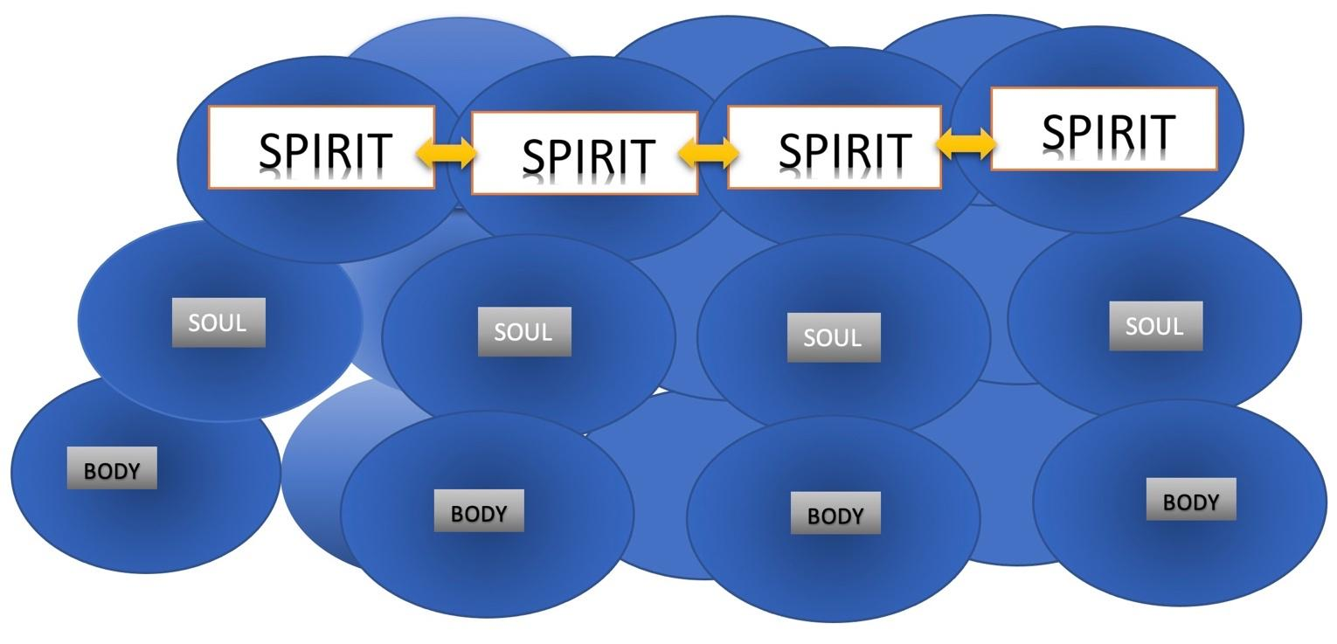
Unity in the spirit is different than unity in the body or soul. (show graphic)
In the Body, it’s just being together physically, like passengers on an airplane or people in a waiting room
In the Soul, it means that your mind and/or emotions made a connection. You share something in common mentally or emotionally. Perhaps you like the same music, sports teams, movies or even shared significant experiences together.
Unity in the Spirit, this means that you share a spiritual connection with other and experience “Koinonia”.

Koinonia - the deep fellowship that comes only by a connection in the spirit. You are connected with that part of you (spirit) that is made alive by Jesus and connected to God through him.
Unity of the spirit is of vital importance to us individual believers, but even more important to us a church.
Which is why Paul urges us to “Make every effort to keep the unity of the Spirit.”

Unity takes effort. It doesn’t just happen. But it is vitally important to maintain. Friendships, church relationships, even marriage have a tendency, when not maintained to experience “entropy” (gradual decline into disorder).

The Second Law of Thermodynamics states that - over time entropy will increase, not decrease.
This means that without effort, even our relationships will suffer over time and unity will decay, not increase.
Unless…we “Make every effort to keep the unity of the Spirit through the bond of peace.”
How do we make every effort?
We do that through what we just read in Eph 4;
“Be completely humble and gentle;”
Pride and arrogance work directly against unity. They will tend to alienate people, not draw them together. Humility and gentleness are attractive and magnetic and cultivate an environment of unity.

“be patient,”
Others will always let you down, or not live up to your expectations. What do you do when this happens? Exercise your right to complain, react and be quickly angered? NO, patience is forbearance. It’s what how God reacts to us when we mess up and let him down. Patience is always more effective in building relationships than frustration and irritability.

“bearing with one another in love”
1st Cor. 13:7 “Love bears all things, believes all things, hopes all things, endures all things.”
Bearing with one another in love is simply valuing each other more than the conflicts, differences and disagreements that inevitably happen in the course of relationships. If we continually “keep a record of wrongs” instead of as Heb 12:14 says “Strive for peace with everyone”, we will not have unity of the spirit through the bonds of peace.
Unity in the Spirit is of utmost importance.
“Now you are the body of Christ, and each one of you is a part of it.” (1st Cor. 12:27)

We, collectively, in unity are “The Body of Christ”
There are not different true Gods and sovereign Lords. There’s only one.
He has called us into one hope, on Lord, One faith, One baptism,
Eph 4:4-6 “There is one body and one Spirit, just as you were called to one hope when you were called; ⁵ one Lord, one faith, one baptism; ⁶ one God and Father of all, who is over all and through all and in all.”
The truth is that the church in the world is unfortunately very divided. We disagree, argue, and even fight about things of God. This is the result of walking in the Soul, as opposed to the Spirit. The more we walk in the Spirit and are led by Him the more unity of the Spirit and bonds of peace we will experience.

EPH 4:7-13 “But to each one of us grace has been given as Christ apportioned it. ⁸ This is why it says: “When he ascended on high, he took many captives and gave gifts to his people.” (Ps. 68:18)
⁹ (What does “he ascended” mean except that he also descended to the lower, earthly regions? ¹⁰ He who descended is the very one who ascended higher than all the heavens, in order to fill the whole universe.)
¹¹ So Christ himself gave the apostles, the prophets, the evangelists, the pastors and teachers, ¹² to equip his people for works of service, so that the body of Christ may be built up ¹³ until we all reach unity in the faith and in the knowledge of the Son of God and become mature, attaining to the whole measure of the fullness of Christ.”

The Five-Fold ministry (APEPT)
Apostles
Prophets
Evangelists
Pastors
Teachers

Before we explain each one, and the roles of those listed here in verse 11, it’s very important to know their purpose (stated in verse 12).
“to equip his people for works of service, so that the body of Christ may be built up until we all reach unity in the faith”!
If this is not the motivation, purpose, goal and result of these functions, then they are operating outside their Biblical design.
When they are operating as the Lord intended them however, the end result is “UNITY in the faith”.

The Five-Fold ministry - (APEPT / APEST) – (I attended a lecture by Alan Hirsch who wrote a book on this subject, which helped clarify some of my thoughts on this)
Apostles - In Greek, the term apostle literally means “sent one.” As the “sent ones,” they ensure that the faith is transmitted from one context to another and from one generation to the next. They are always thinking about the future, bridging barriers, establishing the church in new contexts, developing leaders, networking trans-locally.

Prophets – “Speaks forth the Word of God” - They are particularly attuned to God and his truth for today. They bring correction and challenge the dominant assumptions we inherit from the culture. They insist that the community obey what God has commanded.

Evangelists - communicators of the gospel message recruit others to the cause. They call for a personal response to God's redemption in Christ, and also draw believers to engage the wider mission, growing the church.

Pastors/Shepherd - Caregivers of the community, they focus on the protection and spiritual maturity of God's flock, cultivating a loving and spiritually mature network of relationships, making and developing disciples. “Tend, Guide, Feed and Protect”

(Important: this is the ONLY place the word “Pastors” appears in the bible. The singular word “Pastor” is not in the Bible. It is usually represented as “Shepherd”.
Pastor is not necessarily the Top Leader of the church in the NT, that would be “Elders”. A Lead Pastor is essentially a leader among “Elders” biblically speaking. This is why many people use the acronym APEST)

Teachers – “Clarifying the truth”, Communicators of God's truth and wisdom, they help others remain biblically grounded to better discern God's will, guiding others toward wisdom, helping the community remain faithful to Christ's word,

These are raised up and given to the church…
“to equip his people for works of service, so that the body of Christ may be built up until we all reach unity in the faith”!
This can only be accomplished through the power of the SPIRIT (God’s Spirit at work in us), NOT by the SOUL (mind/emotions).
These are not necessarily “Spiritual Gifts” like we see in Romans 12, or Spiritual Manifestations like we see in 1st Cor. 12, these “Spiritual Ministries” within the church.
Some of you are called to these things, when God calls you, He also gifts you for ministry.
It’s not based on your own intellect, natural skills or good ideas. It’s driven by the Holy Spirit working within you.
“He doesn’t call the qualified, He qualifies the called”
The church needs these Ministries in operation in powerful ways.
We need;
- Apostles – to develop churches and ministries in desperately needed areas of the world.
- Prophets – to speak forth the word of God in even the most uncomfortable circumstances.
- Evangelists – to preach the good news to unbelievers and motivate all of us to do the same.
- Pastors – to shepherd and keep watch over the flock
- Teachers – to clarify truth and speak it out, especially in a time when deception is prevalent, and truth is twisted, watered-down or misrepresented.
When these are functioning well, the results are…
Eph 4:14-16 “Then we will no longer be infants, tossed back and forth by the waves, and blown here and there by every wind of teaching and by the cunning and craftiness of people in their deceitful scheming.
There is an alarming amount of falsehood being taught, propagated and believed in the church. Social media, for all its faults also gives us a sobering view of what people are thinking and believing.
The world needs to hear about the hope and love of Jesus, and the church needs to hear about the truth of what is God’s word and what is not, because in many ways we have become very much like;
“infants, tossed back and forth by the waves, and blown here and there by every wind of teaching, by the cunning and craftiness of people in their deceitful scheming ”.
It’s terrible, but it’s true. The world needs Spirit-led leaders to rise up and speak the truth in love.
We need more of these types of true Biblical Apostles, Prophets, Evangelists, Pastors and Teachers in the church today.
(APEPT) - Notice there is no “S” for spectator or another “A” for audience.

We are all given ministries and spiritual gifts to use for the kingdom of God.
If it’s not one of these ministries it is most certainly one of the gifts listed in Rom 12:6-8 and see who you are. Go and read for yourself Romans 12:6-8.

Paul ends this section it this way…
Eph 4:15-16 “…speaking the truth in love, we will grow to become in every respect the mature body of him who is the head, that is, Christ. From him the whole body, joined and held together by every supporting ligament, grows and builds itself up in love, as each part does its work”

As we count down the weeks leading up to Resurrection Weekend, make it your commitment to;
- Seek God as to what ministry he has for you that will…
“equip his people for works of service, so that the body of Christ may be built up until we all reach unity in the faith”!
- Ask Him to help you be..
“…completely humble and gentle;
patient, bearing with others in love.
And Make every effort to keep the unity of the Spirit through the bond of peace”
If we can commit to this as individuals and as a church…
“we will grow to become in every respect,
the mature body of him who is the head,
that is, Jesus the Messiah”,
“who is over all, and through all,
and in all.”

