A New Temple

Soul or the Spirit – How does that apply to us as a church, along with us as individuals?

Eph 3:1-5 “For this reason I, Paul, the prisoner of Christ Jesus for the sake of you Gentiles—
² Surely you have heard about the administration of God’s grace that was given to me for you, ³ that is, the mystery made known to me by revelation, as I have already written briefly. ⁴ In reading this, then, you will be able to understand my insight into the mystery of Christ, ⁵ which was not made known to people in other generations as it has now been revealed by the Spirit to God’s holy apostles and prophets.
For this reason – you have heard about the administration of God’s grace that was given to me for you.
For this reason – the mystery was made known to me by revelation
For this reason - you will be able to understand my insight into the mystery of Christ.
For this reason – that which was not made known to people in other generations, has now been revealed by the Spirit to God’s holy apostles and prophets
What is the reason, and the mystery???
The reason and the mystery are very much the same thing.
The reason Paul was writing so enthusiastically, was that God revealed that He was doing a brand new thing that had not been done before. It also had not been revealed or expected to anyone in past generations.
In the past, God’s people were represented by the law, the prophets, the priests and the temple. The prophets spoke on behalf of God and the priests administered the sacrifices at the temple. That’s how seeking, worshiping and belonging to God worked.
The idea of Gentiles (non-Jews) coming into this system was not entirely unheard of, but it was rare. In fact there was prophecies about them coming into the light of Israel all throughout the Hebrew scriptures.
The mystery is that no one was expecting that the joining of Jews and Gentiles into one new Humanity, and then the pouring out of God’s spirit into it, would produce something greater than the law, greater than the prophets and even greater than the temple.
Yes, the mighty temple which was built by Solomon a thousand years prior, rebuilt 500 years prior under Nehemiah and Ezra, and even refortified by Herod the Great 50 years prior creating one of the most powerful and formidable edifices in the ancient world. It was also the place where the Spirit of the Lord is said to have dwelled. This temple was destroyed less than ten years after this was written, and never rebuilt again.
This mystery that was revealed to Paul and now to the Ephesians, is that something greater than the temple is now revealed that is built upon the foundation of the Apostles (like Peter and Paul), and the Prophets (like Isaiah and the rest), and Jesus himself as the cornerstone.
“For this reason” that Paul was referring to was what he had just written at the end of the previous chapter. (FYI, chapter breaks were not part of the original writings of the Bible, they were added over a thousand years later.)
This is the revelation that Paul was continuing when he wrote “for this reason”…
Eph 2:19-22 “you are no longer strangers and foreigners, but fellow citizens with the saints and members of the household of God, ²⁰ having been built on the foundation of the apostles and prophets, Jesus Christ Himself being the chief cornerstone, ²¹ in whom the whole building, being fitted together, grows into a holy temple in the Lord, ²² in whom you also are being built together for a dwelling place of God in the Spirit.
This IS very mysterious.
What is the building he is talking about?
How can the foundation be Apostles and Prophets?
How can Jesus be the cornerstone?
How can God dwell in it by His Spirit?
Is it a person?
Is it a place?
Is it a building?
Is it a Nation?
The mystery revealed here in Ephesians 3 is…
That it is…
…THE CHURCH

Eph 3:6-12 “This mystery is that through the gospel the Gentiles are heirs together with Israel, members together of one body, and sharers together in the promise in Christ Jesus. ⁷ I became a servant of this gospel by the gift of God’s grace given me through the working of his power. ⁸ Although I am less than the least of all the Lord’s people, this grace was given me: to preach to the Gentiles the boundless riches of Christ, ⁹ and to make plain to everyone the administration of this mystery, which for ages past was kept hidden in God, who created all things. ¹⁰ His intent was that now, through the church, the manifold wisdom of God should be made known to the rulers and authorities in the heavenly realms, ¹¹ according to his eternal purpose that he accomplished in Christ Jesus our Lord.¹² In him and through faith in him we may approach God with freedom and confidence.”

The church, which is bult upon the foundation of the writings of both the Apostles and the Prophets.
The church whose very cornerstone is JESUS!
Matt 21:42 “The stone the builders rejected has become the cornerstone; the Lord has done this, and it is marvelous in our eyes’?” – (quoting Ps. 118)

The church is (both collectively and individually) are God’s temple, His dwelling place where the spirit of the Lord dwells.
1 Cor. 6:17,19 “But whoever is united with the Lord is one with him in spirit. … ¹⁹ Do you not know that your bodies are temples of the Holy Spirit, who is in you,
WE ARE IT!

We are the mystery, not only revealed, but fleshed out.

This is Not necessarily talking about a denomination, or a certain local church.

It’s the Church worldwide, the body of Christ here on earth.

Sometimes you hear people say things like;

“I like Christians but don’t like the church.”
“I love Jesus but hate the Church”
“I can seek God on my own, I don’t need the church”

There are severe problems with that kind of thinking.
- The church is God’s plan for believers according the Bible
- We are meant to be in spiritual relationship with others to both give and receive
- Jesus loves the church!

Eph 5:25 “Husbands, love your wives, as Christ loved the church and gave himself up for her.”

The church is not perfect
Then church as an entity has been complicit to many terrible things through history
But if you view the church as those in the world who truly love Jesus, are committed to following Him and have the Holy Spirit living inside of them,
Then they are the only light this world has, and without the church, the world would be a completely dark and evil place.

Those of us who believe upon the Lord, who have been made alive in Him, by Him, ARE the Church and alsoTemple of the Holy Spirit.

We are His body, made up of many members and in Him collectively we “are being built together for a dwelling place of God in the Spirit.” (Eph 2:22)

Our primary connection to one another is “spiritual” – “whoever is united with the Lord is one with him in spirit” (1 Cor. 6:17)

This is why it’s so important to;
- dwell in the spirit,
- walk in the spirit, and
- relate to one another in the Spirit.

We cannot be fully united with the Lord and each other in just the Soul and Body.
We can only have “Unity of the Spirit”, IN the Spirit.
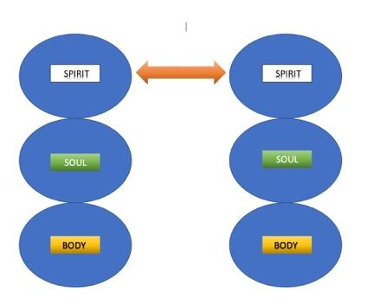

We can only have fellowship with one another “In Christ Jesus” by approaching Him and each other “in the Spirit”

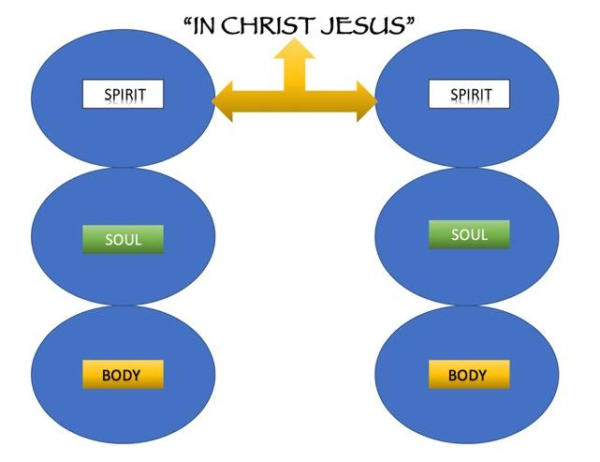
AND…

We can only be “fitted together, into a holy temple in the Lord, and built together for a dwelling place of God” in the Spirit. (Eph. 2:21-22)

- As the Body of Christ
- As the Temple of the Holy Spirit
- As the Church…
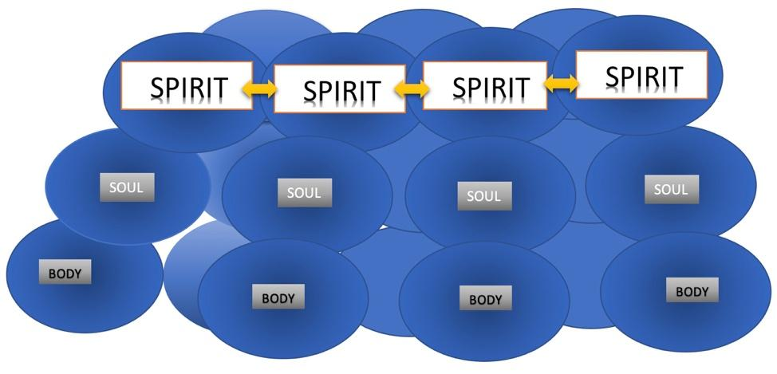

This is what Eph 4:3 calls the “unity of the Spirit”.

How do we do this when we are all so different?

Can we have different styles, methods, preferences and opinions?

Yes, but inasmuch as you are able, build strong relationships with each other that are not based upon the;

BODY - Physical likes and tastes.
SOUL – Mental and Emotional connections

Build you relationships upon the SPIRIT

- The Word of God
- Prayer
- Worship
- Pursuing God’s Will
- Fulfilling God’s Mission
- Loving One Another (Agape - sacrificial)

This will create the kind of deep fellowship, and impenetrable unity that is necessary for us to be built together as the dwelling place of God’s Spirit.

Eph 4:2-4 “Be completely humble and gentle; be patient, bearing with one another in love. ³ Make every effort to keep the unity of the Spirit through the bond of peace. ⁴ There is one body and one Spirit”

In my life I have had many of these relationships, they are built on spiritual connection not superficial commonalities, and because of that they last through the years.
They are usually the first I call, or hear from in times of calamity or trouble. They always pick-up right where they left off and immediately connect on spiritual matters.

We may not have much in common anymore except the unity of the Spirit, but that’s all we need.

I’m asking you to build those kinds of relationships, cultivate them in your life and pursue them, in church.

It’s the only way we can experience being the temple of the God’s spirit and enjoying unity of the spirit and the bonds of peace.
# # #

