R Giglio 4/22/21
Part 2 of two-part series “In Christ”

Part 1:

2nd Cor. 5:17 “If anyone is in Christ, he is a new creation; old things have passed away; behold, all things have become new.”

What does it mean to be “In Christ”?

- In Christ – we are a new creation
- In Christ - “old things have passed away”
- In Christ - “all things have become new”?

- Does it mean that we now just try to stop sinning?

- Does it mean that now we just adopt a new worldview?

- Does it mean that now we just start calling ourselves “Christians”, and identify with a new community or people instead of our old one? (reading different books, listening to different music, attending different events…)

What does it mean to be a “New Creation?”

In our last series “Soul or the Spirit” we read through Ephesians and looked at how Paul tells them to “put off your old self”.

Eph. 4:21-22
²¹ when you heard about Christ and were taught in him in accordance with the truth that is in Jesus. ²² You were taught, with regard to your former way of life, to put off your old self”.

Sanctification – “The process of becoming more and more like Jesus”

1st John 3:2 “Dear friends, now we are children of God, and what we will be has not yet been made known. But we know that when Christ appears, we shall be like him”

- As we continue to grow in the things of the Spirit we “put to death the things of the flesh”, and become more and more alive in the spirit.

Rom 8:13 “For if you live according to the flesh, you will die; but if by the Spirit you put to death the misdeeds of the body, you will live.”

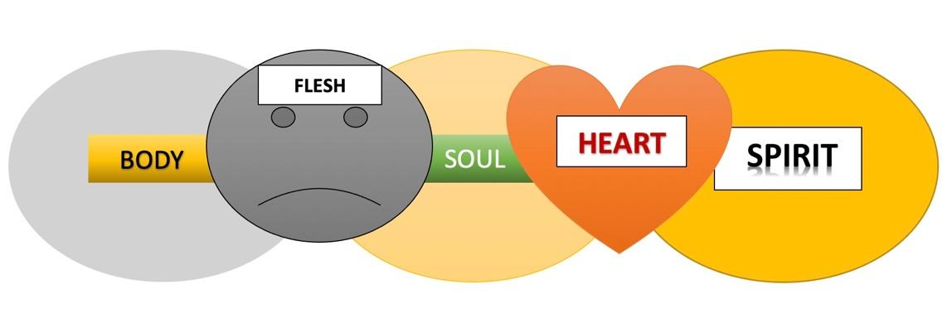

.

As we walk in Sanctification, our body and flesh become less important,
and our Hearts and our Spirits become more important,
because that is who we are “In Christ”.

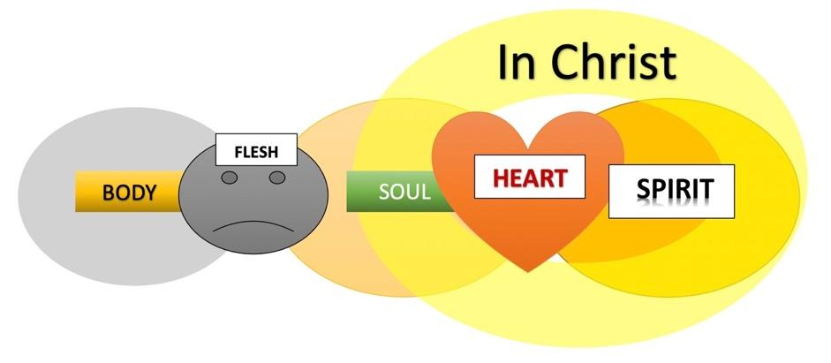

What does it mean to be “in Christ”?
The New Testament phrase; “in Christ” or “in Christ Jesus” simply refers to those who have asked God to forgive their sins and have declared their decision to believe upon and follow Jesus with their life.

Put simply, “All believers” are “in Christ.”
- In Christ (covered by the blood of Christ) , we are spiritually alive.
Romans 6:11 “In the same way, count yourselves dead to sin but alive to God in Christ Jesus”

- In Christ we have eternal life despite deserving death for our sins.
Romans 6:23 – “For the wages of sin is death, but the gift of God is eternal life in Christ Jesus our Lord.”

- In Christ we stand before God righteous, holy, and redeemed.
1 Corinthians 1:30 – “It is because of him that you are in Christ Jesus, who has become for us wisdom from God—that is, our righteousness, holiness and redemption.”

If we are “in Christ” it means:
- (We received the eternal free gift of grace)

2nd Timothy 1:9 “⁹ He has saved us and called us to a holy life—not because of anything we have done but because of his own purpose and grace. This grace was given us in Christ Jesus before the beginning of time,

- (We are children of God)

Galatians 3:26 “ So in Christ Jesus you are all children of God through faith”

- (Nothing can separate us from His love)

Romans 8:38–39 “I am sure that neither death nor life, nor angels nor rulers, nor things present nor things to come, nor powers, nor height nor depth, nor anything else in all creation, will be able to separate us from the love of God in Christ Jesus our Lord.”

Paul REALLY wanted his churches to know what it means to be “IN CHRIST”:
(I do too)
Col. 2:2-16
² My goal is that they may be encouraged in heart and united in love, so that they may have the full riches of complete understanding, in order that they may know the mystery of God, namely, Christ, ³ in whom are hidden all the treasures of wisdom and knowledge. ⁴ I tell you this so that no one may deceive you by fine-sounding arguments. ⁵ For though I am absent from you in body, I am present with you in spirit and delight to see how disciplined you are and how firm your faith in Christ is.
⁶ So then, just as you received Christ Jesus as Lord, continue to live your lives in him, ⁷ rooted and built up in him, strengthened in the faith as you were taught, and overflowing with thankfulness.
⁸ See to it that no one takes you captive through hollow and deceptive philosophy, which depends on human tradition and the elemental spiritual forces of this world rather than on Christ.
⁹ For in Christ all the fullness of the Deity lives in bodily form, ¹⁰ and in Christ you have been brought to fullness. He is the head over every power and authority. ¹¹ In him you were also circumcised with a circumcision not performed by human hands. Your whole self-ruled by the flesh was put off when you were circumcised by Christ, ¹² having been buried with him in baptism, in which you were also raised with him through your faith in the working of God, who raised him from the dead.
¹³ When you were dead in your sins and in the uncircumcision of your flesh, God made you alive with Christ. He forgave us all our sins, ¹⁴ having canceled the charge of our legal indebtedness, which stood against us and condemned us; he has taken it away, nailing it to the cross. ¹⁵ And having disarmed the powers and authorities, he made a public spectacle of them, triumphing over them by the cross.
¹⁶ Therefore do not let anyone judge you…
In Christ – Charges against us are cancelled, and that which condemned us was nailed to the cross! (verse 14)
And the powers and authorities that condemn us were made a public spectacle, when Jesus triumphed over them by the cross (verse 15)
Jesus did all that, but it is our victory to share because we are “In Christ”!

Therefore, let no one judge you!
- Romans 8:1-2 “There is therefore now no condemnation to those who are in Christ Jesus, who do not walk according to the flesh, but according to the Spirit

“IN CHRIST there is No Condemnation”
What does that mean?
It does not just mean condemned by the law.
It means that there are spiritual powers and other people, that want to charge us and condemn us as well, but they are made powerless because of the cross.
Rev. 12:10 “For the accuser of our brothers and sisters, who accuses them before our God day and night, has been hurled down.”

There is so much accusation, condemnation and judgment going on these days, and most of it is, at best, misdirected.
Is it Justice? or is it Judging?
Inviting a “friend of a friend” to church – “Ok, we’ll come and judge you, because that’s what we do, isn’t it?” ??? [facetious] 😐

What is known as the “Justice Generation” is rooted in an awareness of injustices that take place in the world (persecution, slavery, political oppression, starvation and discrimination). They have a passion to make a difference in the world, ->
just as almost every other generation did as well (anti-war, ecology, animal rights, no nukes, occupy Wall Street, etc.), but their focus is to right the wrongs of those who are experiencing injustice and those that perpetrate it.
“Justice” is an excellent focus and a commendable cause, however…
When it gets hijacked by deception, pride, humanism and a rebellious spirit, it can quickly turn from Justice to false Judgement!
(b.k.a. “The Judgement Generation”?) a.k.a. “Cancel Culture”
They decide if what you have to say is acceptable or not, and are quick to silence your voice and remove you from any place of influence if they determine that “in their judgement”, you violate their laws of social justice.
No one belongs in that position of power except GOD.
James 4:12 “There is only one Lawgiver and Judge, the one who is able to save and destroy. But you—who are you to judge your neighbor?”
Blog: “Don’t give them the gavel, they are not your judge!”

The world is not your judge. Don’t put them in that position in your life.

It’s not good for you, and it’s not even good for them!

When we allow people to define righteousness by;
“Doing/Saying the right things”, or not “Doing/Saying the wrong things”, we put them right back into a system of legalism that the Bible speaks vociferously against.

It is not by works that we are made righteous, it’s only by admitting that you are a sinner in the eyes of God, and can’t do anything to save yourself, so you receive the free gift of salvation through the blood of Jesus in humility and meekness.

That goes for everyone.

Sometimes I hear comments or read articles that imply that somehow our goal is to appeal to our worldly friends and family with mutual causes, so that they will affirm and accept us, and then when we impress them enough they will come to faith.

In other words, we let them judge the; words, actions and behaviors of the church in hopes that they will find us acceptable in their eyes, so that they’ll repent and turn to Jesus.

It doesn’t work. Jesus did not do that, and neither did the disciples.

But didn’t Paul say; “I have become all things to all men, that I might by all means save some.” In 1 Cor. 9?

Yes, but he was talking about those who are weak or under the law, it did not mean embracing worldly ideals in order to save some.

It’s tempting, because we want people in culture to like us.
There are causes that we share, even with unbelievers; wonderful, nobles causes, and it feels good to find common ground on things like; feeding the hungry, helping the needy, and speaking out against oppression.
Sometimes you will please them by what you do and say, and you’ll get praise and a pat on the back.

However…,
Other times they will judge you harshly and you will be despised, rejected and maligned. Especially when they find out that you believe what the Bible says about things like; abortion, Human sexuality and the reality of Hell for those who don’t believe in Jesus (Just to name a few),

You will never be fully-accepted by those whose value system is contrary to the Word of God, if you are, you are probably doing something wrong.

Remember; Neither acceptance nor rejection is your goal.

Your goal, and purpose is to please God and do His will. That includes doing the very thing Jesus and the disciples did more than anything else, “preach the gospel of the kingdom of God.”

And in fact, this is everyone’s purpose as well, including unbelievers. Whether they know it or not, …and many are failing miserably.

Our primary hope and prayer is that many others will come into a relationship with Jesus, so that they can be “In Christ” just as we are.

God is the only judge, and when God judges, He does so based on one criterion:

Who IS, and who ISN’T - IN CHRIST.

His will is that all people would be set free from the law of sin and death, and pass from condemnation to eternal life just as we have. But that can only be done “In Christ”.

ROMANS 8:1-2 “There is therefore now no condemnation to those who are in Christ Jesus, who do not walk according to the flesh, but according to the Spirit. ² For the law of the Spirit of life in Christ Jesus has made [us] free from the law of sin and death.”

So what should we do…? Answer: “Abide in Christ” (Jn. 15:4)

How do we do it…? (simple:)

Phil 4:6-7
“Don’t worry about anything;
instead, pray about everything.
Tell God what you need, and thank him for all he has done.
Then you will experience God’s peace,
which exceeds anything we can understand.
His peace will guard your hearts and minds
as you live in Christ”.

