IN CHRIST

2nd Cor. 5:16-17
¹⁷ “If anyone is in Christ, he is a new creation; old things have passed away; behold, all things have become new.

What does it mean to be “In Christ”?

- In Christ – we are a new creation
- In Christ - “old things have passed away”
- In Christ - “all things have become new”?

- Does it mean that we now just try to stop sinning?

- Does it mean that now we just adopt a new worldview?

- Does it mean that now we just start calling ourselves “Christians”, and identify with a new community or people instead of our old one? (reading different books, listening to different music, attending different events…)

What does it mean to be a “New Creation?”

In our last series “Soul or the Spirit” we read through Ephesians and looked at how Paul tells them to “put off your old self”.

Eph. 4:17-22 ^{17 “}So I tell you this, and insist on it in the Lord, that you must no longer live as the Gentiles do, in the futility of their thinking. ¹⁸ They are darkened in their understanding and separated from the life of God because of the ignorance that is in them due to the hardening of their hearts. …
²⁰ That, however, is not the way of life you learned ²¹ when you heard about Christ and were taught in him in accordance with the truth that is in Jesus. ²² You were taught, with regard to your former way of life, to put off your old self”.

Strangely, he is speaking to “Gentiles”, and telling them not to live as the “Gentiles” do.
He is asking them to forsake, and put off their “cultural Identity” and take on a “new identity in Christ”.

He is reminding them, just as he reminded the Corinthians, that they are “New Creations” In Christ.
That they should no longer identify themselves as what they were, but by who they are ”In Christ” (v. 21)
Does that mean that Paul no longer identified as a “Jew from Tarsus”, “a Roman citizen”?
No, he claimed it boldly while he was under arrest in Jerusalem;

Acts 21:39 Paul replied, “I am a Jew, from Tarsus in Cilicia, a citizen of no obscure city. (that makes him a Roman citizen)

Does that mean that he no longer recognized people by their nationality or ethnic distinctions?

No, in fact the letters themselves are addressed people and churches from specific cities, regions and nationalities;
Churches: Ephesians, Galatians, Corinthians, Colossians, etc.
People: A “Roman Centurion”, a “Philippian Jailor” an “Ethiopian Eunuch”, etc.

So then what does it mean to;
“put off your old self”? (Eph. 4:22)

It means forsaking your identity in the flesh. Paul explains it clearly in Philippians 3;

Phil. 3:4-5 “If someone else thinks they have reasons to put confidence in the flesh, I have more:
⁵ circumcised on the eighth day,
of the people of Israel,
of the tribe of Benjamin,
a Hebrew of Hebrews;
in regard to the law, a Pharisee”
Paul highlights his;
Nationality, Ethnicity, Religion, Culture, Education, Position and Status, things he was formerly very proud of.
However, now he goes on to say this in the next verses…
Phil. 3:7-9 ^{7 “}But whatever were gains to me I now consider loss for the sake of Christ. ⁸ What is more, I consider everything a loss because of the surpassing worth of knowing Christ Jesus my Lord, for whose sake I have lost all things. I consider them garbage, that I may gain Christ ⁹ and be found in him, not having a righteousness of my own that comes from the law, but that which is through faith “in Christ”.

Paul shows us who he was and who he is becoming, “In Christ”!

This is what we call “Sanctification”

Sanctification – “The process of becoming more and more like Jesus”

1st John 3:2 “Dear friends, now we are children of God, and what we will be has not yet been made known. But we know that when Christ appears, we shall be like him”

[ Process of putting off our old self, and becoming more like Jesus! ]

- Before we are saved, our Spirit has not been “made alive”. (Eph 2:5)

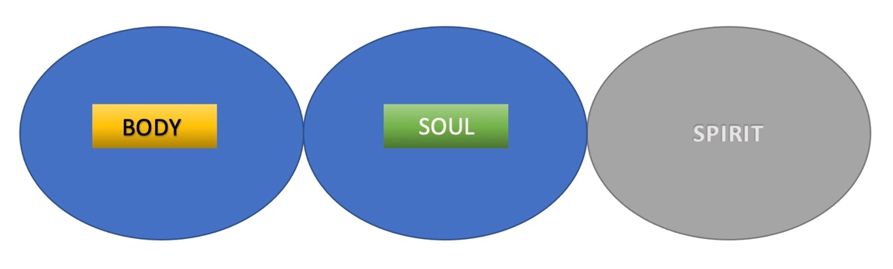

- Once we believe in our hearts and our saved, the struggle between the spirit and flesh continues in the area or our “Soul” (mind/spirit)
Gal. 5:17 “For the flesh desires what is contrary to the Spirit, and the Spirit what is contrary to the flesh. They are in conflict with each other.”

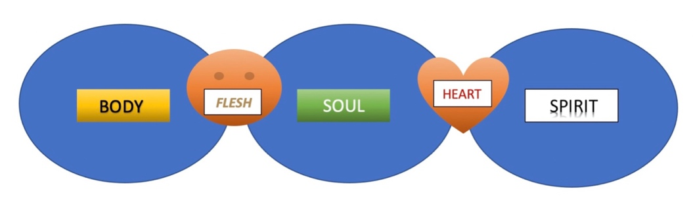

- As we continue to grow in the things of the Spirit we “put to death the things of the flesh, and become more and more alive in the spirit.

Rom 8:13 “For if you live according to the flesh, you will die; but if by the Spirit you put to death the misdeeds of the body, you will live.”

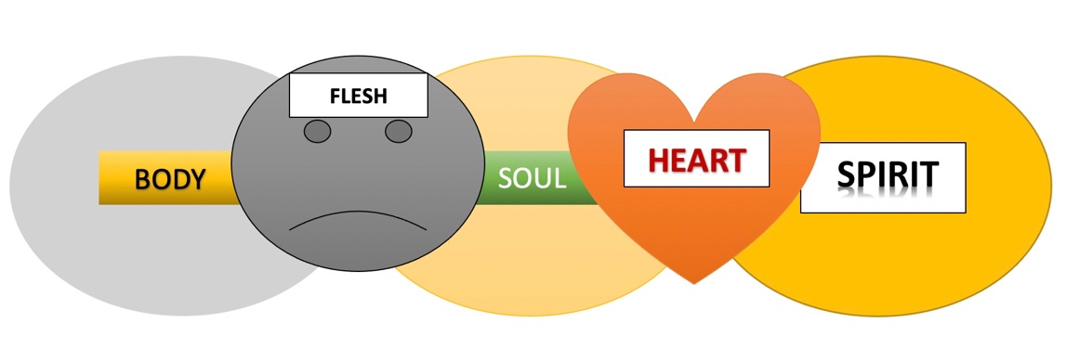

As we walk in Sanctification, our body and flesh become less important, and our Hearts and our Spirits become more important, because that is who we are “In Christ”.
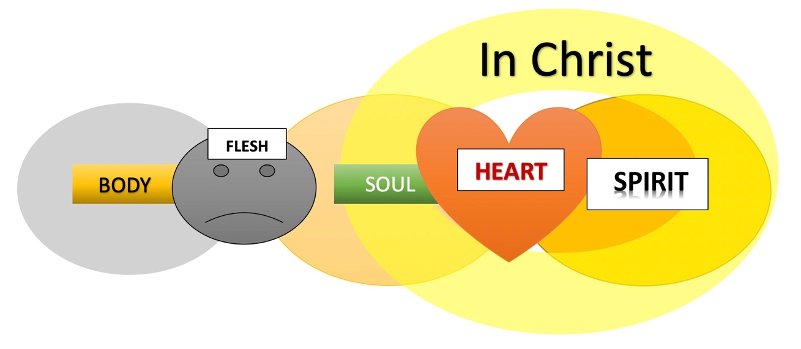

What about our bodies?

Question: "Will we have physical bodies in Heaven?"
Answer: Although the Bible tells us little detail about what it will be like in heaven, it seems that we will most likely have a physical body, although not the same type of “physical body” that we have now.

Phil 3:21 “Jesus Christ, ²¹ who, by the power that enables him to bring everything under his control, will transform our lowly bodies so that they will be like his glorious body.”

First Cor 15 also says that Jesus is "the first fruits" of those who have died. This means that He set the example and leads the way.

1st Cor. 15:42 “⁴² So will it be with the resurrection of the dead. The body that is sown is perishable, it is raised imperishable;

Perhaps we can expect that our resurrected bodies will be like Jesus’ was after the tomb. (Walked through walls, disappeared and appeared from place to place. But still able to touch, be touched and most of all EAT!)
The Bible is not specific, so it remains a mystery, but it does say – “we shall be like Him”.

Matt 22:30 “At the resurrection people will neither marry nor be given in marriage; they will be like the angels in heaven.” (so apparently no weddings and procreation).

The most important thing to remember is that God is Spirit!
He is seeking those who will worship Him in Spirit and in truth.

Jesus first revealed this to the Woman at the Well in John 4

John 4:4-30 “ ⁴ Now he had to go through Samaria. ⁵ So he came to a town in Samaria called Sychar, near the plot of ground Jacob had given to his son Joseph. ⁶ Jacob’s well was there, and Jesus, tired as he was from the journey, sat down by the well. It was about noon.
⁷ When a Samaritan woman came to draw water, Jesus said to her, “Will you give me a drink?” ⁸ (His disciples had gone into the town to buy food.)
⁹ The Samaritan woman said to him, “You are a Jew and I am a Samaritan woman. How can you ask me for a drink?” (For Jews do not associate with Samaritans.)
¹⁰ Jesus answered her, “If you knew the gift of God and who it is that asks you for a drink, you would have asked him and he would have given you living water.”
¹¹ “Sir,” the woman said, “you have nothing to draw with and the well is deep. Where can you get this living water? ¹² Are you greater than our father Jacob, who gave us the well and drank from it himself, as did also his sons and his livestock?”
¹³ Jesus answered, “Everyone who drinks this water will be thirsty again, ¹⁴ but whoever drinks the water I give them will never thirst. Indeed, the water I give them will become in them a spring of water welling up to eternal life.”
¹⁵ The woman said to him, “Sir, give me this water so that I won’t get thirsty and have to keep coming here to draw water.”
¹⁶ He told her, “Go, call your husband and come back.”
¹⁷ “I have no husband,” she replied.
Jesus said to her, “You are right when you say you have no husband. ¹⁸ The fact is, you have had five husbands, and the man you now have is not your husband. What you have just said is quite true.”
¹⁹ “Sir,” the woman said, “I can see that you are a prophet. ²⁰ Our ancestors worshiped on this mountain, but you Jews claim that the place where we must worship is in Jerusalem.”
²¹ “Woman,” Jesus replied, “believe me, a time is coming when you will worship the Father neither on this mountain nor in Jerusalem. ²² You Samaritans worship what you do not know; we worship what we do know, for salvation is from the Jews. ²³ Yet a time is coming and has now come when the true worshipers will worship the Father in the Spirit and in truth, for they are the kind of worshipers the Father seeks. ²⁴ God is spirit, and his worshipers must worship in the Spirit and in truth.”
²⁵ The woman said, “I know that Messiah” (called Christ) “is coming. When he comes, he will explain everything to us.”
²⁶ Then Jesus declared, “I, the one speaking to you—I am he.”
²⁷ Just then his disciples returned and were surprised to find him talking with a woman. But no one asked, “What do you want?” or “Why are you talking with her?”
²⁸ Then, leaving her water jar, the woman went back to the town and said to the people, ²⁹ “Come, see a man who told me everything I ever did. Could this be the Messiah?” ³⁰ They came out of the town and made their way toward him.”

Jesus, was kind and compassionate to this troubled woman.
And while recognizing that they were culturally different,
He did NOT focus on that.
He did not get into a heavy debate about the difference in their beliefs.
He chose not to address prejudice, social injustice or economic inequality between their two ethnic groups.
Why?
Was he callous? Insensitive? Not-Caring? NO!
What he did was far more important.
He offered her the “Living Water” of eternal life and…
invited her to worship God with Him,
Not in the body, not in the flesh not even in the soul…But in Spirit and Truth.

Because of this, many Samaritans believed

John 4:39-41 “³⁹ Many of the Samaritans from that town believed in him because of the woman’s testimony, “He told me everything I ever did.” ⁴⁰ So when the Samaritans came to him, they urged him to stay with them, and he stayed two days. ⁴¹ And because of his words many more became believers.”

IN CHRIST

Gal. 3:26-28 “So in Christ Jesus you are all children of God through faith, ²⁷ for all of you who were baptized into Christ have clothed yourselves with Christ. ²⁸ There is neither Jew nor Gentile, neither slave nor free, nor is there male and female, for you are all one in Christ Jesus.”

“clothed yourselves with Christ” – no longer identified by your outward distinctives, but by Christ within you

Jew nor Gentile, - (Ethnicity) This does not mean they never referred to people as Jews or Gentiles anymore, they did. It means that in Jesus, those things do not matter. ALL are equally given access to the Father. Our ethnicity and race, while it stills exists, and is important to our background, should not be part of our identity of who we are in Christ.

neither slave nor free, (Socio-Economic) This does not mean that everyone is the same socio-economically, It means we are not to value or identify anyone according to that status, only who they are in Christ.

nor is there male and female (Gender) This is NOT a call towards gender-neutrality, only that men and women, while different physically, we are the same spiritually, and equal in Christ.

“In Christ”, we see beyond race, ethnicity, socio-economic status and gender. We see people as God sees them.

1 Sam 16:7 “The LORD does not look at the things people look at. People look at the outward appearance, but the LORD looks at the heart."

This is how we are to look at others, the way God looks at us!

We need to be EXAMPLES TO THE WORLD on how to do that.

“No longer a “worldly” point of view”

2 Cor 5:16-17 “16 So from now on we regard no one from a worldly point of view. Though we once regarded Christ in this way, we do so no longer. 17 Therefore, if anyone is in Christ, the new creation has come: The old has gone, the new is here!”

“from now on we regard no one from a worldly point of view”

Not by Ethnicity, Culture, Accent, skin color, Nationality, Background
Socio-economic status or anything else.

If anyone is in Christ, let us first and foremost regard them as that, “In Christ”

If they are not In Christ, then our first and foremost concern, hope and prayer
is that someday they would be.

Just like Jesus did, Let’s focus on that above anything else.

