Faithful Regardless
A study of 1st Samuel – week 1
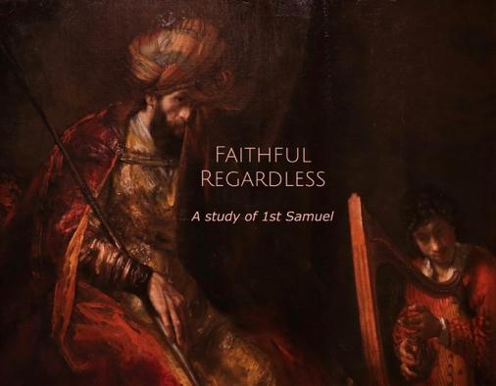
I selected 1st Samuel because it is filled with wonderful relatable narratives during a time when the people of God were in transition from the rule by Judges to the rule by Kings and struggling to know what it is to stay faithful to God in these times, (similar to the times we live.)
But why, in these modern times, perhaps even last days, would we be studying an Old Testament book of stories of people who lived 3000 years ago, and not another epistle, end-times prophecy or an apocalyptic book?
Because the word of God is as applicable today, as it was when it was first written.
Also the New Testament exhorts us to read and learn from the Old testament.
1 Cor. 10:11 “Now these things happened to them as an example, but they were written down for our instruction, on whom the end of the ages has come.”

Romans 15:4 “Such things were written in the Scriptures long ago to teach us. And the Scriptures give us hope and encouragement as we wait patiently for God’s promises to be fulfilled.
Throughout the book of Samuel we see outstanding examples of men and women who are willing to be Faithful to God, regardless of the circumstances they faced. We also see the consequences of those who do not.
From the willingness of Hannah, to the dedication of Samuel, the rise and fall of King Saul to the dramatic humility and faithfulness of Young David who becomes King toward the end of the book.
Even though this is an Old Testament book written about events that took place over three thousand years ago, there are incredible lessons for us as a church and also as individual believers in these days.
We will look at the importance and rewards of staying Faithful to God Regardless of Circumstances.
At one point in 1st Samuel, we will see Saul appointed as the 1st King of Israel and rise to power and prominence. He repeatedly disobeys the Lord however, and loses his anointing. His mind is troubled and he grows increasingly paranoid, jealous and insane. He eventually is overcome with evil and later in the book is intent on only one thing, “to kill David”.
Before all that however, unbeknownst to Saul, the Lord chose David as a young shepherd boy, to be king. Saul was tormented by an evil spirit and the only thing that could relieve him of his suffering is when young David played music for him on his harp. (1st Samuel 16)
[Show and Explain the painting: Rembrandt’s “Saul and David” 1655]
Rembrandt captured that moment in this painting. Saul in his tormented decline, David in his humble ascent.
- See the deep forlorn look in Saul’s eyes, perhaps even wiping his tears with the curtain.
- The humble quiet pondering in David’s eyes.
- Saul’s face is pensive and troubled, yet his hand has become relaxed upon his staff, not clutched tightly as the music plays.
- David’s hands are skillfully playing, though his mind is elsewhere, perhaps in prayer.
- (think about what the music must have been like…)
- David gives us a perfect example of being FAITHFUL to God REGARDLESS of the circumstances he faced.
This is the theme that we will study in 1st Samuel.
..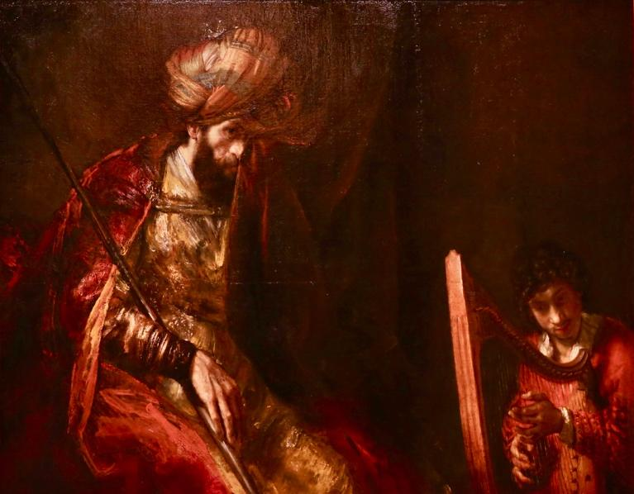…(show painting as I describe it)
BACKGROUND OF THE BOOK OF 1st SAMUEL:
Samuel lived at the end of the period of the judges and ushered in the period of kingship. He was Israel’s last judge and first prophet, after Moses. He functioned as a priest and was a great man of faith.
The books of 1st and 2nd Samuel were originally one book called “Samuel”.
Later when they became part of the Septuagint (the Standard Greek Old Testament) they were changed to 1st and 2nd Kingdoms, followed by 3rd and 4th Kingdoms (1st and 2nd Kings). The book titles that we know today originated around 1517.
The events in 1st Samuel take place between the years 1100BC and 1000BC, beginning with the birth of Samuel and ending with the death of Saul.
Samuel was born in response to his mother Hannah’s prayers. She would travel annually with her husband Elkanah from Ramah to the Shiloh sanctuary where the Tabernacle of the Lord stood. While at the sanctuary, Hannah, who was barren, prayed for a son and promised him to God for full-time service.
God answered the prayer, and Samuel was born. When Samuel was a small child, Hannah gave him to the Lord to serve in the sanctuary with Eli, the high priest.
Main Characters of Chapter one:
Elkanah - husband of Hannah (“God Has Acquired” - El-qana)
Hannah – Barren wife (“Favor – Grace”)
Eli – Priest at the Tabernacle (“My God”)
Samuel – (Shmuel) Baby who becomes both Judge and Prophet of Israel (“God has heard”)

*NOTE: This week we will read the entire chapter, in the coming weeks, please read the next chapter beforehand, and we will focus on one section, chapter-by-chapter as we move through 1st Samuel in our series “Faithful Regardless”)

1st Samuel 1:1-28
There was a certain man from Ramathaim, a Zuphite from the hill country of Ephraim, whose name was Elkanah son of Jeroham, the son of Elihu, the son of Tohu, the son of Zuph, an Ephraimite. ² He had two wives; one was called Hannah and the other Peninnah. Peninnah had children, but Hannah had none.
³ Year after year this man went up from his town to worship and sacrifice to the Lord Almighty at Shiloh, where Hophni and Phinehas, the two sons of Eli, were priests of the Lord. ⁴ Whenever the day came for Elkanah to sacrifice, he would give portions of the meat to his wife Peninnah and to all her sons and daughters. ⁵ But to Hannah he gave a double portion because he loved her, and the Lord had closed her womb. ⁶ Because the Lord had closed Hannah’s womb, her rival kept provoking her in order to irritate her.
[Having children was consider the highest honor for women in those days. Those who could not conceive felt unvalued and in some cases cursed]
⁷ This went on year after year. Whenever Hannah went up to the house of the Lord, her rival provoked her till she wept and would not eat. ⁸ Her husband Elkanah would say to her, “Hannah, why are you weeping? Why don’t you eat? Why are you downhearted? Don’t I mean more to you than ten sons?”
⁹ Once when they had finished eating and drinking in Shiloh, Hannah stood up. Now Eli the priest was sitting on his chair by the doorpost of the Lord’s house. ¹⁰ In her deep anguish Hannah prayed to the Lord, weeping bitterly. ¹¹ And she made a vow, saying, “Lord Almighty, if you will only look on your servant’s misery and remember me, and not forget your servant but give her a son, then I will give him to the Lord for all the days of his life, and no razor will ever be used on his head.”
¹² As she kept on praying to the Lord, Eli observed her mouth. ¹³ Hannah was praying in her heart, and her lips were moving but her voice was not heard. Eli thought she was drunk ¹⁴ and said to her, “How long are you going to stay drunk? Put away your wine.”
¹⁵ “Not so, my lord,” Hannah replied, “I am a woman who is deeply troubled. I have not been drinking wine or beer; I was pouring out my soul to the Lord. ¹⁶ Do not take your servant for a wicked woman; I have been praying here out of my great anguish and grief.”
¹⁷ Eli answered, “Go in peace, and may the God of Israel grant you what you have asked of him.”
¹⁸ She said, “May your servant find favor in your eyes.” Then she went her way and ate something, and her face was no longer downcast.
¹⁹ Early the next morning they arose and worshiped before the Lord and then went back to their home at Ramah. Elkanah knew his wife Hannah, and the Lord remembered her. ²⁰ So in the course of time Hannah became pregnant and gave birth to a son. She named him Samuel, saying, “Because I asked the Lord for him.”
(Samuel - “God has heard”)

Hannah Dedicates Samuel
²¹ When her husband Elkanah went up with all his family to offer the annual sacrifice to the Lord and to fulfill his vow, ²² Hannah did not go. She said to her husband, “After the boy is weaned, I will take him and present him before the Lord, and he will live there always.”
²³ “Do what seems best to you,” her husband Elkanah told her. “Stay here until you have weaned him; only may the Lord make good his word.” So the woman stayed at home and nursed her son until she had weaned him.
²⁴ After he was weaned, she took the boy with her, young as he was, along with a three-year-old bull, an ephah of flour and a skin of wine, and brought him to the house of the Lord at Shiloh. ²⁵ When the bull had been sacrificed, they brought the boy to Eli, ²⁶ and she said to him, “Pardon me, my lord. As surely as you live, I am the woman who stood here beside you praying to the Lord. ²⁷ I prayed for this child, and the Lord has granted me what I asked of him. ²⁸ So now I give him to the Lord. For his whole life he will be given over to the Lord.” And he worshiped the Lord there.
This is an amazing example of someone giving their “all” to God. Her most treasured, cherished, precious and long-awaited “possession”, her son.
Hannah gave Samuel to the Lord (her only begotten son),
She didn’t keep Samuel and wait for another to give to the Lord. She did not change her mind or forget her vow to God.
This is also what God asked Abraham to do in Gen. 22
Gen 22:2 “Then God said, “Take your son, your only son, whom you love—Isaac—and go to the region of Moriah. Sacrifice him”

[Note: first occurrence of the word “Love” in the Bible]
God did not intend for Abraham to sacrifice Isaac, He only wanted to see if he would be willing. It was clearly a test.
God did not expect either of them to do something that He himself would not be willing to do;
John 3:16 “For God so loved the world that he gave his one and only Son, that whoever believes in him shall not perish but have eternal life.”
Because Jesus was given, MANY did not perish and now have eternal life.
In Abraham’s case, there were rewards for his willingness,
Gen 22:16-17 “I swear by myself, declares the Lord, that because you have done this and have not withheld your son, your only son, ¹⁷ I will surely bless you and make your descendants as numerous as the stars in the sky and as the sand on the seashore.
Abraham became the Father of a Great nation, because he was “Faithful Regardless.”

Hannah passed her test, and was rewarded as well; She was faithful regardless.
Faithful to God, regardless of her circumstances. (believing despite her barrenness)
Faithful to her promise, regardless of the fact that it would cost her the most precious thing in her life, (her only son)
Faithful to her other commitments as well , regardless of the fact that she was offering her son. (she not only gave her son, but also the other proper offerings as well)
“v.24 After he was weaned, she took the boy with her, young as he was, along with a three-year-old bull, an ephah of flour and a skin of wine, and brought him to the house of the Lord at Shiloh.”
Sometimes we feel that if we give the Lord one part of our life, we don’t need to give him the rest.
If we give our money, we don’t need to give our time (or vice-versa).
If we give him devotion (prayer and worship), we don’t need to give him service (works)
Or we wait until He blesses us financially, with talent or with resources, then afterwards we will respond by giving to him, but not before.
Hannah did not wait until she had two or more children to give God one of them. She gave her one and only son, along with her other offerings, and God blessed her for it.

What if she hadn’t? Would God have raised up someone else?
Probably, but Hannah’s life would not have been blessed. She would have not impacted history as she has, and she and her son would have probably been forgotten and insignificant.
Instead, because of her obedience, she and her son became a pinnacle part of what God has done on the earth and through history.
They are integral to the story of God and His people, and are directly responsible for bringing about King David, and therefore played a part in bringing the Messiah.
Did the Lord reward Hannah for her incredible act of obedience and faithfulness?

Yes He did!

1 Sam. 2:21 And the LORD was gracious to Hannah; she gave birth to three sons and two daughters. Meanwhile, the boy Samuel grew up in the presence of the LORD.
She was rewarded with more children. “God has Heard” (Shmuel) her prayer and blessed her abundantly for her obedience and faithfulness.

This speaks to all of us.
Are we willing to give God “everything”, our career, our money, our time, our resources, even our children???
The only way to experience God’s full blessing and reward in our lives is if we do.
There is nothing better for you (AND your children) than to experience everything that God has in store. The only way to find that, is to Give your life to Him.
Matt 16:24 “Then Jesus said to his disciples, “Whoever wants to be my disciple must deny themselves and take up their cross and follow me. ²⁵ For whoever wants to save their life^{[f]} will lose it, but whoever loses their life for me will find it.”
Some people wonder why they are not experiencing God’s blessings in their life. It’s possible that you are not trusting God to manage areas of your life, and are telling Him that you can do it without Him. Only you know the truth.

Jesus said in the Sermon on the Mount;
Matt 6:33 “seek first the kingdom of God and His righteousness, and all these things shall be added to you.”

If you want to experience the best life that God has for you, your children and your lasting legacy, you need to give your “all” to God.

My prayer is that you receive all that God has for you in your life.
…and that you discover and receive the rewards and blessings of being Faithful to God, Regardless of anything you face.

If you find it difficult, Ask Him to help you, and He will.

