Faithful Regardless
“Bringing Peace”
Saul had failed as King, disobeyed the Lord and was rejected by God. He was given several chances to show himself Faithful, yet did not succeed.
Samuel loved Saul, but was bitterly disappointed in him, and grieved that he had failed as king.
1st Samuel 15:35 “Until the day Samuel died, he did not go to see Saul again, though Samuel mourned for him. And the Lord regretted that he had made Saul king over Israel.”
A very sad ending to this relationship.
Samuel mourned for Saul even though he would not see him.
It was clear that Saul would never become the leader that Israel needed as their King, and that God had already selected someone else who would take his place
The judgement upon him from chapter 13 still stood, and he would be replaced by someone else. Now God is about to raise up another man to take his place, just as had been prophesied.
1st Samuel 13:14 “But now your kingdom will not endure; the Lord has sought out a man after his own heart and appointed him ruler of his people, because you have not kept the Lord’s command.”
That “man after God’s own heart”, is DAVID
David (Heb. “Dod”- “beloved”)
As chapter 16 begins, Samuel is still mourning for Saul, when God asks him to get up and go find the “man after His own heart”.

1st Samuel 16:1-23 “The Lord said to Samuel, “How long will you mourn for Saul, since I have rejected him as king over Israel? Fill your horn with oil and be on your way; I am sending you to Jesse of Bethlehem. I have chosen one of his sons to be king.”
² But Samuel said, “How can I go? If Saul hears about it, he will kill me.”
The Lord said, “Take a heifer with you and say, ‘I have come to sacrifice to the Lord.’ ³ Invite Jesse to the sacrifice, and I will show you what to do. You are to anoint for me the one I indicate.”
⁴ Samuel did what the Lord said. When he arrived at Bethlehem, the elders of the town trembled when they met him. They asked, “Do you come in peace?”
⁵ Samuel replied, “Yes, in peace; I have come to sacrifice to the Lord. Consecrate yourselves and come to the sacrifice with me.” Then he consecrated Jesse and his sons and invited them to the sacrifice.
⁶ When they arrived, Samuel saw Eliab and thought, “Surely the Lord’s anointed stands here before the Lord.”
⁷ But the Lord said to Samuel, “Do not consider his appearance or his height, for I have rejected him. The Lord does not look at the things people look at. People look at the outward appearance, but the Lord looks at the heart.”
[pause]
⁸ Then Jesse called Abinadab and had him pass in front of Samuel. But Samuel said, “The Lord has not chosen this one either.” ⁹ Jesse then had Shammah pass by, but Samuel said, “Nor has the Lord chosen this one.” ¹⁰ Jesse had seven of his sons pass before Samuel, but Samuel said to him, “The Lord has not chosen these.” ¹¹ So he asked Jesse, “Are these all the sons you have?”
“There is still the youngest,” Jesse answered. “He is tending the sheep.”
Samuel said, “Send for him; we will not sit down until he arrives.”
¹² So he sent for him and had him brought in. He was glowing with health and had a fine appearance and handsome features.
Then the Lord said, “Rise and anoint him; this is the one.
¹³ So Samuel took the horn of oil and anointed him in the presence of his brothers, and from that day on the Spirit of the Lord came powerfully upon David. Samuel then went to Ramah.
David was “Chosen” by God before he knew it and even before Samuel met him.
Samuel reviewed each of Jesse’s older sons, some looked very promising, but they were not the one.
In this process, God told us something about Himself that is very important in helping us understand Him.

1 Sam 16:7 “The LORD does not look at the things people look at. People look at the outward appearance, but the LORD looks at the heart."

This is an inside view at how God sees people. Not by outward appearances, but by the condition of the heart. This is also an example of how we are to look at one another, not the way people see us, but the way God sees us!
If we want to put an end to things like racism, discrimination, bigotry and prejudice, we need to commit to seeing ourselves and other people as God sees us, not how society defines us. (i.e. skin-color, ethnicity, culture, background, socio-economic status etc.).

We need to be the ones to set an example of how to see people from a Godly point of view, not a worldly point of view:

2nd Cor 5:16 “So from now on we regard no one from a worldly point of view.”

Gal. 3:28 “There is neither Jew nor Gentile, neither slave nor free, nor is there male and female, for you are all one in Christ Jesus.”

Our outward appearance is superficial, God looks at our hearts.

David was selected by God and anointed by Samuel, because God saw, that he was a man after his own heart.
Even though he was anointed by Samuel, he was not yet appointed as King of Judah or Israel, where he reigned for 40 years (age 30-70).
2nd Samuel 5:4-5 “David was thirty years old when he began to reign, and he reigned for forty years. ⁵At Hebron he reigned over Judah for seven years and six months; and at Jerusalem he reigned over all Israel and Judah for thirty-three years.”

He is considered Israel’s greatest King, even though he was not the first.
The Kingdom of Israel has long been called the “Throne of David”
Jesus was called “Son of David” 17 times in the New Testament.
Because Jesus is the promised Messiah, which means He had to be of the lineage of David. Jesus is a descendant of David both by adoption through Joseph and by blood through Mary.
The title “Son of David” is more than a statement of physical genealogy. It is a Messianic title. When people referred to Jesus as the Son of David, they meant that He was the long-awaited Messiah, the fulfillment of the Old Testament prophecies.

Note:
He was “anointed” before “appointed”.

David was anointed by Samuel but still waited about 15 years before he became king (ages 15-30). In that time he acted very “kingly”, even before he had the title. He was a brave and faithful shepherd, fighting off lions and bears as when they attacked his sheep. He was a skillful, prudent man of valor, BEFORE he was king. He even became Israel’s champion defeating Goliath, before he had a title of the position of king.

This is a glimpse at how God often raises up leaders. He anoints them with specific giftings and sets them in motion. Many men and women operate for years in a special calling or anointing even before they are ever given an official title, role or position.

I’ve learned that the best way to identify leaders in a church or organization is to find those whose gifts are already apparent, and often times already leading, then if it is appropriate, offer them a role or position that describes their gifting.

David, still a teenager was well on his way to becoming Israel’s greatest king. But what about Saul?

¹⁴ Now the Spirit of the Lord had departed from Saul, and an evil spirit from (allowed by) the Lord tormented him.
¹⁵ Saul’s attendants said to him, “See, an evil spirit from God is tormenting you. ¹⁶ Let our lord command his servants here to search for someone who can play the lyre. He will play when the evil spirit from God comes on you, and you will feel better.”
¹⁷ So Saul said to his attendants, “Find someone who plays well and bring him to me.”
¹⁸ One of the servants answered, “I have seen a son of Jesse of Bethlehem who knows how to play the lyre. He is a brave man and a warrior. He speaks well and is a fine-looking man. And the Lord is with him.”
¹⁹ Then Saul sent messengers to Jesse and said, “Send me your son David, who is with the sheep.” ²⁰ So Jesse took a donkey loaded with bread, a skin of wine and a young goat and sent them with his son David to Saul.
²¹ David came to Saul and entered his service. Saul liked him very much, and David became one of his armor-bearers. ²² Then Saul sent word to Jesse, saying, “Allow David to remain in my service, for I am pleased with him.”
²³ Whenever the spirit from God came on Saul, David would take up his lyre and play. Then relief would come to Saul; he would feel better, and the evil spirit would leave him.”
[Show and Explain the painting: Rembrandt’s “Saul and David” 1655]
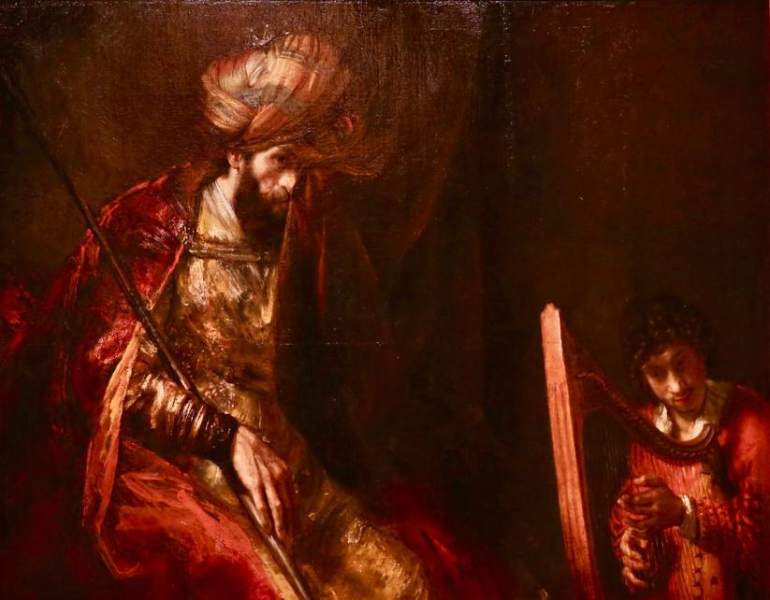

…show painting while I explain it.

Rembrandt captured that moment in this painting. Saul in his tormented decline, David in his humble ascent.
- See the deep forlorn look in Saul’s eyes, perhaps even wiping his tears with the curtain.
- The humble quiet pondering in David’s eyes.
- Saul’s face is pensive and troubled, yet his hand has become relaxed upon his staff, not clutched tightly as the music plays.
- David’s hands are skillfully playing, though his mind is elsewhere, perhaps meditating upon the Lord.
- (think about what the music must have been like…)

1st Sam 16:23 “And it came to pass, when the evil spirit from God was upon Saul, that David took a harp, and played with his hand: so Saul was refreshed, and was well, and the evil spirit departed from him.”

David was filled with the Spirit of God,
v. 13 “and from that day on the Spirit of the Lord came powerfully upon David.”
Saul was not,
v. 14 “Now the Spirit of the Lord had departed from Saul.”

Saul was spiritually tormented void of the Spirit of the Lord,
David was filled with the Spirit of the Lord and was therefore able to minister to Saul.

It was not just the music, although David played skillfully.
It was the Spirit of the Lord upon him that brought peace, comfort and God’s presence into a dark and tormented environment.

David’s music somehow conveyed the Spirit of the Lord within him and it was just what Saul’s troubled soul needed.
Saul would soon welcome David into his home as his own son, but would then turn on him as he becomes overcome with jealousy toward David. Eventually he becomes so insane with jealously and paranoia, that he spends his patter years trying to kill David.

But in this moment there is peace. Not only because of David’s skill, nor even the music itself, but because The Spirit of the Lord within David was ministering to Saul, from who the Spirit of the Lord had departed.

David was faithful to serve God and allow the Spirit of the Lord within him, to bring peace to Saul, regardless of whether or not he deserved it or even recognized it.

In the times that WE live, we need to be Faithful to be ministers of God’s peace to those who are languishing in trouble and torment around us, Regardless of whether or not they recognize or even acknowledge it.

Each of us who believe and call upon the Lord, have the Spirit of the Lord within us. (Eph 1:13)

We are surrounded by people in the world whose minds are set on things of the flesh, as a result they are void of peace. WE have the same Spirit of the Lord that David had and because of that we have life and peace.

Romans 8:6 “The mind governed by the flesh is death, but the mind governed by the Spirit is life and peace.”

We have the unique privilege of being those who bring peace to every situation and person we come in contact with, including those who don’t acknowledge the Lord.

The spirit of the Lord within us can light up any dark room simply by the fruit of the spirit coming forth from us wherever we go.

What is the fruit of the spirit?
love, joy, peace, patience, kindness, goodness, faithfulness, gentleness, and self-control (Gal. 5:22-23)

These are things that this troubled world desperately needs and they can only come from the spirit of the Lord, in those who love by the Spirit.

Unfortunately, sometimes we are adding to the trouble by arguing over issues and condemning those we disagree with.

In these dark and divisive times, let’s not be agitators, pot-stirrers, or troublemakers
Let’s be the “Peacemakers” that Jesus told us would be blessed.

And let’s allow the peace of God to flow from us to those who desperately need it through our; words, our actions, our attitudes, our behavior, our countenance and even our music (the way God used David) if He chooses to use it that way again.
(don’t you wish you could play a harp and cause people’s troubles to go away? In a way, you can.

What about YOUR peace?

In order to offer peace you have to have peace.

How do you get it, by keeping your mind on the Spirit of the Lord.

Isa. 26:3 “You will keep him in perfect peace,
Whose mind is stayed on You”

His peace is different than the peace the world talks about,

QUOTE: “Without Jesus NO PEACE, With Jesus KNOW PEACE!”

John 14:27 “Peace I leave with you; my peace I give you. I do not give to you as the world gives. Do not let your hearts be troubled and do not be afraid.”

Closing:

At times we all can become anxious and fearful and lose our peace, but let’s never forget,
The same spirit of peace that comforted Saul can comfort you, don’t be anxious and afraid, instead be thankful and prayerful and allow his peace to wash over your minds and hearts.

Phil 4:6-7 “Do not be anxious about anything, but in every situation, by prayer and petition, with thanksgiving, present your requests to God. ⁷ And the peace of God, which transcends all understanding, will guard your hearts and your minds in Christ Jesus.

