BEING THE CHURCH
“Who we are”
A Study of 1st Corinthians

__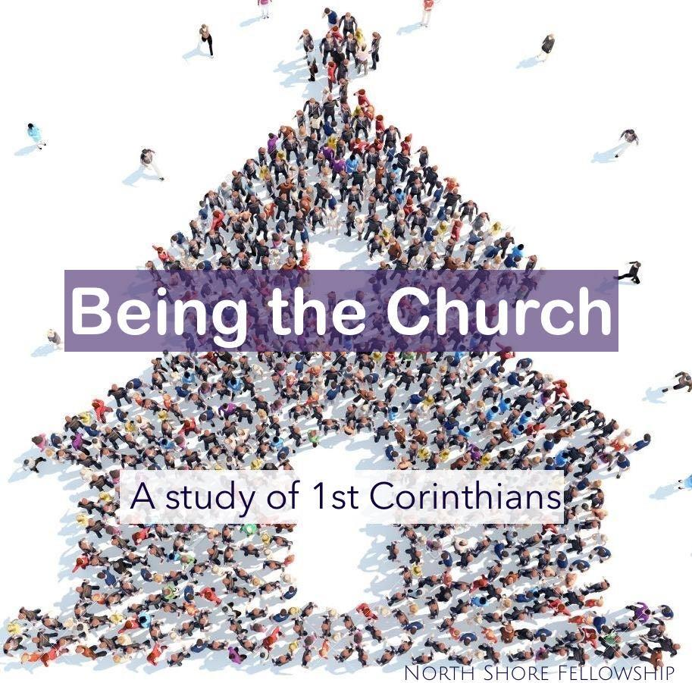__

This is a letter to “The Church”
Paul wrote the letter somewhere around 53-55AD while he was in Ephesus.
The letter is to “the Church” in Corinth addressing some of the divisive issues reported to him by someone named Chloe (1st Corinthians 1:11), and in response to a letter they had sent to him (1st Corinthians 7:1), and also for clarification of a previous letter that he had written to them (1st Corinthians 5:9) which makes 1st Corinthians NOT the first letter Paul ever wrote to this church, but the first one to be widely circulated and considered authoritative beyond its initial Corinthian context.

It’s important for us to make clear as we start a study on “Being the Church”, that we know what “the church” really is.
Many people identify the church as a building. This is not a biblical understanding of the church. The word “church” is a translation of the Greek word ekklesia, which is defined as “an assembly” or “called-out ones.”

1st Corinthians 1:1-2 “Paul, called to be an apostle of Christ Jesus by the will of God, and our brother Sosthenes,
2 To the church of God in Corinth, to those sanctified in Christ Jesus and called to be his holy people, together with all those everywhere who call on the name of our Lord Jesus Christ—their Lord and ours…”

Acts 18 gives an account of Paul’s time in Corinth where he planted the church about 49AD. He and the synagogue leader, Sosthenes experienced intense persecution there. He also met Aquila and Priscilla, who had just gotten kicked out of Rome, who became some of his closest friends, whom he lived and worked for.

Acts 18:1 After “these things” Paul departed from Athens and went to Corinth…

(What things? Acts 16 – he met Timothy in Lystra, He and Silas were miraculously freed from jail in Philippi and the jailor became saved.
Acts 17 – He planted churches in Thessalonica and Berea, then went to Athens and reasoned with the Greek philosophers at the Areopagus, explaining to them who the “Unknown God” is.)

Acts 18:1 After these things Paul departed from Athens and went to Corinth.
2 And he found a certain Jew named Aquila, born in Pontus, who had recently come from Italy with his wife Priscilla (because Claudius had commanded all the Jews to depart from Rome); and he came to them.
3 So, because he was of the same trade, he stayed with them and worked; for by occupation they were tentmakers.
4 And he reasoned in the synagogue every Sabbath, and persuaded both Jews and Greeks.
>>>
11 And he continued there a year and six months, teaching the word of God among them.

Corinth
Corinth was strategically located on the Peloponnesian Peninsula right at the isthmus (3 x 10 miles, now has a canal) that connects southern and northern Greece. It served as a good stopping point between Rome and the East. Because of this geography, Corinth was a major center of commerce and trade. This vitally important city was intellectually proud, materially affluent, and morally corrupt.

__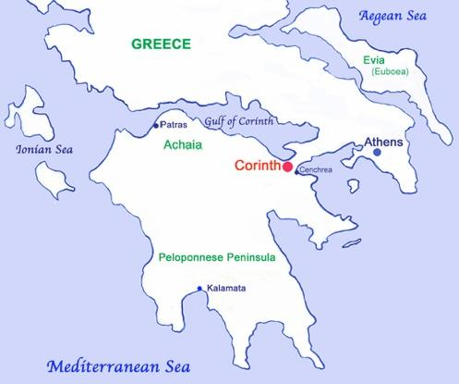__

If we zoom out a little, we can see where it is in relation to Italy, Israel and the New Testament churches.

__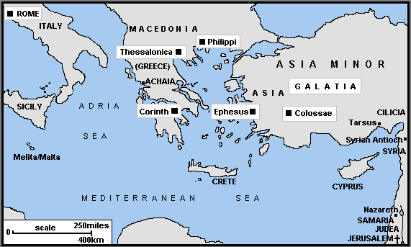__

The Main Themes of 1 Corinthians is not just how to “do church”, or “behave in the church”, but how to “Be the Church”.
Paul is writing to a young church in a hostile environment that is encountering many problems such as division, quarreling, sexual immorality, lawsuits, spiritual gifts, the Lord’s Supper and worship order, theological issues such as the resurrection and freedom in Christ, as well as issues married and single members were facing. The unifying element of this letter is instructing the church in what it means to live as Christians in a non-Christian world, ultimately bringing them to the idea that love itself is the primary driver and conclusion of how to live out our faith and BE the Church.

1st Corinthians 1:1-31 “Paul, called to be an apostle of Christ Jesus by the will of God, and our brother Sosthenes,
² To the church of God in Corinth, to those sanctified in Christ Jesus and called to be his holy people, together with all those everywhere who call on the name of our Lord Jesus Christ—their Lord and ours:
³ Grace and peace to you from God our Father and the Lord Jesus Christ.
⁴ I always thank my God for you because of his grace given you in Christ Jesus. ⁵ For in him you have been enriched in every way—with all kinds of speech and with all knowledge— ⁶ God thus confirming our testimony about Christ among you. ⁷ Therefore you do not lack any spiritual gift as you eagerly wait for our Lord Jesus Christ to be revealed. ⁸ He will also keep you firm to the end, so that you will be blameless on the day of our Lord Jesus Christ. ⁹ God is faithful, who has called you into fellowship with his Son, Jesus Christ our Lord.

In spite of the reputation they had for evil and tolerating evil, Paul begins his letter with very encouraging and affirming words;
“5 For in him you have been enriched in every way—with all kinds of speech and with all knowledge— ⁶ God thus confirming our testimony about Christ among you”
&
“7Therefore you do not lack any spiritual gift as you eagerly wait for our Lord Jesus Christ to be revealed. ⁸ He will also keep you firm to the end, so that you will be blameless on the day of our Lord Jesus Christ.

I have heard some teachers refer to this section as Paul being sarcastic or disingenuous, but I do not believe he would have written these things falsely. I believe that throughout the whole book, he encouraged the things that deserved encouragement, and brought strong correction to the things that needed correction.

He then addresses “Division in the church”
¹⁰ I appeal to you, brothers and sisters, in the name of our Lord Jesus Christ, that all of you agree with one another in what you say and that there be no divisions among you, but that you be perfectly united in mind and thought.
¹¹ My brothers and sisters, some from Chloe’s household have informed me that there are quarrels among you. ¹² What I mean is this: One of you says, “I follow Paul”; another, “I follow Apollos”; another, “I follow Cephas”; still another, “I follow Christ.”
¹³ Is Christ divided? Was Paul crucified for you? Were you baptized in the name of Paul? ¹⁴ I thank God that I did not baptize any of you except Crispus and Gaius, ¹⁵ so no one can say that you were baptized in my name. ¹⁶ (Yes, I also baptized the household of Stephanas; beyond that, I don’t remember if I baptized anyone else.) ¹⁷ For Christ did not send me to baptize, but to preach the gospel—not with wisdom and eloquence, lest the cross of Christ be emptied of its power.

Paul is addressing celebrity-ism even in the early church. All those he listed were wise and godly men (Apollos, Cephas (Peter), Himself,) but he makes clear that we are not follow people, we are to follow Christ Jesus.
It’s important for us to be very careful that we do not become followers of people; Authors, Teachers, Pastors, Preachers, Prophets, Politicians, Celebrities etc, but that we follow Jesus.

( I am very leery of people who are too overly taken with certain leaders and teachers. I personally have no particular teachers, authors, or any influencers that I follow closely (unless I am in a personal relationship with them and personally know them and their character very well).
There is no one person whom I; read all their books, listen to regularly or encourage others to follow, except Jesus. (That includes authors whom I have great respect for; AW Tozer, CS Lewis, AB Simpson etc.)
Not that there aren’t excellent books, resources and teachers out there, there are, but nothing compares to the power of the Holy Spirit breathing life into the Word of God as I read the Bible. That’s where I go to first and most.

Most importantly we need to remain “One in Christ” and any teacher that causes division or speaks things that intentionally create disunity, is not acting in the spirit of God.
Paul was appealing to them (and to us) “¹⁰ I appeal to you, brothers and sisters, in the name of our Lord Jesus Christ, that all of you agree with one another in what you say and that there be no divisions among you, but that you be perfectly united in mind and thought.”

Foolishness & Wisdom “in the World”, versus “In God”
¹⁸ For the message of the cross is foolishness to those who are perishing, but to us who are being saved it is the power of God. ¹⁹ For it is written:
“I will destroy the wisdom of the wise;
the intelligence of the intelligent I will frustrate.”
²⁰ Where is the wise person? Where is the teacher of the law? Where is the philosopher of this age? Has not God made foolish the wisdom of the world? ²¹ For since in the wisdom of God the world through its wisdom did not know him, God was pleased through the foolishness of what was preached to save those who believe. ²² Jews demand signs and Greeks look for wisdom, ²³ but we preach Christ crucified: a stumbling block to Jews and foolishness to Gentiles, ²⁴ but to those whom God has called, both Jews and Greeks, Christ the power of God and the wisdom of God. ²⁵ For the foolishness of God is wiser than human wisdom, and the weakness of God is stronger than human strength.
The world is very impressed with Power, Strength, Ability, Intellect, Influence, Affluence, degrees, titles, fame and all the things that make people proud and boastful. God is not impressed and neither should we be, in fact He calls them foolish. Our priorities, values and measurable success is so different than the world’s that they would call them foolish.
Don’t be naïve and fall for the lies, that those who reject the Lordship of Jesus but are considered intelligent or educated by the world are somehow wiser and stronger than you are in God. “For the foolishness of God is wiser than human wisdom, and the weakness of God is stronger than human strength.”

The things of the world are very “different” than the things of God and therefore very different from the things of the church. The things that are considered wise, intelligent and strong by worldly standards are consider foolish and weak to God and vice versa.

²⁶ Brothers and sisters, think of what you were when you were called.
(Remember, “Church” means “called out ones”
…Not many of you were wise by human standards; not many were influential; not many were of noble birth. ²⁷ But God chose the foolish things of the world to shame the wise; God chose the weak things of the world to shame the strong. ²⁸ God chose the lowly things of this world and the despised things—and the things that are not—to nullify the things that are, ²⁹ so that no one may boast before him. ³⁰ It is because of him that you are in Christ Jesus, who has become for us wisdom from God—that is, our righteousness, holiness and redemption. ³¹ Therefore, as it is written: “Let the one who boasts boast in the Lord.” <end>
This chapter does not need much explanation, in fact Paul does an excellent job teaching in it and it’s almost redundant to do a teaching on a teaching.
In this last section He actually does a thorough job exegeting Jeremiah 9:23-24 which
says,
Jeremiah 9:23-24 “Thus says the LORD: ‘Let not the wise man boast in his wisdom, let not the mighty man boast in his might, let not the rich man boast in his riches, but let him who boasts boast in this, that he understands and knows me, that I am the LORD who practices steadfast love, justice, and righteousness in the earth. For in these things I delight,’ declares the LORD.”
True boasting in the Lord is actually boasting of the Lord—boasting of His great attributes, boasting of what He has done for us, of what He is still doing and of what He has promised to do.

This is completely opposite in boasting of Human wisdom, intelligence, strength or ability. In fact it’s a very humble form of boasting which basically declares what Jesus meant when he said;

John 15:5 “If you remain in me and I in you, you will bear much fruit; apart from me you can do nothing.”

Being the Church
As we do with all scripture, we receive this unto ourselves, in this case our church.
The letter began;
Verse 2 “To the church of God in Corinth, to those sanctified in Christ Jesus and called to be his holy people,”

“To the church (those called out of the world) of God in Corinth (New Jersey?), to those sanctified in Christ Jesus (set apart from the world) and called to be his holy people, (called out, dedicated, consecrated, special people).

Let’s never forget who we are as “The Church”.
Being the Church is not what we do, it’s who we are!
The world will look upon us with worldly wisdom and judge us on their standards and values, which are usually much different, and often opposite of God’s standards and values.

In fact, you sometimes hear people make the statement “That’s the church, BEING THE CHURCH” when we do something, or respond to something that in their opinion is commendable or noteworthy.
But it’s usually something that conforms to human ideas, not necessarily God’s wisdom.

The church “Being the Church” (Ekklesia) happens when people are “called out” of the world to gather as the body of Christ, to seek Him, Live for Him, be His People and declare His Praises.

Jesus loves the church. In fact Paul instructs husbands to love their wives as Jesus loves the church in Eph 5. In Revelation 19 & 21 the church us depicted as the bride of Christ at the Marriage supper of the Lamb.

Jesus loves us! (the church).
Not because of what we do, how we perform, or even how we behave. He loves us because of who we are…

My wife is my wife, NOT because of what she does for me,
but because of “who she is” TO me.
We are the church, Not because of what we “do for Him”,
but because of “who we are” TO Him.

So to understand what “Being the Church” means, we need to fully understand who we are,

Our Final Verse comes not from Paul, but from Peter:

1st Peter 2:9 “But you are a chosen people, a royal priesthood, a holy nation, God’s special possession, that you may declare the praises of him who called you out of darkness into his wonderful light.”

As we pursue what it means to “Be the Church”
- Let’s Be the chosen people,
- Let’s Be the royal priesthood,
- Let’s Be God’s special possession,
- And let’s declare the praises of him who “called us out” of darkness into his wonderful light.”

