BEING THE CHURCH
“God’s Power not Human Wisdom”
A Study of 1st Corinthians

__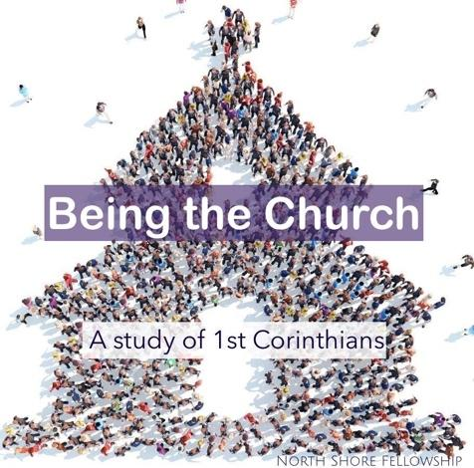__

This is a letter to “The Church”
Paul wrote the letter somewhere around 53-55AD while he was in Ephesus.
The letter is to “the Church” in Corinth addressing some of the divisive issues reported to him by someone named Chloe (1st Corinthians 1:11), and in response to a letter they had sent to him (1st Corinthians 7:1), and also for clarification of a previous letter that he had written to them (1st Corinthians 5:9) which makes 1st Corinthians NOT the first letter Paul ever wrote to this church, but the first one to be widely circulated and considered authoritative beyond its initial Corinthian context.

It’s important for us to make clear as we start a study on “Being the Church”, that we know what “the church” really is.
Many people identify the church as a building. This is not a biblical understanding of the church.

The word “church” is a translation of the Greek word ekklesia, which is defined as “an assembly” or “called-out ones.”

“called out of darkness into His Marvelous light” (1st Peter 2:9)

We are not a building, not an institution, We are his Bride and our local church is just one tiny facet of the Body of Christ worldwide known as “The Church”.
1st Corinthians 2:1-5 “And so it was with me, brothers and sisters. When I came to you, I did not come with eloquence or human wisdom as I proclaimed to you the testimony about God. ² For I resolved to know nothing while I was with you except Jesus Christ and him crucified. ³ I came to you in weakness with great fear and trembling. ⁴ My message and my preaching were not with wise and persuasive words, but with a demonstration of the Spirit’s power, ⁵ so that your faith might not rest on human wisdom, but on God’s power.”

It's important to know that Paul, was an Apostle, the founder of the church in Corinth (along with about 14-20 others), writer of about 25% of the New Testament and the most educated, articulate and accomplished of all the apostles, however He is saying here that nothing he’s done, learned or accomplished amounts to anything without the power of the Holy Spirit.
His education and Hebrew pedigree was unmatched, yet he considered them rubbish compared to what had been revealed to Him through the power and revelation of Jesus Christ.

- Philippians 3:4-8 “If anyone else thinks he may have confidence in the flesh, I more so: circumcised the eighth day, of the stock of Israel, of the tribe of Benjamin, a Hebrew of the Hebrews; concerning the law, a Pharisee; concerning zeal, persecuting the church; concerning the righteousness which is in the law, blameless. But what things were gain to me, these I have counted loss for Christ. Yet indeed I also count all things loss for the excellence of the knowledge of Christ Jesus my Lord, for whom I have suffered the loss of all things, and count them as rubbish.”

- Galatians 1:14 “I advanced in Judaism beyond many of my contemporaries in my own nation, being more exceedingly zealous for the traditions of my fathers.”

- Galatians 1:11-12 “I make known to you, brethren, that the gospel which was preached by me is not according to man. For I neither received it from man, nor was I taught it, but it came through the revelation of Jesus Christ.”

Why was he saying all this? Shouldn’t he have been trying to exude confidence and impress them with his knowledge, pedigree, advanced degrees and gift of excellence in articulation?

This message was not just about him, but is an exhortation to the church about themselves (and through the Word, now to us as well).

We must make sure we don’t ever allow our faith to “rest on human wisdom, but on God’s power.”

[ My friend and mentor Dr. David Schroeder – in an Author, Scholar, past President of multiple Christian Colleges, has several seminary and university degrees and was at one time an Alliance Pastor.

However most of his books and teachings are about NOT relying on human wisdom but on the power of the Holy Spirit. He, like Paul is the first to admit that anything he speaks that is of worth, is not from him but through the Living Word of God by the power of the Holy Spirit.
He wrote a book called “Walking in Your Anointing” that changed my life. It taught me how to rely fully on the Holy Spirit’s gifting in me and not rely on any human wisdom and institutional knowledge in place of God’s power.

He developed a teaching seminar on this subject and asked me to co-teach it with him. I was thrilled, and began studying everything I could about the subject in preparation for the seminar.

He warned me however to not rely too heavily on my own knowledge and preparation but to be lead and directed purely by the Holy Spirit as I taught and presented the material. (Which is especially important when teaching about being led by the Holy Spirit).

In other words; do not “rest on human wisdom, but rely on God’s power.” ]

This doesn’t mean college degrees, seminary, training seminars and further education are wrong, they are not. My studies have served me well in certain situations…

However,
If I came to you each Sunday regurgitating facts and information from a conference, classroom or textbooks and NOT in the power of the Holy Spirit, as He freshly reveals things to me through the Word of God each week, very little would come from my teaching and it would consequently affect the health of this church.

[My latest online course at Harvard Divinity School is called – “Judaism through its Scriptures”. If I read to you from one of the textbooks, or played one of the lectures for you, it might put you all to sleep” : ), (I only study there because of their vast historical offerings on ancient manuscripts.)

Nothing I offer in the form of knowledge or information has any spiritual value unless it’s breathed by the Ruach HaKodesh (Holy Spirit).

That goes for each of us as well, regardless of whatever “platform” we speak from in our lives.

Our best bet, and wisest hope is that we would be like Paul who just told us;

“My message and my preaching were not with wise and persuasive words, but with a demonstration of the Spirit’s power.”

Paul continues the chapter talking about God’s Wisdom Revealed by the Spirit;
1st Corinthians 2:6-10 We do, however, speak a message of wisdom among the mature, but not the wisdom of this age or of the rulers of this age, who are coming to nothing. ⁷ No, we declare God’s wisdom, a mystery that has been hidden and that God destined for our glory before time began. ⁸ None of the rulers of this age understood it, for if they had, they would not have crucified the Lord of glory. ⁹ However, as it is written:
“What no eye has seen, what no ear has heard,
and what no human mind has conceived”— the things God has prepared for those who love him— ¹⁰ these are the things God has revealed to us by his Spirit. (Isa.64:5 & 65:17)

This is such a beautiful scripture for the church. Paul is saying that we are given wisdom, in the form of a hidden mystery that God destined for our glory before time began.
He’s talking about the message of Jesus fulfilling the ancient prophecies and the Holy Spirit pouring out power and wisdom on those who believe.
No one had ever seen it, heard of it or imagined it before, and now God is revealing it to the church through His Spirit.
1st Corinthians 2:10- 16 “The Spirit searches all things, even the deep things of God. ¹¹ For who knows a person’s thoughts except their own spirit within them? In the same way no one knows the thoughts of God except the Spirit of God. ¹² What we have received is not the spirit of the world, but the Spirit who is from God, so that we may understand what God has freely given us. ¹³ This is what we speak, not in words taught us by human wisdom but in words taught by the Spirit, explaining spiritual realities with Spirit-taught words. ¹⁴ The person without the Spirit does not accept the things that come from the Spirit of God but considers them foolishness, and cannot understand them because they are discerned only through the Spirit. ¹⁵ The person with the Spirit makes judgments about all things, but such a person is not subject to merely human judgments,
¹⁶ for, “Who has known the mind of the Lord so as to instruct him?” But we have the mind of Christ.”
In the modern world it seems like everyone has a platform to share their messages. Whatever it is they feel that they have to say, there are many avenues to get a message out to the world; Social Media, Blogs, Tweets, YouTube videos, etc.

Most of the messages out there are meaningless rants or self-serving propaganda. Some are interesting and educational however, and some even have useful value (like the D.I.Y. YouTube instructional videos). [refrigerator repair] : )

Among the cacophony of messages out there, are a lot of messages for and by the church; teachings about God and His Word, video sermons, internet Preaching and teaching and (my least favorite) open letters to the church.

My personal observation is that most of these messages come from the SOUL, not the SPIRIT.

The SOUL is a person’s mind and emotions. What they think, what they feel, ideas they came up with, things they are passionate about, mind-ticklers, heart-stirrers, etc.

Paul is telling us that these things are meaningless to the church unless they are breathed by the Spirit of God.

In 1st Cor. 1, Paul asked “²⁰ Where is the wise person? Where is the teacher of the law? Where is the philosopher of this age? Has not God made foolish the wisdom of the world?

In this chapter he continues this concept by saying; “the wisdom of the world is foolish to those who walk in the spirit, and the wisdom of the Spirit is foolishness to those who walk according to the flesh” (soul).

^{“14} The person without the Spirit does not accept the things that come from the Spirit of God but considers them foolishness, and cannot understand them because they are discerned only through the Spirit.”

Being the Church

To BE the church that God wants us to be, It’s VERY important that we as a church do not rely on our own intellect, talent, abilities and Human wisdom to pursue the things of the Spirit.
Jesus told us:
John 4:24 “God is spirit, and his worshipers must worship in the Spirit and in truth.”

We must fully rely on the Spirit of God in everything we do in the church. That may be extra difficult if you happen to be exceptionally smart, talented, influential or resourceful. It can be a constant temptation to get involved in something of the spirit, maybe even start out in the spirit but somewhere along the line, and continue it through the flesh.

Paul was very direct with the Galatian church in warning them against this;

Gal 3:1,3 “You foolish Galatians! Who has bewitched you? …³ Are you so foolish? After beginning by means of the Spirit, are you now trying to finish by means of the flesh?”

The church is a spiritual entity, not a building or human institution.
We can’t build it or even fully participate in it simply by means of the flesh.

What is “The Flesh”?

(Remember our “Soul and Spirit” teaching?)

The flesh is the part of the Soul that pulls your attention and devotion away from the things of the spirit, to gratify the body, not the spirit.

It is concerned with; comfort, pleasure, material security, etc.

_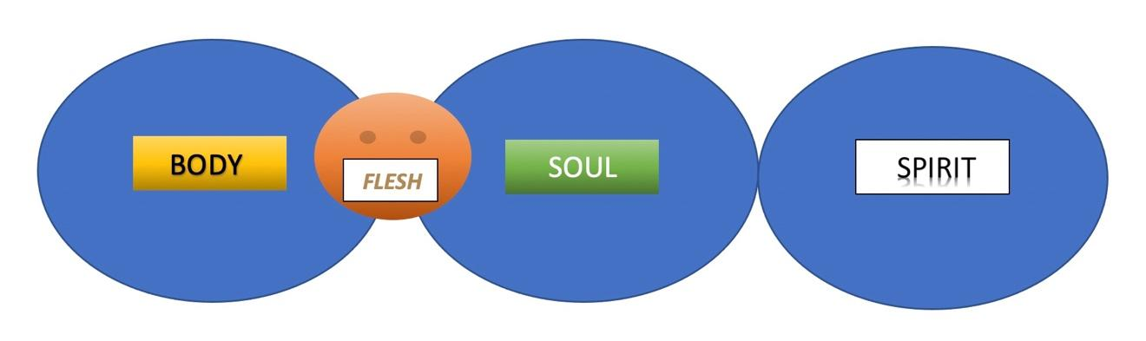_
The flesh has wants to keep us from moving out of our comfort zone.

The Spirit, however, wants to please and commune with God, whatever it takes. The most gratifying experience for those who live by the Spirit is when His Spirit is fully communing with our spirit.

Romans 8:15-16 “by him we cry, “Abba, Father.”
[because,] “The Spirit himself testifies with our spirit that we are God’s children.”

Earlier in this chapter Paul describes the difference between those who live according to the Spirit versus those who live according to the flesh. He talks about what it means to have our minds (souls) set on either the spirit or flesh, and what happens when our mid is governed by the flesh, versus the mind that is governed by the Spirit.”

Romans 8:5 “Those who live according to the flesh have their minds set on what the flesh desires; but those who live in accordance with the Spirit have their minds set on what the Spirit desires. ⁶ The mind governed by the flesh is death, but the mind governed by the Spirit is life and peace.”

Close:

Maybe you’re not sure if you are being driven by the spirit or the flesh. You desire to do the right thing, but sometimes not sure if it’s your own thoughts or God’s Spirit that you are acting in or responding to.

All of us encounter this problem. Sometimes we actually want to respond to the Spirit and find ourselves reverting to things of the flesh.

Jesus observed this in the Apostles when he asked them to stay awake and pray with Him in the Garden of Gethsemane;
“ The spirit is willing, but the flesh is weak.” - Matt 26:41

The best way to know is to check the fruit.

Remember, “The mind governed by the flesh is death, but the mind governed by the Spirit is life and peace”

The mind governed by the flesh will result in things like; strife, division, stress and lack of joy.

The mind governed by the Spirit has the markings of the fruit of the spirit in it and all around it;
love, joy, peace, patience, kindness, goodness, faithfulness, gentleness and self-control.

Let’s commit to Being The Church that does its best to operate in the spirit of God, not in the works of the flesh.
Let’s cultivate and maintain an environment where the Spirit not only leads and empowers us,
but also permeates the environment with the fruit of the spirit (love, peace, joy, etc.) which is not only essential to us in being the church,
but irresistible to those who need to Become part of the church!

