LOVE OTHER CHRISTIANS

Last Week: we finished the book of 1st Corinthians and memorized the verse;
1st Corinthians 16:14 “Do everything in love.”
Paul told the Corinthians that love is more important than spiritual gifts, ministry skills, more important than talents, more important than miracles, more important than social-justice & charities, even more important than martyrdom.
In fact Jesus tells us that the way people will know if we are truly His disciples is not by our doctrine, not by our words, not by our church affiliation or even by our spiritual gifts.
It is by our love. Not just random love for anyone anywhere, but first and foremost by our love for one another.
John 13:34 “A new command I give you: Love one another. As I have loved you, so you must love one another.
By this all men will know that you are My disciples, if you have love for one another."

John 15:12&17 “My command is this: Love each other as I have loved you.” ..¹⁷ “This is my command: Love each other.”

1st Peter 3:8 “All of you should be of one mind. Sympathize with each other. Love each other as brothers and sisters. Be tenderhearted, and keep a humble attitude.”
Gal. 6:10 “Therefore, whenever we have the opportunity, we should do good to everyone especially to those in the family of faith.”

This is truly “THE CHURCH, BEING THE CHURCH”
It’s an important message of Jesus and throughout the whole New Testament that often gets overlooked. We can never ignore the Lord’s command for us to Love one another, or more directly “Love other Christians”.

There are many common, often-repeated phrases about this:
“Love each other” / “Love Your Brother” / “Love One Another” / “Love Your Neighbor as Yourself”
This message often gets lost in the mix of the many of the other important commands in the Bible;
like; reaching the lost, feeding the poor, helping the needy, Loving the sinner/hating the sin, being kind to strangers… Jesus even tells us to: love your enemies! Do good to those who hate you. ²⁸ Bless those who curse you. Pray for those who hurt you.
These are all very important messages in the Bible, but they should never replace or even take priority over the Lord’s repeated command to “Love each other as I have loved you.”
In other words, “LOVE OTHER CHRISTIANS”

Let me explain why;
When we truly love each other, it creates a magnetic core in the center of our church community, one that attracts people to us, and ultimately to Jesus.
There is nothing more attractive to a human being than love. We are created in the Image of God, which means we each have deep innate desires to “Love, and Be loved” just like God does. When people see that true divine, agape love can be experienced on earth, they are drawn to it magnetically.

[ MRI recently, uses huge superconductive electromagnets to create the magnetic waves for imaging. It’s important that there is no metal on you, in you or nearby because once the magnet is charged up and turned on, it is so strong it will draw all the metal it can to itself. (ex: metal chair video, suck it right into the machine)]

This is how the church is when they are lifting up Jesus and operating in His love, by truly loving one another.

John 12: 32 “If I am lifted up from the earth, will draw all peoples to Myself.””

When we lift up Jesus by Loving Him and loving each other, people will be drawn to Him through us.
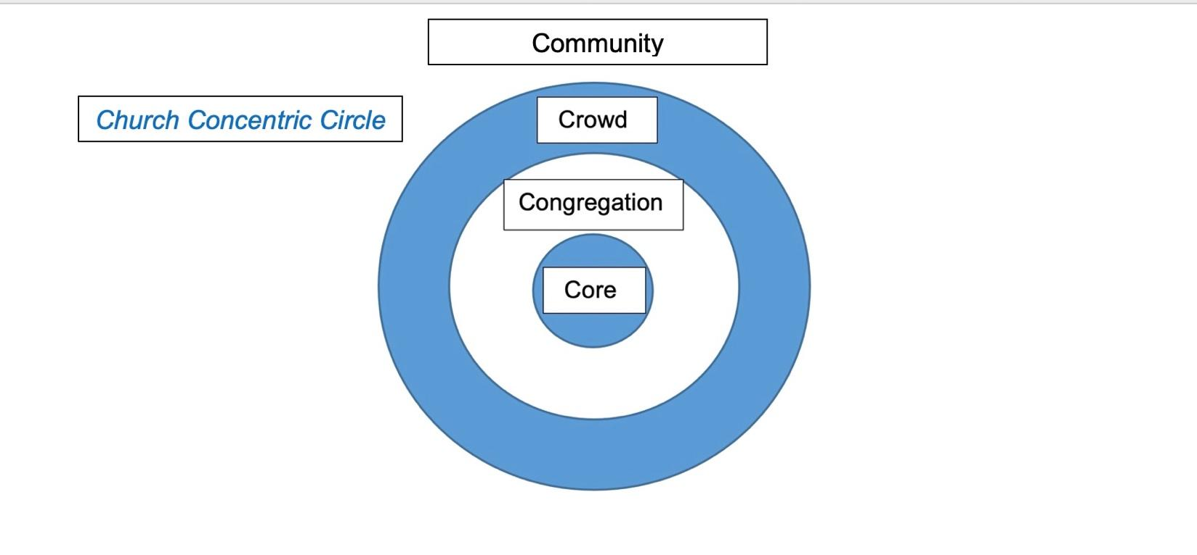

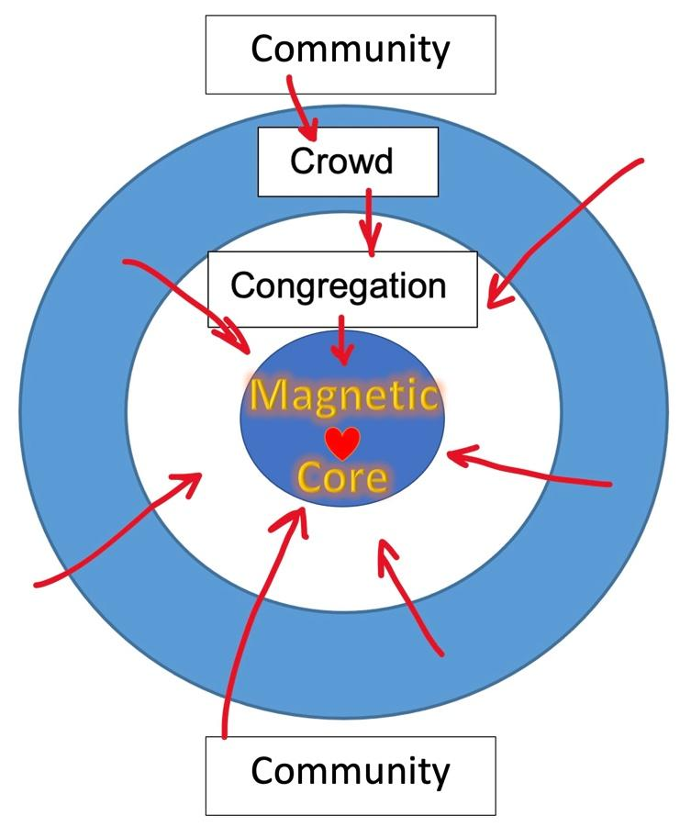
Church Concentric Circle
With Magnetic Core

Acts 2: 44-47 “All the believers were together and had everything in common. ⁴⁵ They sold property and possessions to give to anyone who had need. ⁴⁶ Every day they continued to meet together in the temple courts. They broke bread in their homes and ate together with glad and sincere hearts, ⁴⁷ praising God and enjoying the favor of all the people. And the Lord added to their number daily those who were being saved.”

Paul speaks emphatically in the last chapter of Galatians about this;
Galatians 6:9-10 “Let us not become weary in doing good, for at the proper time we will reap a harvest if we do not give up. ¹⁰ Therefore, as we have opportunity, let us do good to all people, especially to those who belong to the family of believers.”
***We are to do good things for as many people as we are able to, but ESPECIALLY first and foremost we are to do good things to and for Other Christians.***

Sometimes it’s easier to care for the stranger or outsider than it is for our own brother or sister in the Lord, our priority is not to pander to the world to try to prove that we love them, but the greatest commandment is;
Luke 10:27 ‘”You must love the Lord your God with all your heart, all your soul, all your strength, and all your mind.’ And, ‘Love your neighbor as yourself.’”
The word “neighbor” here is the Greek word “plēsion”. It means “those near to you”, or “Those from among your own tribe”. It is not the same word as “Stranger” or “foreigner”. We are to love all people, but the greatest commandment tells us primarily to love God, and love each other.

This is why Jesus gave us the “new commandment” about loving each other.
John 13:34-35 ³⁴ So now I am giving you a new commandment: Love each other. Just as I have loved you, you should love each other. ³⁵ Your love for one another will prove to the world that you are my disciples.”

[Chinese Restaurant Story – The ones who needed and deserved his love the most were his family, not me]

Sometimes we are friendlier and more loving to outsiders and worldly people than we are to our brothers and sisters. Our goal is not to please worldly people, convince them that we like the same things they like, and prove to them that we desperately want to be their friend. Our goal is to show them that we love God, and each other more than anything, and invite them into that love as well.
Romans 12:9-10 “⁹Don’t just pretend to love others. Really love them. Hate what is wrong. Hold tightly to what is good. ¹⁰ Love each other with genuine affection, and take delight in honoring each other.”
When we love and honor each other with genuine affection, it send a message to the world that genuine love actually exists, and they are impressed by it and drawn to it. It more effective than church marketing campaigns, social-media advertising, billboards, magazine ads, even impressive buildings, compelling speakers and popular worship bands.
Jesus said, “If I am lifted up from the earth, I will draw all peoples to Myself.” We do that by loving God and loving each other.

[SOMERVILLE OUTREACH QUOTE ] - “You guys really seem to love each other…”

When we don’t love each other, we show the world that we are no different than they are. That includes when we gossip about, and criticize each other. Or when we neglect to help brothers and sisters who are in need or act more friendly and give more grace to those outside the church than we do our fellow congregants. Nothing pleases the heart of the Father than seeing his children truly loving and caring for one another, and it grieves Him when we don’t.

In fact, I believe that this is what the parable of the Good Samaritan is about. Let’s read this parable in the context of “Love One Another”;

Luke 10:25-37 “One day an expert in religious law stood up to test Jesus by asking him this question: “Teacher, what should I do to inherit eternal life?” ²⁶ Jesus replied, “What does the law of Moses say? How do you read it?”
²⁷ The man answered, “‘You must love the Lord your God with all your heart, all your soul, all your strength, and all your mind.’ And, ‘Love your neighbor as yourself.’” ²⁸ “Right!” Jesus told him. “Do this and you will live!”
²⁹ The man wanted to justify his actions, so he asked Jesus, “And who is my neighbor?”
³⁰ Jesus replied with a story: “A Jewish man was traveling from Jerusalem down to Jericho, and he was attacked by bandits. They stripped him of his clothes, beat him up, and left him half dead beside the road.
³¹ “By chance a priest came along. But when he saw the man lying there, he crossed to the other side of the road and passed him by. ³² A Temple assistant walked over and looked at him lying there, but he also passed by on the other side.
³³ “Then a Samaritan came along, and when he saw the man, he felt compassion for him. ³⁴ Going over to him, the Samaritan soothed his wounds with olive oil and wine and bandaged them. Then he put the man on his own donkey and took him to an inn, where he took care of him. ³⁵ The next day he handed the innkeeper two silver coins,^{[c]} telling him, ‘Take care of this man. If his bill runs higher than this, I’ll pay you the next time I’m here.’
³⁶ “Now which of these three would you say was a neighbor to the man who was attacked by bandits?” Jesus asked.³⁷ The man replied, “The one who showed him mercy.” Then Jesus said, “Yes, now go and do the same.”
This parable is not a lesson in Random Acts of Kindness as some people interpret it.
The Samaritan man showed tremendous mercy and compassion on a Jewish man who was beaten and robbed.
Jesus sums up the parable by saying to the expert in religious law, “now go and do the same”.
In other words; the Samaritan helped the Jewish man in ways that the Jewish priest and the Jewish Temple assistant (Levite) should have done in the first place.
Personal Example;
I have two daughters and a wife and we live in a small subdivision.
Suppose one of my daughters was out riding her bike, and she falls and breaks her leg and can’t make it home.
My other daughter is out for a walk and sees her, but crosses the street and passes her by.
Then my wife walked down the street, saw her lying there and also just passed by and continued her walk.
Then someone from another sub-division happen to come along and saw her. They were moved with compassion, took her to the hospital, waited for her to be cared for and paid her medical bills and brought her home.
If I came home to the three of them and heard what happened, how do you think I would react?
What do you think I would be so upset about?
(Of course the broken leg), but probably more so the fact that two family members walked right passed the other without showing care, compassion and love toward her.
I would tell them that the “stranger from the other sub-division” did what they SHOULD HAVE done.
I would probably lecture them on the importance of Loving One Another.
---
Jesus knew that the priest, the Levite, and these experts in religious law were notorious for saying that they loved God, but did not show His love to one another, and especially not to outsiders.
This is why 1st John tells us;
1st John 4:20 “Whoever claims to love God yet hates a brother or sister is a liar. For whoever does not love their brother and sister, whom they have seen, cannot love God, whom they have not seen. ²¹ And he has given us this command: Anyone who loves God must also love their brother and sister.”
How do we Love One Another? Paul’s “litany of love” in 1st Corinthians 13 is a good place to begin. (Love is patient,Love is kind, not envious, not rude, etc.).
But it also starts with having sympathy and compassion for one another, and having a humble heart.
1st Peter 3:8 “Finally, all of you should be of one mind. Sympathize with each other. Love each other as brothers and sisters. Be tenderhearted, and keep a humble attitude.”
***Now, Make no mistake. We are also to love the stranger and foreigner, as well as our neighbor and brother. We should always be willing to show God’s kindness and Unconditional love to unbelievers. But never in place of loving God or loving each other.
Lev. 19:33-34 “‘When a foreigner resides among you in your land, do not mistreat them. ³⁴ The foreigner residing among you must be treated as your native-born. Love them as yourself, for you were foreigners in Egypt. I am the Lord your God.”

[ Working in NYC, giving out $5 Dunkin Donuts cards - it feels good to give to complete homeless strangers and panhandlers. It makes you feel like a hero, when you picture them with a cup of hot coffee and a French cruller, or Bavarian cream, or chocolate frosted, or one of those premade egg roll-ups, or the one with the chocolate frosting AND the custard filled middle… but why doesn’t it feel the same to give them to people you know from church?] (Let them by their own donut : ), that’s wrong.]
“let us do good to all people, especially to those who belong to the family of believers.”(Gal. 6:10)

Closing:

1st John 3:11-16-18 ”This is the message you heard from the beginning: We should love one another. …
¹⁶ This is how we know what love is: Jesus Christ laid down his life for us. And we ought to lay down our lives for our brothers and sisters. ¹⁷ If anyone has material possessions and sees a brother or sister in need but has no pity on them, how can the love of God be in that person? ¹⁸ Dear children, let us not love with words or speech but with actions and in truth.”
As we prepare for communion, let’s meditate on the following verse, knowing that the whole reason we celebrate communion is that Jesus demonstrated His incomparable unconditional love for us, by suffering torture, being nailed to the cross, and dying for us. Greater love has no one, then He who did this for us.

John 15:9-13 "As the Father has loved me, so have I loved you. Now remain in my love. ¹⁰ If you keep my commands, you will remain in my love, just as I have kept my Father's commands and remain in his love. ¹¹ I have told you this so that my joy may be in you and that your joy may be complete. ¹² My command is this: Love each other as I have loved you. ¹³ Greater love has no one than this: to lay down one's life for one's friends.”

(Communion)

