JESUS BEYOND THE GRAVE
The Great Commission
All four gospels speak in great detail of Jesus’s last days on earth. His Triumphal Entry, The Last Supper, His Crucifixion, His Resurrection, and much of what happened in between.

There is some, but not a lot of detail about what happened during those 40 days where Jesus was once again dwelling with them and appeared to over 500 people after he rose from the grave. But those days, and all His actions and teachings during those times are very significant and unique.

These are things he said and did AFTER he said “it is finished”, and after his finished work on the Cross and resurrection.
Much can be learned from post-resurrection Jesus that is different than what we learned throughout most of the gospels. We will look at some of the key things He spoke and did during that time.
_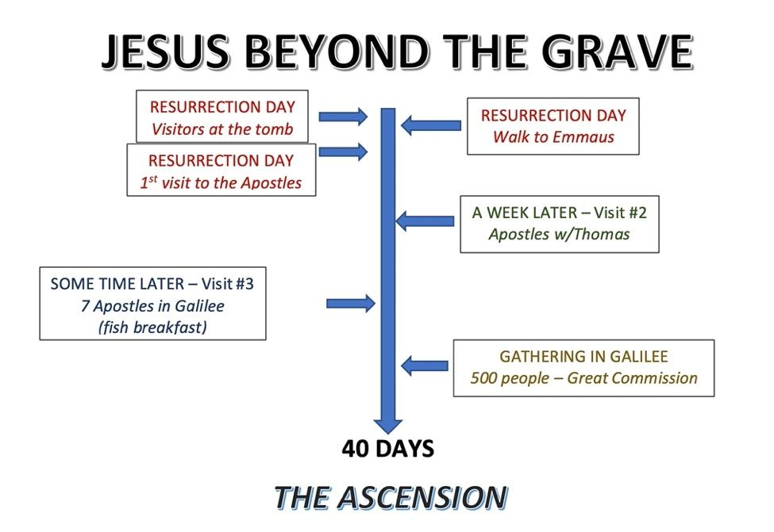_
Jesus appeared to the apostles and other followers only a few times that we know of. Most of what is written about His appearances takes place on Resurrection Day and Ascension Day.

The final chapter of Mark, Chapter 16, verses 9-20.
In some versions, this is considered the “2nd Ending” of Mark.
The reason for this is that some of the earliest manuscripts of the New Testament that were discovered did NOT contain these verses in Mark, and ended at Mark 16:8.
These are; Codex Vaticanus and Codex Sinaiticus (c. 326-360AD)
Those that don’t include or now include it parenthetically are; NIV, ESV, NLT, CSB
HOWEVER, The majority of ancient New Testament manuscripts, that were written after these, DID contain these verses (and others that were omitted by Codex Vaticanus and Codex Sinaiticus) including; KJV, NKJV, NASB, RSV.
Most modern Bibles that contain the longer version of Mark 16 are based upon the Textus Receptus, a translation built largely upon the “Latin Vulgate” by Jerome of Stridon, who was commissioned in 382AD to translate the known Greek texts into Latin.
It’s possible that Peter, who likely dictated this gospel to John Mark felt the need to add some details of the post-resurrection Jesus later in life, so the book of Mark may have been completed at a later date.

Either way, the last chapter is inspiring and powerful, just like the rest of the gospel, so we include in our study of Jesus beyond the grave.
As with all scripture, we read with understanding but learn from illumination as the Holy Spirit teaches us the Word of God.
That’s how we’ll approach this chapter.
Mark 16:9-20 “When Jesus rose early on the first day of the week, he appeared first to Mary Magdalene, out of whom he had driven seven demons. ¹⁰ She went and told those who had been with him and who were mourning and weeping. ¹¹ When they heard that Jesus was alive and that she had seen him, they did not believe it.
¹² Afterward Jesus appeared in a different form to two of them while they were walking in the country. ¹³ These returned and reported it to the rest; but they did not believe them either.
¹⁴ Later Jesus appeared to the Eleven as they were eating; he rebuked them for their lack of faith and their stubborn refusal to believe those who had seen him after he had risen.”
They most likely refused to believe Mary Magdalene’s report, maybe because she was a woman, or due to her past reputation. They were doubting what Jesus who had clearly told them would happen, His Resurrection!
^{15 “}He said to them, “Go into all the world and preach the gospel to all creation. ¹⁶ Whoever believes and is baptized will be saved, but whoever does not believe will be condemned.”
Here is where it gets wild.
The details in the next verses don’t necessarily correspond with what was written in the other gospels, as much as they do with the book of Acts;
¹⁷ And these signs will accompany those who believe: In my name they will drive out demons; they will speak in new tongues; ¹⁸ they will pick up snakes with their hands; and when they drink deadly poison, it will not hurt them at all; they will place their hands on sick people, and they will get well.”
List of signs;
- Drive out Demons
- Speak in new tongues
- Pick Up Snakes
- Drink Deadly Poison – not be hurt
- Place Hands on Sick people and heal them
LET’S LOOK AT EACH OF THESE;
- Drive out Demons – We see this in both the gospels and Acts, as Jesus drove out many demons, and so did Paul in Acts 16 and 19

- Speak in new tongues – Evidenced in both the miracle of languages in Acts Chapter 2, and “speaking in tongues” in Acts 10 & 19, and 1st Cor .12,13,& 14

- Pick Up Snakes – Paul in Malta (Acts 28) as he was throwing some brush into the fire a poisonous snake fastened itself to his arm, he threw it into the fire and continued unharmed, (the locals thought he must be a god).

- Drink Deadly Poison and not be hurt – [No Biblical record of this?]

- Place Hands on Sick people and heal them – Many instances of this in Acts and beyond;

- Ananias layed hands on Saul in Acts 9 and healed his blindness.
- Back in Malta, Paul layed hands on the father of the Chief of the Island and he was healed.
- Sometimes people were healed or delivered in other ways or all at once, like in the case of Philip;

Acts 8:5-7 “Then Philip went down to the city of Samaria and preached Christ to them. ⁶ And the multitudes with one accord heeded the things spoken by Philip, hearing and seeing the miracles which he did. ⁷ For unclean spirits, crying with a loud voice, came out of many who were possessed; and many who were paralyzed and lame were healed.”

The final verses in Mark;

Mark 16:19 “So then, after the Lord had spoken to them, He was received up into heaven, and sat down at the right hand of God. ²⁰ And they went out and preached everywhere, the Lord working with them and confirming the word through the accompanying signs. Amen. <end>
His final command to them were; “Go into all the world and preach the gospel to all creation.” (Mark 16:15)
So, they preached everywhere, and the Lord worked with them and confirmed his word by the signs that accompanied it.”
In the same way that Jesus used these methods and many more to heal people or deliver them, so did the apostles after Him. There was not one set method for signs, wonders and miracles .There still isn’t. The Holy Spirit does it WHEN he wills and HOW he wills. It’s not up to us, it’s up to Him. Our job is to Preach the gospel and let God do the rest.
In Jesus’s final commission(s) in the gospels, his marching orders are to;
Make Disciples, Preach the Gospel, and be my Witnesses,
- Mark: “Go into all the world and preach the gospel”
- Luke: “and in His name repentance and forgiveness of sins will be proclaimed to all nations, beginning in Jerusalem.”
- Acts 1:8 “But you will receive power when the Holy Spirit comes on you; and you will be my witnesses in Jerusalem, and in all Judea and Samaria, and to the ends of the earth.”
- Matt 28:18-20 “The Great Commission”
¹⁸ Jesus came and told his disciples, “I have been given all authority in heaven and on earth. ¹⁹ Therefore, go and make disciples of all the nations,^{[b]} baptizing them in the name of the Father and the Son and the Holy Spirit. ²⁰ Teach these new disciples to obey all the commands I have given you. And be sure of this: I am with you always, even to the end of the age.”

“The Great Commission” – It is not called that in the Bible, it’s a name that was given to this passage of scripture in the post-reformation missionary movement.

It may have been given that label from Dutch missionary Justinian von Welz (born 400 years ago), but it was Hudson Taylor, the famous English missionary to China who popularized the phrase ‘The Great Commission’ nearly 200 years later.

This passage of scripture starts with a claim of Jesus that says he was given all authority;

Matt 28:18 ^{“18} Then Jesus came to them and said, “All authority in heaven and on earth has been given to me.”

This verse, and the Great Commission verses that follow are very controversial to non-Christians. The idea of one religion spreading its ideology to other nations, and particularly other indigenous people groups is revolting to many non-believers.

[example: visiting a church which featured a Missionary to Buddhists in India, a visitor who was with me said “why would someone want to impose a religion like Christianity, upon a peaceful religion like Buddhism”? ]

The answer is that there is one God, who created the Heavens and the Earth. He created mankind and while separated from Him by sin, is now reconciled to Him through Jesus. (2 Cor.5).

The deception and corruption of planet Earth is a result of the evil brought into the world by Satan. His power is limited however, and even he is subject to Jesus’ Authority.
1st Peter 3:21-22 “through the resurrection of Jesus Christ, who has gone into heaven and is at the right hand of God, angels and authorities and powers having been made subject to Him.”

GREAT COMMISSION:

MATT 28:-19-20 “Therefore… go and make disciples of all nations, baptizing them in the name of the Father and of the Son and of the Holy Spirit, ²⁰ and teaching them to obey everything I have commanded you. And surely I am with you always, to the very end of the age.”
- go and make disciples of all nations,
  - baptizing them in the name of the Father and of the Son and of the Holy Spirit,
  - teaching them to obey everything I have commanded you.
Jesus gave this command to the apostles just before His Ascension.
It tells them what Jesus expected the apostles and those who followed them to do in the world after He ascended into heaven.
Most commentaries agree that in the original Greek, the only direct command in Matthew 28:19–20 is “make disciples.” The other commands are particles of the original command. (“go”, “baptize”, “teach”)

So “The Great Commission” basically instructs us to make disciples “as we are going” throughout the world.

We do this by; baptizing them, and teaching them.

Baptizing them: in the name of the Father and of the Son and of the Holy Spirit. In other words, we lead them into a formal public confession, and commitment to Jesus and an understand of all aspects of the Godhead.

Teaching them: to obey everything I have commanded you. In other words. Teach them the truth of scripture. They need to have a foundation of God’s word, both the Old Testament and New Testament, especially as fulfilled by Jesus the Messiah.

This is what He told them before He left them, and this is what they did.
He continued to command them to GO in Acts 1:8, just before He ascended

Acts 1:8 “But you will receive power when the Holy Spirit comes on you; and you will be my witnesses in Jerusalem, and in all Judea and Samaria, and to the ends of the earth.”

We will see this roll out in the Book of Acts:
First, Jerusalem is evangelized (Acts 1 — 7);
then the Spirit expands the church through Judea and Samaria (Acts 8 — 12);
finally, the gospel reaches into “the ends of the earth” (Acts 13 — 28).

Today, we endeavor to fulfill the Great Commission in all we do as a church, teaching preaching, proclaiming and discipling.

We want all people to come into a relationship with God by being reconciled through Jesus.

That’s why one of our church’s foundational scriptures is 2nd Corinthians 5:18.

2nd Cor. 5:18-20 ^{“18} Now all things are of God, who has reconciled us to Himself through Jesus Christ, and has given us the ministry of reconciliation, ¹⁹ that is, that God was in Christ reconciling the world to Himself, not imputing their trespasses to them, and has committed to us the word of reconciliation.²⁰ Now then, we are ambassadors for Christ, as though God were pleading through us: we implore you on Christ’s behalf, be reconciled to God.”

Jesus is calling ALL of us to the ministry of reconciliation! Reconciling people to Him!
2 Timothy 4:5 “But you should keep a clear mind in every situation. Don't be afraid of suffering for the Lord. Work at telling others the Good News, and fully carry out the ministry God has given you.

He wants us all to preach the gospel and declare the good news of the Kingdom of God. We do all we can, with what little we have and He does the rest.
It doesn’t matter if you are a Bible scholar or just brand new to the Word. He doesn’t want us to rely on our own ability, but rely on HIM.
Zech 4:6 “It’s 'Not by might nor by power, but by my Spirit,' says the LORD Almighty.”

The “Great Commission” and the “Ministry of Reconciliation” are given to all of us!
- Not just Pastors and Teachers
- not just gifted evangelists
- not just ministry leaders,
- Not just people who know the Bible really well..

… ALL of us.

