ACTS 17
“Making God Known”

(Previously in Acts and us)
Paul had responded to the Macedonian Call which changed his travel plans and brought him not to Northern Turkey, where he was headed, but to Europe. Once there, he and Silas were stripped, beaten and thrown in jail in Philippi.
The Lord miraculously released them from prison and the jailer and his household became believers. Once it was discovered that they were Roman citizens, and the magistrates tried to get them to leave town quietly.
The chapter ends with a fellowship meeting at the home of Lydia, a wealthy merchant who also became a believer along with her household.

_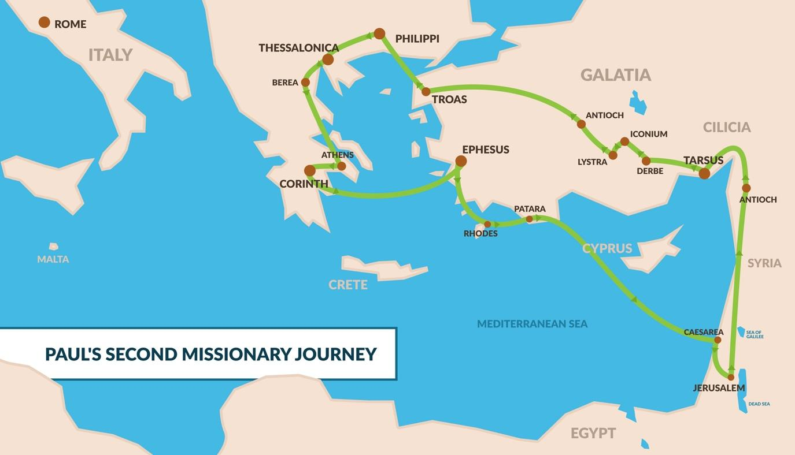_
On to Thessalonica
ACTS 17 “When Paul and his companions had passed through Amphipolis and Apollonia, they came to Thessalonica, where there was a Jewish synagogue. ² As was his custom, Paul went into the synagogue, and on three Sabbath days he reasoned with them from the Scriptures, ³ explaining and proving that the Messiah had to suffer and rise from the dead. “This Jesus I am proclaiming to you is the Messiah,” he said. ⁴ Some of the Jews were persuaded and joined Paul and Silas, as did a large number of God-fearing Greeks and quite a few prominent women.”
As usual Paul, when Paul entered a new town, he went straight to the synagogue and preached to the Jews, explaining to the that Jesus was the Messiah. He also welcomed Greeks (Gentiles) to believe upon Jesus and be saved. Here in Thessalonica many became believers.
In several of the accounts of Paul’s visits to cities, Luke categorizes those who believed into three groups; a. Jews, b. Greeks, c. Prominent women.
The “Prominent Women” were likely those who were, wealthy, educated and influential, in a time and culture where that was not the norm for most women.
This is the beginning of the Thessalonian church, which began in the house of a man named Jason.
As usual however, some rejected their message and turned the city against them.
5-9 “But other Jews were jealous; so they rounded up some bad characters from the marketplace, formed a mob and started a riot in the city. They rushed to Jason’s house in search of Paul and Silas in order to bring them out to the crowd. ⁶ But when they did not find them, they dragged Jason and some other believers before the city officials, shouting: “These men who have caused trouble all over the world have now come here, ⁷ and Jason has welcomed them into his house. They are all defying Caesar’s decrees, saying that there is another king, one called Jesus.” ⁸ When they heard this, the crowd and the city officials were thrown into turmoil. ⁹ Then they made Jason and the others post bond and let them go.”
Jason of Thessalonica is a venerated Saint in the Catholic and Orthodox churches and is considered one of Paul’s closest friends in Romans 16:21.
To Berea
10-12 As soon as it was night, the believers sent Paul and Silas away to Berea. On arriving there, they went to the Jewish synagogue. ¹¹ Now the Berean Jews were of more noble character than those in Thessalonica, for they received the message with great eagerness and examined the Scriptures every day to see if what Paul said was true. ¹² As a result, many of them believed, as did also a number of prominent Greek women and many Greek men.”
The Bereans Jews were more welcoming to Paul and the message of the gospel than many of those on Thessalonica. Many Jews believed (along with a number of prominent Greek women and many Greek men.) The Bereans were considered to be of noble character and were characterized by the description in verse 11;
“the Berean Jews were of more noble character than those in Thessalonica, for they received the message with great eagerness and examined the Scriptures every day to see if what Paul said was true.”
They have become an exemplary model for believers through history of what it is to be open and eager to receive the gospel, but responsible to study and research it to make sure it is correct.
Chased out of Berea by Thessalonian Jews - Paul goes to Athens alone
13-15 “But when the Jews in Thessalonica learned that Paul was preaching the word of God at Berea, some of them went there too, agitating the crowds and stirring them up. ¹⁴ The believers immediately sent Paul to the coast, but Silas and Timothy stayed at Berea. ¹⁵ Those who escorted Paul brought him to Athens and then left with instructions for Silas and Timothy to join him as soon as possible.”
Athens named after the goddess Athena, was the largest and most powerful city in Greece and was the most influential city in the ancient world. It was home to the altar to the 12 Greek gods.
The people of Athens lived below the Acropolis on Mars Hill (Areopagus) which is where the Parthenon and several other significant structures were built.

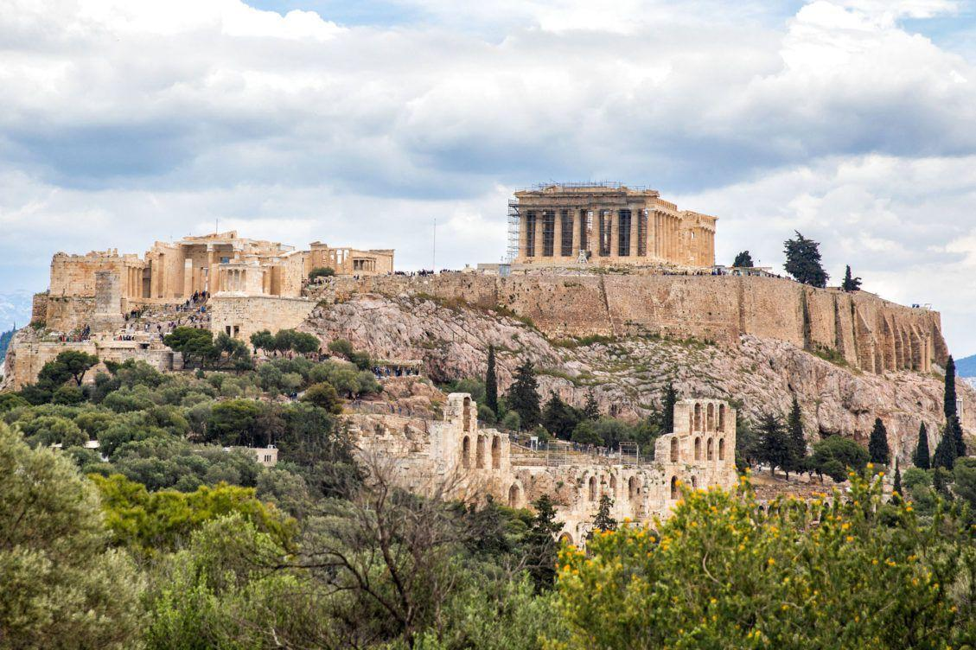

Greek culture was the most pervasive influence at the time in terms of; technology, art, philosophy and religion.

The city of Athens represented Greek culture in every way. Paul, who was escorted there and left there alone while waiting for Silas and Timothy to join him. While there, he decided to go sight-seeing.

In Athens
16-34 “While Paul was waiting for them in Athens, he was greatly distressed to see that the city was full of idols. ¹⁷ So he reasoned in the synagogue with both Jews and God-fearing Greeks, as well as in the marketplace day by day with those who happened to be there. ¹⁸ A group of Epicurean and Stoic philosophers began to debate with him. Some of them asked, “What is this babbler trying to say?” Others remarked, “He seems to be advocating foreign gods.” They said this because Paul was preaching the good news about Jesus and the resurrection. ¹⁹ Then they took him and brought him to a meeting of the Areopagus, where they said to him, “May we know what this new teaching is that you are presenting? ²⁰ You are bringing some strange ideas to our ears, and we would like to know what they mean.” ²¹ (All the Athenians and the foreigners who lived there spent their time doing nothing but talking about and listening to the latest ideas.)
²² Paul then stood up in the meeting of the Areopagus and said: “People of Athens! I see that in every way you are very religious. ²³ For as I walked around and looked carefully at your objects of worship, I even found an altar with this inscription: to an unknown god. So you are ignorant of the very thing you worship—and this is what I am going to proclaim to you.
²⁴ “The God who made the world and everything in it is the Lord of heaven and earth and does not live in temples built by human hands. ²⁵ And he is not served by human hands, as if he needed anything. Rather, he himself gives everyone life and breath and everything else. ²⁶ From one man he made all the nations, that they should inhabit the whole earth; and he marked out their appointed times in history and the boundaries of their lands. ²⁷ God did this so that they would seek him and perhaps reach out for him and find him, though he is not far from any one of us. ²⁸ ‘For in him we live and move and have our being.’ As some of your own poets have said, ‘We are his offspring.’
God did all this to draw people close to Himself.
²⁹ “Therefore since we are God’s offspring, we should not think that the divine being is like gold or silver or stone—an image made by human design and skill. ³⁰ In the past God overlooked such ignorance, but now he commands all people everywhere to repent. ³¹ For he has set a day when he will judge the world with justice by the man he has appointed. He has given proof of this to everyone by raising him from the dead.”
³² When they heard about the resurrection of the dead, some of them sneered, but others said, “We want to hear you again on this subject.” ³³ At that, Paul left the Council. ³⁴ Some of the people became followers of Paul and believed. Among them was Dionysius, a member of the Areopagus, also a woman named Damaris, and a number of others.” < >

Paul’s Message to them:
Acts 17:24,28
²⁴ “The God who made the world and everything in it is the Lord of heaven and earth and does not live in temples built by human hands.>>>
²⁸ ‘For in him we live and move and have our being,” As some of your own poets have said, ‘We are his offspring.”
He wasn’t just preaching the gospel, He was positioning himself as a Philosopher in the Areopagus, the very epicenter of Philosophy in the ancient world.
And he brilliantly used quotes from their own Greek poets and philosophers to do it;
- “For in him we live and move and have our being” - A quote from Epimenides, a Geek philosopher/poet who lived in the 6th or 7th century BC.

- “We are his offspring.” - A quote from the Greek Poet Aratus written 300 years prior, in a famous poem to Zeus.
Here is a perfect example of Paul using their culture and their scope of understanding, to preach the gospel. He did not do it just to fit in, or to get them to like and accept him.
He did not quote secular poets because he believed in their message and philosophy, he was trying to expose the fallacy of it by presenting the truth of Jesus.
He did it to only to use familiar words as a tool to preach the gospel, in hopes that they would repent, turn to God and do away with all their meaningless philosophy and religion in exchange for a relationship with the One True God. That was his goal.
He used their shrine “To an Unknown God.” As a point of reference, and proceeded to define for them who the Unknown God is, with confidence.

He does this by saying:
- “He is the God who made the world and everything in it.” (v. 4)
God is the Creator. This is His first identity in scripture and makes Him relevant to all things created. (Yah-Weh, creator of all things created.)

- “His purpose was for the nations to seek after God and perhaps feel their way toward him and find him—though he is not far from any one of us. (v. 27)
His Purpose is to be in Relationship with people. Not be completely transcendent and unapproachable but being immanent He desires to know and be known.
Jer. 29:13 “You will seek me and find me when you seek me with all your heart. I will be found by you says the Lord”

- He told then about Jesus, God’s risen son (v. 31)
“For he has set a day when he will judge the world with justice by the man he has appointed. He has given proof of this to everyone by raising him from the dead.”

Paul’s message in a nutshell.
- You don’t yet know the Unknown God, but He wants to be known by you.
- He created the world and everything in it, including us.
- His purpose was to be in a relationship with us.
- He sent Jesus here to make that happen.

ACTS IN ACTION >>>

Today, it’s not likely that people have temples and statues that they bow to and worship, however many people have their own “temple” to unknown gods. Most people of the world claim to believe in God but not many can fully describe who He is in detail. Some can talk about their religious experiences, but few can actually describe their encounters with God and in many ways He remains mysterious or “Unknown”.

That’s where you and I can step up like Paul did, and make the “unknown God” known, by describing Him in terms that they can understand.

- He is the Creator of all things. “Almighty Father”
- He wants to be known by all who seek Him.
- He sent Jesus to reconcile and restore our broken relationship with the Father.

In Paul’s case he got three responses:

Acts 17:32-34

³² When they heard Paul speak about the resurrection of the dead, some laughed in contempt, but others said, “We want to hear more about this later.” ³³ That ended Paul’s discussion with them, ³⁴ but some joined him and became believers.

When we tell people about God and present the gospel of Jesus to them, we can expect the same thing.
- Some will laugh or scoff
- Some will show only a limited amount of interest
- Some, however will become believers.

Yes, there will be people whom you speak to, that will believe the Word of the Lord and come out of darkness and into the marvelous light. They will step into a relationship with God, and spend eternity with Him, because you were willing to share the gospel.

It’s for them, those who will someday become believers, that we must be faithful, in spite of opposition to do what Paul did and what Jesus asks us to do:

Matt 28:19-20
“Go therefore and make disciples of all nations, baptizing them in the name of the Father and of the Son and of the Holy Spirit, teaching them to observe all that I have commanded you. And behold, I am with you always, to the end of the age.”

