ACTS 18
ACTS & US
“Truth and Spirit”
(Previously in Acts and Us)
Paul traveled to Thessalonica and planted a church in the home of a man named Jason. He also preached in Berea but was chased out of town and found himself alone in Athens, the Philosophy capital of the ancient world.
Paul used quotations from their philosophers to preach the gospel. He did not do it just to fit in, or to get them to like and accept him.
He did not quote secular poets because he believed in their message and philosophy, he was trying to expose the fallacy of it by presenting the truth of Jesus.
He did it in hopes that they would repent, turn to God and do away with all their meaningless philosophy and religion in exchange for a relationship with the One True God. That was his goal.
He used their shrine “To an Unknown God.” As a point of reference, in order to make God known to them.

This week he continues his journey southward on the Greek Peloponnesian peninsula, to the famous town of Corinth.
_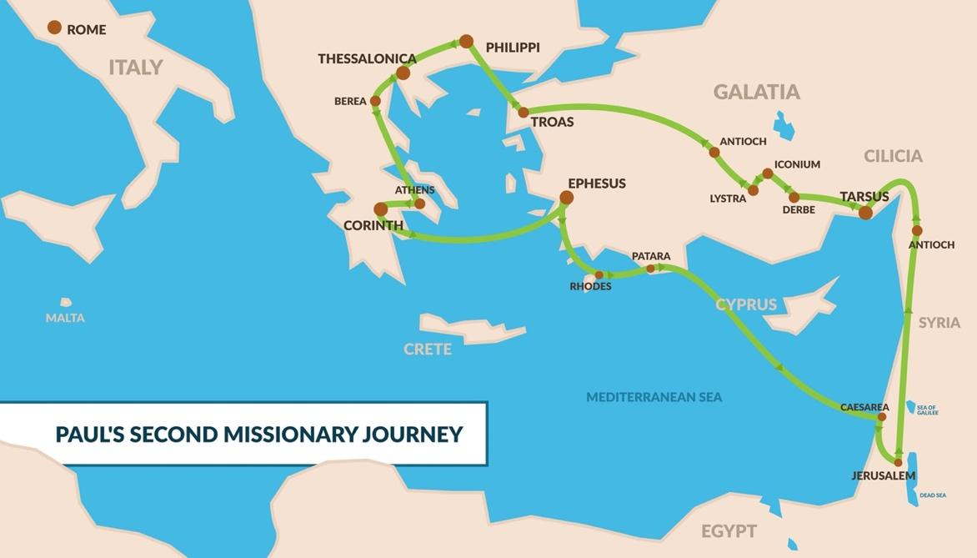_
Corinth
The city of Corinth was believed to be a city of about 600,000 people and was the capitol of Achaia. It was strategically located on the Peloponnesian Peninsula right at the isthmus (3 x 10 miles, now has a canal) that connects southern and northern Greece. It served as a good stopping point between Rome and the East. Because of this geography, Corinth was a major center of commerce and trade. This vitally important city was intellectually proud, materially affluent, and morally corrupt.

__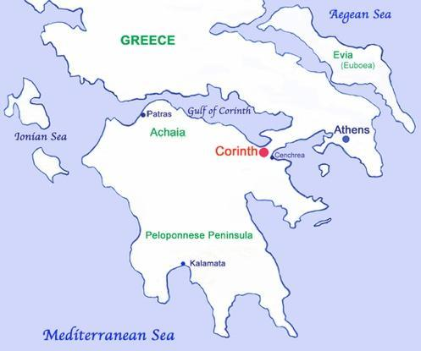__

Acts 18 gives an account of Paul’s time in Corinth where he planted the church about 49AD. He met Aquila and Priscilla, who had just gotten kicked out of Rome, who became some of his closest friends, whom he lived and worked for.

Acts 18:1 “After “these things” Paul departed from Athens and went to Corinth…”

(What things? Acts 16 – he met Timothy in Lystra, He and Silas were miraculously freed from jail in Philippi and the jailor became saved.
Acts 17 – He planted churches in Galatia, Philippi, Thessalonica and Berea, then went to Athens and reasoned with the Greek philosophers at the Areopagus, explaining to them who the “Unknown God” is.)

Acts 18:1 “After these things Paul departed from Athens and went to Corinth.
2 And he found a certain Jew named Aquila, born in Pontus, who had recently come from Italy with his wife Priscilla (because Claudius had commanded all the Jews to depart from Rome); and he came to them.
3 So, because he was of the same trade, he stayed with them and worked; for by occupation they were tentmakers.”
Aquila and Priscilla become some of Paul’s closest friends and two of the most important converts ion the New Testament. This was a Jewish couple who fled Rome and met Paul in Corinth. He stayed in their house and they eventually joined him to work and start a House-Church that became the church of Ephesus as we see in 1st Corinthians.
1st Cor. 16:19 “The churches here in the province of Asia send greetings in the Lord, as do Aquila and Priscilla and all the others who gather in their home for church meetings.”
Here in Corinth Paul began his ministry as he did in most towns by speaking at the local synagogue.
^{4”} Every Sabbath he reasoned in the synagogue, trying to persuade Jews and Greeks. ⁵ When Silas and Timothy came from Macedonia, Paul devoted himself exclusively to preaching, testifying to the Jews that Jesus was the Messiah. ⁶ But when they opposed Paul and became abusive, he shook out his clothes in protest and said to them, “Your blood be on your own heads! I am innocent of it. From now on I will go to the Gentiles.”
⁷ Then Paul left the synagogue and went next door to the house of Titius Justus, a worshiper of God. ⁸ Crispus, the synagogue leader, and his entire household believed in the Lord; and many of the Corinthians who heard Paul believed and were baptized.
⁹ One night the Lord spoke to Paul in a vision: “Do not be afraid; keep on speaking, do not be silent. ¹⁰ For I am with you, and no one is going to attack and harm you, because I have many people in this city.” ¹¹ So Paul stayed in Corinth for a year and a half, teaching them the word of God.”

The Lord promised Paul that no harm would come to him in the city, and that he should continue the work in Corinth. Paul built a strong and strategic church in Corinth. One that he loved very much and took great care in encouraging and correcting. He wrote several letters to the church including 1st and 2nd Corinthians, and took great care to establish leadership there while he was gone.
^{12 “}While Gallio was proconsul of Achaia, the Jews of Corinth made a united attack on Paul and brought him to the place of judgment. ¹³ “This man,” they charged, “is persuading the people to worship God in ways contrary to the law.”
¹⁴ Just as Paul was about to speak, Gallio said to them, “If you Jews were making a complaint about some misdemeanor or serious crime, it would be reasonable for me to listen to you. ¹⁵ But since it involves questions about words and names and your own law—settle the matter yourselves. I will not be a judge of such things.” ¹⁶ So he drove them off. ¹⁷ Then the crowd there turned on Sosthenes the synagogue leader and beat him in front of the proconsul; and Gallio showed no concern whatever.”

Sosthenes was likely a synagogue leader who bore the brunt of the unsuccessful attempt to bring judgement upon Paul. He may have been the synagogue leader who replaced Crispus who, as we just read, became a believer. It’s likely that Sosthenes also later became a believer and traveled with Paul to Ephesus, because when Paul writes 1st Corinthians from Ephesus he opens the letter with these words;

1st Cor. 1:1-2 “1 Paul, called by the will of God to be an apostle of Christ Jesus, and our brother Sosthenes,2 To the church of God that is in Corinth…”

Priscilla, Aquila, Apollos and the beginning of the church in EPHESUS
^{18 “}Paul stayed on in Corinth for some time. Then he left the brothers and sisters and sailed for Syria, accompanied by Priscilla and Aquila. Before he sailed, he had his hair cut off at Cenchreae because of a vow he had taken.”
Paul decides to head back home to Syria (Antioch), but not before stopping in Cenchreae for a haircut. Luke tells us that this is because of a vow he had taken, although not much is known of the vow. Some speculate that t was a Nazarite vow to appeal to the Jews, but this is not certain.
In heading East, he would have every reason to stop at the next major city on the way, Ephesus. He brought Priscilla and Aquila along and left them there after a short visit.
^{19 “}They arrived at Ephesus, where Paul left Priscilla and Aquila. He himself went into the synagogue and reasoned with the Jews. ²⁰ When they asked him to spend more time with them, he declined. ²¹ But as he left, he promised, “I will come back if it is God’s will.” Then he set sail from Ephesus. ²² When he landed at Caesarea, he went up to Jerusalem and greeted the church and then went down to Antioch.”

(see map)
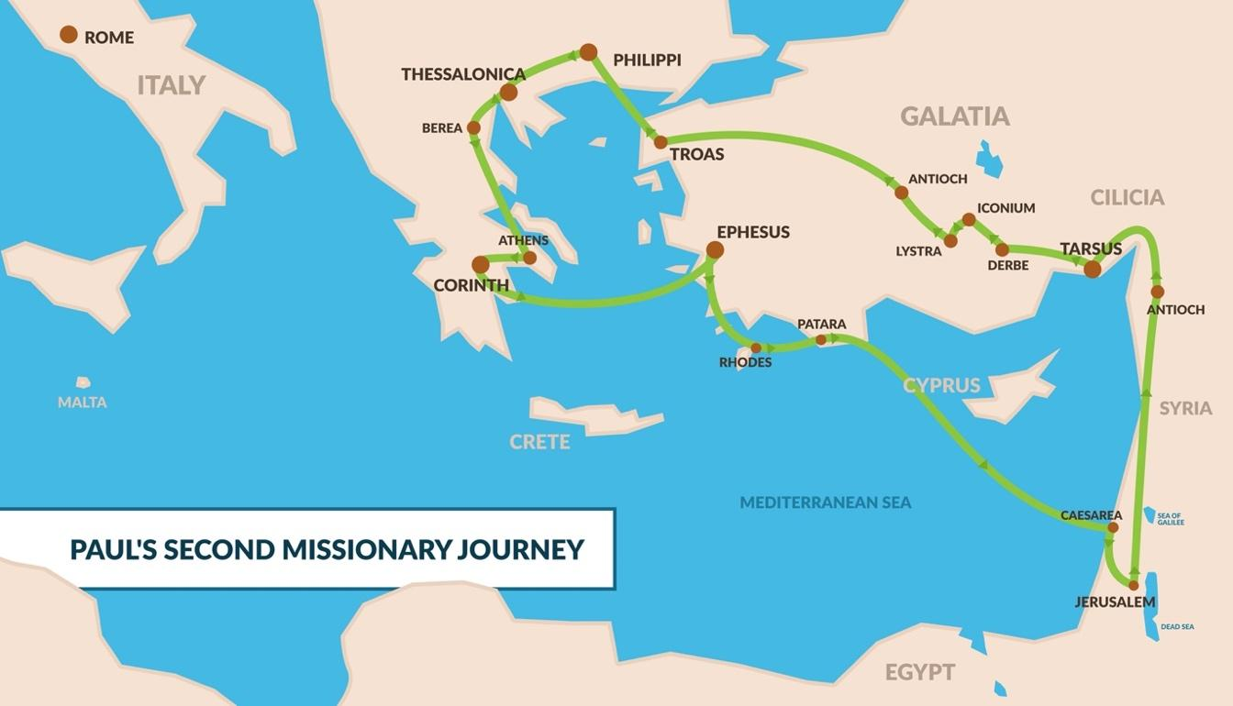

^{23 “}After spending some time in Antioch, Paul set out from there and traveled from place to place throughout the region of Galatia and Phrygia, strengthening all the disciples.
²⁴ Meanwhile a Jew named Apollos, a native of Alexandria, came to Ephesus. He was a learned man, with a thorough knowledge of the Scriptures. ²⁵ He had been instructed in the way of the Lord, and he spoke with great fervor and taught about Jesus accurately, though he knew only the baptism of John. ²⁶ He began to speak boldly in the synagogue. When Priscilla and Aquila heard him, they invited him to their home and explained to him the way of God more adequately.”
Apollos is introduced here as a believer who was already a scholar and zealous evangelist but did not fully know the way of God. He was a Jew from Alexandria, He traveled to Ephesus in 54AD, where he taught boldly in the synagogue. However, at that time, Apollos’ understanding of the gospel was incomplete since he was “acquainted only with the baptism of John”. He eventually found his way to Corinth and was such a popular leader there that factions arose over those who favor Apollos over Paul.
^{27 “}When Apollos wanted to go to Achaia, the brothers and sisters encouraged him and wrote to the disciples there to welcome him. When he arrived, he was a great help to those who by grace had believed. ²⁸ For he vigorously refuted his Jewish opponents in public debate, proving from the Scriptures that Jesus was the Messiah.”

Apollos was in many ways equipped and prepared to share the gospel but in a very significant way he was incomplete.

When he arrived at Ephesus he was scholarly, zealous and had a thorough knowledge of the Scriptures “taught about Jesus accurately”. In other words, he was a believer, he knew about Jesus’ life and teaching, he may even have known about his death, resurrection and ascension, but verse 25 says “he knew only the baptism of John”.

What did he lack?
What other baptism is there?

The answer is in the very beginning of the next chapter. I am assuming that Apollos was very similar to the other believers Paul encountered in the beginning of Acts 19 when he returned to Ephesus to begin to build the church there.

They believed, but had not yet received the Holy Spirit.
Acts 19:1-6 “And it happened, while Apollos was at Corinth, that Paul, having passed through the upper regions, came to Ephesus. And finding some disciples ² he said to them, “Did you receive the Holy Spirit when you believed?”
So they said to him, “We have not so much as heard whether there is a Holy Spirit.”
³ And he said to them, “Into what then were you baptized?”
So they said, “Into John’s baptism.”
⁴ Then Paul said, “John indeed baptized with a baptism of repentance, saying to the people that they should believe on Him who would come after him, that is, on Christ Jesus.”
⁵ When they heard this, they were baptized in the name of the Lord Jesus. ⁶ And when Paul had laid hands on them, the Holy Spirit came upon them.”
Apollos, and these original twelve believers in Ephesus had not yet fully received the Holy Spirit. It’s possible that they only knew about Jesus from what John had told them and what they had heard about through others. They believed all that they had heard, but since they were not present at Pentecost, and the fulfillment of Joel 2 “ I will pour out my Spirit on all flesh”. All they had was what they had learned in their minds and understanding, not what they experienced in their hearts and their spirits.

Apollos, and the “Ephesus Twelve”, are similar to those who receive the Lord by believing, yet don’t allow receive the Holy Spirit into their human spirit. This is usually because they are not aware of the Holy Spirit, as the early Ephesians said “said to him, “We have not so much as heard whether there is a Holy Spirit.” However, when Paul explained it to them, they eagerly received it, as did Apollos through Priscilla and Aquila.
There are many “believers” out there who don’t fully understand the role of the Holy Spirit in their lives and have not fully “received” the Holy Spirit.
This is not to say that they are unsaved, nor is it to say that God did not “put his Spirit in [their] hearts as a deposit” (2nd Cor. 1:22), only God is the judge of that.

But when someone is “living by the Spirit”, two things are evident; Fruit, and Power.

The fruit of the Spirit is an indicator of God’s Spirit within;

FRUIT:
Gal 5:22-23a “²² But the fruit of the Spirit is love, joy, peace, forbearance, kindness, goodness, faithfulness, ²³ gentleness and self-control.

The power of the Spirit is what compels us through gifts, manifestations and supernatural abilities enabling us to do far more than we could do through our own human resources;

POWER:
Acts 1:8 “But you will receive power when the Holy Spirit comes on you; and you will be my witnesses in Jerusalem, and in all Judea and Samaria, and to the ends of the earth.”

All through the new testament we are told to;
- “walk by the spirit” - Gal. 5:16
- “live by the Spirit” - Gal. 5:25
- “be filled with the Spirit” - Eph. 5:18

We need to rely on the indwelling of the Holy Spirit to live the life God has for us, instead of relying on our own abilities and resources.

This is in essence the difference between the Soul (Mind and Emotions) and the Spirit (God’s spirit dwelling within us).

Walking by the Spirit, living by the Spirit, and being filled with the Spirit is not just an optional preference for Christians who like to refer to themselves as “Spirit-filled.” It’s for all who consider themselves children of God. In fact it’s only through the Spirit that we receive the adoption that makes us sons and daughters of God.

Romans 8:14–16 “For those who are led by the Spirit of God are the children of God. The Spirit you received does not make you slaves, so that you live in fear again; rather, the Spirit you received brought about your adoption to sonship. And by Him we cry, “Abba, Father.” The Spirit himself testifies with our spirit that we are God’s children.”
Apollos, and the early Ephesians had Truth, but not the Spirit. We need both. When Jesus encountered the woman at the will He recognized that she had limited truth, but not the “Spirit of Truth”,
John 4:23–24 “But the hour is coming, and now is, when the true worshipers will worship the Father in spirit and truth; for the Father is seeking such to worship Him. God is Spirit, and those who worship Him must worship in spirit and truth.”

God is Spirit, and true worshippers must worship, walk, and live in spirit (and in truth).
We don’t have a choice. If we want to worship God, or even seek, follow, serve, or believe in God,
we must do it not through our own limited cognitive abilities (minds and emotions),
but with the power and fruit of the Holy Spirit, because God is Spirit.

