ACTS & US
Acts 19 - Emphasis on Ephesus

(previously on Acts an Us…)

Apollos and the “Ephesian 12” believed, but had not yet received the Holy Spirit.
Acts 19:1-6 “And it happened, while Apollos was at Corinth, that Paul, having passed through the upper regions, came to Ephesus. And finding some disciples ² he said to them, “Did you receive the Holy Spirit when you believed?”
So they said to him, “We have not so much as heard whether there is a Holy Spirit.”
³ And he said to them, “Into what then were you baptized?”
So they said, “Into John’s baptism.”
⁴ Then Paul said, “John indeed baptized with a baptism of repentance, saying to the people that they should believe on Him who would come after him, that is, on Christ Jesus.”
⁵ When they heard this, they were baptized in the name of the Lord Jesus ⁶ When Paul placed his hands on them, the Holy Spirit came on them, and they spoke in tongues and prophesied. ⁷ There were about twelve men in all.”
Apollos, and these original twelve believers in Ephesus had not yet fully received the Holy Spirit. It’s possible that they only knew about Jesus from what John had told them and what they had heard about through others. They believed all that they had heard, but since they were not present at Pentecost, and the fulfillment of Joel 2 “ I will pour out my Spirit on all flesh”. All they had was what they had learned in their minds and understanding, not what they experienced in their hearts and their spirits.
Acts 19:1 “Paul, having passed through the upper regions, came to Ephesus.”
He had briefly visited Ephesus and began speaking at the local synagogue in Acts 18. They asked him to stay longer but he was already on his way home back east. He came back to them here in chapter 19 by land after visiting the Galatian and Colossian church in Asia minor and Phrygia.
About Ephesus:
In the ancient world, Ephesus was a center of travel and commerce. Situated on the Aegean Sea at the mouth of the Cayster River, the city was one of the greatest seaports of the ancient world. The city is no longer on the shoreline because silt from the river filled in the harbor and the caused the coastline to shift.
Temple of Artemis (Diana)
Considered one of the seven wonders of the ancient world, Ephesus' Temple of Artemis was dedicated to the goddess of the hunt.
Ephesus is one of the seven churches listed in in Revelation: The first of the Seven Churches listed in Revelation 1 & 2. They had “lost their first love”. Here in the beginning, we get a chance to see them while they still had their first love.
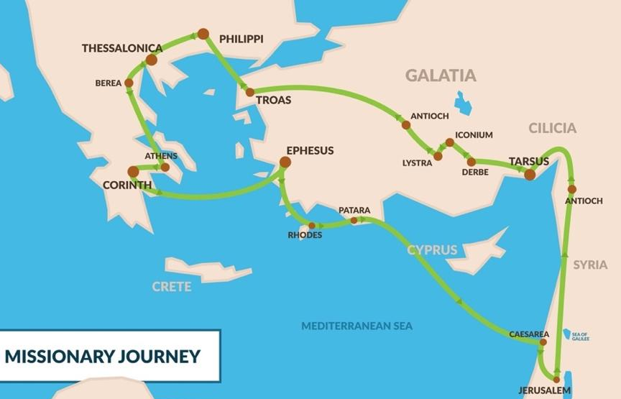
⁸ Paul entered the synagogue and spoke boldly there for three months, arguing persuasively about the kingdom of God. ⁹ But some of them became obstinate; they refused to believe and publicly maligned “the Way”.
He returned to the synagogue when he came back to Ephesus and continued his ministry there. As usual there were some who believed and some who didn’t. In this case there were some who were disparaging the believers who were known as “The Way”.
“So Paul left them. He took the disciples with him and had discussions daily in the lecture hall of Tyrannus. ¹⁰ This went on for two years, so that all the Jews and Greeks who lived in the province of Asia heard the word of the Lord.”
Just as in Corinth. When they were rejected in the synagogue, they found another location to gather. In this case it was the “lecture hall of Tyrannus”, presumably a philosophy school that welcomed them.
^{11 “}God did extraordinary miracles through Paul, ¹² so that even handkerchiefs and aprons that had touched him were taken to the sick, and their illnesses were cured and the evil spirits left them.
¹³ Some Jews who went around driving out evil spirits tried to invoke the name of the Lord Jesus over those who were demon-possessed. They would say, “In the name of the Jesus whom Paul preaches, I command you to come out.” ¹⁴ Seven sons of Sceva, a Jewish chief priest, were doing this. ¹⁵ One day the evil spirit answered them, “Jesus I know, and Paul I know about, but who are you?” ¹⁶ Then the man who had the evil spirit jumped on them and overpowered them all. He gave them such a beating that they ran out of the house naked and bleeding.” 😐

This incident is sadly comical, but shows us a very important truth.

“In the name of Jesus” – means under His authority and according to His will.
NOT just invoking His name for your own purposes.

When we say or do anything “In Jesus Name”, it does not mean simply using the word J-E-S-U-S for our own purposes.

When we speak or pray “in Jesus’ name”, it means we are aligned and submitted with His will, His purposes and His Spirit not our own.

If it is for our own selfish purposes or our own vanity (pride), then it could be that we are “taking the Lord’s name in vain” according to the 3rd commandment.
Examples:
- Politicians who use Bible verses in their speeches yet have no intention of honoring God in their lives or their policies.

- High-Profile Ministries who use words like; “Faith, “the Word of God” and even the name of “Jesus” primarily to make millions of dollars for themselves. (only God knows their heart)

- Activists and social justice warriors who take parts out of the Bible that promote their cause yet have no intention of applying the whole counsel of God or submitting their lives to Him.

^{17 “}When this became known to the Jews and Greeks living in Ephesus, they were all seized with fear, and the name of the Lord Jesus was held in high honor. ¹⁸ Many of those who believed now came and openly confessed what they had done. ¹⁹ A number who had practiced sorcery brought their scrolls together and burned them publicly. When they calculated the value of the scrolls, the total came to fifty thousand drachmas ²⁰ In this way the word of the Lord spread widely and grew in power.”
Amazing! God was moving so powerfully through Paul and the other believers that many became believers and those who had been sorcerers burned their evil magic books publicly which were valued at 50,000 drachmas. (A drachma was a day’s wages).
^{21 “}After all this had happened, Paul decided to go to Jerusalem, passing through Macedonia and Achaia. “After I have been there,” he said, “I must visit Rome also.” ²² He sent two of his helpers, Timothy and Erastus, to Macedonia, while he stayed in the province of Asia a little longer.”
So Paul announced his plans to go back east to Jerusalem, but not before going West to the churches he planted in Macedonia and Achaia, and then also making a stop in Rome, where he had not yet been. But he stayed in Ephesus a little longer, just enough time to be there for the riot.
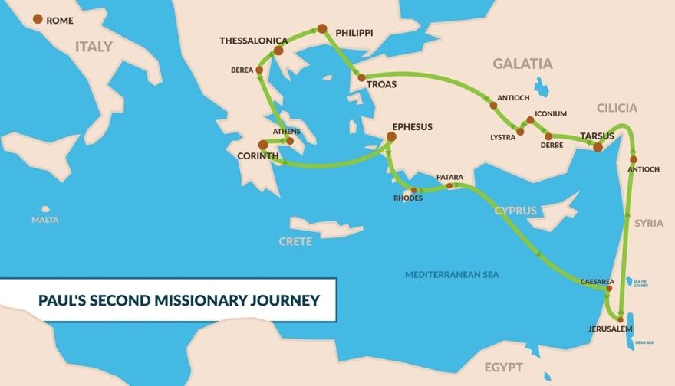
The Riot in Ephesus
^{23 “}About that time there arose a great disturbance about the Way. ²⁴ A silversmith named Demetrius, who made silver shrines of Artemis, brought in a lot of business for the craftsmen there. ²⁵ He called them together, along with the workers in related trades, and said: “You know, my friends, that we receive a good income from this business. ²⁶ And you see and hear how this fellow Paul has convinced and led astray large numbers of people here in Ephesus and in practically the whole province of Asia. He says that gods made by human hands are no gods at all. ²⁷ There is danger not only that our trade will lose its good name, but also that the temple of the great goddess Artemis will be discredited; and the goddess herself, who is worshiped throughout the province of Asia and the world, will be robbed of her divine majesty.”
²⁸ When they heard this, they were furious and began shouting: “Great is Artemis of the Ephesians!” ²⁹ Soon the whole city was in an uproar. The people seized Gaius and Aristarchus, Paul’s traveling companions from Macedonia, and all of them rushed into the theater together. ³⁰ Paul wanted to appear before the crowd, but the disciples would not let him. ³¹ Even some of the officials of the province, friends of Paul, sent him a message begging him not to venture into the theater.
³² The assembly was in confusion: Some were shouting one thing, some another. Most of the people did not even know why they were there. ³³ The Jews in the crowd pushed Alexander to the front, and they shouted instructions to him. He motioned for silence in order to make a defense before the people. ³⁴ But when they realized he was a Jew, they all shouted in unison for about two hours: “Great is Artemis of the Ephesians!”
So for two hours, they had to endure the being brought in front of an amphitheater with angry crowds spewing antisemitism and pagan worship. Things did not look good.

^{35 “}The city clerk quieted the crowd and said: “Fellow Ephesians, doesn’t all the world know that the city of Ephesus is the guardian of the temple of the great Artemis and of her image, which fell from heaven? ³⁶ Therefore, since these facts are undeniable, you ought to calm down and not do anything rash. ³⁷ You have brought these men here, though they have neither robbed temples nor blasphemed our goddess. ³⁸ If, then, Demetrius and his fellow craftsmen have a grievance against anybody, the courts are open and there are proconsuls. They can press charges. ³⁹ If there is anything further you want to bring up, it must be settled in a legal assembly. ⁴⁰ As it is, we are in danger of being charged with rioting because of what happened today. In that case we would not be able to account for this commotion, since there is no reason for it.” ⁴¹ After he had said this, he dismissed the assembly.”
Once again, just as with Gallio in Corinth, the city official exonerated Paul when the crowds turned against him and brought him to trial. No harm came to Paul, he was rescued from persecution and death.
Paul was operating “In the name of Jesus”. He was committed to serving Jesus, following Jesus, submitting to Jesus, and was willing to suffer and die for Jesus.
In the last chapter (18) in the previous city (Corinth), the Lord told Paul:
“Do not be afraid; keep on speaking, do not be silent. For I am with you, and no one is going to attack and harm you…”
In the next chapter (20), the Lord tells Paul; “prison and hardships / chains and tribulations await you”.
This did not change his plans. Paul was willing to accept suffering OR success as he followed the Holy Spirit’s leading and operated in Jesus’ name.

This is a lesson to all of us.
There will be times when no harm will come to us and everything will go our way.
There will be other times when it seems that hardships and tribulations are all around us and we can’t get a break.
It’s important that we never interpret comfortable easy times as a sign of “God’s favor” and difficult challenging times as a sign of “God’s disapproval”.
When we commit to follow Jesus and operate in “His name” we will experience triumphs and also trials, suffering and success.
This has been the theme for the believers all throughout Acts. They experienced incredible miracles, moves and outpourings of God’s power, mixed with suffering persecution and in some cases even martyrdom.
Jesus is with us in all seasons and situations, He himself even warned us of this;
John 16:33 “I have told you these things, so that in me you may have peace. In this world you will have trouble. But take heart! I have overcome the world.”
Paul’s life is marked with incredible moments of powerful moves of God and tremendous success. He also suffered as much or more than any of the other apostles.

2 Cor. 11:23-28 “I have worked much harder, been in prison more frequently, been flogged more severely, and been exposed to death again and again. ²⁴ Five times I received from the Jews the forty lashes minus one. ²⁵ Three times I was beaten with rods, once I was pelted with stones, three times I was shipwrecked, I spent a night and a day in the open sea, ²⁶ I have been constantly on the move. I have been in danger from rivers, in danger from bandits, in danger from my fellow Jews, in danger from Gentiles; in danger in the city, in danger in the country, in danger at sea; and in danger from false believers. ²⁷ I have labored and toiled and have often gone without sleep; I have known hunger and thirst and have often gone without food; I have been cold and naked. ²⁸ Besides everything else, I face daily the pressure of my concern for all the churches.”

When I perform a wedding ceremony, I often ask the bride and groom to commit to each other through the formal traditional vows. They are promises to love each other through good and bad, hard and easy times.

- for better for worse, (regardless of circumstance)
- for richer or poorer, (through feast or famine)
- in sickness and in health, (though any kind of ailment or condition)

This is the commitment the Lord has toward us and asks of us toward Him as well.

If we only are willing to follow him “for better not worse, for richer not poorer, and in health not sickness” we are not fully committed to Him.

I know that it is difficult when things become seemingly unbearable in our situations, relationships or health. But the same God who asks us to follow him for better or for worse, gives us the strength to help us in times of weakness.

Paul gives great advice on this subject as one who has learned to both be abased and to abound, to “have nothing but need”, and to “have need of nothing”.

Never despair when hard times come, instead learn to be content, knowing that every difficulty or weakness is a new opportunity for you to see God’s power and strength in your life.

Phil 4:11-13 “I have learned to be content regardless of my circumstances. I know how to live humbly, and I know how to abound. I am accustomed to any and every situation—to being filled and being hungry, to having plenty and having need. I can do all things through Christ who gives me strength”.

