ACTS AND US / Acts Review
__
After Jesus rose from the dead, he remained on earth for 40 days. During that time, he appeared to the Apostles several times and to over 500 people continuing to teach them about the scriptures and the Kingdom of God.
At the end of the 40 days he ascended to heaven, but not before giving special instructions, and the promise of the Holy Spirit.
- Writer of Acts: LUKE – Not one of the 12, a physician, close friend and traveler with Paul. The only non-Jewish writer of a New Testament book. Very articulate, observant and careful historian.
- Time it was written: 63-70 AD – Interesting that there is no mention however of major events that took place toward the end of that span; i.e. Burning of Rome (64AD), Martyrdom of Peter OR Paul (67AD +/-), and the destruction of Jerusalem in 70AD.
- Written to: Theophilus – The same person the gospel of Luke was written to. Likely a person of prominence, perhaps Greek, possibly Roman.
- Theme: A written accurate historical account of the last moments of the life of Jesus and the beginnings of the early church.
Acts is filled with accounts of God’s power manifested through the Apostles after Jesus ascended.
It begins with the ascension and moves quickly into Pentecost.
From there we see the Apostle’s operate in the power of the Holy Spirit first in Jerusalem, then into Syria, Asia Minor, Macedonia, Achaia, throughout the northeastern Mediterranean and finally Rome.
For the first half of Acts we see Peter as the primary instrument that God used to establish the church, first among the Jews in Jerusalem, then on into Joppa and Caesarea.
The second half of Acts focuses primarily on Paul as he is saved in Damascus, and goes on to plant churches in Galatia, Ephesus, Philippi, Thessalonica, Corinth and presumably many places in between.
_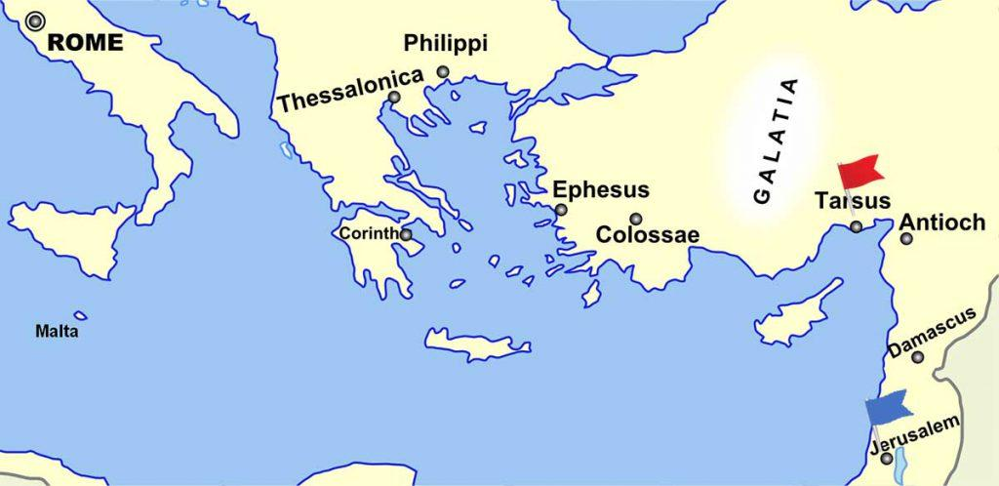_

Key verses of each chapter of the book of Acts

Each chapter tells the story of the development of the early church. Journey through the entire book, we are able to see the will of God unfold and His Word and power revealed. By selecting a passage from each chapter we are able to look at the progression of events that led to gospel being preached not only all throughout the region of the early church in the first century, but all throughout the world for thousands of years.

Acts 1:8 “But you will receive power when the Holy Spirit comes on you; and you will be my witnesses in Jerusalem, and in all Judea and Samaria, and to the ends of the earth.”

These are the last words of Jesus just before he was taken up to heaven in the Ascension. They are prophetic, because in the coming chapters, we see them filled with the Holy Spirit, and boldly witnessing starting in their local region of Jerusalem, into Judea, and eventually Rome (1300 miles away).

Acts 2 is the account of Pentecost, when the Holy Spirit was poured out over all those gathered for Shavuot in Jerusalem. It was an extraordinary manifestation of signs and wonders and the empowerment of the apostles, particularly Peter who preached to the Jews gathered there and over 3000 were saved and baptized.
Luke describes the daily life of the early church after Pentecost in the following verse.

Acts 2:42-47 “They devoted themselves to the apostles’ teaching and to fellowship, to the breaking of bread and to prayer. ⁴³ Everyone was filled with awe at the many wonders and signs performed by the apostles. ⁴⁴ All the believers were together and had everything in common. ⁴⁵ They sold property and possessions to give to anyone who had need. ⁴⁶ Every day they continued to meet together in the temple courts. They broke bread in their homes and ate together with glad and sincere hearts, ⁴⁷ praising God and enjoying the favor of all the people. And the Lord added to their number daily those who were being saved.”

Acts 3 opens up with Peter and John going to the temple to pray as they normally would (showing that they did not “jettison their Jewishness” after Pentecost). They encountered a lame man at the gate and healed him. In that healing we see the richness of currency that they were dealing with. It was not financial but was richly powerful in the name of Jesus.

Acts 3:6 “Then Peter said, “Silver or gold I do not have, but what I do have I give you. In the name of Jesus Christ of Nazareth, walk.”
( he got up walking, leaping and praising God)

By Acts 4 the Sanhedrin had gotten wind of what was happening, they responded by demanding that the Apostle no longer do or say anything in the name of Jesus.
Peter, filled with the Holy Spirit responded with a statement that has become a cornerstone in our faith and denomination, declaring that it is only in Jesus’ name that we can be saved.

Acts 4:12 “ Salvation is found in no one else, for there is no other name under heaven given to mankind by which we must be saved.”

In Acts 5, the High Priests strictly commanded them to not teach in His name. They were not willing to obey, and explained why.

Acts 5:29-32 “²⁹ Peter and the other apostles replied: “We must obey God rather than human beings! ³⁰ The God of our ancestors raised Jesus from the dead—whom you killed by hanging him on a cross. ³¹ God exalted him to his own right hand as Prince and Savior that he might bring Israel to repentance and forgive their sins. ³² We are witnesses of these things, and so is the Holy Spirit, whom God has given to those who obey him.”

Persecution persisted, but the church continued to grow larger and larger and needed organization. By Acts 6, they realized that they needed to establish leadership within the church. They had a large meeting of the church and commissioned leaders from among them, primarily for the duties of organization and logistics.

Acts 6:3-4 “Brothers and sisters, choose seven men from among you who are known to be full of the Spirit and wisdom. We will turn this responsibility over to them ⁴ and will give our attention to prayer and the ministry of the word.”

One of those who was chosen was Stephen, a very powerful disciple whom God used to work miracles and preach the word. He was the first however to be martyred. During his execution we get to see a glimpse of what he saw when heaven was opened to welcome him.

Acts 7:55-56 “ But Stephen, full of the Holy Spirit, looked up to heaven and saw the glory of God, and Jesus standing at the right hand of God. ⁵⁶ “Look,” he said, “I see heaven open and the Son of Man standing at the right hand of God.”

In Acts 8 we see the conversion of the Ethiopian Eunuch through the ministry of Philip. He was an African man in service to a wealthy queen. He was also Jewish and puzzled over the reading of Isaiah 53. We get a closeup look at a new convert receiving the Lord and being baptized in the spot.

Acts 8:36-39 “³⁶ Now as they went down the road, they came to some water. And the eunuch said, “See, here is water. What hinders me from being baptized?”³⁷ Then Philip said, “If you believe with all your heart, you may.” And he answered and said, “I believe that Jesus Christ is the Son of God.” ³⁸ So he commanded the chariot to stand still. And both Philip and the eunuch went down into the water, and he baptized him. ³⁹ Now when they came up out of the water, the Spirit of the Lord caught Philip away, so that the eunuch saw him no more; and he went on his way rejoicing.”
One of the most remarkable events in the entire New Testament was the conversion of Saul on the road to Damascus. Saul was a mean-spirited Pharisee who vehemently opposed Jesus followers and did all he could to chase them down and drag them off to jail. He was struck blind in his tracks by Jesus and became the most prolific follower of Jesus for the rest of the New Testament and wrote more books of the Bible than any other writer.
Acts 9:21-22 “²¹ Then all who heard were amazed, and said, “Is this not he who destroyed those who called on this name in Jerusalem, and has come here for that purpose, so that he might bring them bound to the chief priests?” ²² But Saul increased all the more in strength, and confounded the Jews who dwelt in Damascus, proving that this Jesus is the Christ (Messiah).”
Up until this point in church history, everyone was Jewish. All the disciples, converts and multitudes were people who were ethnically and traditionally Jewish, but that was about to change. In Acts 10 and 11 Peter first receives a puzzling symbolic vision while asleep on a rooftop of Joppa, that came into fruition the next day in Caesura, when Cornelius a Roman (Gentile) centurion received the Lord along with his household.

In Joppa
Acts 10:15-16 “And a voice spoke to him again the second time, “What God has cleansed you must not call common.”
In Caesarea
Acts 11:18 “When they heard these things they became silent; and they glorified God, saying, “Then God has also granted to the Gentiles repentance to life.”

Severe persecution continued. In the beginning of Acts 12 the apostle James (brother of John) was killed by Herod. Peter was taken into custody and was presumably next. The apostles prayed. By the end of the chapter, Peter was miraculously released. Herod was miraculously killed. And the gospel continued to spread.
Acts 12:23-24 “ Then immediately an angel of the Lord struck [Herod], because he did not give glory to God. And he was eaten by worms and died. ²⁴ But the word of God grew and multiplied.”
In Acts 13 the missionary journeys had successfully begun. First with Paul and Barnabas into Cyprus, Pamphylia and Antioch…

Acts 13:49 & 52 “And the word of the Lord was being spread throughout all the region…^{. 52} And the disciples were filled with joy and with the Holy Spirit.”

Next to the Galatian churches (Lystra, Iconium and Derbe)

Acts 14: 27 “ Now when they had come and gathered the church together, they reported all that God had done with them, and that He had opened the door of faith to the Gentiles.”

The Gentiles issue proved to be problematic for some. The Jews were questioning whether they should require them to go through all the Jewish customs, rituals and “mitzvot” to accept the Jewish Messiah. Peter worked it out in a meeting that is called “The Jerusalem Council”. This is Peter’s last appearance in Acts.

Acts 15:10-11 “Now therefore, why do you test God by putting a yoke on the neck of the disciples which neither our fathers nor we were able to bear? ¹¹ But we believe that through the grace of the Lord Jesus Christ we shall be saved in the same manner as they.”

In Acts 16 Paul and Silas find themselves in a Philippian Jail. When they were miraculously freed at night, the Philippian jailor asked a question whose answer confirms a very important soteriological statement about the requirements of salvation.
Acts 16:29-31 “The jailer called for lights, rushed in and fell trembling before Paul and Silas. ³⁰ He then brought them out and asked, “Sirs, what must I do to be saved? ³¹ They replied, “Believe in the Lord Jesus, and you will be saved.”
In Acts 17 Paul travels to Thessalonica, and Berea, before being sent alone to Athens where he addressed the Greek Philosophers of the Areopagus. Using quotes from their own philosophers, he explained that the “unknown God” is the maker of heaven and earth, and the giver of life.

Acts 17:24-25 “ “The God who made the world and everything in it is the Lord of heaven and earth and does not live in temples built by human hands. ²⁵ And he is not served by human hands, as if he needed anything. Rather, he himself gives everyone life and breath and everything else.”

In Acts 18 & 19 we are introduced to some of the leaders Paul raised up in the early church including Aquila, Priscilla and Apollos. He also established the churches of both Corinth and Ephesus.
In Acts 20 and 21 he announced to the elders of the churches that he is being compelled to go back to Jerusalem, even though it is dangerous and he will get persecuted and imprisoned.
Acts 20:22-24 ““And now, compelled by the Spirit, I am going to Jerusalem, not knowing what will happen to me there. ²³ I only know that in every city the Holy Spirit warns me that prison and hardships are facing me. ²⁴ However, I consider my life worth nothing to me; my only aim is to finish the race and complete the task the Lord Jesus has given me—the task of testifying to the good news of God’s grace.”

Acts 21:13 “When we heard this, we and the people there pleaded with Paul not to go up to Jerusalem. ¹³ Then Paul answered, “Why are you weeping and breaking my heart? I am ready not only to be bound, but also to die in Jerusalem for the name of the Lord Jesus.”

[ How many of us have this commitment to the work of the Lord and preaching the gospel?]

It happened just as Paul expected. In Acts 22 he went back to Jerusalem and preached to “good news” to the Jewish people that the Messiah had come, and it was Jesus of Nazareth who died and rose again. And just as was prophesied, he was persecuted and bound in jail.

That night the Lord visited him and promised him, that he would go to Rome to testify just as he did in Jerusalem.

Acts 23:11 “The following night the Lord stood near Paul and said, “Take courage! As you have testified about me in Jerusalem, so you must also testify in Rome.”

In the next four chapters, Paul is taken to Caesarea by a Roman battalion, where he spent two years testifying before the High Priests who were sent from Jerusalem to accuse him, as well as two Roman governors and one king.

Each time he explained to them that he is being accused of speaking against the Hebrew scriptures and inciting crowds to do likewise. He explained very thoroughly that the message of the gospel is not in opposition to the Jewish scriptures, but a completion of it, and that Jesus of Nazareth is the long-awaited Messiah.

Acts 24:14 “I worship the God of our ancestors as a follower of the Way, which they call a sect. I believe everything that is in accordance with the Law and that is written in the Prophets.”

In Acts 25 and 26 he appealed to Caesar as a Roman citizen, and was sent to Rome by way of the sea in Acts 27 and 28.

The Final verse:

Acts 28:30 “For two whole years Paul stayed there in his own rented house and welcomed all who came to see him. ³¹ He proclaimed the kingdom of God and taught about the Lord Jesus Christ—with all boldness and without hindrance!”

ACTS & US

The message of Acts is simple, be filled with the Holy Spirit and watch what happens…
The stories of Acts are not meant to tease us, as if to say “…THEY did extraordinary things as God moved mightily through them, but YOU can’t experience any of that and will live boring, fruitless and ordinary lives.” : {
It’s the opposite, “see what God can do through YOU!”

Each chapter of Acts serves as an example of what can happen if we fully devote ourselves to the work of the Lord, be willing, available, and obedient to do all that He asks of us.

I believe that if we can commit to these three things, being;
WILLING, AVAILBLE, AND OBEDIENT.
- we will see God ignite the gifts within us, to use us mightily to preach the gospel,
- and proclaim the kingdom of God with “all boldness and without hindrance” in Jerusalem, Judea, Samaria and to the ends of the earth.
- And the Lord will add to our number daily, those who were being saved! <>

