ACTS AND US – Acts 28
“See, Hear, and Understand”
Previously on Acts and Us
Luke reports all that happens to Paul and accompanies him every step of the way (we).
- Paul went back to Jerusalem after planting and cultivating many churches in Asia Minor, Macedonia and Achaia including; Galatia, Philippi, Thessalonica, Corinth, Ephesus and others (including Colossae).

- When he got back to Jerusalem, the Jews turned against him based on false reports of his teaching that were sent by some in Asia Minor.

- The mob turned against him and tried to kill him.

- The Romans took him into protective custody in Caesarea, they questioned him, and would have released him if he had not appealed to Caesar as a Roman citizen.

- The Lord came to him at night and told him that he must go and testify in Rome.

- The Romans sent him on a ship bound for Rome, that experienced several delays and storms along the way.

- Before reaching Rome they were shipwrecked just off the shore of the island of Malta (just south of Sicily).

ACTS 28:1-6 “Once safely on shore, we found out that the island was called Malta. ² The islanders showed us unusual kindness. They built a fire and welcomed us all because it was raining and cold. ³ Paul gathered a pile of brushwood and, as he put it on the fire, a viper, driven out by the heat, fastened itself on his hand. ⁴ When the islanders saw the snake hanging from his hand, they said to each other, “This man must be a murderer; for though he escaped from the sea, the goddess Justice has not allowed him to live.” ⁵ But Paul shook the snake off into the fire and suffered no ill effects. ⁶ The people expected him to swell up or suddenly fall dead; but after waiting a long time and seeing nothing unusual happen to him, they changed their minds and said he was a god.”
So after 14 days and nights at sea, they finally reach land. The islanders show them unusual kindness and build a fire in the cold rain (which is hard to do – like church planting on the Peninsula).
When Paul was bitten by a venomous snake in the brush he had grabbed, the locals assumed that he was about to die as punishment from the goddess of justice (possibly Themis) because he must be a murderer.
When he just shook the snake off and survived the snake bite, they decided that he was a “god”.
This was the fulfillment of the very last words that Jesus spoke in the long ending of the book of Mark.
Mark 16:18 “they will pick up snakes with their hands; and when they drink deadly poison, it will not hurt them at all; they will place their hands on sick people, and they will get well.”
The “snake part” had just happened, the part where they “place their hands on sick people, and they get well” was about to take place here on the island.
^{7 “}There was an estate nearby that belonged to Publius, the chief official of the island. He welcomed us to his home and showed us generous hospitality for three days. ⁸ His father was sick in bed, suffering from fever and dysentery. Paul went in to see him and, after prayer, placed his hands on him and healed him. ⁹ When this had happened, the rest of the sick on the island came and were cured. ¹⁰ They honored us in many ways; and when we were ready to sail, they furnished us with the supplies we needed.”
This all took place during the Fall and Winter of the year ’57. Paul was eager to get to Rome, he had never been there but had already written his letter to the Roman church called “Romans”. In it he writes;
Romans 1:11-13 “¹¹I long to see you so that I may impart to you some spiritual gift to make you strong— ¹² that is, that you and I may be mutually encouraged by each other’s faith. ¹³ I do not want you to be unaware, brothers and sisters, that I planned many times to come to you (but have been prevented from doing so until now) in order that I might have a harvest among you, just as I have had among the other Gentiles.”
There was a strong growing church happening in Rome. It seems to be primarily Gentile from what we read in Romans 1. Unlike the other cities where Paul planted churches, here in Rome he will go to the believers first (Jews/Gentiles) and then preach to the unbelieving Jews.
The Lord’s plan for him was to testify to the Jews in Rome, just as he did to those in Jerusalem when this journey began.
Acts 23:11 “The following night the Lord stood near Paul and said, “Take courage! As you have testified about me in Jerusalem, so you must also testify in Rome.”
It is uncertain if Paul ever stood before Caesar (Nero), but he did get to Rome here at the end of his third missionary journey and was kept under house-arrest where he could meet with people, write epistles and testify to the Jews.
^{11 “}After three months we put out to sea in a ship that had wintered in the island—it was an Alexandrian ship with the figurehead of the twin gods Castor and Pollux. ¹² We put in at Syracuse and stayed there three days. ¹³ From there we set sail and arrived at Rhegium. The next day the south wind came up, and on the following day we reached Puteoli. ¹⁴ There we found some brothers and sisters who invited us to spend a week with them.”

So they left Malta after the winter, and traveled to Sicily (“Ciao Siciliani”), where they stayed a few days in Syracuse (a Roman city on the opposite side of the Island from Palermo). Then they crossed over into Italy at Rhegium, (modern day Calabria, the toe of the boot – “anyone Calabrezie out there?”). Then they spent a week in Puteoli (near Naples) before heading into Rome.

^{14b}And so we came to Rome. ¹⁵ The brothers and sisters there had heard that we were coming, and they traveled as far as the Forum of Appius and the Three Taverns to meet us. At the sight of these people Paul thanked God and was encouraged. ¹⁶ When we got to Rome, Paul was allowed to live by himself, with a soldier to guard him.”

(Recap the journey on the map)

_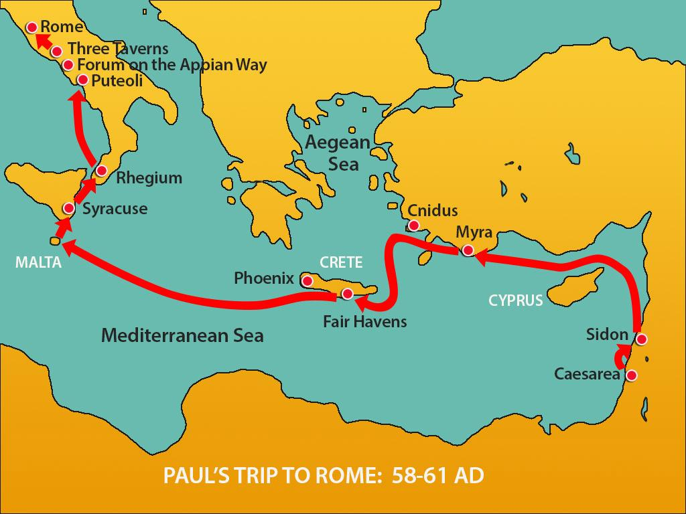_

Paul Preaches at Rome Under Guard
^{17 “}Three days later he called together the local Jewish leaders. When they had assembled, Paul said to them: “My brothers, although I have done nothing against our people or against the customs of our ancestors, I was arrested in Jerusalem and handed over to the Romans. ¹⁸ They examined me and wanted to release me, because I was not guilty of any crime deserving death. ¹⁹ The Jews objected, so I was compelled to make an appeal to Caesar. I certainly did not intend to bring any charge against my own people. ²⁰ For this reason I have asked to see you and talk with you. It is because of the hope of Israel that I am bound with this chain.”
Once again, Paul’s message is not against Judaism in any way, it’s a fulfillment of it. He gave them the same message he gave the Jerusalem Jews; he told them about “The Hope of Israel” (Yeshua HaMashiach – Jesus the Messiah).
^{21 “}They replied, “We have not received any letters from Judea concerning you, and none of our people who have come from there has reported or said anything bad about you. ²² But we want to hear what your views are, for we know that people everywhere are talking against this sect.”
Thankfully they did not receive any false accusations waged against Paul like they did in Jerusalem. They were actually very interested in hearing what Paul had to say about his “sect” of Judaism (The Nazarenes) that people are speaking against.
^{23 “}They arranged to meet Paul on a certain day, and came in even larger numbers to the place where he was staying. He witnessed to them from morning till evening, explaining about the kingdom of God, and from the Law of Moses and from the Prophets he tried to persuade them about Jesus. ²⁴ Some were convinced by what he said, but others would not believe.
²⁵ They disagreed among themselves and began to leave after Paul had made this final statement:
“The Holy Spirit spoke the truth to your ancestors when he said through Isaiah the prophet:
²⁶ “‘Go to this people and say,
“You will be ever hearing but never understanding;
you will be ever seeing but never perceiving.”
²⁷ For this people’s heart has become calloused;
they hardly hear with their ears,
and they have closed their eyes.
Otherwise they might see with their eyes,
hear with their ears,
understand with their hearts
and turn, and I would heal them.’

²⁸ “Therefore I want you to know that God’s salvation has been sent to the Gentiles, and they will listen!”
This portion of scripture from Isaiah 6:9-10 is quoted in each of the four gospels (Matt. 13:14-15; Mark 4:11-12; Luke 8:10; John 12:40) and finally here by Paul.
It is taken from one of the most frequently quoted passages of the Old Testament Prophets, Isaiah 6 during his commissioning at the beginning of his ministry;
Isaiah 6:1-9 “In the year that King Uzziah died, I saw the Lord, high and exalted, seated on a throne; and the train of his robe filled the temple. ² Above him were seraphim, each with six wings: With two wings they covered their faces, with two they covered their feet, and with two they were flying. ³ And they were calling to one another:
“Holy, holy, holy is the Lord Almighty; the whole earth is full of his glory.”
⁴ At the sound of their voices the doorposts and thresholds shook and the temple was filled with smoke. ⁵ “Woe to me!” I cried. “I am ruined! For I am a man of unclean lips, and I live among a people of unclean lips, and my eyes have seen the King, the Lord Almighty.”
⁶ Then one of the seraphim flew to me with a live coal in his hand, which he had taken with tongs from the altar. ⁷ With it he touched my mouth and said, “See, this has touched your lips; your guilt is taken away and your sin atoned for.”
⁸ Then I heard the voice of the Lord saying, “Whom shall I send? And who will go for us? “And I said, “Here am I. Send me!”
⁹ He said, “Go and tell this people…”
Tell his people what?
What was the message that the Lord told Isaiah to tell his people?
The exact same message that the Lord told Paul to tell the Jews here at the very end of the book of Acts.
Acts 28:26-27 “‘Go to this people and say…
“You will be ever hearing but never understanding; you will be ever seeing but never perceiving.” ²⁷ For this people’s heart has become calloused; they hardly hear with their ears, and they have closed their eyes. Otherwise they might see with their eyes, hear with their ears, understand with their hearts and turn, and I would heal them.’”
These are very strong words from the Lord.
Who was he talking to in Isaiah, who was Paul talking to in Rome?
How is God speaking to us today?
In Isaiah - the people of Judah who had turned a deaf ear to the Lord. Instead of seeking Him, and serving Him with humility They turned their backs on God.
In Rome – Some of the Jews believed, but many rejected the word of the Lord and the message of Jesus Messiah, even after Paul endured such a long period of hardship and struggle to bring them the message. They hardened their hearts and still would not believe.
How about us? - Have our hearts become calloused to the word of God? DO we neglect the study of His Word, or fail to apply it to our lives? It’s easy to become like those this scripture is directed to;
“ever hearing but never understanding; ever seeing but never perceiving…they hardly hear with their ears, and they have closed their eyes.”
In other words, we hear the word of God and see Him at work but we don’t fully understand it or fully perceive it because our hearts are hardened.
How does this happen? When we allow sin and doubt to take root in our lives. When we open our hearts to things other than that which the Lord has for us. It makes us blind, deaf, and callous to the things of God.
God wants us to fully experience the joy of His presence. He wants us to understand His word and perceive the work of the Spirit all around us.

In other words, He wants us to “see with our eyes, hear with our ears, understand with our hearts.”
Paul prayed this prayer to the Ephesians that I want us to receive today. Especially those who are experiencing the blindness or hardening of our hearts.

Eph 1:18-19 “I pray that the eyes of your heart may be enlightened in order that you may know the hope to which he has called you, the riches of his glorious inheritance in his holy people, ¹⁹ and his incomparably great power for us who believe.”

That’s my prayer for you, that you would know; His Hope, the riches of His glory, and His incomparably great power by believing in Him with all your heart.

When you know it, see it, hear it, and feel it, you can’t help but share it and proclaim it, just as Paul did in the very last verse of Acts.
Acts 28:30 “For two whole years Paul stayed there in his own rented house and welcomed all who came to see him. ³¹ He proclaimed the kingdom of God and taught about the Lord Jesus Christ—with all boldness and without hindrance!” <>

ACTS & US
So, as it was in Acts, so it is for Us;
Let’s proclaim the kingdom of God,
and tell about the Lord Jesus Christ,
with all boldness and without hindrance,
in Jerusalem, Judea, Samaria and to the ends of the earth!

