TRICHOTOMY
(BODY, SOUL, AND SPIRIT)
From the book: Soul or the Spirit
﻿﻿
The Word of God reveals to us that we are made up of three primary parts: body, soul, and spirit, which make us trichotomous (having three parts). This concept, which is sometimes referred to as trichotomy, is supported throughout the Bible in various verses. The key verse for our study is 1st Thessalonians 5:23. It is here where we see it explained most clearly that we are comprised of these three unique parts.

1st Thessalonians 5:23 “May God himself, the God of peace, sanctify you through and through. May your whole spirit, soul and body be kept blameless at the coming of our Lord Jesus Christ.”

Most of us know what our body is, but it is sometimes confusing clearly defining what our soul and spirit are and how they are different. To fully understand the difference between the soul and the spirit, we need to understand the entire makeup of who we are and how we are created. That includes not just the soul and spirit, but the body as well. The term used to describe an entity made up of three unique parts is “Tripartite.”

Paul tells us that these three parts are how he identifies a whole person, whom he prays that God would “sanctify through and through.” He carefully identifies each of these and is careful to use the words that describe them best.
1. Spirit (Greek: pneuma)
2. Soul (Greek: psuchē)
3. Body (Greek: sōma)

Pastor Chuck Smith compared our trichotomy to the concept of the tripart divine Trinity. We, as those made in His image also function as three-in-one; however, in our case, we exist as an “inferior trinity”—our spirit is the part that communes with God.

“The superior Trinity is made up of the Father, Son, and Holy Spirit.
The inferior trinity is the spirit, soul, and body of man. And it is in the realm of the spirit where man meets God.” (Pastor Chuck Smith)

Each of us is intentionally designed by our Creator with these three unique parts of our being. Each is different, but each is necessary. Each gives us the ability to relate to God and others in unique ways.
Charles Spurgeon presents trichotomy with an emphasis on the spirit as the power of the three.

“Man consists of three parts, body, soul, and spirit, and the spirit is the power of the three.” (C. H. Spurgeon)
Watchman Nee, whose powerful ministry transformed Christianity in China nearly one hundred years ago through preaching, church-planting, and theological works, writes very clearly on this subject:

“The Bible never confuses spirit and soul as though they are the same. Not only are they different in terms; their very natures differ from each other. The Word of God does not divide man into the two parts of soul and body. It treats man, rather, as “tripartite,” spirit, soul, and body.” (Watchman Nee)

There have been several forms of diagrams that have emerged in the study of trichotomy, or body, soul, and spirit. Probably the most popular version is the concentric version created by Watchman Nee as a diagram in his book The Release of the Spirit.

_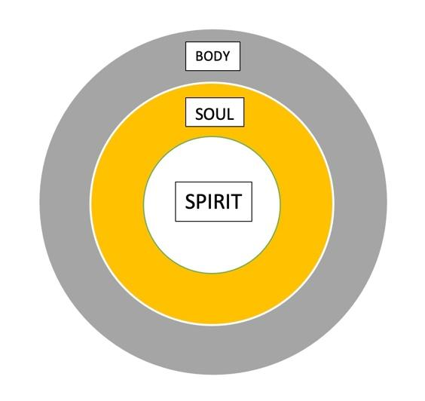_

Nee places the spirit at the center of the concentric diagram, emphasizing it as the innermost entity, and the body as the most external, with the soul in between. He even compares it with the structure of the Temple, with the outer court being the most common area, the Holy Place as the area by which one can draw close to God, and of course the Holy of Holies at the center, the dwelling place of God.

This is an excellent analogy, especially since Paul describes our spirit as our “inner man.” His diagram is accurate and effective in this context; however, for our purposes, we will most often refer to the lateral diagram (below) that I have created to compare and show the dynamics of the relationship between the three parts.

_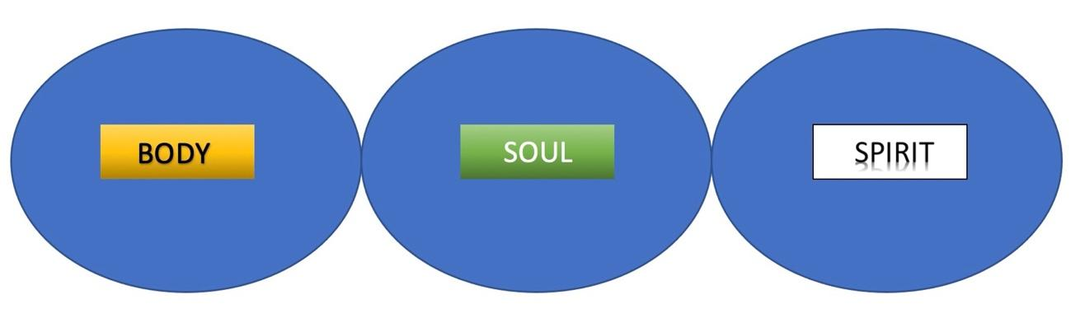_
﻿This diagram allows us to look at each part separately within the whole of one individual. We will study each part specifically, using scripture to see how they relate to one another. We will also look at other components within them, particularly parts of the soul.

So, now having identified the three parts of our tripart being, let’s look at each one and see what it is and what it does.

BODY, SOUL, and SPIRIT

BODY – (easiest to identify)

1st Cor 6:19 “Do you not know that your bodies are temples of the Holy Spirit, who is in you…”

This is our physical body, our temporary “tent” that we are housed in while here on earth. It is designed by God with senses, behaviors, and survival instincts.
It’s important to mention that as important as our bodies are, they are only temporary and superficial. They do not define who we are “In Christ”

Galatians 3:26-28 “So in Christ Jesus you are all children of God through faith, for all of you who were baptized into Christ have clothed yourselves with Christ. There is neither Jew nor Gentile, neither slave nor free, nor is there male and female, for you are all one in Christ Jesus.”

“clothed yourselves with Christ” – no longer be identified by your outward appearance, but by Christ within you, neither…

Jew nor Gentile, - (Ethnicity) This does not mean that the writers of the Bible would never refer to people as Jews or Gentiles anymore, they did. It simply means that in Christ, those things do not matter. All people, regardless of religious or ethnic background are equally given access to the Father. Our ethnicity and race, while it stills exists, and may in some ways be important to our background, should not be part of our identity of who we are as new creations in Christ Jesus.

neither slave nor free, (Socio-Economic) This does not mean that everyone is the same socio-economically, It means we are not to value or identify anyone according to that status, only who they are in Christ.

nor is there male and female (Gender) This is not a call towards gender-neutrality, only that men and women, while different physically, are the same spiritually, and equal in Christ Jesus.
SOUL – (a little more difficult to describe)

2nd Peter 2:14 “ They entice unsteady souls…”
1st Peter 1:9 “the salvation of your souls.”
1st Peter 1:22 “you have purified your souls in obeying the truth.”

Our soul is basically minds and our emotions, what we feel and what we think. This is our internal immaterial self, or personality and usually directs our will. So it could be said that our soul is our mind and emotions and in effect, our will.

SPIRIT – (who we are spiritually)

This is the spiritual part of us that is made alive when we are saved. Until that point it is dead or atrophied, keeping us from operating the way were intended, and most importantly preventing us from experiencing fellowship with God.

This spiritual death is a result of the curse, when God created ,man and woman, their spirits were alive. They could experience God fully and without restriction. When sin entered into the world however, “man surely died”, and could no longer operate on a spiritual realm.

Gen 2:17 “in the day that you eat from it you shall surely die.”

Man did not physically die (obviously) but became dead in the spirit and transferred the dead spirit to every generation to all those born of man.

This is how we are before we receive the Spirit of God by believing upon Jesus.
Sadly, this is how many of our friends, family and most of the people of the world are until they believe.

- [ Like the deflated beachball illustration]

_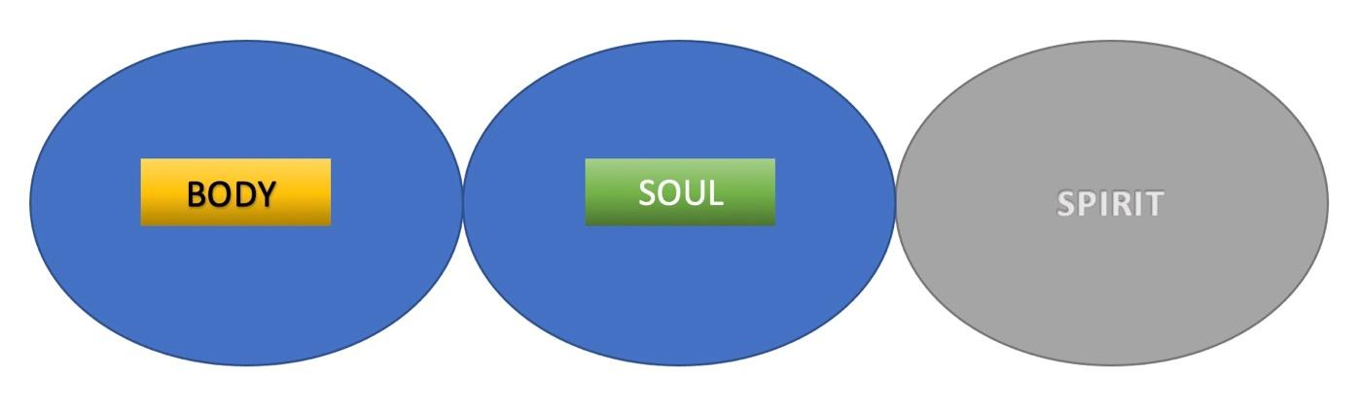

The only hope mankind had, was that someone be born whose spirit was not dead, because their Father’s spirit was alive – Jesus!

When we believe upon Jesus and invite Him into us by believing with our hearts, we don’t just change opinions or accept new intellectual concepts of theology, our spirits come to life!

Romans 8:10 “But if Christ is in you, your body is dead because of sin, yet your spirit is alive because of righteousness.”

_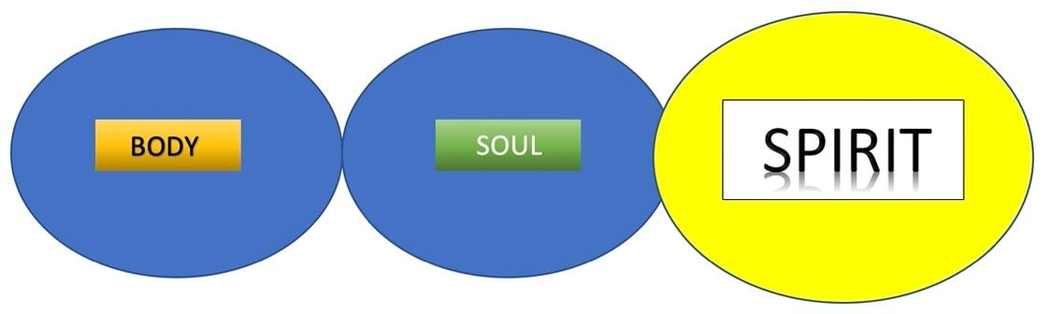_

Our Spirit is the part of us that God indwells and empowers by His Spirit. “It is in the realm of the spirit where man meets God.” (Chuck Smith)

All three parts of our being are unique and important. Each functions separately but alongside the other parts to make us who we are physically, mentally, emotionally, and spiritually.

The Soul or the Spirit?

It’s very common for people to confuse their soul and their spirit since these two invisible aspects of our being are not quite as easily identifiable as our bodies are. That’s why we need the Word of God to “divide,” or help make a distinction between the two.

Hebrews 4:12a “For the word of God is living and powerful, and sharper than any two-edged sword, piercing even to the division of soul and spirit.”

- W. Tozer, one of the founders of C&MA, confesses that he sometimes got confused between “soulish” expressions and “spiritual” worship.

“It seems, Lord, that I sometimes become caught up in soulish expressions of worship and mistake them for spiritual worship.” He goes on to describe “spiritual worship” in the same prayer as; “my spirit communing with Your Spirit.” (A.W. Tozer)
It will help us all to think about the spiritual part of our being the way Tozer did. The part of us that goes beyond our thoughts and emotions. The part of us that is deeper than that which our mind and emotions could fully grasp. The spiritual part of us, where God’s Spirit communes with our spirit.

Romans 8:16 “The Spirit himself testifies with our spirit that we are God’s children.”

As we read the Bible, we find that in some scriptures the words mind, heart, will, and thoughts are used interchangeably, but they all are part of, or connected to, our soul. This is why the soul is the battleground. It’s where we wrestle with the choice of following God with all of our hearts, or succumbing to the temptations of the flesh. It’s where we deal with lust, habits, ill intent, and pride. It’s also where we are most vulnerable to fear, anxiety, stress, and worry.

Galatians 5:17 “For the flesh desires what is contrary to the Spirit, and the Spirit what is contrary to the flesh. They are in conflict with each other, so that you are not to do whatever you want.”

THE FLESH IS PART OF OUR SOUL (our “Sin Nature”)
_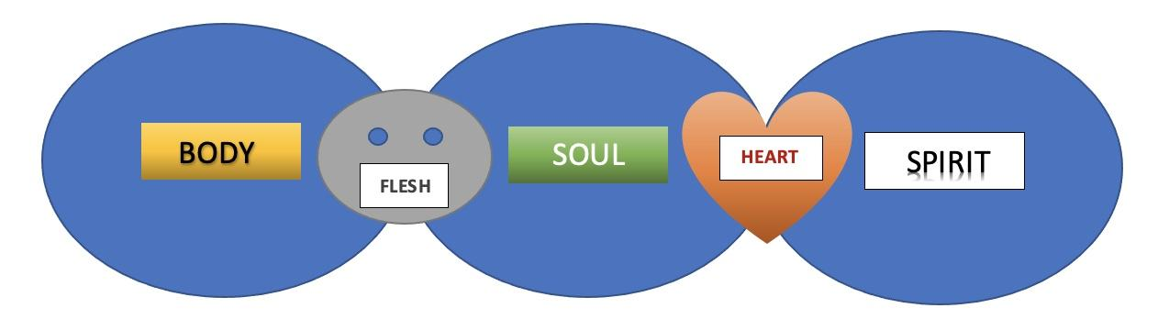_

This is why it’s so important to be led by the Spirit, NOT by the soul. When the Spirit is in control of your soul, you experience what it means to “walk in the Spirit.” When your soul is in control, it can cause you to “walk in the flesh.”
The soul, as represented by the “mind” will either be “governed” and controlled by the flesh, or the Spirit. There are severe consequences in the one and tremendous blessings in the other. This is why it’s so important to understand and meditate on the following scripture:

“The mind governed by the flesh is death, but the mind governed by the Spirit is life and peace.” (Romans 8:6 NIV)

So let’s take a closer look at what this verse means:

The mind (soul) governed by the flesh is death (stress, worry, anxiety, fear).

The mind (soul) governed by the Spirit is life and peace (love peace, joy, patience . . .)

If you are feeling overwhelmed by fear, worry, stress, and anxiety, it’s likely because you are allowing your mind (soul) to be governed by and controlled by your flesh instead of the Spirit.
As your focus shifts from soul to Spirit, you will find that you will worry less and pray more. You’ll freely make your needs known to God and thank Him for all He has done for you. Then you will experience the most amazing part of the journey: peace!
Not just temporary peace in the absence of chaos, but His peace that surpasses all human understanding.
This peace is given to us by the “God of peace.”
It’s a peace that the world can’t offer, or understand.
It’s the peace of Jesus, who is the Prince of Peace.
It’s the peace that can fill every part of your tripart being—your whole spirit, soul, and body through and through.
“May God himself, the God of peace, sanctify you through and through. May your whole spirit, soul and body be kept blameless at the coming of our Lord Jesus Christ.” (1st Thessalonians 5:23 NIV)

