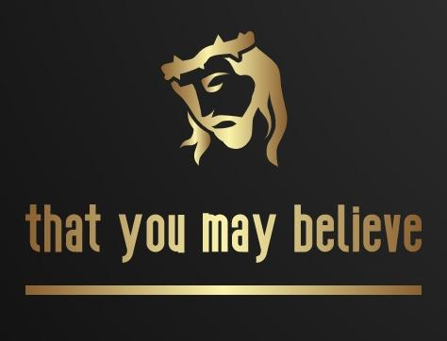

The Gospel of John – Chapter 1: “To Those Who Believe”

Most scholars believe it was written approx.. 85-90AD, making it the latest Gospel.

It was written by The apostle John, (although some contest John’s authorship).

In Christian tradition, John’s gospel has always been referred to as the fourth gospel, meaning it was composed after the other three. Polycarp, a second-century Christian martyr who knew John personally, told Irenaeus that John had written the book during the apostle’s time serving the church in Ephesus. These factors suggest that John wrote the book between AD 85 and AD 95.

John, along with his brother James were the sons of Zebedee and Salome. Jesus nicknamed them “Sons of Thunder”. (James was the first of the twelve apostles to be martyred, in Acts 12).

It is quite different than the Syn-optic gospels (Matt, Mark, Luke), whereas they were written as historical accounts, to present Jesus as the Messiah. There are events and sayings in John that are not in the other gospels.

John’s purpose for writing his gospel was to present both the human and divine nature of Jesus in order to encourage others “TO BELIEVE”.

In fact, he states this very clearly in our title verse:

John 20:31“But these are written that you may believe that Jesus is the Messiah, the Son of God, and that by believing you may have life in his name.”

The gospel of John is often looked at in four main parts;

Chapter 1 (known as the Prologue) The presentation of Jesus and His purpose and the introduction of John the Baptist, and several key disciples.

Chapters 2-12 (known as the Book of Signs) – Seven select Miracles (signs) performed by Jesus and the events surrounding them.

Chapters 13-20 (known as the Book of Glory) Jesus primarily addresses His 12 apostles, preparing them for the cross and beyond.

Chapter 21 (known as the Epilogue) Some additional interactions between Jesus and the Apostles after the resurrection.

The gospel begins the exact same way the Book of Genesis begins. With the words “In the Beginning”. (“bereshith” in Hebrew). The words “In the beginning”, refer to the “time before time”, the very beginning.

John 1
1 In the beginning was the Word, and the Word was with God, and the Word was God.
Right away, John presents Jesus as “The Word”. In doing so, he proclaims that Jesus was not only with God in the beginning, but IS God.
² He was with God in the beginning. ³ Through him all things were made; without him nothing was made that has been made.
By being God in the beginning, it gives Jesus credit for the creation of the world.
⁴ In him was life, and that life was the light of all mankind. ⁵ The light shines in the darkness, and the darkness has not overcome it.
“In Him was life” This statement was very important to establish who Jesus was and what he came for. The life that Jesus had in him, was the opposite of the “death” that mankind had in us. This is speaking directly to the spiritual death of our race that occurred in the garden of Eden. When Adam and Eve ate of the forbidden fruit, they surely died, just as God said.
(Gen 2:17) “but you must not eat from the tree of the knowledge of good and evil, for when you eat from it you will certainly die.”

The death they experienced was not their physical death, Adam lived to be 930 years old. They experienced Spiritual Death, and no longer had the deep spiritual fellowship with God that they had before the fall. Not only did this death affect them, but it has been passed down through generations to all mankind throughout the history of the world.
The light of all mankind had been snuffed out at the time Jesus came into the world. The only way someone could be born with that light, was to be born from a Father who did not bear the curse, and therefore was not of this world. Jesus was born as God’s son, and “In him was life, and that life was the light of all mankind.”
John the Baptist
⁶ There was a man sent from God whose name was John. ⁷ He came as a witness to testify concerning that light, so that through him all might believe.
John came as a witness to testify about Jesus so that ALL might believe. That was John’s purpose, to prepare the way for the Lamb of God who takes away the sins of the world.
⁸ He himself was not the light; he came only as a witness to the light. ⁹ The true light that gives light to everyone was coming into the world.
Jesus was bringing long awaited light into a very dark world. This is what the Prophet Isaiah wrote about in Isa. 60.
Isaiah 60:1-2
“Arise, shine, for your light has come, and the glory of the Lord rises upon you.
² See, darkness covers the earth and thick darkness is over the peoples,
but the Lord rises upon you and his glory appears over you.”
Jesus was the creator of the world, (being one with God). He came to bring light into the dark world, but He was not recognized or received by that which was His own.
¹⁰ He was in the world, and though the world was made through him, the world did not recognize him. ¹¹ He came to that which was his own, but his own did not receive him.
Isaiah also wrote;
“Who has believed our message and to whom has the arm of the Lord been revealed?^{…3} He was despised and rejected by mankind.” (Isa. 53:1&3)
But some did receive Him. These are those who accepted His message and believed on Him. We begin to meet some of the first “believers” toward the end of the chapter.
¹² Yet to all who did receive him, to those who believed in his name, he gave the right to become children of God— ¹³ children born not of natural descent, nor of human decision or a husband’s will, but born of God.
This is very important because sadly many people fail to realize that; ‘All people are God’s creation, but not all people are God’s children, only those who believe.’

The Bible is clear that all people are God’s creation, Col. 1:16 “For by him all things were created”,
and that God loves the entire world (John 3:16), but only those who are born again of spirit are children of God.

Romans 8:14 “For those who are led by the Spirit of God are the children of God.”
In Scripture, the lost are never referred to as God’s children. Ephesians 2:3 tells us that before we were saved we were “by nature objects of wrath”.

Romans 9:8 “it is not the natural children who are God’s children, but it is the children of the promise.”

THE WORD BECAME FLESH!
This is John’s version of the Christmas story. It is unlike Luke’s and Matthews’. There are no Angels, Shepherds, Manger. He doesn’t even mention Bethlehem or Joseph and Mary. He presents it in a very unique way;
^{14a}The Word became flesh and made his dwelling among us.
Up until this point, “the Word” was unnamed, in this section we will see that the “Word became flesh”, when Jesus was born.
Interestingly, John refers to Jesus by the name “The Word of God”, toward the end of Revelation, when he describes the rider of the white horse;
Rev. 19:11,13 “Now I saw heaven opened, and behold, a white horse. And He who sat on him was called Faithful and True,.... ¹³ He was clothed with a robe dipped in blood, and His name is called The Word of God.”
This is Jesus! Later in the chapter he bears the title; “KING OF KINGS AND LORD OF LORDS”.
^{14b}We have seen his glory, the glory of the one and only Son, who came from the Father, full of grace and truth. ¹⁵ (John testified concerning him. He cried out, saying, “This is the one I spoke about when I said, ‘He who comes after me has surpassed me because he was before me.’”) ¹⁶ Out of his fullness we have all received grace in place of grace already given. ¹⁷ For the law was given through Moses; grace and truth came through Jesus Christ.
The grace (unmerited favor) of Jesus is contrasted here that of Moses and the law. Of course, the law and God’s dealings with Israel did involve grace and truth, but the emphasis was more on obedience and punishment. Jesus replaces that with salvation by grace through faith (believing).
¹⁸ No one has ever seen God, but the one and only Son, who is himself God and is in closest relationship with the Father, has made him known.
John the Baptist Denies Being the Messiah
¹⁹ Now this was John’s testimony when the Jewish leaders in Jerusalem sent priests and Levites to ask him who he was. ²⁰ He did not fail to confess, but confessed freely, “I am not the Messiah.”
²¹ They asked him, “Then who are you? Are you Elijah?”
He said, “I am not.”
“Are you the Prophet?”
He answered, “No.”
²² Finally they said, “Who are you? Give us an answer to take back to those who sent us. What do you say about yourself?”
²³ John replied in the words of Isaiah the prophet, “I am the voice of one calling in the wilderness, ‘Make straight the way for the Lord.’”
²⁴ Now the Pharisees who had been sent ²⁵ questioned him, “Why then do you baptize if you are not the Messiah, nor Elijah, nor the Prophet?”
The Jews were waiting for the Messiah, but before He would come, Elijah would precede him (last verses of the Old Testament in Malachi), Moses also promised that a prophet would come that was like he was.
²⁶ “I baptize with water,” John replied, “but among you stands one you do not know. ²⁷ He is the one who comes after me, the straps of whose sandals I am not worthy to untie.”
²⁸ This all happened at Bethany on the other side of the Jordan, where John was baptizing.
John Testifies About Jesus
²⁹ The next day John saw Jesus coming toward him and said, “Look, the Lamb of God, who takes away the sin of the world! ³⁰ This is the one I meant when I said, ‘A man who comes after me has surpassed me because he was before me.’ ³¹ I myself did not know him, but the reason I came baptizing with water was that he might be revealed to Israel.”
³² Then John gave this testimony: “I saw the Spirit come down from heaven as a dove and remain on him. ³³ And I myself did not know him, but the one who sent me to baptize with water told me, ‘The man on whom you see the Spirit come down and remain is the one who will baptize with the Holy Spirit.’ ³⁴ I have seen and I testify that this is God’s Chosen One.”
John is referring to Jesus’ baptism, where the Spirit came upon Jesus as a dove.
Matt 3:16 “As soon as Jesus was baptized, he went up out of the water. At that moment heaven was opened, and he saw the Spirit of God descending like a dove and alighting on him. ¹⁷ And a voice from heaven said, “This is my Son, whom I love; with him I am well pleased.”
(Notice the Father, Son and Holy Spirit all represented in this passage.)
John’s Disciples Follow Jesus
³⁵ The next day John was there again with two of his disciples. ³⁶ When he saw Jesus passing by, he said, “Look, the Lamb of God!”
³⁷ When the two disciples heard him say this, they followed Jesus. ³⁸ Turning around, Jesus saw them following and asked, “What do you want?”
They said, “Rabbi” (which means “Teacher”), “where are you staying?”
³⁹ “Come,” he replied, “and you will see.”
So they went and saw where he was staying, and they spent that day with him. It was about four in the afternoon.
⁴⁰ Andrew, Simon Peter’s brother, was one of the two who heard what John had said and who had followed Jesus. ⁴¹ The first thing Andrew did was to find his brother Simon and tell him, “We have found the Messiah” (that is, the Christ). ⁴² And he brought him to Jesus.
Jesus looked at him and said, “You are Simon son of John. You will be called Cephas” (which, when translated, is Peter).
⁴³ The next day Jesus decided to leave for Galilee. Finding Philip, he said to him, “Follow me.”
⁴⁴ Philip, like Andrew and Peter, was from the town of Bethsaida. ⁴⁵ Philip found Nathanael and told him, “We have found the one Moses wrote about in the Law, and about whom the prophets also wrote—Jesus of Nazareth, the son of Joseph.”
⁴⁶ “Nazareth! Can anything good come from there?” Nathanael asked.
“Come and see,” said Philip.
⁴⁷ When Jesus saw Nathanael approaching, he said of him, “Here truly is an Israelite in whom there is no deceit.”
⁴⁸ “How do you know me?” Nathanael asked.
Jesus answered, “I saw you while you were still under the fig tree before Philip called you.”
⁴⁹ Then Nathanael declared, “Rabbi, you are the Son of God; you are the king of Israel.”
⁵⁰ Jesus said, “You believe because I told you I saw you under the fig tree. You will see greater things than that.” ⁵¹ He then added, “Very truly I tell you, you will see ‘heaven open, and the angels of God ascending and descending on the Son of Man.” <>
These men and the others that followed, gave up their entire livelihood, family, reputation, and future to follow Jesus, because “they believed”.

The most vital question you can ask yourself or anyone else in this life, because so much depends upon it, is; “Do You Believe?”

What does it mean to “Believe in Jesus”?

Does it just mean acknowledge the existence of. NO.

Does it mean to simply Admit that He exists or existed? NO.

It’s much more than that…

The word “believe” in Greek is “PISTEUO”.

Pisteuo is the verb form of the noun Pistis (Faith/Trust)

To Believe is to put your faith and trust completely into His hands.
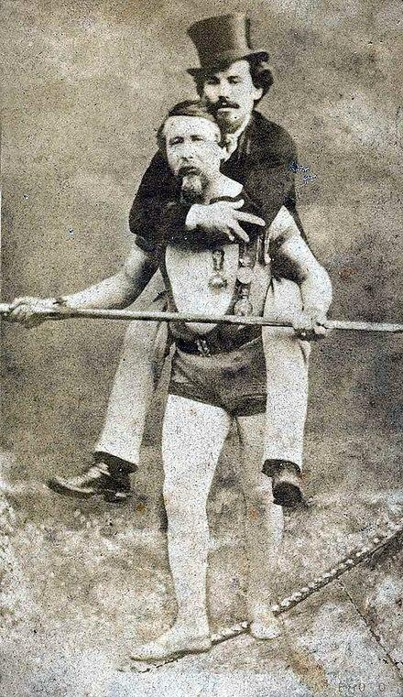
Popular story: Famous Tightrope walker, Charles Blondin in 1859 walked an 1,100ft tightrope 160 feet above Niagara falls doing tricks to amaze the crowd Once he crossed on stilts, another time on a bicycle, and once he even carried his manager Harry Colcord on his back. [picture]
On July 15, Blondin walked backward across the tightrope pushing a wheelbarrow.
He then asked the crowd, "Do you believe I can carry a person across in this wheelbarrow?" Of course the crowd shouted that yes, they believed!
It was then that Blondin posed the question - "Who will get in the wheelbarrow?' Of course...no one did.

To Believe in Jesus, is to put your faith and trust completely into His hands.

We see in John’s gospel, and also throughout the entire Bible the importance of believing in Jesus, because our salvation depends upon it, our eternal destination depends upon it. And the question of whether or not we are God’s children, according to John chapter 1, depends on whether, or not, you believe.

Closing:

Do whatever you have to do to;

Search your heart,

Quiet your soul,

take every thought captive,

and make sure…

that You Believe!

