John 10 “My Sheep Know My Voice”

_ _

Last week:

“Schmutz in the eye”, wash in the pool of Siloam.

John 9:25 “…One thing I do know. I was blind but now I see!”

Being a witness, means; “telling what you know to be true”. This is the Lord’s final command (Acts 1:8). You don’t need to be a theological expert; you just need to bear witness of the truth of what Jesus has done in your life.

The Good Shepherd and His Sheep
John 10 “Very truly I tell you Pharisees, anyone who does not enter the sheep pen by the gate, but climbs in by some other way, is a thief and a robber. ² The one who enters by the gate is the shepherd of the sheep. ³ The gatekeeper opens the gate for him, and the sheep listen to his voice. He calls his own sheep by name and leads them out. ⁴ When he has brought out all his own, he goes on ahead of them, and his sheep follow him because they know his voice. ⁵ But they will never follow a stranger; in fact, they will run away from him because they do not recognize a stranger’s voice.” ⁶ Jesus used this figure of speech, but the Pharisees did not understand what he was telling them.
Throughout Jerusalem and the surrounding area of Judea we saw several wandering shepherds tending sheep. Much of the shepherding is done the same way it was done 2000 years ago in the time of Jesus, and even 3000 years ago in the time of David. There is usually a lone shepherd out there in the wilderness leading the sheep toward any of the rare patches of grass to eat, or sources of water to drink. He speaks to them, and they follow. There are not a lot of fences, sheep herding dogs or corrals to keep them together, the shepherd just calls out, they recognize his voice, and they follow.
_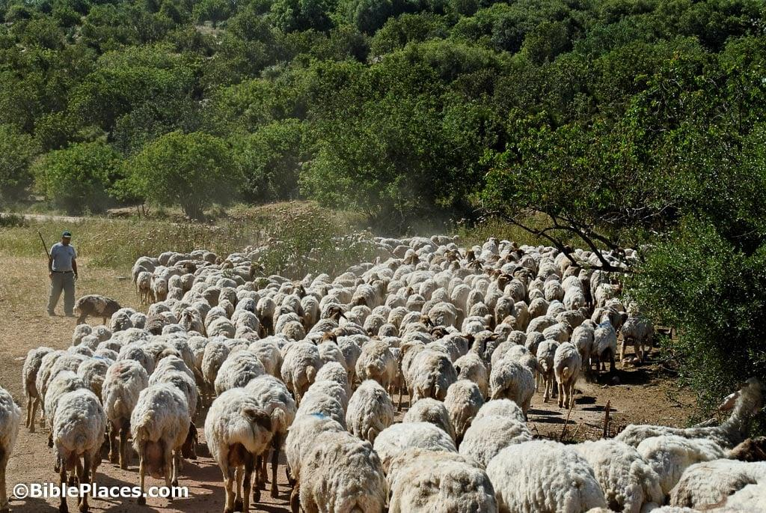_
_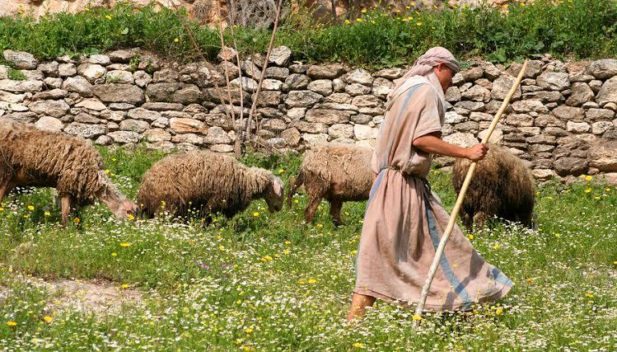_
Our guide told us that sheep can recognize the shepherd’s voice so distinctly, that if any other shepherd tries to guide them, they will refuse to follow.
Audiologists say that; “The human voice is as unique as a fingerprint. In fact, no two voices on the planet are identical. Even if two people shared identical physical characteristics, there would still be recognizable differences in voice due to differences in habitual movements of the articulators. No two individuals modulate their lips, tongue, palate, vocal cords or lungs in the same way when speaking.
If you belong to Jesus, you will recognize His voice. He will speak to your heart and you will know it. It will be different than all other voices, even those that try to deceive you, to make you think that it is Him.
⁷ Therefore Jesus said again, “Very truly I tell you, I am the gate for the sheep. ⁸ All who have come before me are thieves and robbers, but the sheep have not listened to them. ⁹ I am the gate; whoever enters through me will be saved. They will come in and go out, and find pasture.
¹⁰ The thief comes only to steal and kill and destroy; I have come that they may have life, and have it to the full.
¹¹ “I am the good shepherd. The good shepherd lays down his life for the sheep. ¹² The hired hand is not the shepherd and does not own the sheep. So when he sees the wolf coming, he abandons the sheep and runs away. Then the wolf attacks the flock and scatters it. ¹³ The man runs away because he is a hired hand and cares nothing for the sheep.
¹⁴ “I am the good shepherd; I know my sheep and my sheep know me— ¹⁵ just as the Father knows me and I know the Father—and I lay down my life for the sheep.
Jesus was clearly comparing the Pharisees to thieves and robbers. They were called to be Shepherds over the house of Israel, yet they did nothing to seek out the hurting and the lost. They even rejected a man healed from blindness in the previous chapter and castigated him. They likely shunned him and cast him out of the community. They, along with the Chief Priests made themselves rich off the people’s temple tax and offerings.
They very much fit the profile of “false shepherds” that were prophesied about in Ezekiel, so they knew that all this shepherd talk was directed at them.
Ezekiel 34:1-6, 11-15 “The word of the Lord came to me: ² “Son of man, prophesy against the shepherds of Israel; prophesy and say to them: ‘This is what the Sovereign Lord says: Woe to you shepherds of Israel who only take care of yourselves! Should not shepherds take care of the flock? ³ You eat the curds, clothe yourselves with the wool and slaughter the choice animals, but you do not take care of the flock. ⁴ You have not strengthened the weak or healed the sick or bound up the injured. You have not brought back the strays or searched for the lost. You have ruled them harshly and brutally. ⁵ So they were scattered because there was no shepherd, and when they were scattered they became food for all the wild animals. ⁶ My sheep wandered over all the mountains and on every high hill. They were scattered over the whole earth, and no one searched or looked for them.
>>>
Then the Lord speaks…
¹¹ “‘For this is what the Sovereign Lord says: I myself will search for my sheep and look after them. ¹² As a shepherd looks after his scattered flock when he is with them, so will I look after my sheep. I will rescue them from all the places where they were scattered on a day of clouds and darkness. ¹³ I will bring them out from the nations and gather them from the countries, and I will bring them into their own land. I will pasture them on the mountains of Israel, in the ravines and in all the settlements in the land. ¹⁴ I will tend them in a good pasture, and the mountain heights of Israel will be their grazing land. There they will lie down in good grazing land, and there they will feed in a rich pasture on the mountains of Israel. ¹⁵ I myself will tend my sheep and have them lie down, declares the Sovereign Lord.”
Jesus did all this! He is the Good Shepherd!
- He said in Matt 15, “I came for the lost sheep of Israel.”
- In Luke 19:10, he said; “¹⁰ For the Son of Man came to seek and to save the lost.”
- After his resurrection, when he was reunited with Peter, one of the last things he said to him was “if you love me, feed my sheep.” (John 21).
In Jesus’ time there were many voices trying to influence the people like sheep and lead them astray. Jesus’ following had climbed into the thousands. These were those who were experiencing the truth of the Word of God and following the truth of Jesus, because of that were now rejecting the voices of the false shepherds. He described it in John 8 “[They] will know the truth, and the truth will set you free.” People were being set free from the deception and tyranny of the Pharisees and chief priests.
It is the same today. The voice of the shepherd is the voice of truth. Once you’ve learned it and know it, you will not be interested in following any other voice. You don’t need someone to translate or interpret God’s message to you, if you are one of His sheep, you will know His voice. The Word of God will come alive to you and the Spirit of God will reveal all truth to you, as a shepherd feeds, guides and guards, his sheep.
(Continuing in Chapter 10)
¹⁶ I have other sheep that are not of this sheep pen. I must bring them also. They too will listen to my voice, and there shall be one flock and one shepherd.
This is about the Gentiles, who up to this point have not been included in the household of God but soon will. (Acts 10)
¹⁷ The reason my Father loves me is that I lay down my life—only to take it up again. ¹⁸ No one takes it from me, but I lay it down of my own accord. I have authority to lay it down and authority to take it up again. This command I received from my Father.”
This is about the cross. He knew that true freedom can only come through His death on the cross. They did not take His life from Him; He gave His life willingly for us.
¹⁹ The Jews who heard these words were again divided. ²⁰ Many of them said, “He is demon-possessed and raving mad. Why listen to him?”
²¹ But others said, “These are not the sayings of a man possessed by a demon. Can a demon open the eyes of the blind?”
²² Then came the Festival of Dedication that is, Hanukkah at Jerusalem. It was winter, ²³ and Jesus was in the temple courts walking in Solomon’s Colonnade.
This verse says so much about Jesus as an adherent and observant Jew. Hanukkah is not one of the Biblical Feasts mentioned in Leviticus 23. It is not one of the Pilgrimage Feasts that require all men to come up to Jerusalem. Yet here Jesus is, in the center of the great holiday of the Feast of dedication/Lights in Jerusalem, walking among the celebration in Solomons Colonnade.
²⁴ The Jews who were there gathered around him, saying, “How long will you keep us in suspense? If you are the Messiah, tell us plainly.”
²⁵ Jesus answered, “I did tell you, but you do not believe. The works I do in my Father’s name testify about me, ²⁶ but you do not believe because you are not my sheep. ²⁷ My sheep listen to my voice; I know them, and they follow me. ²⁸ I give them eternal life, and they shall never perish; no one will snatch them out of my hand. ²⁹ My Father, who has given them to me, is greater than all; no one can snatch them out of my Father’s hand. ³⁰ I and the Father are one.”
Back in chapter 8, Jesus said “Before Abraham was, “I AM”, calling Himself by the most Holy name of the God of Moses. As expected, the Jews picked up stones to kill Him with.
The same thing happens here. Jesus made what they considered a blasphemous statement about Himself and God “I and the Father are One.”
³¹ Again his Jewish opponents picked up stones to stone him, ³² but Jesus said to them, “I have shown you many good works from the Father. For which of these do you stone me?”
³³ “We are not stoning you for any good work,” they replied, “but for blasphemy, because you, a mere man, claim to be God.”
This is a truth about Jesus that they were not prepared to hear, but a truth, nonetheless. John explained this in the very first chapter of his gospel.
John 1:1 “In the beginning was the Word, and the Word was with God, and the Word was God.”
Continue,
^{John 10:34} Jesus answered them, “Is it not written in your Law, ‘I have said you are “gods”’? ³⁵ If he called them ‘gods,’ to whom the word of God came—and Scripture cannot be set aside—
(He is quoting Psalm 82 “you are like gods”)
³⁶ what about the one whom the Father set apart as his very own and sent into the world? Why then do you accuse me of blasphemy because I said, ‘I am God’s Son’? ³⁷ Do not believe me unless I do the works of my Father. ³⁸ But if I do them, even though you do not believe me, believe the works, that you may know and understand that the Father is in me, and I in the Father.” ³⁹ Again they tried to seize him, but he escaped their grasp.
Once again, they were so infuriated and filled with rage that they wanted to kill Him right them and there, but he would not have it,. It was not yet His time. So he slipped away and went back over the Jordan and ministered there.
⁴⁰ Then Jesus went back across the Jordan to the place where John had been baptizing in the early days. There he stayed, ⁴¹ and many people came to him. They said, “Though John never performed a sign, all that John said about this man was true.” ⁴² And in that place many believed in Jesus. <>
As Jesus often did, when those He was speaking to rejected Him, he went to another place and ministered to those who would believe in Him. This is the case here. He left Jerusalem for the time being, and went to Qasr El Yehud past Jericho and ministered there, And in that place many people believed.

Closing Thoughts; back to John 10:10;

John 10:10 “The thief comes only to steal and kill and destroy; I have come that they may have life, and have it to the full.”

The thief is the Devil. What does he Steal, Kill and Destroy???
- Steals - Joy
- Kills - Opportunities
- Destroys - relationships

- He wants to steal our joy, because he knows that the Joy of the Lord is our strength,

- He wants to kill of our opportunities because he knows the potential we have if we really walk fully in the plans and purposes God has for us.

- He wants to destroy our relationship with God and others because he knows that those relationship may be the very reason we were created; “To love God and Love others”

He is our enemy and works relentlessly to try to ruin the great things God has for us in our lives. He comes to kill, steal, and destroy. But Jesus says;

John 10:10 “I have come that they may have life, and have it to the full.” (NIV)

John 10:10 “I have come that they may have life, and that they may have it more abundantly.” (NKJV)
There is a difference between eternal life and abundant life.

Eternal life means spending eternity in heaven with Jesus, as a result of our salvation that is given to those who believe. It is the Hope of Glory that Jesus has gone to prepare a place for us, that where He is, we will also be.

Abundant Life is the essence of “living your best life”. It’s where Jesus frees you from the things that are detriments, and impediments to your life and gives you the ability to walk in the fullness of peace, power, purpose, protection and prosperity.

This is not the same prosperity in the “Prosperity Gospel” that promises that you’ll be materially rich. It’s being prosperous in the things of God; intimacy with Him, fulfillment in your relationships, success in your ministry, and the peace of mind that only comes from salvation.

This is the abundant life that Jesus promises to give all those who believe.

Don’t let the thief kill, steal and destroy it.

Remember:

We are the sheep of the Good Shepherd,
He guides us,
leads us,
provides for us
and feeds us.

The Lord is our Shepherd and we know His voice.

He gives us eternal and abundant life, and no one can snatch us out of His hand.

