John 13 - THAT YOU MAY BELIEVE - “Love Each Other”
John 12 was the end of the first half of John known as “The Book of Signs”. The rest of the gospel is called the “Book of Glory” and contains only The Upper room to the empty tomb, and a bit beyond.

In chapter 12,
Mary demonstrated that she was more interested in honoring Jesus than anything else in her life. She gave Jesus her complete devotion. Are we willing to love Jesus more than anyone or anything else in our lives?
John 13
1 “It was just before the Passover Festival. Jesus knew that the hour had come for him to leave this world and go to the Father. Having loved his own who were in the world, he loved them to the end.”
Jesus was on a very precise time schedule throughout his entire life. Everything He did and said led him to be at this place at this precise time. He gave himself to be crucified on Passover of His final year of ministry. He was the lamb who was slain.
² The evening meal was in progress, and the devil had already prompted Judas, the son of Simon Iscariot, to betray Jesus.
Passover had just begin, the “evening meal”, was the Passover Supper, which is what we call a Seder.
³ Jesus knew that the Father had put all things under his power, and that he had come from God and was returning to God;
Jesus knew the authority that was given to Him by God, and that the time had come to return to the Father. So what did he do?
What would you do??
⁴ so he got up from the meal, took off his outer clothing, and wrapped a towel around his waist. ⁵ After that, he poured water into a basin and began to wash his disciples’ feet, drying them with the towel that was wrapped around him.
Even in His position of ultimate authority and power, he humbled himself and washed His disciple’s dirty feet. Washing hands is the first order of practices in a seder (Urchatz), Jesus took it to another level by washing his disciples’ feet.
⁶ He came to Simon Peter, who said to him, “Lord, are you going to wash my feet?”
⁷ Jesus replied, “You do not realize now what I am doing, but later you will understand.”
⁸ “No,” said Peter, “you shall never wash my feet.”
Jesus answered, “Unless I wash you, you have no part with me.”
Have you ever washed someone’s feet, or had your feet washed?
This was something that was pretty common in the Jesus Movement that I experienced as a kid. People would occasionally wash one another’s feet in fellowship meetings.
It feels awkward to wash someone’s feet, but I think it’s more awkward to have your feet washed. (Ask Aly : ).
When someone washes your feet, you feel uncomfortable because it seems too humiliating for the washer, and too personal for the “washee” (not a real word).
Peter and the others felt awkward and uncomfortable. Jesus knew it, but washed their feet anyway.
It’s that awkward feeling of; uncomfortable, undeserving, unworthy that helps us understand the essence of grace.
Grace – Unmerited favor. Undeserved gift. We need to feel that feeling, everyday!
⁹ “Then, Lord,” Simon Peter replied, “not just my feet but my hands and my head as well!”
¹⁰ Jesus answered, “Those who have had a bath need only to wash their feet; their whole body is clean. And you are clean, though not every one of you.” ¹¹ For he knew who was going to betray him, and that was why he said not every one was clean.
¹² When he had finished washing their feet, he put on his clothes and returned to his place. “Do you understand what I have done for you?” he asked them. ¹³ “You call me ‘Teacher’ and ‘Lord,’ and rightly so, for that is what I am. ¹⁴ Now that I, your Lord and Teacher, have washed your feet, you also should wash one another’s feet. ¹⁵ I have set you an example that you should do as I have done for you. ¹⁶ Very truly I tell you, no servant is greater than his master, nor is a messenger greater than the one who sent him. ¹⁷ Now that you know these things, you will be blessed if you do them.
Leadership is servanthood. Jesus exhibited this so vividly to His Apostles. He was demonstrating what he told them in,
Matt 20:26-28 “whoever wants to become great among you must be your servant, ²⁷ and whoever wants to be first must be your slave— ²⁸ just as the Son of Man did not come to be served, but to serve, and to give his life as a ransom for many.”

Jesus then predicts His Betrayal, He knew that the devil had already prompted Judas he was about to betray him;
¹⁸ “I am not referring to all of you; I know those I have chosen. But this is to fulfill this passage of Scripture: ‘He who shared my bread has turned against me.’
¹⁹ “I am telling you now before it happens, so that when it does happen you will believe that I am who I am. ²⁰ Very truly I tell you, whoever accepts anyone I send accepts me; and whoever accepts me accepts the one who sent me.”
²¹ After he had said this, Jesus was troubled in spirit and testified, “Very truly I tell you, one of you is going to betray me.”
²² His disciples stared at one another, at a loss to know which of them he meant. ²³ One of them, the disciple whom Jesus loved, was reclining next to him. ²⁴ Simon Peter motioned to this disciple and said, “Ask him which one he means.”
²⁵ Leaning back against Jesus, he asked him, “Lord, who is it?”
It is interesting that the other apostles did not immediately think that the betrayer was going to be Judas. He must have presented himself as a very authentic and unsuspecting apostle. They doubted themselves before suspecting him.
²⁶ Jesus answered, “It is the one to whom I will give this piece of bread when I have dipped it in the dish.” Then, dipping the piece of bread, he gave it to Judas, the son of Simon Iscariot. ²⁷ As soon as Judas took the bread, Satan entered into him.
So Jesus told him, “What you are about to do, do quickly.” ²⁸ But no one at the meal understood why Jesus said this to him. ²⁹ Since Judas had charge of the money, some thought Jesus was telling him to buy what was needed for the festival, or to give something to the poor. ³⁰ As soon as Judas had taken the bread, he went out. And it was night.
The Judas betrayal is very interesting because Jesus knew it was going to happen before it took place, and wanted the apostles to know that he was aware of it. Judas had the full capacity of making his choice however. God’s foreknowledge in no way supersedes our ability to make any given choice. In other words, God in his omniscience may know the choices we are going to make, even before we make them, but because of free will, He allows us to make them, and does not make them for us.
Peter explained this in;
Acts 1:16-17 “and [Peter] said, “Brothers and sisters, the Scripture had to be fulfilled in which the Holy Spirit spoke long ago through David concerning Judas, who served as guide for those who arrested Jesus. ¹⁷ He was one of our number and shared in our ministry.”
Still, Jesus was troubled in spirit (v. 21) about the Betrayal and also about the Denial which was about to take place, something that he also predicted would happen by another of His friends;
³¹ When he was gone, Jesus said, “Now the Son of Man is glorified and God is glorified in him. ³² If God is glorified in him, God will glorify the Son in himself, and will glorify him at once.
³³ “My children, I will be with you only a little longer. You will look for me, and just as I told the Jews, so I tell you now: Where I am going, you cannot come.
³⁴ “A new command I give you: Love one another. As I have loved you, so you must love one another. ³⁵ By this everyone will know that you are my disciples, if you love one another.”
(34 & 35) are key verses of this chapter. (We will revisit them later)
³⁶ Simon Peter asked him, “Lord, where are you going?”
Jesus replied, “Where I am going, you cannot follow now, but you will follow later.”
Jesus was speaking about going to the cross and then going to Father, the Paradise that He spoke to the thief on the cross about. He tells the apostles in the next chapter (14)
John 14:3 “And if I go and prepare a place for you, I will come back and take you to be with me that you also may be where I am.”
Then Peter makes a promise he doesn’t keep.
³⁷ Peter asked, “Lord, why can’t I follow you now? I will lay down my life for you.”
³⁸ Then Jesus answered, “Will you really lay down your life for me? Very truly I tell you, before the rooster crows, you will disown me three times!” <>
In Mark’s account Peter is even more vehement;
Mark 14:30-31 “Peter declared, “Even if all fall away, I will not.” ³⁰ Jesus said to him, “Assuredly, I say to you that today, even this night, before the rooster crows twice, you will deny Me three times.” ³¹ But he spoke more vehemently, “If I have to die with You, I will not deny You!”
Jesus certainly did not want or will for Peter to deny him, nor did He cause it to happen, but again, He knew it would take place even after He warned Peter of it (we will read about it in John 18). He would later forgive and restore Peter, and set him in place as a leader in the early church.
Jesus may know about our sins and failures before they happen, yet still allow them to happen, and then choose to forgive and restore us after they happen. It is our will that causes us to sin, and also our will to repent of our sins and seek forgiveness.
This is an example of both God’s sovereignty, and man’s free will.
“Man’s will is free because God is sovereign. A God less than sovereign could not bestow moral freedom upon His creatures. He would be afraid to do so.” (AW Tozer)
----------------------
A New Commandment
John 13:34-35 “A new commandment I give to you, that you love one another; as I have loved you, that you also love one another. ³⁵ By this all will know that you are My disciples, if you have love for one another.” (NKJV)

A NEW COMMANDMENT!?!?
There were already Ten Commandments given to Moses on Mt. Sinai on tablets of Stone!
There were a total of 613 Commandments given in the Hebrew Scriptures!
Is Jesus now using His authority to make it 614, by adding a “new Commandment?1?”

Yes, He had already stated that all of the Law and the Prophets (Torah & Nevi’im) could be summed up in the statement, “You shall love the Lord your God with all your heart, and with all your soul, and with all your mind.” He also said, “the second is like it: ‘Love your neighbor as yourself.”
But now he is giving a new commandment, and He tells us that our adherence to this commandment will let others know whether or not we are truly His disciples.
A disciple is someone who studies, honors and tries to emulate the one who is discipling them. Jesus loves us. He laid His life down for us, and tells us, that if we are truly His disciples, we will do the same.

“By this all will know that you are My disciples, if you have love for one another.”
Old Song; “They will know we are Christians by our love…….[for one another]!”
Jesus is not just talking about random acts of kindness by Good Samaritans to strangers here. He is not even talking about loving your enemies here. He is telling His ELEVEN Apostles that the true test of discipleship is your love for “one another”.

This message often gets lost in the mix of the many of the other important commands in the Bible like;
reaching the lost, feeding the poor, helping the needy, Loving the sinner/hating the sin, being kind to strangers… Jesus even tells us to: love your enemies! Do good to those who hate you, Bless those who curse you. Pray for those who hurt you.
These are all very important messages in the Bible, but they should never replace or even take priority over the Lord’s repeated command to “Love each other as I have loved you.”
In other words, “LOVE OTHER CHRISTIANS”
I know this sounds a bit self-serving, but it is exactly what Jesus commanded us.
Let me explain why;
When we truly love each other, it creates a magnetic core in the center of our church community, one that attracts people to us, and ultimately to Jesus.
There is nothing more attractive to a human being than love. We are created in the Image of God, which means we each have deep innate desires to “Love, and Be loved” just like God does. When people see that true, divine, agape love can be experienced on earth, they are drawn to it magnetically.

[ Example: MRI’s use huge superconductive electromagnets to create the magnetic waves for imaging. It’s important that there is no metal on you, in you or nearby because once the magnet is charged up and turned on, it is so strong it will draw all the metal it can to itself. (ex: metal chair video, suck it right into the machine)]
_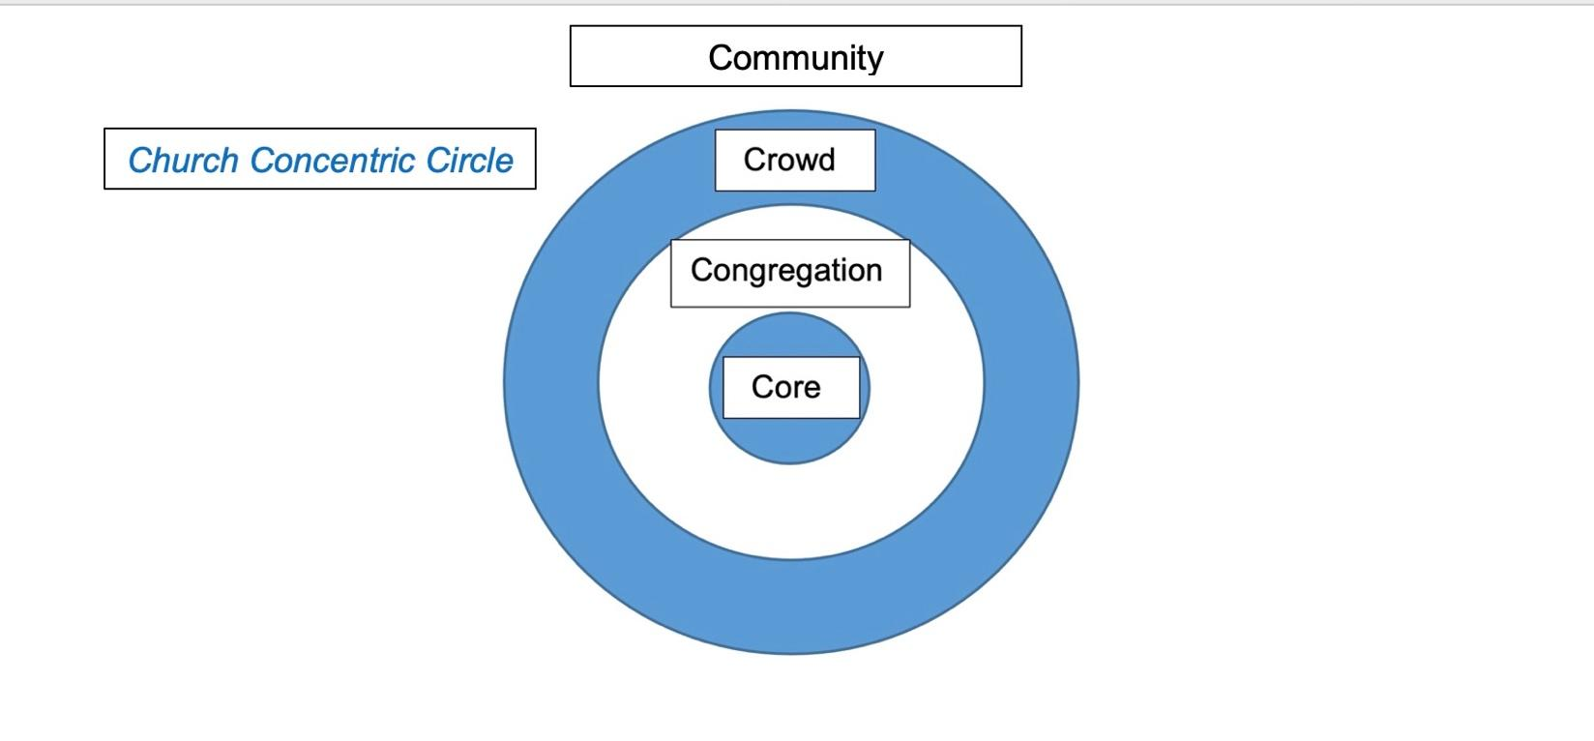_
_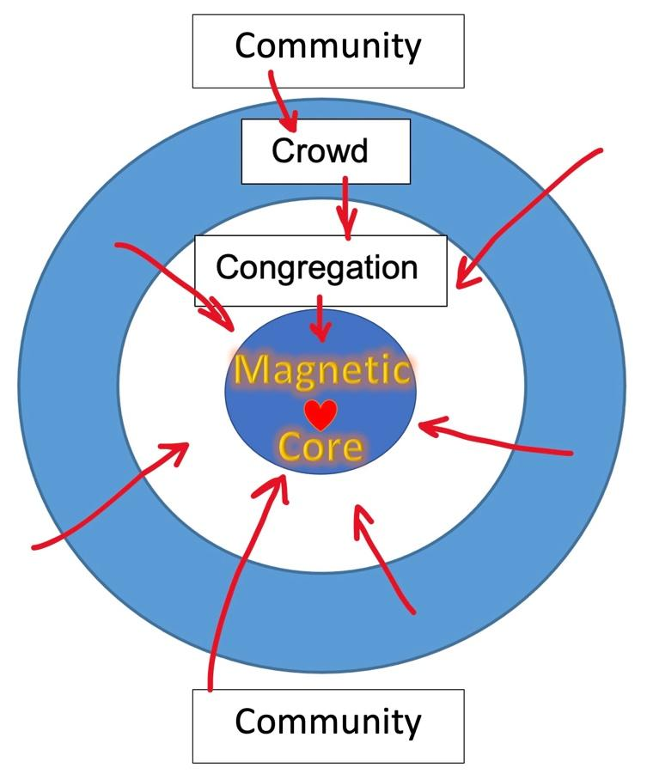_
Church Concentric Circle
With Magnetic Core

Paul speaks emphatically in the last chapter of Galatians about this;
Galatians 6:9-10 “Let us not become weary in doing good, for at the proper time we will reap a harvest if we do not give up. ¹⁰ Therefore, as we have opportunity, let us do good to all people, especially to those who belong to the family of believers.”
***We are to do good things for as many people as we are able to, but ESPECIALLY first and foremost we are to do good things for, and love Other Christians.***

Sometimes it’s easier to care for the stranger or outsider than it is for our own brother or sister in the family of believers.

This is why Jesus gave us the “new commandment” about loving each other.

[Chinese Restaurant Story – The ones who needed and deserved his love the most were his family, not me]
Sometimes we are friendlier and more loving to outsiders and worldly people than we are to our brothers and sisters. Our goal is not to please worldly people, convince them that we like the same things they like, and prove to them that we desperately want to be their friend. Our goal is to show them that we love God, and each other more than anything, and invite them into that love as well.

When we love and honor each other with genuine affection, it sends a message to the world that genuine love actually does exist, and they are impressed by it and drawn to it. It’s more effective than church marketing campaigns, social-media advertising, billboards, magazine ads, even impressive buildings, compelling speakers and popular worship bands.
Love is the most compelling, impactful and irresistible message we can give. When we genuinely love God, and make every effort to love one another the way Jesus loves us, we are inviting the world to come to Him and experience the love that they crave, yearn for and were created for.

Romans 12:9-10 “Don’t just pretend to love others. Really love them. Hate what is wrong. Hold tightly to what is good. ¹⁰ Love each other with genuine affection, and take delight in honoring each other.”
<>

