WITHOUT EXCUSE
Romans 7 - Cognitive Dissonance

Last verse of chapter 6.
Romans 6:23 “For the wages of sin is death, but the gift of God is eternal life in Christ Jesus our Lord.”
The law says that sin deserves death. But God’s gift of grace is eternal life through the death of Jesus.
Throughout Romans we have been studying topics such as God’s wrath, Justification by Faith, sin, and grace. We also looked at the purpose of ‘the law” from several angles.
Paul, who as a Pharisee, is an authority of the law, continues to explain what the law is, and what it isn’t. He also describes something within us called “sinful nature” the part of our soul, that is intent on satiating the sinful desires and cravings of our body and our mind.
If we have been justified by faith, forgiven of our sins, and free from the wrath of God, why do we still sin, and what are the consequences of the law concerning our sin?
Paul addresses this in one of the most candid and transparent chapters he ever wrote. He exposes his struggle with sin, his own sinful nature, and the COGNITIVE DISSONANCE he experiences by doing the very things he does not want to do, and not doing the thing he wants to do.

Romans 7:1-6 “Do you not know, brothers and sisters—for I am speaking to those who know the law—that the law has authority over someone only as long as that person lives? ² For example, by law a married woman is bound to her husband as long as he is alive, but if her husband dies, she is released from the law that binds her to him. ³ So then, if she has sexual relations with another man while her husband is still alive, she is called an adulteress. But if her husband dies, she is released from that law and is not an adulteress if she marries another man.
⁴ So, my brothers and sisters, you also died to the law through the body of Christ, that you might belong to another, to him who was raised from the dead, in order that we might bear fruit for God. ⁵ For when we were in the realm of the flesh, the sinful passions aroused by the law were at work in us, so that we bore fruit for death. ⁶ But now, by dying to what once bound us, we have been released from the law so that we serve in the new way of the Spirit, and not in the old way of the written code.
… “the new way of the Spirit, and not in the old way of the written code”.
Paul begins a deep comprehensive segment on life in the Spirit that is fully explained in the next chapter. He compares life in the spirit to the old law, by comparing it to the laws concerning marriage saying that; “by law a married woman is bound to her husband as long as he is alive, but if her husband dies, she is released from the law that binds her to him.” So it is with the old law. If we sin, we deserve death. But new way of the spirit, frees us from the law of sin and death.
Next chapter he begins with the statement;
Romans 8:2 “Therefore, there is now no condemnation for those who are in Christ Jesus, ² because through Christ Jesus the law of the Spirit who gives life has set you free from the law of sin and death.”

About the Law of Sin and Death…
⁷ What shall we say, then? Is the law sinful? Certainly not! Nevertheless, I would not have known what sin was had it not been for the law. For I would not have known what coveting really was if the law had not said, “You shall not covet.” ⁸ But sin, seizing the opportunity afforded by the commandment, produced in me every kind of coveting. For apart from the law, sin was dead. ⁹ Once I was alive apart from the law; but when the commandment came, sin sprang to life and I died. ¹⁰ I found that the very commandment that was intended to bring life actually brought death. ¹¹ For sin, seizing the opportunity afforded by the commandment, deceived me, and through the commandment put me to death. ¹² So then, the law is holy, and the commandment is holy, righteous and good.
Paul confesses the sin of coveting which is disobedient to the 10th Commandment “Thou Shall not covet”. )Not sure if this is his only sin, worst sin, or just makes for a good example). Coveting may not seem wrong to some people. In fact Paul said he wouldn’t have known it was a sin, except for the fact that the law lists it as one. God commanded the Israelites not to desire, long for, or set their hearts on anything that belonged to anyone else. Whereas several of the commandments prohibit certain actions, such as murder and theft, this is one of the commandments that address the inner person, his heart and mind.
We’re not sure who or what Paul was coveting, it could have been possessions, a woman, a home or position. Or it could have been the payment that the other apostles were getting while he and Barnabas got none. He writes in 1st Corinthians about this;
1st Corinthians 9:4-6 “Don’t we have the right to food and drink? ⁵ Don’t we have the right to take a believing wife along with us, as do the other apostles and the Lord’s brothers and Cephas? ⁶ Or is it only I and Barnabas who lack the right to not work for a living?
Either way, his example was that he was committing a sin in his mind that he might not have been aware of if the law had not revealed it and convicted him of not only his sin, but his sinful nature. So in that sense the law is good to reveal that which is bad, and brings about death. (The law is kind of like an x-ray machine, it reveals harmful things in us, sometimes even deadly).

^{“13} Did that which is good, then, become death to me? By no means! Nevertheless, in order that sin might be recognized as sin, it used what is good to bring about my death, so that through the commandment sin might become utterly sinful.
¹⁴ We know that the law is spiritual; but I am unspiritual, sold as a slave to sin.”
What?!?!? Here Paul is switching from a very general first-person plural, to a very personal first-person singular. He is confessing his own struggle with sin.
Notice that up until this point he was addressing “we”, here in this verse and beyond he switches to “I” in this chapter.
So the great Apostle Paul, who has just planted an astounding line of churches throughout Asia Minor and Macedonia, who is the most prolific teacher of Christian doctrine in History, and is at this time engaged in the most Holy task imaginable (writing the Bible), is calling himself a “slave to sin”. How can this be?
Is this good news or bad news? It’s easy to rationalize our own sin, if Paul can’t live a sinless life, how can we?
What he is really saying here is that there is always an internal struggle within us, between our Soul and our Spirit.
Our soul contains our flesh (sinful nature), our spirit is our “inner being” that delights in God’s word, because of the Holy Spirit.
That’s why the ESV translates this last verse as;
Romans 7:14 (ESV) “For we know that the law is spiritual, but I am of the flesh,”
The struggle is real, and takes place within us, no matter who we are.
This is why Paul writes to the Galatians;
Gal. 5:17 “For the flesh desires what is contrary to the Spirit, and the Spirit what is contrary to the flesh. They are in conflict with each other”
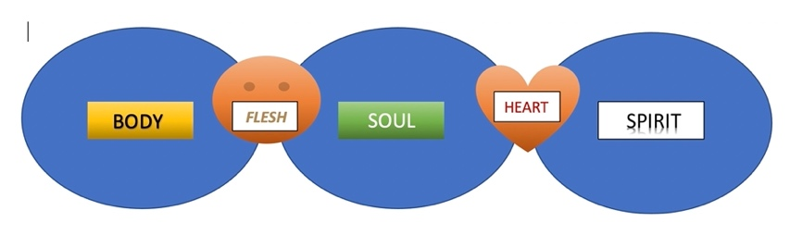
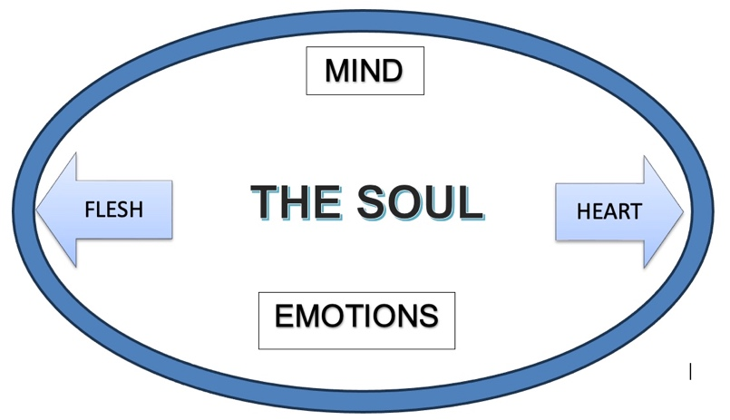
Paul’s "cacophony of cognitive dissonance"
Cognitive dissonance is a term for the state of discomfort felt when two or more modes of thought contradict each other. In other words, when you do the very thing you don’t want to do.
------------------------------------------break ----------------------------------------------------------------
¹⁵ I do not understand what I do. For what I want to do I do not do, but what I hate I do. ¹⁶ And if I do what I do not want to do, I agree that the law is good. ¹⁷ As it is, it is no longer I myself who do it, but it is sin living in me. ¹⁸ For I know that good itself does not dwell in me, that is, in my sinful nature. For I have the desire to do what is good, but I cannot carry it out. ¹⁹ For I do not do the good I want to do, but the evil I do not want to do—this I keep on doing. ²⁰ Now if I do what I do not want to do, it is no longer I who do it, but it is sin living in me that does it.
We can all relate to this.
Not just about spiritual things, but about physical things as well. We all know that we should eat healthy, exercise often, not waste time on worthless activities, and read the word and pray more. So when we don’t do what we absolutely know we should, and even want to do, why don’t we do it?
It’s because;
“Our flesh within us desires to satiate the cravings of our body and appease the weakness of our soul.”
Whenever you purpose in your heart to pursue God and seek His will, the enemy immediately responds with temptations to keep you from that goal.
Examples:
You are about to spend time in the word or in prayer, and you are immediately distracted by something that diverts your attention to something else.
You set out to serve God and minister to others, and are met with interference or conflict that makes it difficult to stay on task, extinguishes your desire to serve God.
Or worse yet, You are reminded of times where you felt disappointed by God, or let down by other Christians, and you develop a sense of bitterness or cynicism that quenches your desire to seek God, serve Him, or even be in fellowship with others.
In some cases a believer may experience what John Bunyan in his allegory Pilgrim’s Progress calls “The Slough of Despond”. This is a miry pit where you’ve become so overcome with sin and guilt that you live out your days in endless discouragement, and allow your sinful nature to take hold of your life without any resistance or pursuit of holiness.
Paul seems to have been faced with all of these and cries out to be rescued from the sin that is at work within him.
²¹ So I find this law at work: Although I want to do good, evil is right there with me. ²² For in my inner being I delight in God’s law; ²³ but I see another law at work in me, waging war against the law of my mind and making me a prisoner of the law of sin at work within me. ²⁴ What a wretched man I am! Who will rescue me from this body that is subject to death? ²⁵ Thanks be to God, who delivers me through Jesus Christ our Lord!

Who will rescue us?
Jesus Christ our Lord!

His Spirit within us is greater and more powerful than the sinful nature that is also within us. As we walk in His spirit, He empowers us, He rescues us, He gives us strength and then we can overcome the things of the flesh.

Eph. 5:16 “I say then: Walk in the Spirit, and you shall not fulfill the lust of the flesh.”

This verse is sometimes misread as if to say, “stop fulfilling the lust of the flesh, so you can walk in the spirit”.

That’s actually the opposite of its message. Our focus should not be on the flesh, but on the spirit.

In other words, “walk in the Spirit, and watch what happens”,
What happens when you pursue, live by, submit to, and are lead by the Spirit???
“you will not fulfill the lust of the flesh.”

There is great blessing when we walk in the spirit, and great consequence whne we don’t.
Romans 8:6 “The mind governed by the flesh is death, but the mind governed by the Spirit is life and peace.”

It starts with our desire. Do we really desire the things of the spirit. Is our longing to be close with Him, and walk in the power of His presence?

For some the answer is an easy “of course!”

For others, if we’re honest it may be “I’m honestly no longer sure.”

You know you want to feel close with God, but your actions prove otherwise.
You know what happens when you seek the Lord with all your heart, but sometimes have a hard time convincing your heart to seek Him.

AW Tozer was very honest in his writings about these types of struggles. He was a man of God, a very well-respected writer, teacher, theologian and minister. But at times he found himself saying; “For I do not do the good I want to do, but the evil I do not want to do—this I keep on doing”.

He knew that he needed to rekindle his desire to walk in the spirit, before he can begin to walk in the spirit.

His found the answer was to pray for; want, longing, and thirst.

“I want to want you; I long to be filled with longing; I thirst to be made more thirsty still.” (AW Tozer – The Pursuit of God)
If we pray for these things, the Lord can actually ignite in us the “want to want”, the desire to desire Him. This is something God does from the inside out.

Phil. 2:13 “For it is God who works in you, both to will and to do for His good pleasure.”

