WITHOUT EXCUSE
“Governed By The Spirit”
Romans 7:20-25 ²⁰ Now if I do what I do not want to do, it is no longer I who do it, but it is sin living in me that does it.
²¹ So I find this law at work: Although I want to do good, evil is right there with me. ²² For in my inner being I delight in God’s law; ²³ but I see another law at work in me, waging war against the law of my mind and making me a prisoner of the law of sin at work within me. ²⁴ What a wretched man I am! Who will rescue me from this body that is subject to death? ²⁵ Thanks be to God, who delivers me through Jesus Christ our Lord! So then, I myself in my mind am a slave to God’s law, but in my sinful nature a slave to the law of sin…”

Who will rescue us?
Jesus Christ our Lord!

His Spirit within us is greater and more powerful than the sinful nature that is also within us. As we walk in His spirit, He empowers us, He rescues us, He gives us strength and then we can overcome the things of the sinful nature, a.k.a. “the flesh”.

Paul continues...
8:1“Therefore, there is now no condemnation for those who are in Christ Jesus, ² because through Christ Jesus the law of the Spirit who gives life has set you free from the law of sin and death.”
The law of sin and death is simple – “if you’ve sinned, you are deserving of God’s wrath, and will experience eternal death.”
The written law was given to make it possible to be forgiven of sin, through the requirement of the law (blood sacrifice), but that did not produce life in the spirit.
BUT, “through Christ Jesus the law of the Spirit who gives life, has set you free from the law of sin and death.” So there is no condemnation (wrath of God) for those who are in Christ Jesus! (this is the very good news of the gospel).
But what about the law?
The law had been the only way to draw near to God, obeying its commandments and keeping its ordinances, including animal sacrifice for forgiveness of sins.

3 “For what the law was powerless to do because it was weakened by the flesh, God did by sending his own Son in the likeness of sinful flesh to be a sin offering. And so he condemned sin in the flesh, ⁴ in order that the righteous requirement of the law might be fully met in us, who do not live according to the flesh but according to the Spirit.”
Jesus’ death on the cross fulfilled “the righteous requirement of the law, and did what the law could not do, give us the ability to live not by the flesh, but by the Spirit.
The Flesh = Sinful Nature
There is a huge difference, between living according to the flesh, and living according to the Spirit.
The Holy Spirit indwells us when we first truly believe, and becomes our power, our comforter, and our guide.
As we yield to his governance, He transforms our thinking and our behavior, producing in us the fruit of the power, and working through us by the gifts of the spirit. He also gives us wisdom, understanding and spiritual perception, that we could not achieve in the flesh.
5 “Those who live according to the flesh have their minds set on what the flesh desires; but those who live in accordance with the Spirit have their minds set on what the Spirit desires.”
The Spirit’s desires are contrary with the desires of the flesh. The flesh desires to appease and satiate the cravings and impulses of the body and pride. The Spirit wants to please God and do His will.
Galatians 5:17 “For the flesh desires what is contrary to the Spirit, and the Spirit what is contrary to the flesh. They are in conflict with each other, so that you are not to do whatever you want.
The flesh and Spirit are in conflict with each other for control over your Mind (soul). If you just do whatever you want, meaning whatever your lusts and desires crave, you will be governed by the flesh. The consequences of this is death. If you allow the Spirit to control or govern your mind, by seeking him by faith through your heart, the result will be “life and peace”.
Romans 8:6 “The mind governed by the flesh is death, but the mind governed by the Spirit is life and peace.”
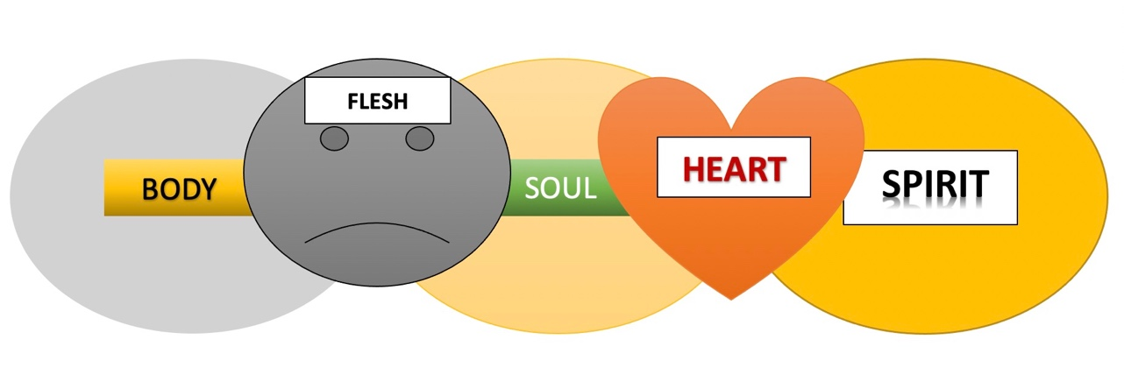
7 “The mind governed by the flesh is hostile to God; it does not submit to God’s law, nor can it do so. ⁸ Those who are in the realm of the flesh cannot please God.”
Without operating in the Spirit, we cannot please God, because we are operating in the realm of the flesh. The ‘realm of the flesh” describes someone who is not operating in the spirit and only operating in the “flesh”. It’s not necessarily someone who is engaging in abhorrent behavior, or would be described as a terrible person. It’s basically anyone who does what comes naturally in their sinful nature, with no regard to the Spirit of God. Paul also describes this as a “natural man”.
1st Corinthians 2:14 “But the natural man does not receive the things of the Spirit of God, for they are foolishness to him; nor can he know them, because they are spiritually discerned.”
The natural man is equipped only with his mind and emotions (soul). He is what A. B. Simpson calls the “psychical man”.
A. B. Simpson - “In 1st Cor. 2, the apostle Paul very clearly distinguishes between the soul and the spirit in man. The psychical man, that is, the soul man, he tells us, “receiveth not the things of the Spirit of God neither can he know them for they are spiritually discerned, but he that is spiritual discerneth all things.” The psychical man, therefore, is the man of the soul, the spiritual man is the man of quickened spirit.”
Back to Romans 8…
9 “You, however, are not in the realm of the flesh but are in the realm of the Spirit, if indeed the Spirit of God lives in you. And if anyone does not have the Spirit of Christ, they do not belong to Christ.”
[Christian, but not spiritual??? ]
There is no way to be saved without the Spirit, and there is no way to belong to Christ unless the Spirit lives in you. We don’t have an option to be non-spiritual Christians, nor do we have the option. To reject the Spirit and still belong to Jesus.
Romans 8:14 “For those who are led by the Spirit of God are the children of God.”
If we are led by the Spirit, that means our minds are governed by the Spirit and that the Spirit lives in us.

10 “But if Christ is in you, then even though your body is subject to death because of sin, the Spirit gives life because of righteousness. 11 And if the Spirit of him who raised Jesus from the dead is living in you, he who raised Christ from the dead will also give life to your mortal bodies because of his Spirit who lives in you.”

There is a common misconception that the Holy Spirit was only introduced at Pentecost (acts 2) but was not present in the Hebrew Scriptures (OT). This is simply not true.

The Holy Spirit (Ruach HaKodesh) was present from the very beginning. In fact in Genesis 1:2 “the Spirit of God was hovering over the waters.” That same Spirit would manifest Himself occasionally and sporadically through the Hebrew Scriptures. The visible manifest presence is nothing new, it’s what we read about at Pentecost in Acts 2, but it happened throughout the entire Old Testament and continues today.

The “Shekinah Glory”, or dwelling of the presence of God” is exactly what Moses experienced on Mount Sinai, in the tabernacle, as they crossed the Red Sea, and beyond. It was always “The Holy Spirit”.

- The Holy Spirit (Ruach HaKodesh) was upon Samson in Judges 13, which enabled him to do amazing feats of strength.
- The Holy Spirit (Ruach HaKodesh) came upon Saul in 1st Samuel 10 and he prophesied with the prophets.
- The Holy Spirit (Ruach HaKodesh) came upon David as he was anointed in 1st Samuel 16 “Spirit of the Lord came on David from that day forward.”
- The Holy Spirit (Ruach HaKodesh) was upon all the Prophets as they prophesied, He was in the cloud by day, and pillar of fire in the wilderness.
- The Holy Spirit (Ruach HaKodesh) dwelled in both the Tabernacle and then the Temple.

The difference, however, is that the Holy Spirit was only poured out on certain select people, but had not yet been “poured out on all people” like He was at Pentecost and beyond as sons and daughters can now be “filled with the Holy Spirit” (Ruach HaKodesh).
Until the Spirit was poured out, most people could only rely upon their own Soul (mind/emotions), and not the Spirit.

Romans 8:16 “The Spirit Himself bears witness with our spirit that we are children of God.”

This is why it’s important to know the difference between our “Soul and our Spirit”, and why I wrote the book.

I had was given an incredible life-changing vision as a teenager that turned my life around when I was 16 years old. “I was lifting people from a place of deep darkness below, into a high place of the glory of God’s manifest presence.” I later discovered that it was a prophetic vision that would be fulfilled. It was my calling into life-long ministry.

Through worship, teaching and other forms of ministry, I have been able to lift people, saved and unsaved, from a place where their minds/flesh (soul) held them in darkness and death, to a place where they would experience life and peace through the Holy Spirit.

Remember;

“The mind governed by the flesh is death, but the mind governed by the Spirit is life and peace.” (Romans 8:6)

Our enemy, the devil, wants to influence our soul (mind/emotions/will) to pull against God and the things of the Spirit. He wants to influence our soul to react to this battle by thinking, feeling, and decision-making under the direction of the flesh, rather than having our mind (soul) controlled by the Spirit through our heart.

Most of this battle takes place within our mind and emotions, in other words in what we think and in what we feel. That is the enemy’s most strategic method of influencing our will. Every day we find ourselves constantly bombarded with provocative media, incendiary information, misleading communications, hostile exchanges, intentional deceptions, and fear-inducing information that is designed to tempt, discourage, frustrate, or even confuse us.

We become overwhelmed with such an enormous number of stressful thoughts and inflammatory emotions that are tempted and stirred up by what we think and feel, that we often find ourselves, anxious, frustrated, annoyed, angry, and sometimes even gripped with fear. That is the goal of the enemy. He wants to keep us “walking in the soul (flesh).” He wants us to be completely driven and controlled by our minds and emotions instead of by God’s Spirit.

The Bible tells us, however, to “walk in the Spirit” (Gal. 5:16), and explains what happens when we do:
Galatians 5:22–23 “But the fruit of the Spirit is love, joy, peace, longsuffering, kindness, goodness, faithfulness, gentleness, self-control.”

How can we have peace, joy, patience, or even self-control when we are in the middle of so much crisis, tension, and dissonance? What does it actually mean to “walk in the Spirit”, and how do we do it?

Eph 5:16 “I say then: Walk in the Spirit, and you shall not fulfill the lust of the flesh.”

“Walk in the spirit; and watch what happens…”, you won’t fulfill the lusts of the flesh.

How do you walk in the spirit?

- Pray/worship…
- Live out His Word…
- Submit to His will…
- Seek His face…

I am delighted when people tell me that they like our church because of good worship, interesting teaching, and friendly people. I imagine that they will like it even more when we have a really cool space to do all that in.

However, I also want our church to be a place where we are known for seeking the Lord and pursuing the things of the Spirit, not just good worship, interesting teaching, and friendly people.

My prayer is that every day, we are moved, compelled, empower, and governed more and more by the Spirit so much so; that we have meaningful impactful worship, genuinely loving people, life-changing teaching and experiences, and people who are flowing with the fruit of the spirit, and walking in His power.

I believe this is what God has for us in this new season as we choose to be governed by His spirit, and not our flesh.

