Romans Review
As we conclude our 16-chapter study of the book of Romans, we come away with many valuable and vital points of wisdom and instruction. Paul’s powerful letter to the Roman church was filled with important topics and teachings that have become the framework of Christian doctrine throughout the ages.

Paul wrote this, his longest epistle, while living in Corinth among many early disciples who had been to Rome but were now living in Corinth. He had heard reports of the growing church in the world’s largest and most powerful city and stated many times how he longed to visit them. He wrote that his plan was to come to them after he had gone back to Jerusalem, and on his way to Spain. In the end he was arrested in Jerusalem, and when he finally did get to Rome, he was in chains, (and as far as we know, never got to Spain).

The book clearly presents the gospel, which is the doctrine of; ‘Justification by faith in Jesus as Messiah, not only for the Jews, but also the Gentiles’.

Each of the 16 chapters is rich in content and teaching. We will look at a key theme from each of these chapters, and end with a primary take-away from the collective teachings of Romans.

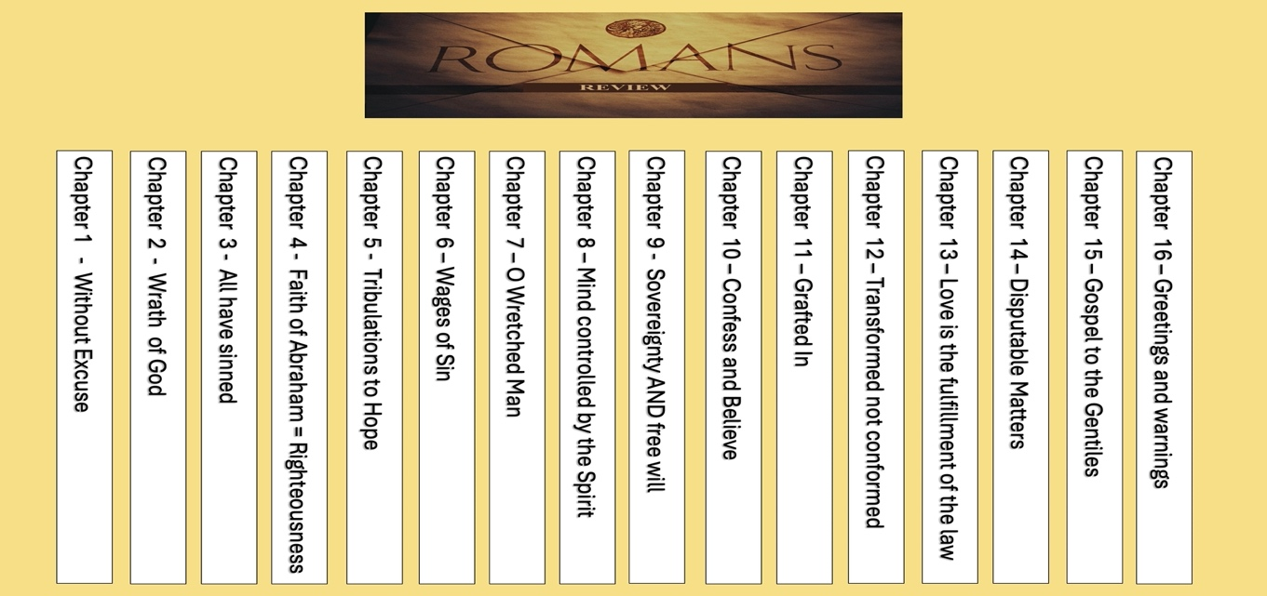

Chapter 1 – Without Excuse

Series Title Verse - “WITHOUT EXCUSE”

Romans 1:20 “For since the creation of the world God’s invisible qualities—his eternal power and divine nature—have been clearly seen, being understood from what has been made, so that people are without excuse.”

Paul talks repeatedly about how God made himself known to mankind since the creation of the world, and has shown himself through His divine nature and eternal power, so that no one can deny his existence.

In chapter 1, he makes a statement about the gospel, that he carries throughout the rest of the Book of Romans;
Romans 1:16-17 “For I am not ashamed of the gospel, because it is the power of God that brings salvation to everyone who believes: first to the Jew, then to the Gentile.”
This is how he starts the book, and ends it in the final chapters by declaring the gospel to both Jews and Gentiles.

Chapter 2 – The Wrath of God

Romans 2:5 “But because of your stubbornness and your unrepentant heart, you are storing up wrath against yourself for the day of God’s wrath, when his righteous judgment will be revealed.”

Paul is very clear that all of mankind needs a savior because we are deserving of God’s wrath. Without this understanding, we do not know the importance of Jesus’ sacrifice for our sins. As he rolls out the scriptures of “Romans Road to Salvation” we see Jesus rescues us from the coming wrath.

Chapter 3 – All Have Sinned

This is made very clear in this next chapter;

Romans 3:23 “for all have sinned and fall short of the glory of God, ²⁴ and all are justified freely by his grace through the redemption that came by Christ Jesus.”

This is the first of four scriptures in what we call “Romans Road to Salvation”, the other three are in chapter 5,6,and 10.

Chapter 4 – Abraham’s Faith = Righteousness
Romans 4:1-3 “What then shall we say that Abraham, our forefather according to the flesh, discovered in this matter? ² If, in fact, Abraham was justified by works, he had something to boast about—but not before God. ³ What does Scripture say? “Abraham believed God, and it was credited to him as righteousness.”
Six different times the Bible uses the phrase “Abraham believed God, and it was credited to him as righteousness”. Paul explains that Abraham, the Father of Faith did not obtain righteousness by obeying the law, because at the time there was no law. He was declared righteous by believing and having faith in God.
This is the foundation of the doctrine of “Justification by Faith”

Chapter 5 – Tribulations to Hope

Paul knows that the Roman church us under the heavy oppression of the brutal and violent Roman Empire. They are experiencing sever tribulations. Yet he tells them that tribulations are a way to bring about hope, as we endure and persevere.

ROMANS 5:3-4a …we also glory in tribulations, knowing that tribulation produces perseverance; ⁴ and perseverance, character; and character, hope.

This passage begins with tribulation, and ends with HOPE.

Tribulations Perseverance Character HOPE!

Chapter 6 – The Wages of Sin

The next two scriptures in Romans Road are found in chapters 5 & 6, but in reverse order.

Romans 6:23 “For the wages of sin is death, but the gift of God is eternal life in Christ Jesus our Lord.”

Romans 5:8 “God demonstrates his own love for us in this: While we were still sinners, Christ died for us.”

Chapter 7 – “O wretched man that I am”

In chapter 7 of Romans, Paul gets very honest, transparent, and vulnerable about his own sin.
He confesses;
Romans 7:19 “For the good that I will to do, I do not do; but the evil I will not to do, that I practice.”
Romans 7:24 “O wretched man that I am! Who will deliver me from this body of death?”
Romans 7:25 “I thank God”—"through Jesus Christ our Lord!”

Chapter 8 – The mind controlled by the Spirit
He begins this important chapter addressing the issue of the last chapter. Laboring under the weight of the “law of sin and death”, which basically says, if you sin, you are deserving of the wrath of God which brings about death. He answers it with these words;
Romans 8:1-2 “There is therefore now no condemnation to those who are in Christ Jesus, who do not walk according to the flesh, but according to the Spirit. ² For the law of the Spirit of life in Christ Jesus has made me free from the law of sin and death.”
He also tells us how we can live in such a way as to bring about Life and peace as opposed to the death that comes from sin and the flesh;
Romans 8:6 “ ⁶ The mind governed by the flesh is death, but the mind governed by the Spirit is life and peace.”

Chapter 9 – Sovereignty AND free will
These chapters (9 & 10 ), have become very divisive in Christian doctrine, because they seem to imply that God knows and controls all things, while also asserting that man can determine his eternal outcome by choosing to believe.
In chapter 9, Paul asks some questions that are answered clearly in chapter 10 showing us that while God is unquestionably sovereign, He reserves the right to have mercy on whomever He chooses, and offers salvation to all those “who believe”.
Romans 9:14-16 “What then shall we say? Is God unjust? Not at all! ¹⁵ For he says to Moses, “I will have mercy on whom I have mercy, and I will have compassion on whom I have compassion.” ¹⁶ It does not, therefore, depend on human desire or effort, but on God’s mercy.”

Chapter 10 – Confess and Believe

This chapter is written in direct response to the previous chapter. In fact it could be that Paul did not mean to “Chapter-ize” his letters. (These were done in 1205 AD by Cardinal Stephen Langton).

In it he gives us clear instructions on who can be saved and how to go about it;

Romans 10:13 “Everyone who calls on the name of the Lord will be saved.”

And the last stop on Romans Road;

Romans 10:9-10 “If you declare with your mouth, “Jesus is Lord,” and believe in your heart that God raised him from the dead, you will be saved. ¹⁰ For it is with your heart that you believe and are justified, and it is with your mouth that you profess your faith and are saved.”

Chapter 11 – “Grafted In”

Romans 11 is the ‘quintessential chapter’ on the subject of Israel and the Jewish people.

In the beginnings of chapter 9 and 10, he emphasized how much he yearns for how own people Israel “the Jews” to know the Messiah. Here in chapter 11 he compares Israel to a cultivated Olive tree. Some of the branches (Jews) were broken off due to unbelief. Other branches of non-cultivated olive trees (Gentiles) were “grafted in” by believing.

Romans 11:17 “If some of the branches have been broken off, and you, though a wild olive shoot, have been grafted in among the others and now share in the nourishing sap from the olive root, ¹⁸ do not consider yourself to be superior to those other branches. If you do, consider this: You do not support the root, but the root supports you.”

He ends the chapter with a warning to Gentiles to not boast against the broken branches (the Jews), and by delaring that it is God’s will for “All of Israel to be saved” (Romans 11:26).

Romans 11:29 “for God’s gifts and his call are irrevocable.”

Chapter 12 – Transformed not Conformed

This chapter reads like the book of Proverbs, filled with nuggets of wisdom.
Among the most memorable is Romans 12:2 which offers us important advice about avoiding the patterns of this world.

Romans 12:2 “Do not conform to the pattern of this world, but be transformed by the renewing of your mind. Then you will be able to test and approve what God’s will is—his good, pleasing and perfect will.”

Chapter 13 – Love is the fulfillment of the Law

Just as ‘1st Corinthians 13’ is the famous love chapter in Corinthians, Romans 13 mentions the word love more than any other chapter in Romans.

It reminds us of Jesus’ teaching regarding love for one another;

Romans 13:8,10 “Let no debt remain outstanding, except the continuing debt to love one another, “Love your neighbor as yourself.”
¹⁰ Love does no harm to a neighbor. Therefore love is the fulfillment of the law.”

He also urges us to live in peace in submission to governing authorities.

Romans 13:7 “If you owe taxes, pay taxes; if revenue, then revenue; if respect, then respect; if honor, then honor.”

Chapter 14 – Disputable Matters

Paul realizes the need for love and unity in the church in Rome, and warns them about things that can become divisive.

Arguments over non-essential issues has a way of dividing any church, so Paul begins this chapter with a warning against quarrelling over disputable matters and looking out for the weaker brethren.

Romans 14:1 “Accept the one whose faith is weak, without quarreling over disputable matters.”

Romans 14:19 “Let us therefore make every effort to do what leads to peace and to mutual edification.”

Chapter 15 – Gospel to the Gentiles

Paul begins to wrap up his letter summarizing some of the points he wrote to them about. He reminds them that he was given the task of being the “Apostle to the Gentiles” (just as Peter was commissioned to be the Apostle to the Jews in Galatians 2).
Romans 15:15-16 “Yet I have written you quite boldly on some points to remind you of them again, because of the grace God gave me ¹⁶ to be a minister of Christ Jesus to the Gentiles. He gave me the priestly duty of proclaiming the gospel of God, so that the Gentiles might become an offering acceptable to God, sanctified by the Holy Spirit.”
Just as he stated in the very beginning of the letter;
Romans 1:16-17 “For I am not ashamed of the gospel, because it is the power of God that brings salvation to everyone who believes: first to the Jew, then to the Gentile.”
He closes here be reiterating that this is the Gospel of God that he was give the priestly duty of proclaiming, which he did quite effectively.

Chapter 16 – Greetings and Warnings
In the final chapter, Paul takes the time to individually greet, commend, or thank over 34 individual people by name. These are those who helped him, served with him, were ministered to by him, and suffered with him for the sake of the gospel. He shows the importance of Christians friendships and relationships in the personal greetings and words of affection that he directs toward the recipients of this letter. He gives us a clear example of what it looks like to walk in peace, love and unity with other believers.
He also gives us a warning about those who work against the peace, love and unity in the body of Messiah, and urges us to watch out, and keep away from them.
Romans 16:17 “I urge you, brothers and sisters, to watch out for those who cause divisions and put obstacles in your way that are contrary to the teaching you have learned. Keep away from them.”
Closing thoughts:
The book of Romans is much too vast to sum up in a few simple statements, but our 16-chapter journey revealed to us many several things that are central to the message of this letter, and important for Christian life in today’s world.
- The sinful state of man and the critical need for salvation that can come to anyone who believes through faith in Jesus.

- The promises and purposes of God toward Israel which are irrevocable.

- Love and unity must remain of utmost importance in the church.

- We can only fully experience victory over the flesh, and the life God wants us to live through the filling, power, and presence of the Holy Spirit.

I believe this is the central theme of Romans and is located in the center of the letter.

Romans 8:6,9,11,14,15,16 “The mind governed by the flesh is death, but the mind governed by the Spirit is life and peace.
⁹ You, however, are not in the realm of the flesh but are in the realm of the Spirit, if indeed the Spirit of God lives in you. And if anyone does not have the Spirit of Christ, they do not belong to Christ.
¹¹ And if the Spirit of him who raised Jesus from the dead is living in you, he who raised Christ from the dead will also give life to your mortal bodies because of his Spirit who lives in you.
¹⁴ For those who are led by the Spirit of God are the children of God. ¹⁵ The Spirit you received does not make you slaves, so that you live in fear again; rather, the Spirit you received brought about your adoption to sonship. And by him we cry, “Abba, Father.” ¹⁶ The Spirit himself testifies with our spirit that we are God’s children.
The Holy Spirit, living in us, gives us life, peace, power, victory over the flesh, and brings about our adoption as children of God, into a deep relationship where we can cry “Abba Father”.
Living, dwelling, operating, and walking in the Spirit is the only way to experience the joy peace, hope and power that can only be found through the Holy Spirit dwelling in us.
Closing Verse:
Romans 15:13 “May the God of hope fill you with all joy and peace as you trust in him, so that you may overflow with hope by the power of the Holy Spirit.

