WITHOUT EXCUSE
Romans 15 – “His will is not always your will”
Review:
Romans 14:1 “Accept the one whose faith is weak, without quarreling over disputable matters.”
Paul tells us to accept the weaker brethren. He is not specific here about what are considered “Disputable Matters” versus what is considered non-disputable core doctrine. But he spent most of the chapter exhorting the church to not allow peripheral beliefs and practices to divide them. He lists some examples of food, drink, and observances, without ever telling us which is right and which is wrong, but usually points to the more legalistic and restrictive people as “those whose faith is weak.”

ROMANS 14 - Those who are weak, vs. ROMANS 15 those who are strong…

Romans 15 “We who are strong ought to bear with the failings of the weak and not to please ourselves. ² Each of us should please our neighbors for their good, to build them up. ³ For even Christ did not please himself but, as it is written: “The insults of those who insult you have fallen on me.” ⁴ For everything that was written in the past was written to teach us, so that through the endurance taught in the Scriptures and the encouragement they provide we might have hope.”
It's important to remember that when the Bible mentions Scriptures, they specifically referring to the Old Testament, because the New Testament had not been written yet.
The Old Testament, which is more accurately known as the Hebrew Scriptures, is made up of the Law, The Prophets, and the Writings.
The Old Testament, or The Hebrew Bible is also known as the TaNaKh, an acronym derived from the names of its three divisions:
- Torah (The five books of Moses)
- Neviʾim (Prophets)
- Ketuvim (Writings; like Psalms, Proverbs, Song of Solomon, etc.).
Knowing the Hebrew scriptures is the only way we can fully understand the New Testament. Without a strong understanding of the Hebrew foundation of our faith, teaching can become lost, unfounded and often times false.
(many times when false teachings or doctrines occur, it is because there is an inaccurate understanding of the Hebrew scriptures, including the covenants, and the Messianic prophecies), this is not true only for Bible teachers with Jewish backgrounds it’s true for all Bible teachers and studiers.)
Paul understands the importance of the Hebrew scriptures as he writes this chapter to the mostly-Gentile church in Rome. He puts it into practice right away, encouraging them with verses from the Tanakh.
V. 5 “May the God who gives endurance and encouragement give you the same attitude of mind toward each other that Christ Jesus had, ⁶ so that with one mind and one voice you may glorify the God and Father of our Lord Jesus Christ.
⁷ Accept one another, then, just as Christ accepted you, in order to bring praise to God. ⁸ For I tell you that Christ has become a servant of the Jews on behalf of God’s truth, so that the promises made to the patriarchs might be confirmed ⁹ and, moreover, that the Gentiles might glorify God for his mercy. As it is written:
“Therefore I will praise you among the Gentiles;
I will sing the praises of your name.” (2 Samuel 22:50; Psalm 18:49)

¹⁰ Again, it says,
“Rejoice, you Gentiles, with his people.” (Deut. 32:43)
¹¹ And again,
“Praise the Lord, all you Gentiles;
let all the peoples extol him.” (Psalm 117:1)
¹² And again, Isaiah says,
“The Root of Jesse will spring up,
one who will arise to rule over the nations;
in him the Gentiles will hope.” (Isaiah 11:10)

V. 13 “May the God of hope fill you with all joy and peace as you trust in him, so that you may overflow with hope by the power of the Holy Spirit.”
Paul was appointed the Apostle to the Gentiles. When he first became a believer and began his ministry, he went to the elders of the church who were in Jerusalem to be commissioned. Here’s how it went;

Gal. 2:1-2, 6-10 “Then after fourteen years, I went up again to Jerusalem, this time with Barnabas. I took Titus along also. ² I went in response to a revelation and, meeting privately with those esteemed as leaders, I presented to them the gospel that I preach among the Gentiles. I wanted to be sure I was not running and had not been running my race in vain.
⁶ As for those who were held in high esteem—whatever they were makes no difference to me; God does not show favoritism—they added nothing to my message. ⁷ On the contrary, they recognized that I had been entrusted with the task of preaching the gospel to the Gentiles just as Peter had been to the Jews ⁸ For God, who was at work in Peter as an apostle to the Jews, was also at work in me as an apostle to the Gentiles. ⁹ James, Cephas^{[c]} and John, those esteemed as pillars, gave me and Barnabas the right hand of fellowship when they recognized the grace given to me. They agreed that we should go to the Gentiles, and they to the circumcised. ¹⁰ All they asked was that we should continue to remember the poor, the very thing I had been eager to do all along.”

Peter and Paul each had a different commissioning.
Peter was called to be the “apostle to the Jews”, and Paul “the apostle to the Gentiles”.

Peter wrote to the Jewish believers who were under his care about their special place and purpose in God’s heart;

1st Peter 2:9 “But you are a chosen people, a royal priesthood, a holy nation, God’s special possession, that you may declare the praises of him who called you out of darkness into his wonderful light.” (1st Peter 2:9)

Paul wrote to the Gentile believers who were under his care that they were given the spirit of adoption and are sons and daughters of God;

Romans 8:15 “the Spirit you received brought about your adoption to sonship. And by him we cry, “Abba, Father.”

Paul embraced his calling to the Gentiles, although as we see throughout Acts, he would initially bring the gospel to the local synagogue to the Jews first, before presenting it to the Gentile people of each city he visited.
V.14 “I myself am convinced, my brothers and sisters, that you yourselves are full of goodness, filled with knowledge and competent to instruct one another. ¹⁵ Yet I have written you quite boldly on some points to remind you of them again, because of the grace God gave me ¹⁶ to be a minister of Christ Jesus to the Gentiles. He gave me the priestly duty of proclaiming the gospel of God, so that the Gentiles might become an offering acceptable to God, sanctified by the Holy Spirit.
¹⁷ Therefore I glory in Christ Jesus in my service to God. ¹⁸ I will not venture to speak of anything except what Christ has accomplished through me in leading the Gentiles to obey God by what I have said and done— ¹⁹ by the power of signs and wonders, through the power of the Spirit of God.”
“power of signs and wonders, through the power of the Spirit of God”.
What do you believe about the Supernatural. Power, signs and wonders, power through the spirit of God?
Do we truly believe that all the amazing things that happened in the Bible were true? Could they and other signs and wonders still take place?
I love when people tell me their supernatural stories of miraculous provision and intervention, healings, and amazing experiences they’ve had through God’s power. They are more common than you may think.
We’ve probably all seen or heard of abuses and false presentations of miracles, but does that mean that they no longer exist? Not at all.
I would caution us all to be wise as serpents, but also as gentle as doves in believing God for “power of signs and wonders, through the power of the Spirit of God”. Don’t be gullible, but don’t lose faith in the God of Miracles. Whether it’s for healing, provision, signs, or any other type of supernatural miracle.
[Sid Roth’s perspective, vs. his wife]
Dr. Michael Brown: “Some err on the side of criticism, others on err the side of gullibility. Both are unhealthy tendencies.”
Chuck Smith “I would rather have the wrong facts and a right attitude, than right facts and a wrong attitude.”

V. 19 “So from Jerusalem all the way around to Illyricum, I have fully proclaimed the gospel of Christ. ²⁰ It has always been my ambition to preach the gospel where Christ was not known, so that I would not be building on someone else’s foundation. ²¹ Rather, as it is written:
“Those who were not told about him will see,
and those who have not heard will understand.”

(Isaiah 52:15 regarding Gentiles coming to Faith in Messiah)

V. 22 “This is why I have often been hindered from coming to you.²³ But now that there is no more place for me to work in these regions, and since I have been longing for many years to visit you, ²⁴ I plan to do so when I go to Spain. I hope to see you while passing through and to have you assist me on my journey there, after I have enjoyed your company for a while. ²⁵ Now, however, I am on my way to Jerusalem in the service of the Lord’s people there. ²⁶ For Macedonia and Achaia were pleased to make a contribution for the poor among the Lord’s people in Jerusalem. ²⁷ They were pleased to do it, and indeed they owe it to them. For if the Gentiles have shared in the Jews’ spiritual blessings, they owe it to the Jews to share with them their material blessings.”
Paul had been collecting money from the churches along his journey which were predominantly Gentile, to bring back to the Jerusalem church, which was predominantly Jewish, and were the poor that he was asked to remember in Gal. 2 when he was commissioned. They were suffering the famine that Agabus prophesied about in Acts 11, when the collection for Jerusalem was initiated.
V. 28 “So after I have completed this task and have made sure that they have received this contribution, I will go to Spain and visit you on the way. ²⁹ I know that when I come to you, I will come in the full measure of the blessing of Christ.”
[map]
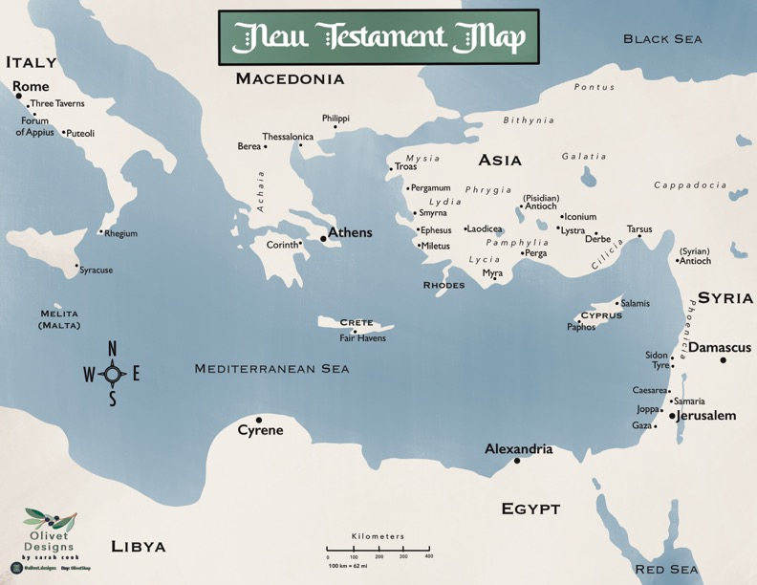
Journey:
From Jerusalem through Asia Minor, Macedonia, Achaia, and apparently as far east as Illyricum (Croatia). He had spent the past several years planting the churches of Galatia, Colossae, Philippi, Thessalonica, Athens, Corinth, Ephesus and likely others. But he had not yet been to Rome, and aspired to go to Spain.

V. 30 “I urge you, brothers and sisters, by our Lord Jesus Christ and by the love of the Spirit, to join me in my struggle by praying to God for me. ³¹ Pray that I may be kept safe from the unbelievers in Judea and that the contribution I take to Jerusalem may be favorably received by the Lord’s people there, ³² so that I may come to you with joy, by God’s will, and in your company be refreshed. ³³ The God of peace be with you all. Amen.” <>
Paul hoped to visit the people whom he was writing this letter to enroute to Spain, after his current trip to Jerusalem. He writes “by God’s will”, which basically means “God Willing”, leaving room for God to affirm OR redirect his plans.
On this trip, he left Corinth where he was staying (with Priscilla and Aquilla in their tentmaking business). He sailed to Miletus, to say goodbye to his dear friends in nearby Ephesus. While there, he was warned;
Prison and hardships:
Acts 20:22-23 “And now, compelled by the Spirit, I am going to Jerusalem, not knowing what will happen to me there. I only know that in every city the Holy Spirit warns me that prison and hardships are facing me.”
Handed over to the Gentiles:
Acts 21:10-12 “After we had been there a number of days, a prophet named Agabus came down from Judea. ¹¹ Coming over to us, he took Paul’s belt, tied his own hands and feet with it and said, “The Holy Spirit says, ‘In this way the Jewish leaders in Jerusalem will bind the owner of this belt and will hand him over to the Gentiles.’”
This is exactly what happened. He traveled back to Jerusalem and the Jews rejected him and tried to kill him. The Romans took him into custody for two years until finally when he appealed to Caesar, they put him on a prison ship to Rome, where he finally went and was able to meet and see the brethren whom he wrote to in the Roman church. It probably did not go exactly like he hoped it would, however.
His life’s journey ended in Rome where he spent years in prison; “preaching the kingdom of God and teaching the things which concern the Lord Jesus Christ with all confidence.” (Acts 28:31)
He wrote the letters of Ephesians, Philippians, Colossians and Philemon and strengthened the church in Rome (which incidentally, hundreds of years later became the center of Christianity in the world).
But what about Spain?
Did he ever get there? No one knows for sure, but according to what read in the Bible, he probably didn’t. It was a dream of his to visit Spain, a hope that he had in his heart. As much as he said he “longed to” visit Rome, it was only supposed to be a stop off to where he really wanted to go, Spain.
This had happened before to Paul. They desired to go North beyond Galatia to Bithynia on the Black Sea, but the Lord stopped them in their tracks and sent them to Macedonia.
Prov. 16:9 “A man’s heart plans his way, but the Lord directs his steps..”
Often when we get caught up in our own desires and aspirations, we conflate them with what we believe the will of the Lord is for our lives. When we submit to His will, we are subject to His plans, not our own. His plans are subject to change in accordance with His purposes which could be different than our own. When we try to force God’s to will to bend toward ours, we become disappointed and unfulfilled.
It's very important that we are careful to stay willing, available, and obedient. Yes, we can hope, plan, and even delight in our aspirations, we can also pray for them. But our plans must remain flexible as to bend to His will if He directs us another way.
Psalm 16:11 “You make known to me the path of life; you will fill me with joy in your presence, with eternal pleasures at your right hand.”
As he reveals his path for your life, and you (as Paul did), follow where He leads, you will experience the fulness of joy that comes from being where He wants you to be, and doing what He wants you to do.
But we must remember (as Paul did) to pray “By God’s will” or “God willing” knowing that God’s ways are better than ours.
James 4:13,15 “Now listen, you who say, “Today or tomorrow we will go to this or that city, spend a year there, carry on business and make money.” ^{…15} Instead, you ought to say, “If it is the Lord’s will, we will live and do this or that.”
Even Jesus, as He pondered the suffering of the cross said to His Father;

Luke 22:42 “Father, if it is Your will, take this cup away from Me; nevertheless not My will, but Yours, be done.”

God wants to use each of us in amazing and wonderful ways. In order for him to do that however, we have to be willing to say, “not My will, but Yours, be done.”

